



**Club Assistant Bot**

**Introduction**

Colleges provide students with many choices of clubs. These clubs carry out rich and colorful activities. They do this, not only to motivate their members to fully engage in the field which exerts a tremendous fascination with them but also to help other students cultivate enthusiasm and inspire them to join the clubs. Except organizing abundant and absorbing activities, rigorous management of clubs plays a crucial role. Two vital components of managing the clubs are setting up the hierarchical structure of the club and efficiently transfer information to the different subgroups. In general, two main ways are prevalently adopted to broadcast messages within groups: emails (usually packed with google forms to indicate the participation of the activities) and official accounts (mostly on Facebook). Through the above approaches, club members will be informed of the upcoming activities.

**Problem Statement**

However, two methods mentioned above have certain defects:

1. It is inconvenient for members to fill in personal information for every registration.

Members are usually required to enter their personal information for two reasons.

1. Ease the work of ExCos on checking registered member profile within club member list;
2. Update each members’ profile on time when there is an activity.

However, this will be an insignificant work for most members.

1. Many databases may be set for one activity.

If the club intends to collect feedback, a new database may be set with another requirement for basic information together with the feedback. This will increase the difficulty for ExCos to sort the database file as the club activities increase.

1. The emails may not be noticed by members.

Mailboxes are often saturated with tons of information other than club registration. For most members, club activity registration posted on the official accounts is not highlighted. Consequently, the announcements of the activities may be covered by other emails or spams. The same is true for the Facebook registration link. To solve this, ExCos usually upload registration link multiple times. However, repetitive counting in registered members occurs, when one forgot their registration and submit another form.

1. The spam caused by registration information

For notify the members of the registration, many emails will be sent to members including registered ones. Those are useless information and should be considered as spam.

1. Manage club in multiple platforms is inconvenient.

To manage a club, the ExCos need emails to notify the members of the activity, google drive or Dropbox to store the data, and separate chat groups to send messages to subgroups or registered members in an activity. It is inconvenient for the officers and members to switch application from one to another for club management and communication.

**Proposed Solution**

“Club Assistant” is a specially designed telegram bot targeting on campus clubs. The functions of the telegram bot cover every step from setting up the club, electing the committees, to initiating activities and send announcement and files.

Here are the four parts that Club Assistant can do:

1. *Managing the club through Club Assistant:* (Aims at providing different hierarchy with different privilege)

Four hierarchy will be set in the Club Assistant environment:

1. President – highest hierarchy, can read the database of the club, which is all the information of the members, initiate club activity, send announcement, change club members’ hierarchy;
2. ExCos – second hierarchy, have all the function of President but can only change the group leaders’ and normal members’ hierarchy;
3. Group leaders – third hierarchy, can read the profile of the group members and send announcement to them;
4. Members – fourth hierarchy, the majority of the club, they can change their own profile, change group, and register the activity. All the officer will obtain all the function of members but ‘change group’ because their groups are set according to their official position.
5. *Databases structuring:*

The following work can be done easily with database structuring in Club Assistant.

1. Club Assistant will create the main database to store all the members’ profile. Activity databases will be created when there is an event.
2. ExCos can download all databases from Heroku cloud storage, group leaders can view the profile of group members through the main database. (Aims at problem 4)
3. Whenever there is an activity, members only need to click on the register button and check if their profile is correct. If the information needs updating, the member change it once and a new profile will be updated in all database. (Aims at problem 1)
4. Databases will be set for specific activities, packed with feedbacks and activity queries. Hence, the ExCos can easily read members’ profile, answer to the registration query and feedback in one file. (Aims at problem 2)
5. *Initiate activity by steps.*
6. Request registration with queries. The registration link is solid on chat interface and the registered member will not receive register button on their main menu. (Aims at problem 3 & 4)
7. Send invitation announcement;
8. Provide file and URL references;
9. Receive feedback.

***Detailed function description.***

1. **Setting up the club** (Illustrated by a flow chart in Appendix A)**:**
2. ***Create a club in Club Assistant.***

Start by setting the name of the group, the first account that access the bot will automatically have the highest hierarchy, the President.

1. ***Specify the information that is needed for creating a profile.***

For the function of the bot, “Group name, Hierarchy, Name” is essential keywords to be set. User id will be recorded as for receiving announcements.

1. ***Set up officer position. (ExCos and group leaders)***

Different positions will be endued with different hierarchy and privilege, as suggested in proposed solution 1.

**B. Creating Profiles:**

After setting up the club, the main database is created, one will be asked to create their own profile if their id is not in the main database. _Create_Member_Profile will be called.

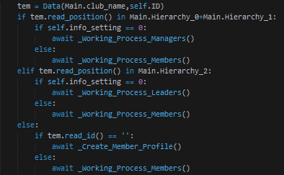

‘read_id’ is a method we created in Data_class.py to facilitate database structuring.



The information is stored in the main database in ".csv" format

**C. Accessing the main menu:**

Due to the different hierarchy and authority, the main menu for different members varies.

***The main menu of the ExCos is listed below:***

* Initiate the club activity

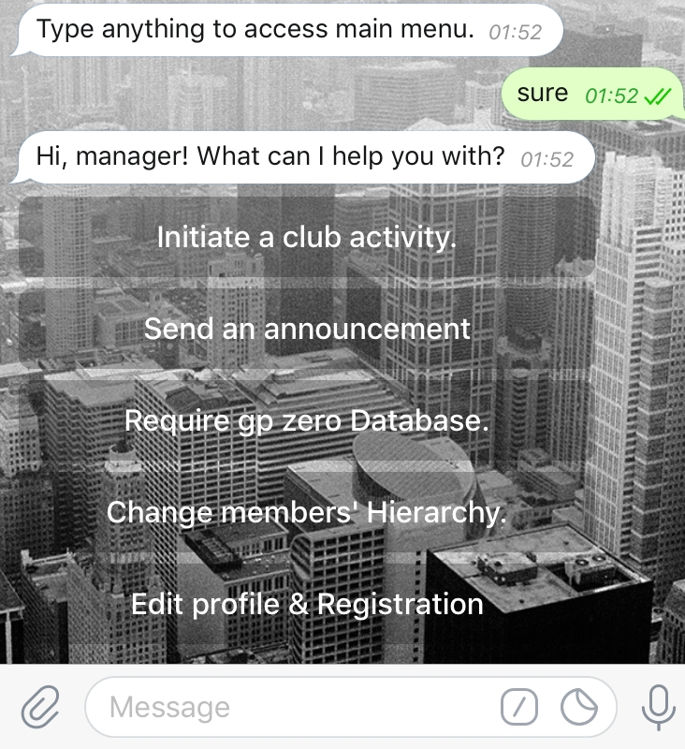

The ExCos will create club activity in steps with clear instruction. Detail will be described in Part D below.

* Send announcement

ExCos can send announcements to all members through Club Assistant, they can send messages or documents.

* Download database

ExCos can require for all databases to check the members of the club or the registered members for each activity and review their feedbacks for the improvement of the club.

* Change members’ Hierarchy

Change the official position of a member. (i.e. From member to event group leader)

When an officer clicks the button, the members below his hierarchy will be listed in buttons. The transformation will be executed when the officer clicks on the person’s name and then the position to change. When member’s position changed, both the member and the ExCos will receive a notification.

* edit profiles & registration

This button provides the method for the ExCos to access the main menu of members to change their profile and register the activity in the club.

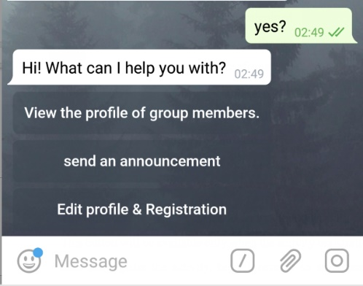***The main menu of the group leaders is listed below:***

To specify the hierarchy, group leaders’ privilege is lower.

* View the profile of group members
* Send announcement

Send announcements to the group members only, announcements can be in form of message or document.

* Edit profile & Registration

This button provides the method for the group leaders to access the main menu of members to change their profile and register the activity in the club.

Group leaders will take care of the specific tasks for their groups, ease the workload for the ExCos.

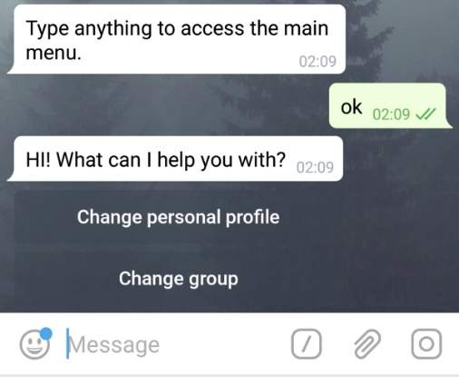***The main menu of the members is listed below:***

* Change profile

By clicking this button, members can change any of the information they have submitted before. After rewriting the information, the bot will show all the information for confirmation.

* Change group

Originally the members are not assigned to any group, so they must click on this button to choose one group to join. After joining a group, members can activate the bot again to check their current group or change to another group.

* Register the ‘activity’

The word activity will be the name set by the ExCos who initiates the activity.

This button will be available only when the activity registration is on. If the member does not register the activity, he will receive an announcement which reads the activity is terminated.

**D. Creating club activity:**

1. ***Register***

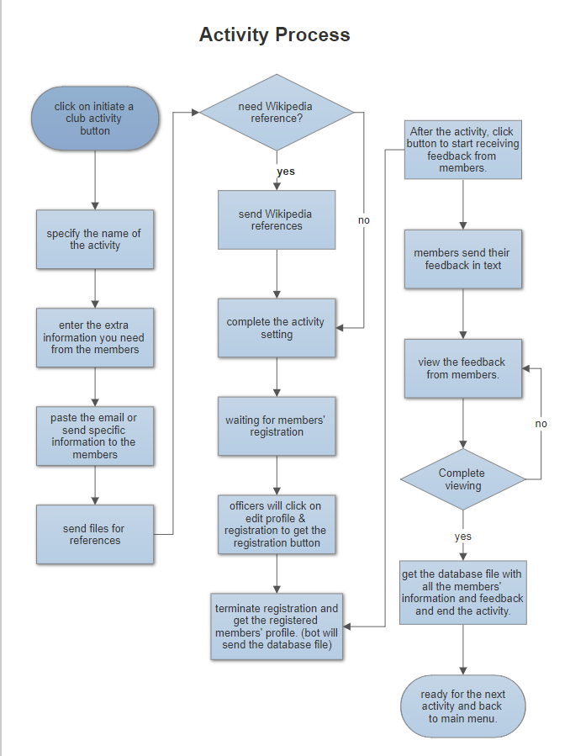If the ExCos initiate a new activity, members will immediately receive announcements and references from the ExCos. The registration information will not be covered by any other unrelated information. During registration time, an additional button "register the (activity name)" would appear in the members’ main menu. On click the button, members need to answer the additional queries for the activity (if any), then they should check their personal profiles. After confirmation of the profile, the profiles of the member will be automatically sent to the specific activity database.

1. ***Terminate***

After the ExCos close the registration for an activity the member who did not register will receive a notification and he/she will not receive any other message concerning the activity.

1. ***Feedback***

After the activity, ExCos can start receiving feedback. An automatic announcement will be sent to all registered member for sending feedback. A button "send my feedback now" will appear in members’ main menu. Members can submit their feedback to the bot and the feedback will be stored in the activity database after the members’ profile.

1. ***End***

After the ExCos close the activity registered members would receive an announcement "The activity is ended. Hope to see you next time!".

**Benefits**

Club Assistant is beneficial to the development of the club and all club members.

1. Club Assistant enhances the efficiency of club management.

Databases, registration content, club announcement, group chat and the updating of members’ profile will all perform automatically in the Telegram. It will be more convenient for managing the club as well as keep profile of everyone up-to-date.

1. the process of registering for events is simplified.
2. Members can be informed of the updated announcement on time;
3. Since the registration information is solid in private chat interface, they need not check their email and worry about missing out any significant notices.
4. The registered members’ profiles will be automatically transferred to the activity database, meanwhile unregistered members will not be spammed by activity information.

Compared with other club communication channels, Club Assistant is extremely user-friendly and helpful.

1. the structure of the club is exceedingly unambiguous. Different hierarchies will obtain different functions to work differently. With rigorous structure and explicit division of work, group leaders will help the club work neatly in one application. Therefore, higher efficiency will be achieved.
2. Other than solving all the problems concerned, we have implemented the Club Assistant with other functions.
3. Powerful web scraping is used to cite information from Wikipedia to every member as the brief introduction of a certain project.
4. A developer account is set in the bot. Every time the developer needs to add function or maintain the bot, he can close the app and restart it without losing any data. Therefore, the data is always safe in Club Assistant.

**Constraint and implementation**

1. Club Assistant could not deal with message type other than ‘text’ and ‘document’ for the time being.

a. The implementation will be, at the end of the activity, each member will be able to upload photos. The photo sent by members will be selected by ExCos. File id will be stored into activity database. Members can access the photo part of activity database to review the activity.

b. Implement on collecting club fees so that every club can manage their fund conveniently. Transactions will be recorded in the database properly and can be viewed by the treasurers and the ExCos.

2. Club Assistant currently can only deal with one club environment.

The implementation will be upgrade the Club Assistant to process multiple clubs’ information, in which case the base structure of the bot should be modified.

3. Club Assistant is not integrated with other APIs.

After this assignment, we intended to connect Club Assistant with Dropbox API for larger and safer storage of club databases. File transfer between the bot and Dropbox should be done autonomously so that the users only need Telegram for club management.

**Conclusion**

For the ExCos, managing a large club is challenging and, for the members, registering a club activity is not convenient enough. With the Club Assistant Telebot, the information can be collected and distributed with high efficiency, which makes a club well-organized and attractive. After this project, it is likely that the developers will continue to improve Club Assistant and intend to use it in a real club environment.

(For UI you may approach the bot link https://t.me/zaynTest_bot)

**Appendix A**

