**Midterm Project**

**Project description:**

1. Using Python and Numpy, write a class named LogisticRegression with necessary methods, which implements the logistic regression model for binary classification.
2. Using Python and Numpy, write a class named MLP with necessary methods, which implements a fully connected neural network with its hidden layer number and the number of units in each layer being the properties of the class. You can use the sigmoid function as the activation function in the neural network.
3. Consider the binary classification problem, with the samples (you create mock data sets) in the plane like the following figures.
   1. Try the logistic regression model developed in 1) for the binary classification problem and show your results.
   2. Try the neural network model with a single hidden layer developed in 2) for the binary classification problem and show your results. You should use different number of units in the hidden layer, such as 3 hidden neurons, 6 hidden neurons, and 20 hidden neurons, to get your results.
   3. Try the neural network model with a more than 1 hidden layers for the binary classification problem and show your results. You could try different number of hidden layers (such as 2, 6) and different number of neurons in each hidden layer, to get your results.

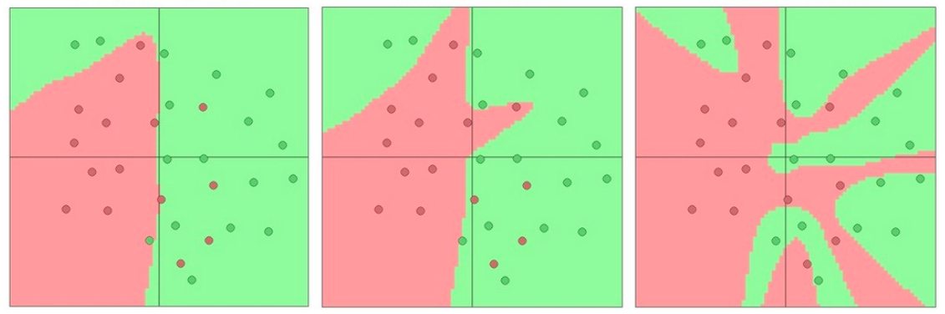

1. Consider Recall, precision and F1 score to evaluate the performance of binary classification results for different models carried out as in 3).
2. Analyze your experiments, for example, by showing how the loss function changes when you change the hyper-parameter (learning rate and tolerance for the loss difference in two consecutive steps to stop training) in your training process, and how the performance changes when you increase the neuron numbers in each hidden layer or the layer numbers in the neural network. Draw some plots and summarize some data in tables to support your conclusions.

**Requirement:**

1. You should complete your project by yourself only, and then hand in your code as well as a project report before the deadline.
2. The midterm project takes 20 marks for the course (20%).
3. The deadline to submit your project report and code packages is 23:59PM of Nov. 29, 2023. It is a firm deadline (Late submission will receive 0 mark).
4. When completing your course project, you are required to write a project report together with the codes for the project. Base on the project report and the code package, the project will be marked.
5. The project report should be written in English.
6. The project report should be presented in the IEEE conference paper style and suggest to use LaTex if possible. Refer to the following link

https://www.ieee.org/conferences/publishing/templates.html

for the LaTex Template (a LaTex template package is also included in the zipped file), or you can work in Overleaf (an online LaTex editor). The project report should contain the project title, author, abstract, keywords, I. Introduction, II. Problem formulation, III. Method and algorithms, IV. Experiment results and analysis, V. Conclusion and future problems, and possibly References.

1. Hand in a complete code package including the data set, code files with detailed description of dependencies, etc., so that the code can be checked and run on another computer without any problem.
2. The project and the codes should not be copied from others. Once it is noticed that the hand-in is copied from others including your classmates or online available work, you will receive 0 mark.