MMDBS – Practical Assignment
Fuad Shirinli and Alexander Eble

Evaluation

Querying Brontosaurus/0017 using the color histogram and euclidean distance with 16 bins and 4^2=16 cells produces the following output (the first image is the query):
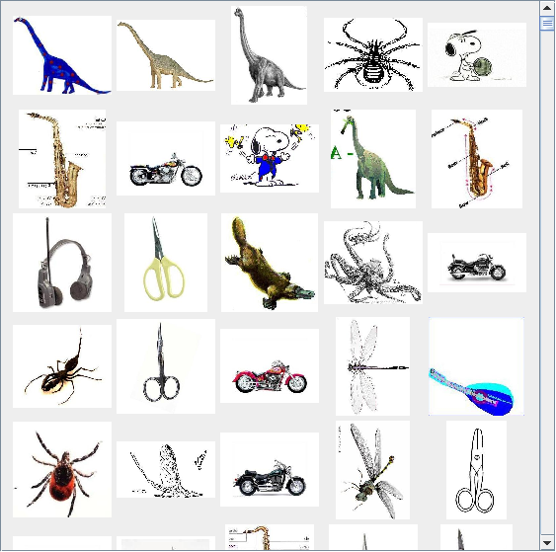
The precision-recall curve for this query looks as follows (only the first 30 results are shown):
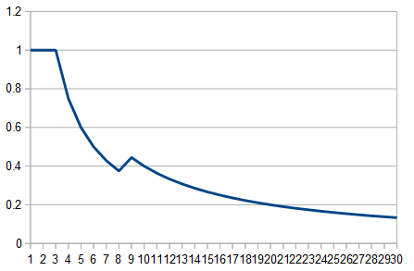
If we instead use the Quadratic Form Distance (without cutoff) we get a much better result:
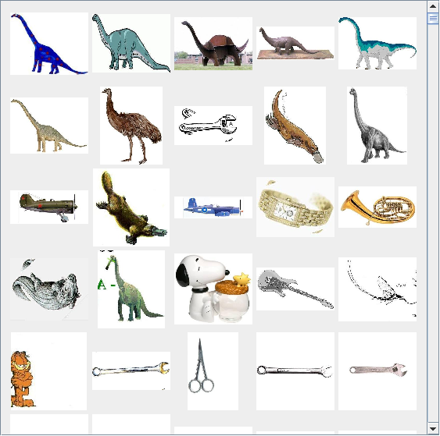

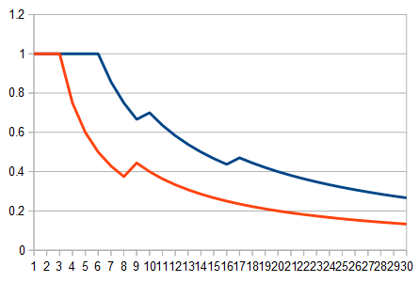
(blue = Quadratic Form Distance, orange = Euclidean Distance)

If we change the local color histogram to a global one (only one cell), the results suffer a lot:
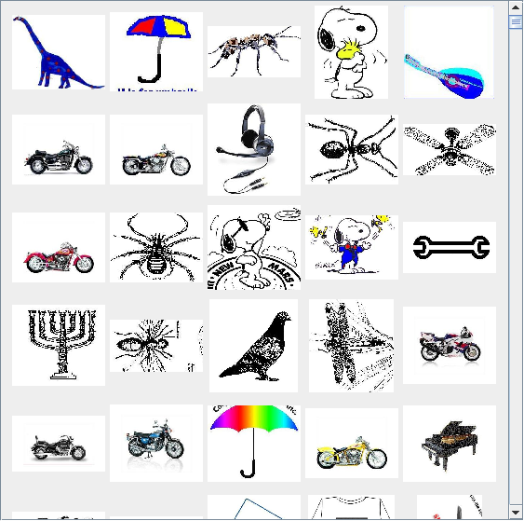

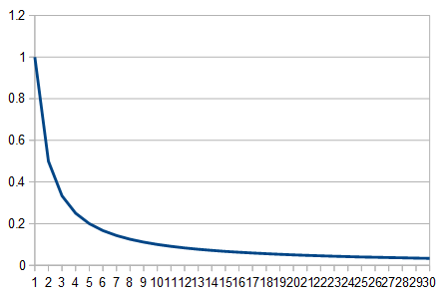
Anything that is mostly white with a bit of color is recognized here. While this is helpful to find clipart-style images it doesn't find the dinosaurs we want.

Using the Global Edge feature extraction method with the Euclidean distance gives us better results than the Color Histogram with the Euclidean distance:
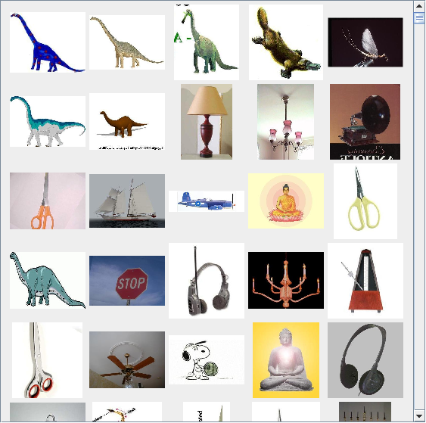
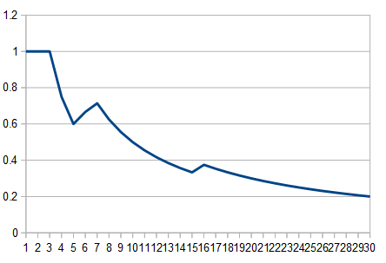
Here the shape of the figure is important and so the dinosaur that is distinctly different than the background is found, and so are other dinosaurs looking similar.

Using the Quadratic Form Distance for distance measurement does not help much in this case:
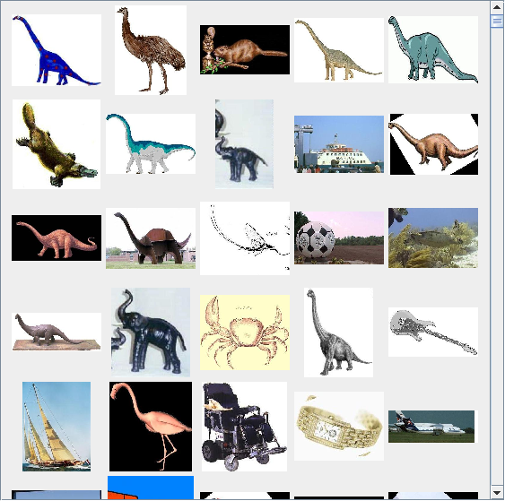
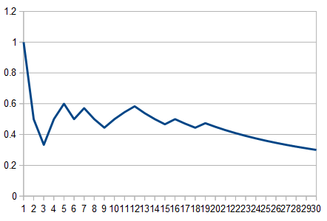
The reason for that is clear: The global edge feature extraction removes most of the color from the image. Everything except of the edges is black. However the Quadratic Form Distance works on colors and how people see the similarity between different colors. It can't give as accurate results if most of the image it gets to compare is black.

If we increase the amount of bins in our histogram we also increase how close two images have to be to match. Both examples have brontosaurus/0017 as query, color histogram with quadratic form distance with 4^2 = 16 cells. On the left we use 16 bins and on the right we use 64 bins:
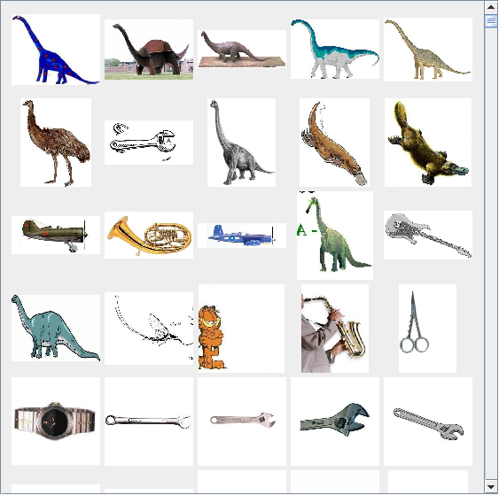
The second dinosaur is much further down in the ranking when using 64 bins since its shade of blue is not similar enough to the shade of blue of the query dinosaur.

The difference in the precision-recall-curves however is not large:
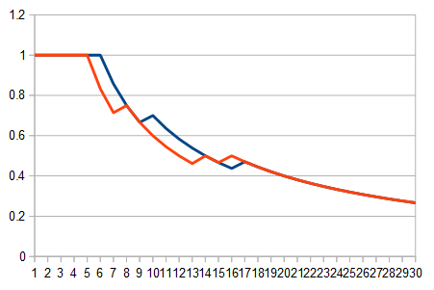
(blue = 16 bins, orange = 64 bins)

Now that you're probably tired of seeing that same dinosaur all the time, let's query some other images.

Querying mayfly/0023 with the color histogram and quadratic form distance returns:
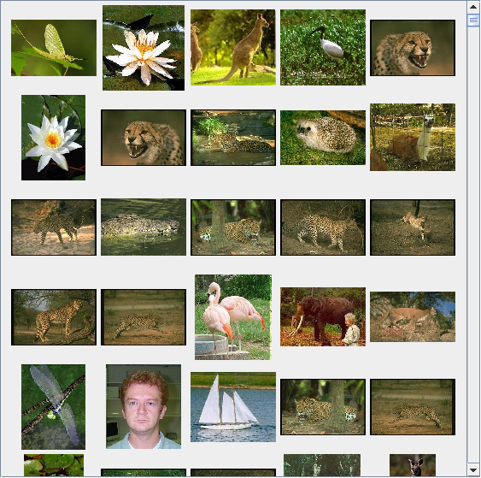

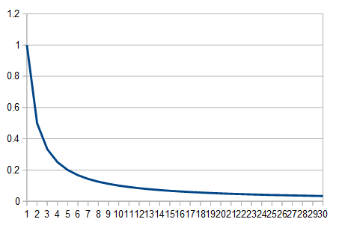
The precision-recall isn't good at all, but it is obvious why that happens: There are just a lot of greenish-brownish images in the dataset and the mayfly folder itself isn't all green and uniform either:
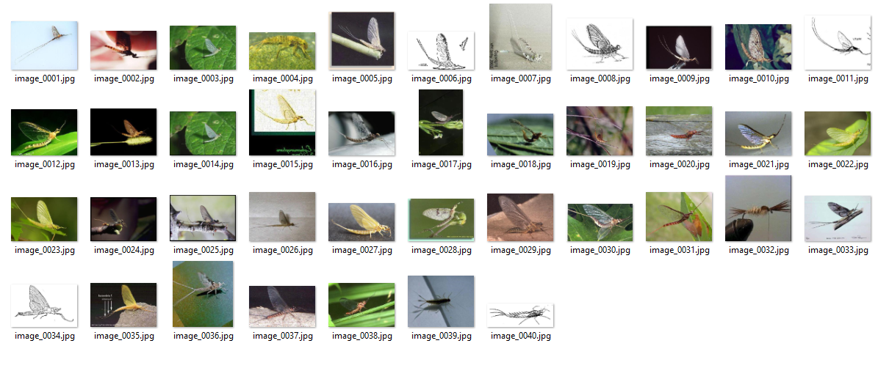

Let's take a closer look at these leopards (some of which are actually cheetahs). We ran a global edge query over the dataset with Leopards/0030 as query thinking that the body structure would help.
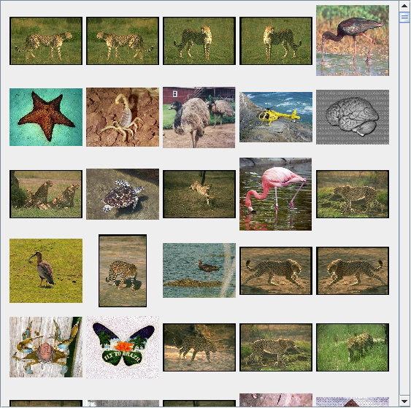
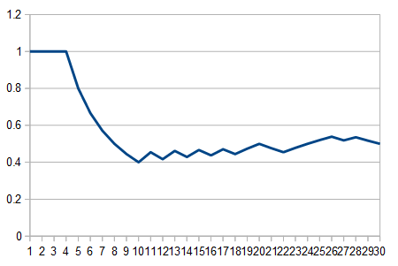
As it turns out, it finds twins of leopards quite well, however there are lots of false positives in the front page too. (we define front page as the first page of the results)
Going back to simply using the color histogram (16 bins, 4^2 = 16 cells) and Euclidean distance however brings that savanna-feel to the front page:
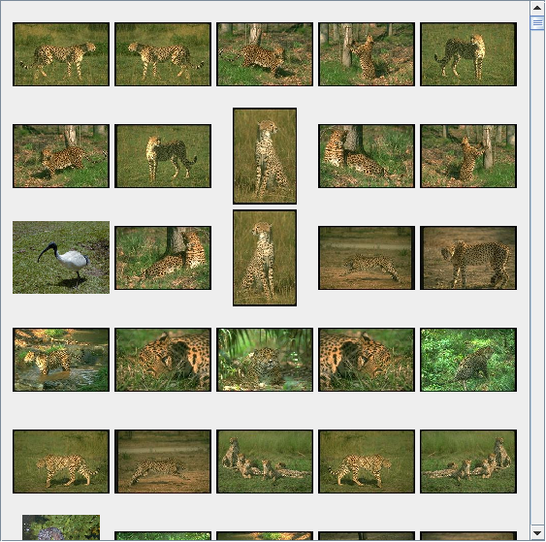
Just take a look at that precision-recall-curve (note that the y axis only goes to 0.86):
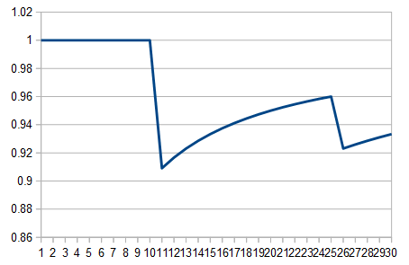
Even if we plot the first 120 results, the precision-recall-curve ends at over 0.5:
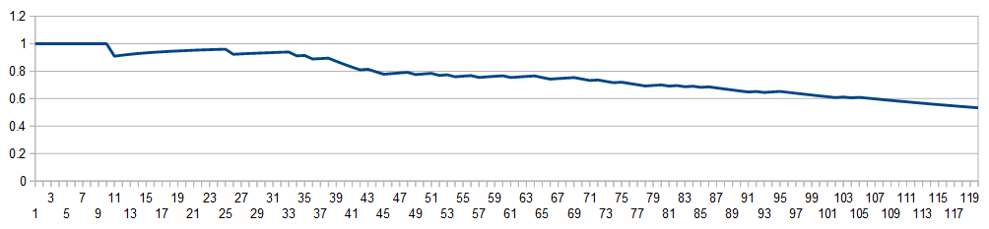
That looked pretty good already, but can we improve using the Quadratic Form Distance?
The answer is: yes. Only the last image on the front page is not a leopard / cheetah!
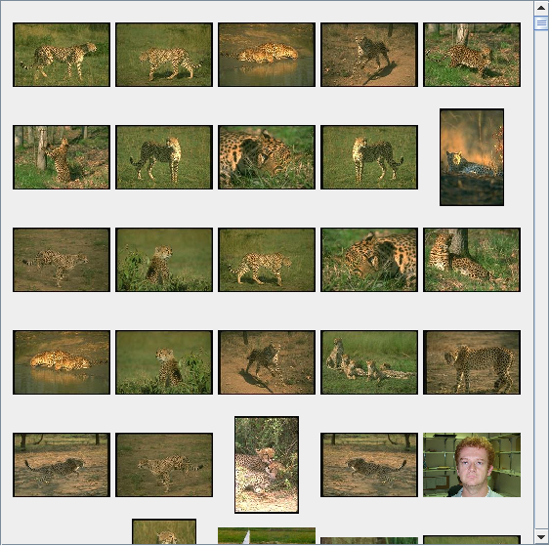
The precision-recall-curve illustrates this well: Result number 25 is the first non-leopard result.
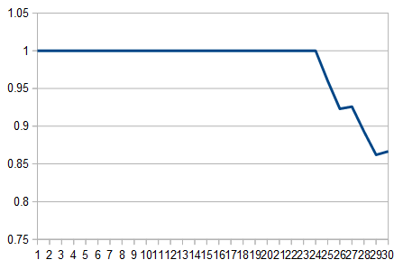
If we take a look at the long precision-recall-curve (up to 120 results) there isn't much of a difference between using the Quadratic Form Distance and the Euclidean Distance to compare:
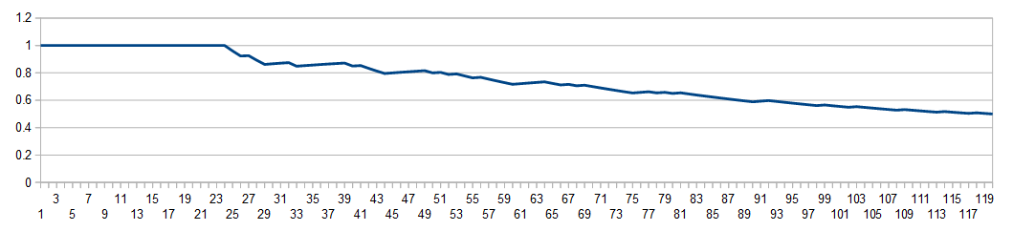
Ending up at a value of 0.5 for the 120th image the QFD is even slightly worse than the Euclidean Distance.

Let's lastly take a look at pizza/0003:
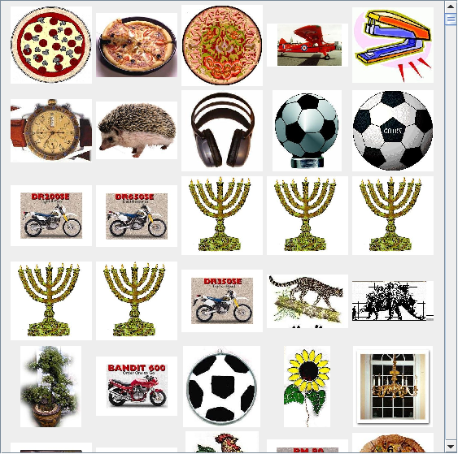
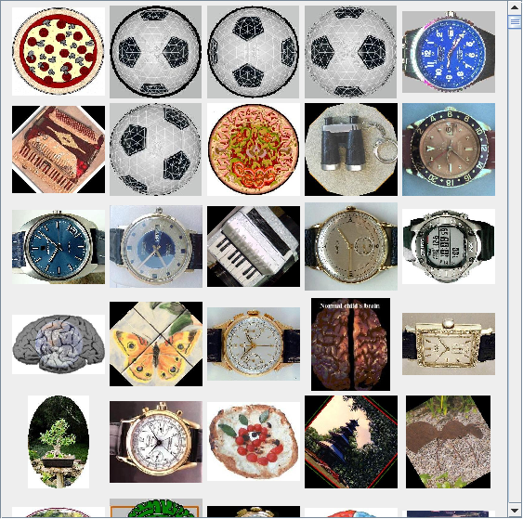

(left is Color Histogram, right is Global Edge Histogram)
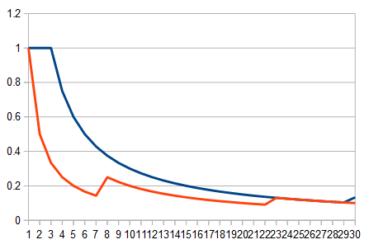
Here we can see that there are just a lot of things that are colored similarly to pizza or similarly round as pizza (blue = color histogram, orange = global edge histogram).

Conclusion:
- Different types of images need different feature extraction methods.
- Tweaking both the number of bins and the number of cells in the color histogram feature extraction needs to be done carefully and overshooting the optimal value is easy.
- Quadratic form distance is generally more accurate than Euclidean distance (at least for the examples tested here). This is due to it describing the way humans perceive color more exactly than the Euclidean distance.
- The Global Edge Histogram is only useful if one wants to find the shape of an object and here most of the shapes weren't defined well enough for it to be actually useful.

