**Abstract**

*This report provides a comprehensive analysis of BP UK Retail's information systems infrastructure and its impact on business operations. The study examines the various IS solutions implemented across BP's 300+ company-owned retail sites, including integrated systems for store management, inventory control, and customer engagement.*

*A key focus is placed on the Employee Mobile App's current limitations and proposed enhancements to improve workforce management. The report also details BP's robust approach to data security and privacy, addressing the critical aspects of confidentiality, integrity, and availability in data management.*

*Through detailed analysis of operational requirements and system design principles, this study demonstrates how technological improvements can enhance both employee satisfaction and organizational efficiency while maintaining strict compliance with data protection regulations.*

**Task 1a**

**BP UK Retail**

**BP p.l.c.** is a British multinational energy company headquartered in London, England. While it focuses mainly on oil and gas, it has five transition growth businesses today: bioenergy, EV charging, convenience, hydrogen, and renewables & power. **BP UK Retail** provides advanced fuels and market-leading convenience across the UK through its partnership with **M&S Food**.

**Information Systems (IS)**

Different information systems (IS) have been used to support its UK convenience retail business, which comprises over 300 company-owned retail sites.

**StorePoint Back Office:** It helps store managers manage daily business activities. It’s a cloud-based, fully integrated solution that includes cash management, employee management, supplier management, inventory management, fuel control, sales, and data-driven insights and reporting.

**M&S Central Store Stock Management (CSSM):** It is a cloud-based M&S stock management solution integrated with the BP system to provide accurate stock levels, waste management, logistics, finance, and reporting.

**Point of Sale (POS):** This in-store transaction processing system provides detailed data-driven insights to forecast future demands, such as buying trends.

**Checkit:** This workflow management system ensures the consistent quality of in-store food-to-go services and reduces waste while gathering real-time data on key performance metrics.

**Employee App:** This personalised employee scheduling app provides a shift clocking functionality and a detailed timecard.

**BPme App:** It uses cloud-based technology designed for customers to pay digitally for fuel. The app is integrated with **BPme Rewards**, a customer loyalty programme from BP that uses data analytics to provide a personalised experience to customers.

**Resources**

**People:**

Store managers and employees are the primary users of different information systems.

A team of information technology (IT) support professionals, both in-house and outsourced, provides 24/7 technical support across all BP retail stores. This includes installing new tools or troubleshooting software and hardware issues.

**Hardware:**

Desktop computers, tablets, sensors, and laser printers support the stores' day-to-day activities.

**Software:**

A cloud computing model, Software as a Service (SaaS) provides different software solutions for all stores, such as Microsoft 365 for word processing, spreadsheets, email, team collaboration, and all specialised information systems software.

**Data:**

Transactional data from Point of Sale (POS), sensor-generated data, in-store food-to-go production data from Checkit, and customer engagement data from BPme App/BPme Rewards are stored securely in a cloud-based database management system for store operation, management decision-making, and data analysis.

**Task 1b**

**Employee Mobile App (Extended Features)**

BP is always looking to improve operational efficiencies using digital technologies. An employee mobile app can foster productivity by streamlining communication between employees and managers.

By analysing the current employee app, we have identified the problems using different fact-finding techniques, interviewing, observations, and brainstorming, and we have created a requirements specification to make the system more efficient.

**Problems of the specified domain**

* Most of the employees in the BP stores work part-time. They have flexible contracts. Based on business demand and employees’ availability, they often work more than their contracted weekly hours.
* However, the employee mobile app does not provide up-to-date information on accrual holiday balances that employees worked in a week. Employees need to request management to get their actual accrual holiday balances.
* Employees cannot book their holidays directly on the app. They must request management for their holiday booking through a paper-based holiday booking form.
* There is no instant access to payslips on the app.

**Requirements specification**

**Functional**

1. **The purpose of the Employee Mobile App (Extended Features)**
   1. The purpose of the system is convenience for employees.
   2. The system aims to improve productivity for employees and management.
   3. The purpose of the system is better communication.
2. **Accrual holiday balance**
   1. The system enables employees to view up-to-date accrual holiday balances.
   2. The system enables the calculation of the actual accrual holiday balance based on the employee’s work in a week.
   3. The system enables managers to audit employee’s accrual holiday balance.
   4. The system enables human resource (HR) personnel to audit employee’s accrual holiday balance.
3. **Holiday requests**
   1. The system enables employees to book their holiday.
   2. The system enables employees to get their holiday booking confirmation.
   3. The system enables employees to see the available slots for holiday booking.
   4. The system enables managers to approve or decline employee's holiday bookings.
   5. The system enables employees to modify their holiday bookings.
   6. The system enables human resource (HR) personnel to audit approved holiday bookings for payment.
4. **Instant access to payslips**
   1. The system enables employees to view their payslips.
   2. The system enables employees to download payslips.
   3. The system enables the auto-generation of employee payslips.
   4. The system enables human resource (HR) personnel to audit employee payslips.

**Task 2**

When adding features to an existing employee mobile app, the System Development Life Cycle (SDLC) ensures that the result will meet both employee and employer needs. Given the needs and the importance of feedback from end-users I have concluded that the Agile methodology is better suited for this project. Agile’s flexibility makes it ideal for a project where requirements may shift.

System Development Life Cycle (SDLC) for the employee mobile application.

1. **Planning**: In this phase we shall outline the objectives of the app, identify resources and assess the feasibility of the project. Key aspects of this stage are defining system requirements, for example, showing accrual holiday balance, holiday requests, and instance access to payslips. A timeline and budget should also be designed.
2. **Analysis**: Detailed requirement research is needed for this stage, this involves consulting with stakeholders such as investors but also long-term employees, regional managers and corporate. In this stage we clarify the specific needs of the project.
3. **Design**: Based on the research, we shall create the architecture for our app. This phase involves defining the user interface etc. We also have the social, ethical and legal responsibility to ensuring that sensitive data (e.g., payslips records) are protected.
4. **Development**: Using the Agile methodology, we break down the development process into sprints, with each sprint concentrating on building a particular component. By building in regular stages, we can quickly deliver usable features regularly.
5. **Testing**: After each sprint, thorough testing is performed to make sure each feature is functioning as needed and if there are any aspects to change.
6. **Implementation**: Once the core components are completed and tested, we should consider starting with a sample store to gather initial feedback before the full launch.
7. **Maintenance**: After deployment, we maintain the system with regular updates, address any issues that arise, and make enhancements based on user feedback.

Key benefits of Agile in this context include:

* **More responsive to Feedback:** Agile’s iterative sprints enable regular check-ins with stakeholders after each development cycle. This ensures that the project stays aligned with user expectations.
* **Increased room to pivot and experiment:** Agile’s flexibility allows us to adapt to shifts easily by adjusting priorities.
* **Faster fixes and solutions:**  With Agile, we can release prototypes with core features early in the development cycle. This enables us to add new features in subsequent sprints.

**Why not use Waterfall methodology?**

The waterfall methodology is not ideal for creating an employee mobile app due to its rigid structure.

Waterfall follows a strict sequence (requirements, design, development, testing and deployment). Once a phase is completed, it is challenging to go back and adjust. Employee mobile apps often need changes based on feedback, new business needs, or unforeseen issues, which Waterfall struggles to accommodate efficiently. Also testing usually occurs late in the waterfall development cycle making it challenging to identify and resolve issues early. Waterfall can also result in a lengthy development timeline; this can be a disadvantage in competitive or fast-moving environments.

**Task 3**

**Safeguarding data**

**BP** continuously collaborates with its stakeholders to make it a cyber-resilient organisation. Cyber security is one of BP’s highest priority risks, and breaches can significantly threaten the security of its information systems and operations.

BP's different information systems collect, process, and store sensitive data and information about its customers, employees, internal operations, and other critical matters. By protecting these data, information, and systems, the organisation must ensure that **the three main goals of information security**—confidentiality, integrity, and availability—are achieved.

**Confidentiality** ensures that only authorised persons can access data, information, and resources.

**Integrity** means no unauthorised changes to data, information, and systems exist.

**Availability** ensures that data, information, and systems are available to authorised persons only when necessary.

There are three states of data: “**Data at rest**,” “**Data in transit**,” and “**Data in use**.” The organisation safeguards data in each state using the following **security controls**.

**Data Encryption**

Encryption technology uses mathematical algorithms to protect data and information from unauthorised usage.

**Data Loss Prevention (DLP)**

Data loss prevention involves enforcing an organisation's data and information handling policies and procedures to prevent data loss and theft.

**Data Minimisation**

Data minimisation techniques are used to reduce risk by reducing the unnecessary sensitive information that is not required anymore.

**Access Restrictions**

Access restrictions limit the ability of individuals or systems to access sensitive data, information, and resources.

**Segmentation and Isolation**

Segmentation separates networks by restricting communication with systems or other networks, while isolation separates a system completely from outside networks.

**Social, Ethical, and Legal issues associated with managing data to ensure data privacy**

A data breach can affect BP, its customers, employees, and other stakeholders. It can impact the organisation’s goodwill or reputation and its business continuity. By exposing personally identifiable information (PII) of customers, employees, and other stakeholders, there is a risk of identity theft that can damage their social status.

BP must act ethically to ensure data privacy. Its internal code of ethics ensures all employees act honestly, responsibly, and ethically while handling sensitive data and information.

BP ensures data privacy to comply with data protection laws such as the UK **Data Protection Act 2018** or the European Union’s **General Data Protection Regulation (GDPR)**. A compliance risk assessment from a security breach can cause the organisation to run afoul of legal or regulatory requirements.

Task 5. Modelling and Designing of the proposed system (Above):** In this section, you will be Modelling and Designing the Proposed System that should at least meet the following system requirements: The company may have single or multiple branches across the country or globally. Each branch will have staff who will assist their customers with their operations both in the branch and over the phone. Each branch will have at least a Manager and an Assistant with other roles needed for their operations, including sales, admins, ...etc. Based on your selected system, consider the company's conditions, from flexible orders to VIP deposits (or booking fees), cancellations, modifications charges, payments…etc.

Task 5.a Draw an Entity Relationship Diagram (ERD

Identify the entities you would require for developing an information system app for your organisation and management for the given scenario. Show how these entities relate to each other in an ERD, including any assumptions. *(10 Marks)

Task 5.b List all the attributes you have identified in each Entity

You could use Draw.io or provide the screenshots of MS Access. You must also highlight the Primary keys, Foreign keys, Data types and null/not null values in a schema table. *(5 Marks)*

TASK 5A

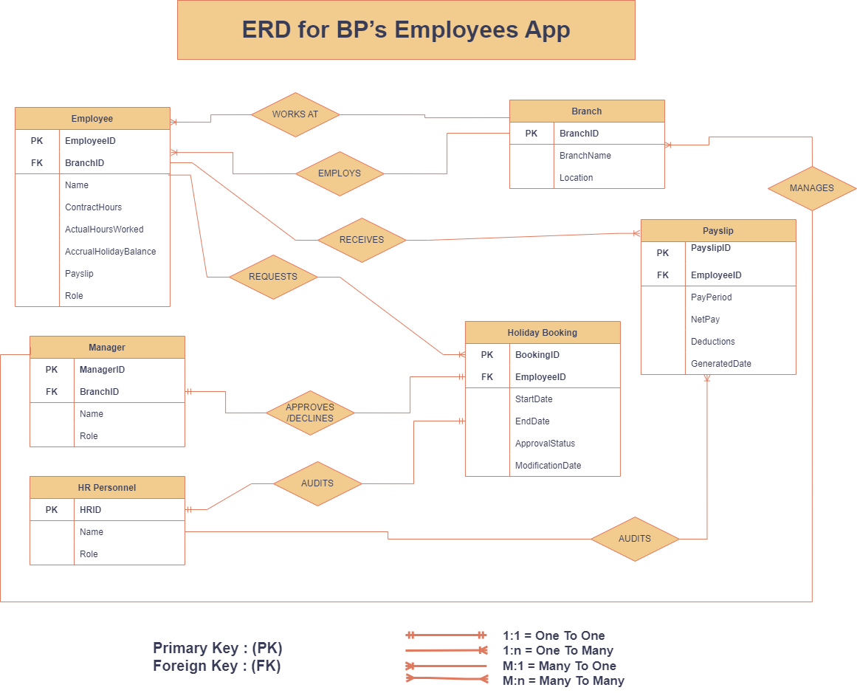

**Entities Required For the Employee Mobile App System**

1. **Employee**
   * Represents employees working at BP stores, both part-time and full-time.
   * Attributes: EmployeeID, Name, ContractHours, ActualHoursWorked, AccrualHolidayBalance, Payslip, Role.
2. **Manager**
   * Represents managers responsible for approving holiday bookings and auditing balances.
   * Attributes: ManagerID, Name, Role.
3. **HR Personnel**
   * Represents HR staff auditing payslips and holiday balances.
   * Attributes: HRID, Name, Role.
4. **Holiday Booking**
   * Represents employee holiday requests.
   * Attributes: BookingID, EmployeeID, StartDate, EndDate, ApprovalStatus, ModificationDate.
5. **Payslip**
   * Represents a record of employees' payslips.
   * Attributes: PayslipID, EmployeeID, PayPeriod, NetPay, Deductions, GeneratedDate.
6. **Branch**
   * Represents the BP store where the employee works.
   * Attributes: BranchID, BranchName, Location.

**Relationships and Verbs Connecting Entities**

1. **Branch ↔ Employee**
   * **Relationship Word:** *EMPLOYS*
   * A branch *employs* multiple employees, and each employee *works at* one branch.
2. **Employee ↔ Holiday Booking**
   * **Relationship Word:** *REQUESTS*
   * An employee *requests* multiple holiday bookings, and each holiday booking *belongs to* one employee.
3. **Manager ↔ Holiday Booking**
   * **Relationship Word:** *APPROVES/DECLINES*
   * A manager *approves or declines* holiday bookings, and each holiday booking *is reviewed by* a manager.
4. **HR Personnel ↔ Holiday Booking**
   * **Relationship Word:** *AUDITS*
   * HR personnel *audit* approved holiday bookings for payment purposes.
5. **Employee ↔ Payslip**
   * **Relationship Word:** *RECEIVES*
   * An employee *receives* multiple payslips, and each payslip *belongs to* one employee.
6. **HR Personnel ↔ Payslip**
   * **Relationship Word:** *AUDITS*
   * HR personnel *audit* employee payslips for compliance and accuracy.
7. **Employee ↔ Branch**
   * **Relationship Word:** *WORKS AT*
   * An employee *works at* one branch, and each branch *has* multiple employees.
8. **Manager ↔ Branch**
   * **Relationship Word:** *MANAGES*
   * A manager *manages* one or more branches, and each branch *is managed by* a manager.

**Scenario Fitting the System**

1. **Branch and Employee Context:**
   * Lisa works part-time at the BP London branch. Her contract hours are 20 hours/week, but due to increased demand, she worked 35 hours last week.
2. **Accrual Holiday Balance Update:**
   * Lisa checks her **Employee Mobile App** and views her updated **Accrual Holiday Balance** based on the extra hours worked.
3. **Holiday Booking Request:**
   * Using the app, Lisa submits a **holiday booking request** for two weeks in December. She can see the available slots in real-time.
4. **Manager Approval:**

|  |  |  |  |  |
| --- | --- | --- | --- | --- |
| **Employee** | **Attribute** | **Data Type** | **PK/FK** | **Null/Not Null** |
|  | EmployeeID | INT | Primary Key (PK) | Not Null |
|  | Name | VARCHAR(100) |  | Not Null |
|  | ContractHours | INT |  | Not Null |
|  | ActualHoursWorked | INT |  | Not Null |
|  | AccrualHolidayBalance | FLOAT |  | Not Null |
|  | Role | VARCHAR(50) |  | Not Null |
|  | BranchID | INT | Foreign Key (FK) | Not Null |
|  |  |  |  |  |
| **Manager** | **Attribute** | **Data Type** | **PK/FK** | **Null/Not Null** |
|  | ManagerID | INT | Primary Key (PK) | Not Null |
|  | Name | VARCHAR(100) |  | Not Null |
|  | Role | VARCHAR(50) |  | Not Null |
|  | BranchID | INT | Foreign Key (FK) | Not Null |
|  |  |  |  |  |
| **HR Personnel** | **Attribute** | **Data Type** | **PK/FK** | **Null/Not Null** |
|  | HRID | INT | Primary Key (PK) | Not Null |
|  | Name | VARCHAR(100) |  | Not Null |
|  | Role | VARCHAR(50) |  | Not Null |
|  |  |  |  |  |
| **Holiday Booking** | **Attribute** | **Data Type** | **PK/FK** | **Null/Not Null** |
|  | BookingID | INT | Primary Key (PK) | Not Null |
|  | EmployeeID | INT | Foreign Key (FK) | Not Null |
|  | StartDate | DATE |  | Not Null |
|  | EndDate | DATE |  | Not Null |
|  | ApprovalStatus | VARCHAR(20) |  | Not Null |
|  | ModificationDate | DATE |  | Null Allowed |
|  |  |  |  |  |
| **Payslip** | **Attribute** | **Data Type** | **PK/FK** | **Null/Not Null** |
|  | PayslipID | INT | Primary Key (PK) | Not Null |
|  | EmployeeID | INT | Foreign Key (FK) | Not Null |
|  | PayPeriod | VARCHAR(50) |  | Not Null |
|  | NetPay | FLOAT |  | Not Null |
|  | Deductions | FLOAT |  | Null Allowed |
|  | GeneratedDate | DATE |  | Not Null |
|  |  |  |  |  |
| **Branch** | **Attribute** | **Data Type** | **PK/FK** | **Null/Not Null** |
|  | BranchID | INT | Primary Key (PK) | Not Null |
|  | BranchName | VARCHAR(100) |  | Not Null |
|  | Location | VARCHAR(150) |  | Not Null |

* + The **Branch Manager**, Mr. Taylor, receives a notification about Lisa’s request. After reviewing her availability and workload, he **approves** the holiday.

1. **Payslip Generation:**
   * At the end of the month, Lisa’s payslip for November is **auto-generated** and available for **instant download** from the app.
2. **HR Audit:**
   * The **HR Personnel** audits Lisa’s payslip for accuracy and also reviews the list of approved holiday bookings to ensure correct payouts.

**Connecting the Scenario to the Relationships**

* **Branch EMPLOYS Lisa** as an employee.
* Lisa **REQUESTS a holiday booking**, and Mr. Taylor, the **Manager, APPROVES it**.
* Lisa **RECEIVES a payslip** based on her hours worked and **HR AUDITS** the payslip and holiday booking.

TASK 5B

The requirements in **Task 5b** involve creating a schema that organizes the attributes of each entity in a structured format. Here's a **summary of why the schema design is structured that way**:

1. **Normalization:**
   * The schema adheres to normalization principles to eliminate redundancy and ensure data consistency. Each attribute is uniquely tied to its respective entity, minimizing duplication. For instance, EmployeeID uniquely identifies an employee without duplicating branch details.
2. **Relationships:**
   * Primary and Foreign Keys establish relationships between entities. This helps enforce data integrity and maintain clear connections, e.g., linking EmployeeID in the **Payslip** table to the **Employee** table ensures that each payslip is valid for an existing employee.
3. **Flexibility:**
   * The design supports scalability. Adding new employees, branches, or payslips does not disrupt the database structure. For example, multiple holiday bookings can be made for a single employee without creating redundant data.
4. **Data Types:**
   * Attributes are assigned data types based on their purpose. For instance, FLOAT for numerical calculations like AccrualHolidayBalance, and VARCHAR for textual data like Name. This ensures accuracy and efficiency in data handling.
5. **Constraints:**
   * Not Null constraints ensure that critical fields like EmployeeID or StartDate in holiday bookings cannot be left blank. This guarantees essential data is always recorded.
6. **Real-World Mapping:**
   * The schema reflects real-world relationships in the system. For example, a **Branch** employs many **Employees**, and an **Employee** requests many **Holiday Bookings**—both represented in the relationships.

In summary, the schema ensures that the database is **well-organized, consistent, and scalable** while meeting the requirements of the system. It reflects the business rules, ensuring data accuracy and simplifying future queries and reports.

**Here are references and citations to justify the schema design principles used in Task 5b:**

1. **Normalization**
   * Elmasri, R., & Navathe, S. B. (2015). *Fundamentals of Database Systems* (7th ed.). Pearson Education.
     + Explains the importance of normalization to avoid redundancy and ensure data consistency.
2. **Relationships and Keys**
   * Silberschatz, A., Korth, H. F., & Sudarshan, S. (2020). *Database System Concepts* (7th ed.). McGraw-Hill Education.
     + Discusses how primary and foreign keys establish relationships in a relational database.
3. **Data Types and Constraints**
   * Connolly, T., & Begg, C. (2014). *Database Systems: A Practical Approach to Design, Implementation, and Management* (6th ed.). Pearson Education.
     + Provides detailed guidelines on assigning appropriate data types and applying constraints like NOT NULL.
4. **Real-World Mapping and Scalability**
   * Date, C. J. (2019). *An Introduction to Database Systems* (8th ed.). Pearson Education.
     + Focuses on designing databases that accurately reflect real-world scenarios and support scalability.
5. **Relational Database Theory**
   * Codd, E. F. (1970). *A Relational Model of Data for Large Shared Data Banks*. Communications of the ACM, 13(6), 377–387.
     + Foundational paper introducing relational database concepts and normalization principles.

**Conclusion**

The analysis reveals that BP UK Retail has established a sophisticated network of information systems that effectively support its retail operations. However, there are opportunities for improvement, particularly in employee-facing applications.

The proposed enhancements to the Employee Mobile App, including automated holiday balance tracking and digital payslip access, represent significant steps toward modernizing workforce management. These improvements align with BP's commitment to operational excellence and employee satisfaction.

The organization's comprehensive approach to data security demonstrates its dedication to protecting sensitive information while meeting regulatory requirements. This commitment to security, combined with continuous system improvements, positions BP well for future growth and operational efficiency.

Overall, the findings suggest that by implementing the recommended system enhancements and maintaining robust security measures, BP can further strengthen its position as a leader in retail operations while ensuring the protection of stakeholder interests.