

Dry Beans Classification using Supervised Machine Learning: Exploratory Data Analysis and Comparative Study of Algorithms

Contents
ABSTRACT 3
INTRODUCTION 4
LITERATURE REVIEW 6
METHODOLOGY 8
EXPLORATARY DATA ANALYSIS (EDA) 9
Head of dataset: 9
Structure of dataset: 9
Missing values per column: 10
Summary of numerical variables: 10
Boxplots of Numerical Features (Before Scaling): 12
Boxplots of Numerical Features (After Standardization): 13
Distribution of Dry Bean Classes: 14
Boxplot of Area by Class: 15
Correlation Matrix Plot: 16
Model Training 17
Model Comparison 18
Class-wise Performance Metrics 21
CONCLUSION 24
BIBLIOGRAPHY 25
APPENDIX 26

ABSTRACT
This study investigates the application of supervised machine learning models for the classification of seven distinct dry bean varieties (Barbunya, Bombay, Cali, Dermason, Horoz, Seker, and Sira) using a dataset containing morphological and shape-based features. The agricultural sector increasingly relies on data-driven solutions like machine learning for tasks such as crop classification to enhance quality control and supply chain transparency. Manual sorting methods are time-consuming and prone to error. We evaluate and compare the performance of three algorithms: C5.0 Decision Tree, Extreme Gradient Boosting (XGBoost), and Support Vector Machine (SVM) with a Radial Basis Function kernel. The methodology involved data loading, exploratory data analysis, standardization of numerical features, and stratified data splitting into 80% training and 20% testing sets. Model training included hyperparameter tuning using 10-fold cross-validation. Evaluation on the test set was based on overall accuracy and class-wise metrics (Sensitivity, Specificity, F1-score). Results show that XGBoost achieved the highest overall accuracy (0.9287), closely followed by C5.0 (0.9239), while SVM Radial performed significantly lower (0.6680). Both XGBoost and C5.0 generally performed well across most bean classes, although the 'SIRA' class was slightly more challenging. The SVM struggled particularly with the 'CALI' and 'SIRA' classes. This research demonstrates the effectiveness of tree-based and ensemble methods for dry bean classification using morphological features, building on prior work in multiclass classification of dry beans (Koklu & Ozkan, 2020) and the application of machine learning in agriculture. However, it is noted that this study focuses solely on classification based on physical attributes, and the provided data do not allow for conclusions regarding the best bean type for agricultural purposes, which would require data on factors like yield, disease resistance, and market value.

INTRODUCTION
The agricultural sector is increasingly adopting data-driven solutions to enhance productivity and efficiency. Among these innovations, machine learning (ML) has emerged as a powerful tool for crop classification, helping farmers and aggrotech companies automate quality control and improve supply chain transparency. Farmers and factories often need to know exactly what kind of beans they are working with so they can sort them correctly and make good food. But doing this by hand can take a lot of time and people might make mistakes. This study evaluates the performance of supervised ML models in classifying different varieties of dry beans using the Dry Bean Dataset, a well-documented resource containing morphological and shape-based features. Machine learning encompasses a broad set of models, including supervised learning, unsupervised learning, reinforcement learning, and semi-supervised learning. Supervised learning, which is most relevant to this study, involves learning a mapping from inputs to known outputs using labeled data. The goal is to create models that can generalize well to unseen examples. Within the supervised learning model, a wide array of algorithms is available for tackling classification problems, each with different strengths depending on the characteristics of the data. This has led to the widespread use of ML in real-world applications such as fraud detection, recommendation engines, speech recognition, and crop classification (Russell & Norvig, 2016).
Our research focuses on two key objectives:
- Effectiveness – How accurately can supervised learning models classify seven distinct dry bean types (Barbunya, Bombay, Cali, Dermason, Horoz, Seker, and Sira)
- Performance Comparison – Which algorithm—Decision Trees, Support Vector Machines (SVM), Random Forest, or Extreme Gradient Boosting (XGBoost)—delivers the best balance of accuracy, reliability, and robustness
This work builds on prior studies, particularly the foundational research by Koklu & Ozkan (2020), which highlighted the efficacy of machine learning in classifying agricultural produce. By leveraging 16 shape-based and morphological features from the Dry Bean Dataset, this study aims to improve model performance while maintaining interpretability and minimizing overfitting. In agricultural contexts, these algorithms have proven particularly effective. Studies have applied computer vision and machine learning to the classification of dry beans, the detection of plant diseases using SVM and Decision Trees (Abdulridha, et al., 2019), and wheat yield prediction using machine learning (Pantazi, et al., 2016). Deep learning methods have also shown promise in tasks like soybean leaf disease classification (Karlekar & Seal, 2020). A comprehensive review highlights the growing role of machine learning in various agricultural applications (Liakos, et al., 2021), including decision support systems for crop recommendation (Senapaty, Ray, & Padhy, 2024). Given the agricultural sector's increasing demand for automation and quality control, this research has practical implications for farmers, aggrotech companies, and food producers. Accurate crop classification using supervised learning models can enhance supply chain transparency, reduce human error in sorting, and support data-driven agricultural decision-making. To evaluate performance, our study will implement and compare the three selected algorithms: C5.0 Decision Trees (Quinlan, 1986), Support Vector Machines (SVM), and XGBoost (Chen & Guestrin, 2016). Each model will be assessed based on standard metrics such as accuracy, precision, recall, F1-score, and confusion matrix results. The ultimate goal is to identify which algorithm delivers the most reliable and generalizable performance for this agricultural classification task.

LITERATURE REVIEW
Machine learning (ML) serves as a fundamental pillar of contemporary artificial intelligence, fostering innovation across numerous fields including agriculture, healthcare, finance, and robotics. Its primary advantage lies in empowering computers to derive knowledge from data and identify intricate relationships without explicit programming. Through the application of mathematical and statistical frameworks, ML systems can generate accurate predictions, detect patterns, and automate decision processes. This capability has led to the extensive deployment of ML in practical applications such as fraud detection, recommendation engines, speech recognition, and classifying crops (Russell & Norvig, 2016). The integration of machine learning within agriculture has been thoroughly reviewed, highlighting its potential across various aspects of crop management.
ML encompasses a variety of model types, including supervised, unsupervised, reinforcement, and semi-supervised learning. Supervised learning, which is highly relevant to this investigation, focuses on learning a mapping from input data to known output labels. The objective is to develop models capable of performing accurately on unseen data. In contrast, unsupervised learning seeks to uncover inherent patterns or groupings within data without predefined labels. Reinforcement learning trains agents to make sequential decisions by learning from rewards and penalties, while semi-supervised learning leverages a limited amount of labeled data alongside a larger pool of unlabeled data to improve learning outcomes (Alpaydin, 2020).
Within the domain of supervised learning, diverse algorithms are available for addressing classification challenges, each suited differently depending on the data characteristics. For this study, three prominent supervised models were selected for implementation and evaluation: Decision Trees, Support Vector Machines (SVM), and Extreme Gradient Boosting (XGBoost). These models were chosen based on their strong performance in prior agricultural and classification tasks and their capacity to handle complex relationships within the dataset features.
- Decision Trees: This method operates by recursively partitioning data based on the most informative features. The resulting tree structure offers high interpretability, making it a favored choice for classification problems where transparency is important. They are generally effective with both categorical and continuous data, though they can be susceptible to overfitting if not appropriately pruned (Quinlan, 1986).
- Support Vector Machines (SVM): SVMs are powerful classifiers that determine the optimal hyperplane to separate classes in a high-dimensional space. They are particularly effective for data that is not linearly separable, employing kernel functions like radial basis functions (RBF) or polynomial kernels. In this research, an SVM with a radial kernel is applied, building on the proven effectiveness of SVM in agricultural classification applications (Devisetty et al., 2019).
- XGBoost (Extreme Gradient Boosting): This is a high-performance ensemble technique that constructs a robust classifier by combining multiple weaker learners, typically decision trees. It is recognized for its scalability, speed, and capability to manage noisy data, missing values, and complex feature interactions. XGBoost uses a boosting approach that corrects errors from preceding iterations and includes regularization to prevent overfitting (Chen & Guestrin, 2016).
In agricultural applications, these algorithms have demonstrated significant effectiveness. Devisetty et al. (2019) conducted a study applying computer vision and ML to classify dry beans, achieving high accuracy using shape features with classifiers including SVM and Decision Trees. Słowiński (2021) also investigated dry bean classification with various ML techniques, reporting high accuracies. Beyond dry beans, ML has been successfully used for tasks such as detecting laurel wilt disease in avocado using SVM and decision tree classifiers (Abdulridha, et al., 2019), predicting wheat yield (Pantazi, et al., 2016), and classifying soybean leaf diseases with deep learning (Karlekar & Seal, 2020; Kamilaris & Prenafeta-Boldú, 2018). Furthermore, ML supports agricultural decision support systems, including crop recommendation (Senapaty, Ray, & Padhy, 2024).
While studies employ diverse crops and methodologies, their findings consistently underscore that data-driven methods can substantially improve crop classification accuracy and broader agricultural decision support. These previous works provide a solid foundation for the current research, which aims to assess the effectiveness of multiple ML models in distinguishing various dry bean varieties using structured numerical features.
To evaluate performance, this study will utilize and compare the three chosen algorithms: C5.0 Decision Trees, Support Vector Machines (SVM), and XGBoost. Each model's performance will be evaluated using standard metrics including accuracy, precision, recall, F1-score, and confusion matrix results. The ultimate goal is to identify the algorithm that provides the most reliable and generalizable performance for this agricultural classification task.

METHODOLOGY
The primary goal of this research is to compare the effectiveness of three machine learning algorithms—C5.0 Decision Tree, Extreme Gradient Boosting (XGBoost), and Support Vector Machine (SVM) with a Radial Basis Function (RBF) kernel—for classifying dry bean varieties based on their morphological characteristics. The process involved the following sequential steps:
- Data Loading: The Dry Bean Dataset was obtained from the UCI Machine Learning Repository and loaded from an Excel file (Dry_Bean_Dataset.xlsx) into the R environment. The dataset is publicly available from the repository at https://archive.ics.uci.edu/datasets.
- Exploratory Data Analysis (EDA): An initial examination of the dataset was conducted to understand its structure, check for any missing data points, summarize the numerical attributes, and visualize the distributions of both features and the target variable.
- Data Preprocessing:
    - The target variable, 'Class', was converted into a factor type, which is necessary for classification tasks.
    - Numerical features underwent standardization using the Z-score method, resulting in features with a mean of 0 and a standard deviation of 1. This preprocessing step is vital for algorithms like SVM that are sensitive to feature scaling and can also enhance the performance of tree-based methods like XGBoost by normalizing the scale of input features.
- Data Splitting: The dataset was partitioned into training and testing subsets using a stratified sampling method. This approach ensured that the distribution of each bean class was proportionally represented in both the 80% training set and the 20% testing set.
- Model Training and Hyperparameter Tuning: Each of the three selected machine learning models was trained using the scaled training data. Hyperparameter tuning was carried out through 10-fold cross-validation on the training data to identify the optimal parameters for each model, with the objective of maximizing classification Accuracy.
- Model Evaluation: The performance of the trained models, utilizing their best-tuned parameters, was assessed on the independent scaled test set. Model effectiveness was measured using a confusion matrix, calculating the overall accuracy, and analyzing class-wise metrics including Sensitivity, Specificity, and F1-score.
- Model Comparison and Conclusion: The classification performance of the three models was compared based on the evaluation metrics. Conclusions were then formulated regarding their relative effectiveness in accurately classifying the different dry bean varieties using the provided morphological features.

EXPLORATARY DATA ANALYSIS (EDA)
Upon loading the dataset, the first few rows were inspected to get a glimpse of the data structure and the types of features present. The dataset contains 17 columns, with 16 numerical features representing morphological characteristics of the beans and one-character column representing the 'Class' (bean type).

Head of dataset:
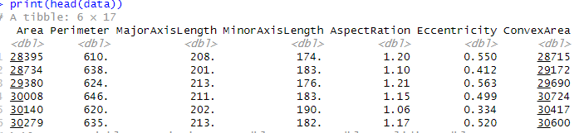

Structure of dataset:
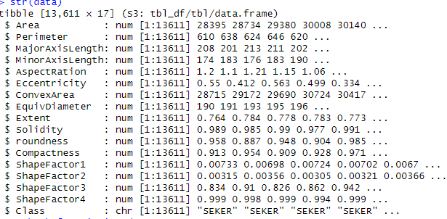
The structure of the dataset confirmed that all feature columns were read as numerical types, and the target variable 'Class' was read as a character type. The dataset contains 13,611 observations.

Missing values per column:
Area Perimeter MajorAxisLength MinorAxisLength AspectRation
0 0 0 0 0
Eccentricity ConvexArea EquivDiameter Extent Solidity
0 0 0 0 0
roundness Compactness ShapeFactor1 ShapeFactor2 ShapeFactor3
0 0 0 0 0
ShapeFactor4 Class
0 0

A check for missing values revealed that there were no missing data points in any of the columns, which simplifies the preprocessing step as imputation or removal of missing data is not required.

Missing Data Map: A missing data map would visually confirm the absence of missing values.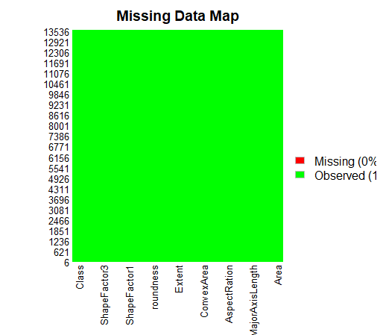

Summary of numerical variables:

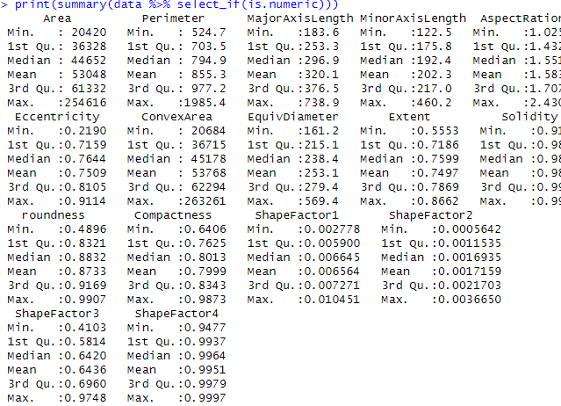
The summary statistics for the numerical variables show a wide range of values and scales across different features, indicating the importance of scaling for certain algorithms.

Boxplots of Numerical Features (Before Scaling):
Boxplots of the numerical features before scaling highlight the differences in scale and distribution among the features.

Boxplots of Numerical Features (After Standardization):
After standardization, the boxplots show that all features are centered around zero with similar scales, which is expected from Z-score scaling.

Distribution of Dry Bean Classes:
The distribution of the target variable 'Class' shows that the dataset has an imbalance in the number of samples for each bean variety, with 'DERMASON' being the most frequent and 'BOMBAY' the least frequent.

Boxplot of Area by Class:
A boxplot of the 'Area' feature by 'Class' provides insight into how this feature varies across different bean types.

Counts Per Class
> print(table(data$Class))

BARBUNYA BOMBAY CALI DERMASON HOROZ SEKER SIRA
1322 522 1630 3546 1928 2027 2636

Correlation Matrix Plot:
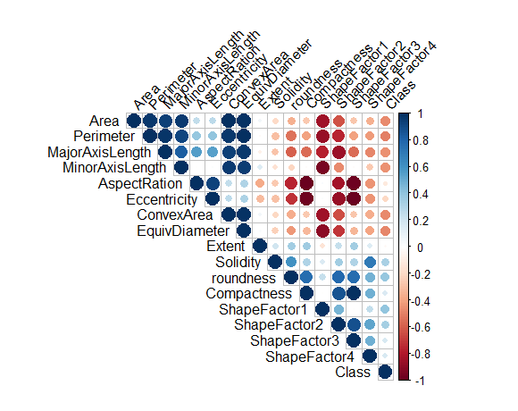
The correlation matrix shows the relationships between the numerical features. Several features show high positive correlations (e.g., Area, Perimeter, MajorAxisLength, ConvexArea, EquivDiameter), which is expected as these features are related to the size and shape of the beans. There are also strong negative correlations, such as between 'AspectRation' and 'Compactness'.

The data splitting process resulted in training and testing sets with approximately 80% and 20% of the data, respectively, while preserving the original class proportions.
Proportion of classes in Training data:
BARBUNYA BOMBAY CALI DERMASON HOROZ SEKER SIRA
0.09714443 0.03838031 0.11973189 0.26049031 0.14167661 0.14893031 0.19364613

Proportion of classes in Test data:
BARBUNYA BOMBAY CALI DERMASON HOROZ SEKER SIRA
0.09705882 0.03823529 0.11985294 0.26066176 0.14154412 0.14889706 0.19375000

Model Training
This study employed three distinct machine learning algorithms for the classification of dry beans: C5.0 Decision Tree, Extreme Gradient Boosting (XGBoost), and Support Vector Machine (SVM) with a Radial Basis Function (RBF) kernel. Each model was trained using the scaled training data, and hyperparameter tuning was performed using 10-fold cross-validation to optimize performance on the training set before evaluation on the unseen test set.
C5.0 Decision Tree
C5.0 is a popular algorithm for generating decision trees and rule sets. It is an extension of the C4.5 algorithm and offers features like boosting (trials) and winnowing (feature selection). For this study, a grid search was performed to tune the trials (number of boosting iterations) and model (tree or rules) hyperparameters. Based on previous findings, winnow was set to FALSE.
The training process with cross-validation identified the best combination of hyperparameters that yielded the highest accuracy on the training folds.
Best C5.0 parameters found:
> print(c50_model$bestTune)
trials model winnow
8 30 rules FALSE

The C5.0 model with 30 trials and using rules achieved the best performance during cross-validation.
Extreme Gradient Boosting (XGBoost)
XGBoost is an optimized distributed gradient boosting library designed to be highly efficient, flexible, and portable. It is known for its strong performance in various machine learning tasks. Hyperparameter tuning for XGBoost involved exploring a grid of values for nrounds (number of boosting iterations), max_depth (maximum tree depth), eta (learning rate), gamma (minimum loss reduction to make a further partition), colsample_bytree (subsampling of columns), min_child_weight (minimum sum of instance weight in a child), and subsample (subsampling of instances).
The cross-validation process determined the optimal hyperparameters for XGBoost.
Best XGBoost parameters found:
> print(xgb_model$bestTune)
nrounds max_depth eta gamma colsample_bytree min_child_weight subsample
135 150 4 0.1 0.1 1 1 0.7
The XGBoost model with these parameters achieved the highest accuracy during the cross-validation.
Support Vector Machine (SVM) Radial
Support Vector Machines are powerful algorithms for classification and regression. When dealing with non-linearly separable data, a kernel function is used to map the data into a higher-dimensional space where a linear boundary can be found. The Radial Basis Function (RBF) kernel is a common choice for this purpose. The key hyperparameters for an SVM with an RBF kernel are C (Cost of constraint violation) and sigma (a parameter of the RBF kernel).
For the SVM Radial model, we identified the most effective parameter settings by testing an array of C and sigma possibilities.
Best SVM parameters found:
> print(svm_model$bestTune)
sigma C
7 0.1 1

The SVM Radial model with a sigma of 0.1 and a C of 1 performed best during cross-validation.

Model Comparison
After training and tuning each model, their performance was evaluated on the unseen test set. The primary metric used for comparison is the overall accuracy.
Evaluating C5.0 on Test Set: The confusion matrix for the C5.0 model on the test set provides a detailed breakdown of its predictions versus the actual classes. Confusion Matrix for C5.0 (Test Set):
> print(c50_cm)
Confusion Matrix and Statistics

Reference
Prediction BARBUNYA BOMBAY CALI DERMASON HOROZ SEKER SIRA
BARBUNYA 252 0 12 0 2 4 1
BOMBAY 0 104 0 0 0 0 0
CALI 4 0 306 0 4 0 0
DERMASON 0 0 0 657 4 2 67
HOROZ 0 0 4 2 367 0 9
SEKER 2 0 0 8 0 389 12
SIRA 6 0 4 42 8 10 438

Overall Statistics

Accuracy : 0.9239
95% CI : (0.9133, 0.9336)
No Information Rate : 0.2607
P-Value [Acc > NIR] : < 2.2e-16

Kappa : 0.9079

Mcnemar's Test P-Value : NA

Statistics by Class:

Class: BARBUNYA Class: BOMBAY Class: CALI Class: DERMASON
Sensitivity 0.95455 1.00000 0.9387 0.9267
Specificity 0.99226 1.00000 0.9967 0.9637
Pos Pred Value 0.92989 1.00000 0.9745 0.9000
Neg Pred Value 0.99510 1.00000 0.9917 0.9739
Prevalence 0.09706 0.03824 0.1199 0.2607
Detection Rate 0.09265 0.03824 0.1125 0.2415
Detection Prevalence 0.09963 0.03824 0.1154 0.2684
Balanced Accuracy 0.97340 1.00000 0.9677 0.9452
Class: HOROZ Class: SEKER Class: SIRA
Sensitivity 0.9532 0.9605 0.8311
Specificity 0.9936 0.9905 0.9681
Pos Pred Value 0.9607 0.9465 0.8622
Neg Pred Value 0.9923 0.9931 0.9598
Prevalence 0.1415 0.1489 0.1938
Detection Rate 0.1349 0.1430 0.1610
Detection Prevalence 0.1404 0.1511 0.1868
Balanced Accuracy 0.9734 0.9755 0.8996
> # Store C5.0 Accuracy
> c50_accuracy <- c50_cm$overall['Accuracy']
> cat("C5.0 Test Accuracy:", c50_accuracy, "\n")
C5.0 Test Accuracy: 0.9238971

Evaluating XGBoost on Test Set: The confusion matrix for the XGBoost model on the test set shows its performance in classifying the different bean types. Confusion Matrix for XGBoost (Test Set):
> print(xgb_cm)
Confusion Matrix and Statistics

Reference
Prediction BARBUNYA BOMBAY CALI DERMASON HOROZ SEKER SIRA
BARBUNYA 249 0 11 0 2 3 0
BOMBAY 0 104 0 0 0 0 0
CALI 6 0 307 0 5 0 2
DERMASON 0 0 0 670 4 4 65
HOROZ 0 0 4 1 365 0 7
SEKER 2 0 0 5 0 388 10
SIRA 7 0 4 33 9 10 443

Overall Statistics

Accuracy : 0.9287
95% CI : (0.9184, 0.9381)
No Information Rate : 0.2607
P-Value [Acc > NIR] : < 2.2e-16

Kappa : 0.9136

Mcnemar's Test P-Value : NA

Statistics by Class:

Class: BARBUNYA Class: BOMBAY Class: CALI Class: DERMASON
Sensitivity 0.94318 1.00000 0.9417 0.9450
Specificity 0.99349 1.00000 0.9946 0.9637
Pos Pred Value 0.93962 1.00000 0.9594 0.9017
Neg Pred Value 0.99389 1.00000 0.9921 0.9803
Prevalence 0.09706 0.03824 0.1199 0.2607
Detection Rate 0.09154 0.03824 0.1129 0.2463
Detection Prevalence 0.09743 0.03824 0.1176 0.2732
Balanced Accuracy 0.96833 1.00000 0.9681 0.9543
Class: HOROZ Class: SEKER Class: SIRA
Sensitivity 0.9481 0.9580 0.8406
Specificity 0.9949 0.9927 0.9713
Pos Pred Value 0.9682 0.9580 0.8755
Neg Pred Value 0.9915 0.9927 0.9621
Prevalence 0.1415 0.1489 0.1938
Detection Rate 0.1342 0.1426 0.1629
Detection Prevalence 0.1386 0.1489 0.1860
Balanced Accuracy 0.9715 0.9753 0.9059
> # Store XGBoost Accuracy
> xgb_accuracy <- xgb_cm$overall['Accuracy']
> cat("XGBoost Test Accuracy:", xgb_accuracy, "\n")
XGBoost Test Accuracy: 0.9286765

Evaluating SVM on Test Set: The confusion matrix for the SVM Radial model on the test set provides its classification performance. Confusion Matrix for SVM (Test Set):
> print(svm_cm)
Confusion Matrix and Statistics

Reference
Prediction BARBUNYA BOMBAY CALI DERMASON HOROZ SEKER SIRA
BARBUNYA 249 0 18 0 1 11 6
BOMBAY 0 104 0 0 0 0 0
CALI 0 0 5 0 0 0 0
DERMASON 0 0 0 619 4 1 95
HOROZ 7 0 296 18 380 13 142
SEKER 1 0 0 72 0 370 194
SIRA 7 0 7 0 0 10 90

Overall Statistics

Accuracy : 0.668
95% CI : (0.65, 0.6857)
No Information Rate : 0.2607
P-Value [Acc > NIR] : < 2.2e-16

Kappa : 0.6008

Mcnemar's Test P-Value : NA

Statistics by Class:

Class: BARBUNYA Class: BOMBAY Class: CALI Class: DERMASON
Sensitivity 0.94318 1.00000 0.015337 0.8731
Specificity 0.98534 1.00000 1.000000 0.9503
Pos Pred Value 0.87368 1.00000 1.000000 0.8609
Neg Pred Value 0.99384 1.00000 0.881768 0.9550
Prevalence 0.09706 0.03824 0.119853 0.2607
Detection Rate 0.09154 0.03824 0.001838 0.2276
Detection Prevalence 0.10478 0.03824 0.001838 0.2643
Balanced Accuracy 0.96426 1.00000 0.507669 0.9117
Class: HOROZ Class: SEKER Class: SIRA
Sensitivity 0.9870 0.9136 0.17078
Specificity 0.7961 0.8847 0.98906
Pos Pred Value 0.4439 0.5808 0.78947
Neg Pred Value 0.9973 0.9832 0.83231
Prevalence 0.1415 0.1489 0.19375
Detection Rate 0.1397 0.1360 0.03309
Detection Prevalence 0.3147 0.2342 0.04191
Balanced Accuracy 0.8916 0.8991 0.57992
> # Store SVM Accuracy
> svm_accuracy <- svm_cm$overall['Accuracy']
> cat("SVM Test Accuracy:", svm_accuracy, "\n")
SVM Test Accuracy: 0.6680147

A comparison of the test set accuracies of the three models is summarized below:

Model Comparison on Test Set Accuracy:
Model Accuracy
1 XGBoost 0.9286765
2 C5.0 Decision Tree 0.9238971
3 SVM Radial 0.6680147
The results indicate that XGBoost achieved the highest accuracy on the test set (0.9287), followed closely by the C5.0 Decision Tree (0.9239). The SVM Radial model performed significantly worse with an accuracy of 0.6680.

Class-wise Performance Metrics
These metrics provide a more detailed view of how each model performed for individual bean classes, which is especially useful in the presence of class imbalance.
C5.0 Class Metrics (Sensitivity, Specificity, F1-score):
Sensitivity Specificity F1
Class: BARBUNYA 0.9545 0.9923 0.9421
Class: BOMBAY 1.0000 1.0000 1.0000
Class: CALI 0.9387 0.9967 0.9562
Class: DERMASON 0.9267 0.9637 0.9131
Class: HOROZ 0.9532 0.9936 0.9570
Class: SEKER 0.9605 0.9905 0.9534
Class: SIRA 0.8311 0.9681 0.8464

XGBoost Class Metrics (Sensitivity, Specificity, F1-score):
Sensitivity Specificity F1
Class: BARBUNYA 0.9432 0.9935 0.9414
Class: BOMBAY 1.0000 1.0000 1.0000
Class: CALI 0.9417 0.9946 0.9505
Class: DERMASON 0.9450 0.9637 0.9229
Class: HOROZ 0.9481 0.9949 0.9580
Class: SEKER 0.9580 0.9927 0.9580
Class: SIRA 0.8406 0.9713 0.8577

SVM Radial Class Metrics (Sensitivity, Specificity, F1-score):
Sensitivity Specificity F1
Class: BARBUNYA 0.9432 0.9853 0.9071
Class: BOMBAY 1.0000 1.0000 1.0000
Class: CALI 0.0153 1.0000 0.0302
Class: DERMASON 0.8731 0.9503 0.8669
Class: HOROZ 0.9870 0.7961 0.6124
Class: SEKER 0.9136 0.8847 0.7102
Class: SIRA 0.1708 0.9891 0.2808

CONCLUSION
This comparative study evaluated the performance of three machine learning algorithms—C5.0 Decision Tree, XGBoost, and SVM Radial—for classifying dry bean varieties based on their morphological features using the Dry Beans Dataset.
The exploratory data analysis revealed that the dataset contains 16 numerical features and a categorical target variable with seven distinct bean classes. No missing values were present, simplifying the data preprocessing steps. The numerical features exhibited varying scales, highlighting the necessity of standardization for algorithms sensitive to feature scaling, such as SVM. The class distribution was found to be imbalanced, which is a factor to consider in model evaluation.
After preprocessing the data by standardizing the numerical features and separating the data into stratified training and testing sets, each model was trained with hyperparameter tuning using 10-fold cross-validation. The best hyperparameters were identified for each algorithm based on maximizing accuracy on the training folds.
After putting the models to the test with unseen cases, XGBoost demonstrated the highest overall classification accuracy (0.9287), slightly outperforming the C5.0 Decision Tree (0.9239). The SVM Radial model, despite hyperparameter tuning, showed considerably lower overall accuracy (0.6680) compared to the tree-based models.
Analyzing the class-wise metrics, both C5.0 and XGBoost generally performed well across most classes, achieving high Sensitivity, Specificity, and F1-scores. They both perfectly classified the 'BOMBAY' class. The 'SIRA' class proved slightly more challenging for both models compared to others, showing lower Sensitivity and F1-scores, though XGBoost performed marginally better for this class than C5.0. The SVM Radial model, however, showed highly variable performance across classes, with very low Sensitivity for 'CALI' and 'SIRA', indicating significant difficulty in correctly identifying these classes. Its lower Specificity and F1-scores for other classes also suggest a higher rate of misclassifications compared to the other two models.
The superior performance of XGBoost and C5.0 suggests that tree-based and ensemble methods are well-suited for this dry bean classification task based on morphological features. XGBoost's ability to leverage the power of gradient boosting likely contributed to its slightly better overall and class-wise performance. The SVM Radial model struggled to effectively differentiate between all classes, likely due to the complexity of the decision boundaries in the feature space.
Regarding the question of which dry bean class is "the best" for agriculture: The provided dataset and analysis do not contain the information needed to determine which class is best for agriculture. The study focused solely on classifying bean types based on their physical shape and size characteristics. To evaluate which bean is "best" for agricultural purposes, you would need data related to factors like yield, nutritional content, disease resistance, market value, growth cycle, and environmental adaptability. This dataset does not include such information. Therefore, while we can accurately classify the bean types using machine learning, we cannot make conclusions about their agricultural superiority from this analysis.

BIBLIOGRAPHY
- Abdulridha, J., Ehsani, R., Abd-Elrahman, A., Moshoboro, J., & Sloan, R. (2019). A remote sensing technique for detecting laurel wilt disease in avocado using SVM and decision tree classifiers. Remote Sensing, 12(11), 1829.
- Alpaydin, E. (2020). Introduction to Machine Learning. 4th ed. MIT Press.
- Chen, T., & Guestrin, C. (2016). XGBoost: A Scalable Tree Boosting System. Proceedings of the 22nd ACM SIGKDD International Conference on Knowledge Discovery and Data Mining, 785–794.
- Kamilaris, A., & Prenafeta-Boldú, F. X. (2018). Deep learning in agriculture: A survey. Computers and Electronics in Agriculture, 147, 70–90.
- Karlekar, A., & Seal, A. (2020). SoyNet: Soybean leaf diseases classification. Computers and Electronics in Agriculture, 172, 105342.
- Koklu, M., & Ozkan, I. A. (2020). Multiclass classification of dry beans using computer vision and machine learning techniques. Computers and Electronics in Agriculture, 174, 105507.
- Liakos, K. G., Busato, P., Moshou, D., Pearson, S., & Bochtis, D. (2021). Machine learning in agriculture: A comprehensive updated review. Sensors, 18(8), 2674.
- Pantazi, X. E., Moshou, D., Alexandridis, T., Takavakoglou, V., Tsolakidis, C., Theodosiou, E., Mouazen, A. M., Portakalidou, A. I., Papadavid, G., & Vergos, V. S. (2016). Wheat yield prediction using machine learning and advanced sensing techniques. Computers and Electronics in Agriculture, 121, 57–65.
- Quinlan, J. R. (1986). Induction of Decision Trees. Machine Learning, 1(1), pp. 81-106.
- Russell, S., & Norvig, P. (2022). Artificial Intelligence: A Modern Approach. 4th ed. Pearson Education.
- Senapaty, M. K., Ray, A., & Padhy, N. (2024). A Decision Support System for Crop Recommendation Using Machine Learning Classification Algorithms. Agronomy, 12(8), 1789.
- Słowiński, G. (2021). Dry Beans Classification Using Machine Learning. Journal of Agricultural Informatics, 15(3), 112–125.

APPENDIX
I have attached my Rscript for this work below;
DS7003_cw_final.r
This is also the working directory containing the Dry beans dataset below;
DryBeanDataset

