Autobiography
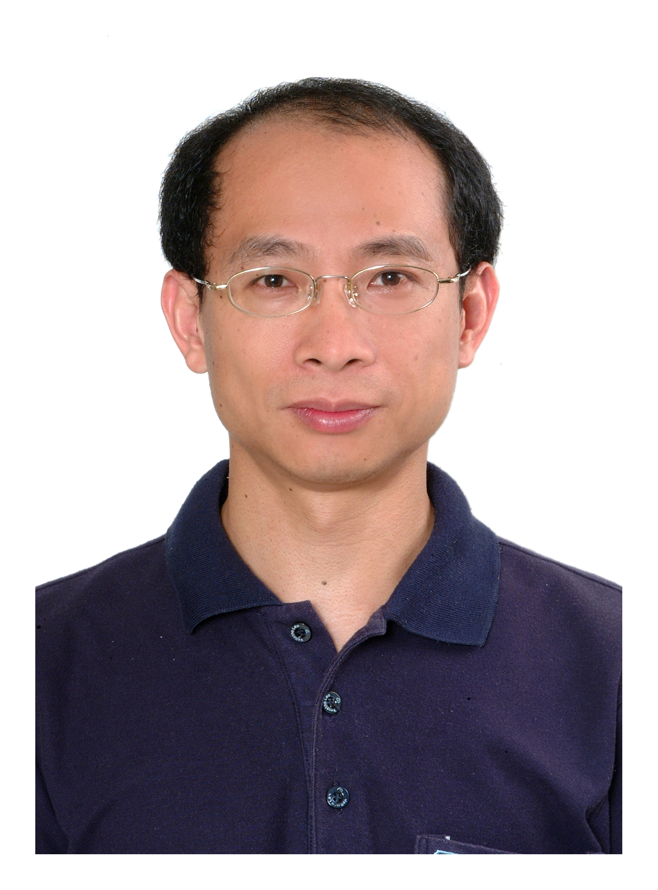
Dr. Ping-Lang Yen was born in 1966. He Received B.S. degree from Department of Power Mechanical Engineering, National Tsing-Hua University, M.S. degree from Department of Mechanical Engineering, National Taiwan University, and PhD. degree from Department of Mechanical Engineering, Imperial College, London in 1998, 1990 and 1996 respectively. He is currently an associate professor in the Department of Bio-Industrial Mechatronics Engineering, National Taiwan University. His main research interests are mechatronic control systems, medical robotics, computer-assisted orthopaedic surgery.

