**Zhenya Vovchuk**

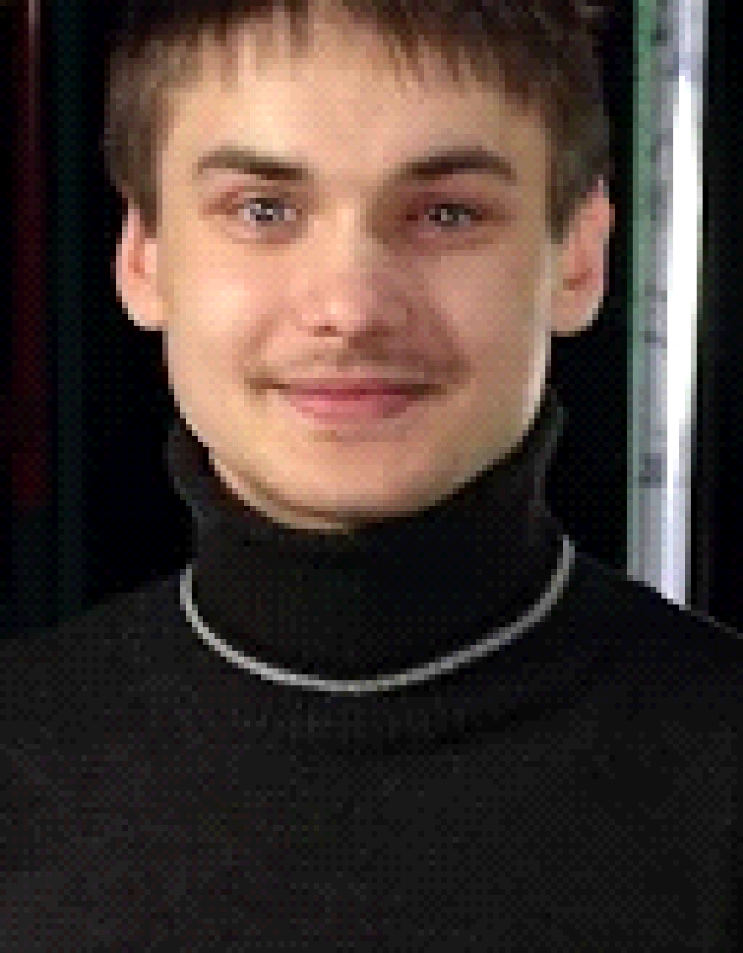

**Address: Ukraine, Kiev**

**Phone: 3 (093) 521 12 21**

**E-mail address:** [Jen9.Vovchyk@outlook.com](mailto:Jen9.Vovchyk@outlook.com)

**Education: specialized secondary education**

**Schedule: Full time, all life**

**Objective:**

Find a stable job in an international company ( And what can be more stable than Microsoft ) Start a career junior developer in the Microsoft and in five years to grow up to timlida, but in generai I think to move Satya Nadella.. 😎

**Experience:**

**-** "Musical Television" ( MTV ) - Decorator

**-** Restaurant "Fish Place" - Cook

**-** Sushi bar "Asia" – Cook

**-** "Billa" Delicacy department- Assistant cook, seller

**Professional skills:**

**-** At the moment I am working on the project "RocketDrive" for Windows 10.

**-** Knowledge of HTML,CSS. Design of internet pages. Basic Knowledge of programming languages… ( I will develop further in the direction of the language of XAML, Java )

**-** Knowledge of Microsoft products**:** Windows, Azure, Hyper-V, Visual Studio.( By itself Git, Visual Studio Team Service ) Google products.

**-** Modernization of equipment (Provision of inventory update for all equipment categories, first line of technical support, second line also ( implementation of complex settings )

Organization and quality control of technical personnel. Acceptance of goods. Processing and analysis of user requests, as well as non-standard situations

In the "Google Translate community" Ukrainian, English, Russian. ( Practice English )

Psychology of personality, social psychology, developmental psychology.

**Personal qualities:**

Adequate, resourceful, ability to persuade (it seems to me), purposefulness, responsibility, discipline, self-criticism, accuracy, decency, self-control.- All this is not about me ...😎 Sense of humor, the ability to make decisions in unusual situations.

**Bad Personal qualities:**

Well, here's a complete set, like a typical bad person, Stupidity, cowardice, greed, meanness, all this is also not about me. ;) I have a lot of bad qualities, but I'm working on myself ...