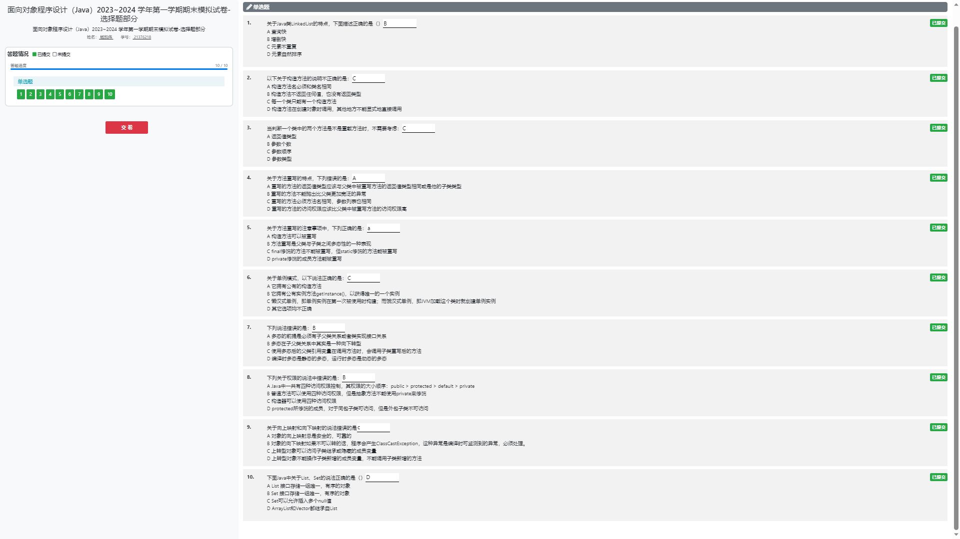import javafx.collections.transformation.SortedList;
import java.math.BigInteger;
import java.util.Scanner;
import java.util.*;
public class Test {
public static void main(String[] args) {
Scanner in=new Scanner(System.in);
BigInteger n= BigInteger.valueOf(in.nextInt());
BigInteger b= new BigInteger("1");
Boolean flag=b.compareTo(n)==-1;//1<n
for(BigInteger i = BigInteger.valueOf(1); flag; i=i.add(BigInteger.valueOf(1))) {
b = b.multiply(i);
flag=i.compareTo(n)==-1;
}
System.out.println(b);
/*Scanner in=new Scanner(System.in);
int n=in.nextInt();
List<Integer> l=new ArrayList<>();
for(int i=0;i<n;i++){
int ne=in.nextInt();
if(l.contains(ne))continue;
else l.add(ne);
}
int m=in.nextInt();
List<Integer> f=new ArrayList<>();
for(int i=0;i<m;i++){
int ne=in.nextInt();
if(f.contains(ne))continue;
else f.add(ne);
}
l.sort(Comparator.naturalOrder());
f.sort(Comparator.naturalOrder());
if(l.equals(f)){
System.out.println(1);
}else{
System.out.println(0);
}
for(Integer i:l)
System.out.print(i+" ");*/
/* Scanner in = new Scanner(System.in);
int n = in.nextInt();
Map<Integer, Integer> s = new HashMap<>();
for (int i = 0; i < n; i++) {
int ne = in.nextInt();
if (s.containsKey(ne)) {
s.put(ne, s.get(ne) + 1);
} else {
s.put(ne, 1);
}
}
List<Integer> l = new ArrayList<>();
int ans = 0;
for (Integer i : s.keySet()) {
if (s.get(i) > ans) {
ans = s.get(i);
l.clear();
l.add(i);
} else if (s.get(i) == ans) {
l.add(i);
}
}
l.sort(Comparator.naturalOrder());
for (Integer i : l)
System.out.println(i + " " + ans);*/
}
}
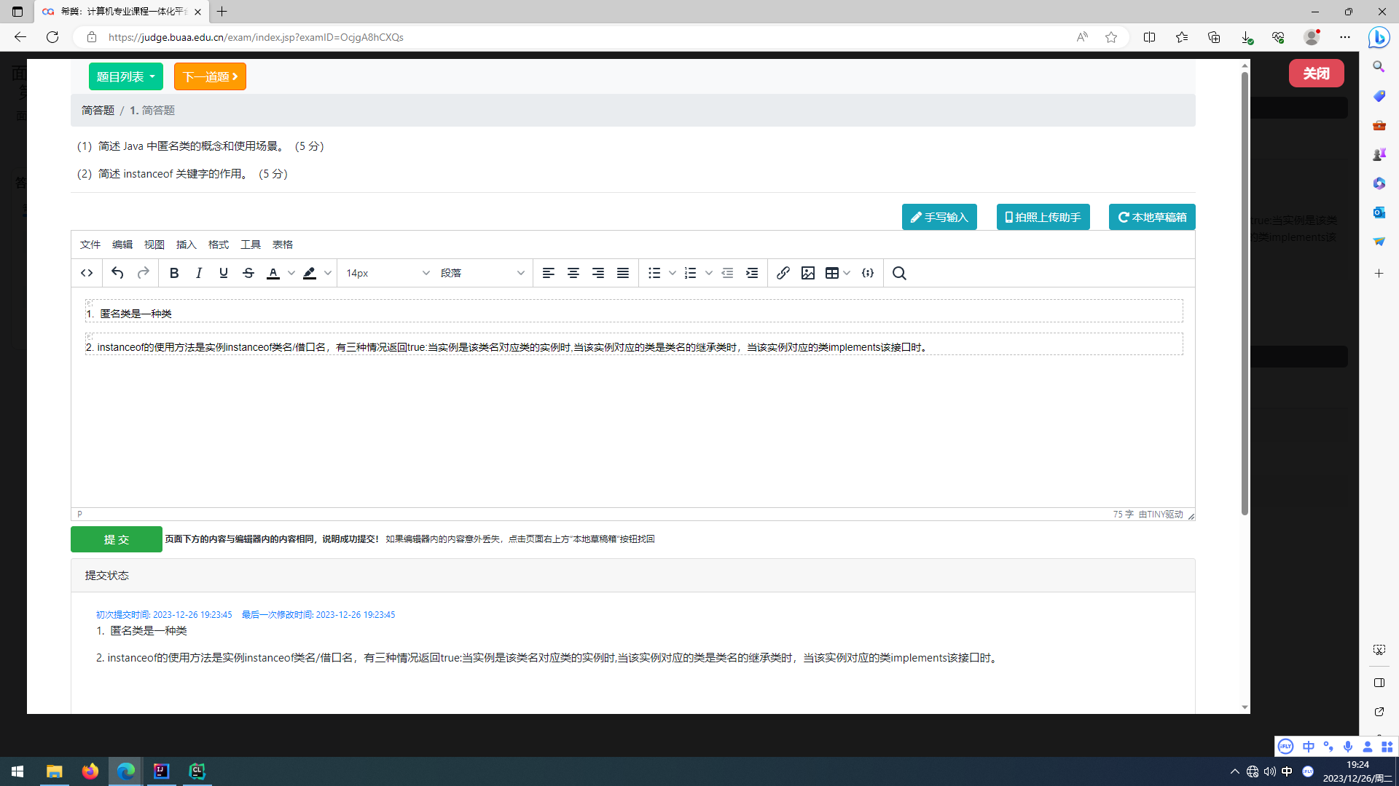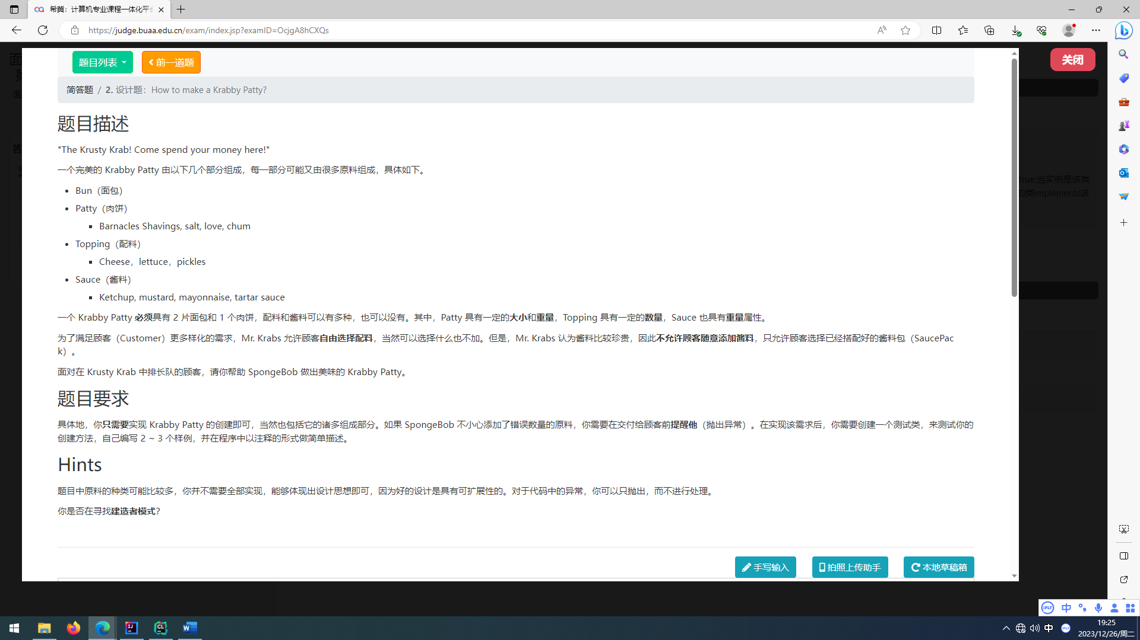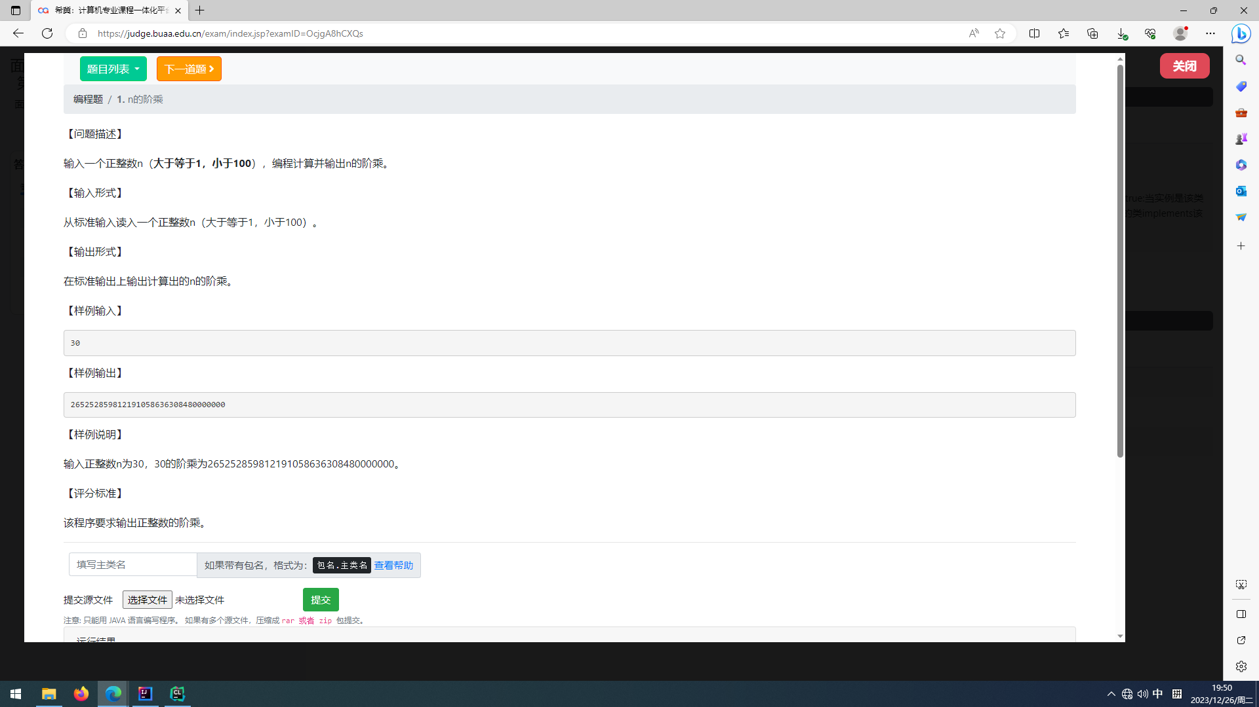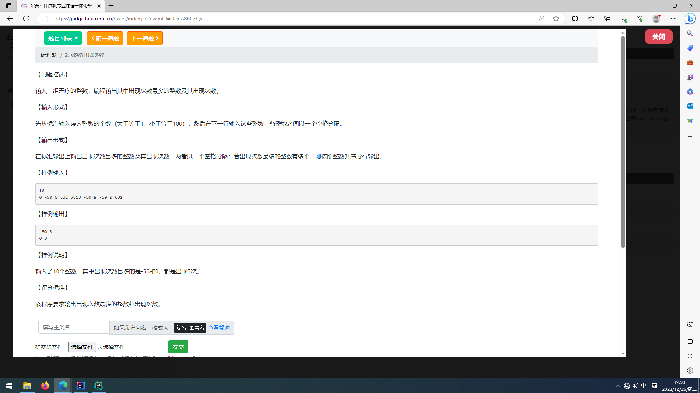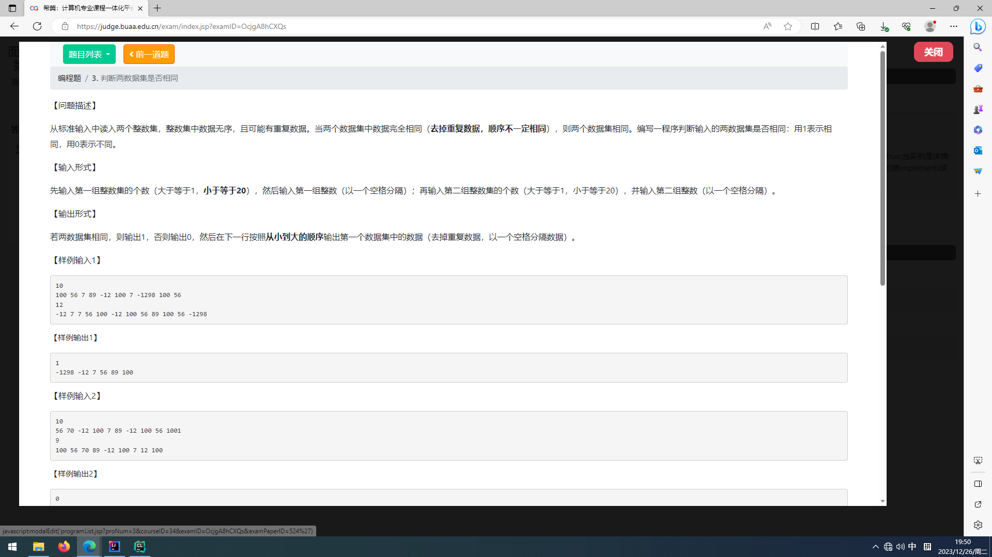import javafx.collections.transformation.SortedList;
import java.math.BigInteger;
import java.util.Scanner;
import java.util.*;
public class Test {
public static void main(String[] args) {
Scanner in=new Scanner(System.in);
BigInteger n= BigInteger.valueOf(in.nextInt());
BigInteger b= new BigInteger("1");
Boolean flag=b.compareTo(n)==-1;//1<n
for(BigInteger i = BigInteger.valueOf(1); flag; i=i.add(BigInteger.valueOf(1))) {
b = b.multiply(i);
flag=i.compareTo(n)==-1;
}
System.out.println(b);
/*Scanner in=new Scanner(System.in);
int n=in.nextInt();
List<Integer> l=new ArrayList<>();
for(int i=0;i<n;i++){
int ne=in.nextInt();
if(l.contains(ne))continue;
else l.add(ne);
}
int m=in.nextInt();
List<Integer> f=new ArrayList<>();
for(int i=0;i<m;i++){
int ne=in.nextInt();
if(f.contains(ne))continue;
else f.add(ne);
}
l.sort(Comparator.naturalOrder());
f.sort(Comparator.naturalOrder());
if(l.equals(f)){
System.out.println(1);
}else{
System.out.println(0);
}
for(Integer i:l)
System.out.print(i+" ");*/
/* Scanner in = new Scanner(System.in);
int n = in.nextInt();
Map<Integer, Integer> s = new HashMap<>();
for (int i = 0; i < n; i++) {
int ne = in.nextInt();
if (s.containsKey(ne)) {
s.put(ne, s.get(ne) + 1);
} else {
s.put(ne, 1);
}
}
List<Integer> l = new ArrayList<>();
int ans = 0;
for (Integer i : s.keySet()) {
if (s.get(i) > ans) {
ans = s.get(i);
l.clear();
l.add(i);
} else if (s.get(i) == ans) {
l.add(i);
}
}
l.sort(Comparator.naturalOrder());
for (Integer i : l)
System.out.println(i + " " + ans);*/
}
}

