# Feature #1 Results

# Results for PWR – MOX done by IN2P3 with CLASS

**Reactor Description**

Thermal water reactor model in CLASS are built from a 17x17 standard PWR assembly geometry. The FLM uses neural network to predict the assembly infinite reactivity kinf. From the reconstructed evolution of the reactivity, the maximal Burn-Up is calculated when the current reactivity is below a reactivity threshold kth. In the case of a one third batching pattern, the kth used in the exercise is 1.034. For the calculations presented in this part, the core characteristics are:

* Heavy mass: 72 tons
* Thermal power: 3 GWth
* Irradiation time: 3 years that correspond to a burn-up closed to 34 GWd/t
* Loading factor: 75%

**Stock Pu Composition @ Beginning Of Cycle**

The Pu composition at Beginning Of Cycle (BOC) is sampled from a Latin Hyper Square (LHS) algorithm. In order to have a wide range of possibilities, following boundaries have been chosen:

|  |  |  |
| --- | --- | --- |
| Isotope | Min. Frac. In Pu (Mass %) | Max. Frac. In Pu (Mass %) |
| 238Pu | 0 | 10 |
| 239Pu | 13 | 100 |
| 240Pu | 0 | 30 |
| 241Pu | 0 | 20 |
| 242Pu | 0 | 20 |
| 241Am | 0 | 7 |

All isotopes but 239Pu are sampled and the 239Pu is deduced as the complement to one. From such a design of experiment, some composition may be outside from CLASS model authorized composition for PWR-MOX fuel. Those compositions are excluded from the further developments.

The Design Of Experiment (DOE) is composed of 1000 simulations. The LHS used both for the FLM and FF approach is represented on the Figure 1. As we can see, 239Pu is correlated to other isotopes, due to the normalization of isotopes of plutonium to one.

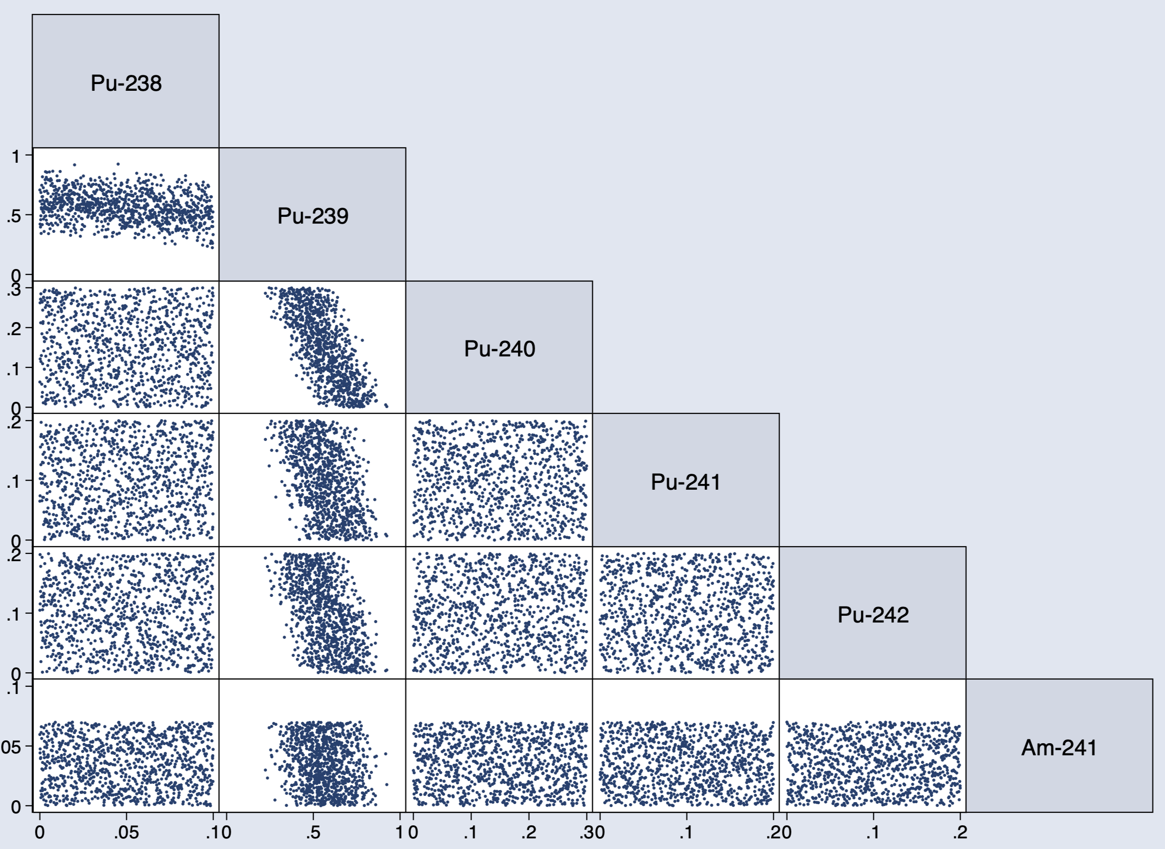

Figure 1: Matrix plot of the Latin Hyper Space obtained from 1000 compositions at BOC.

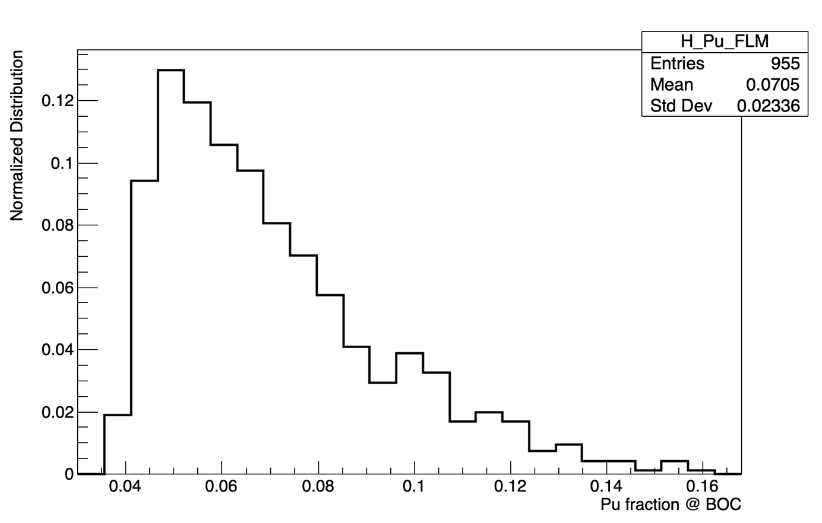

Figure 2 : Plutonium fraction in the fresh fuel at beginning of cycle.

**Methodology description**

The first step consists to run the 1000 simulations with the FLM approach. In this case, for each simulation, the plutonium fraction is calculated so that the expected Burn-Up (around 34 GWd/t) could be achieved. The plutonium fraction distribution at BOC for all the FLM runs is showed on Figure 2. As we can see in the statistics information, there is only 955 simulations represented instead of 1000. Some simulations have unloaded reactors because the plutonium composition was outside from the allowed boundaries of the FLM. We also note that the mean value of plutonium fraction is:

This value will be used to run the same design of experiment but with a fixed fraction of plutonium in the fuel. At this step, we have two sets of simulations, one that has been run from FLM and the other one from FF approach. Those two sets will be compared in order to quantify the impact of using a FLM rather than a FF model.

**Data analysis**

In this part, we present some data analysis of the FLM simulations in order to understand the physics at the basis of the sample. The Figure 3 shows causal links between variables. The first variable is the fissile fraction, calculated as following:

This variable is deduced from the LHS sample. As we can see on limit values, the fissile fraction ranges between 45% and 90% in the LHS. The middle variable of the figure is the plutonium fraction at BOC calculated as the ratio between plutonium mass and initial heavy mass. This variable is calculated from the FLM in CLASS according to the plutonium composition. Plutonium fraction lies between 4% and 16%. The third variable is the plutonium relative difference between BOC and EOC. This variable is between 12% and 30% which shows the maximal deviation of the plutonium relative slope during a reactor evolution. The last variable is the plutonium absolute difference between BOC and EOC divided by the reactor cycle time. This variable lower limit is around 0.25 tons / year and the higher limit closed to 0.50 tons per year.

Some ranges have been imposed in order to highlight pathways of the matrix plot. If the fissile fraction (purple line) is lower than 50%, the plutonium fraction in the fuel is high and thus, the plutonium relative difference is high. This is due to the initial mass effect that is more important than the absolute slope effect. Finally, this produce a high plutonium absolute difference between BOC and EOC. As the plutonium fraction is high, the absolute slope is higher as well.

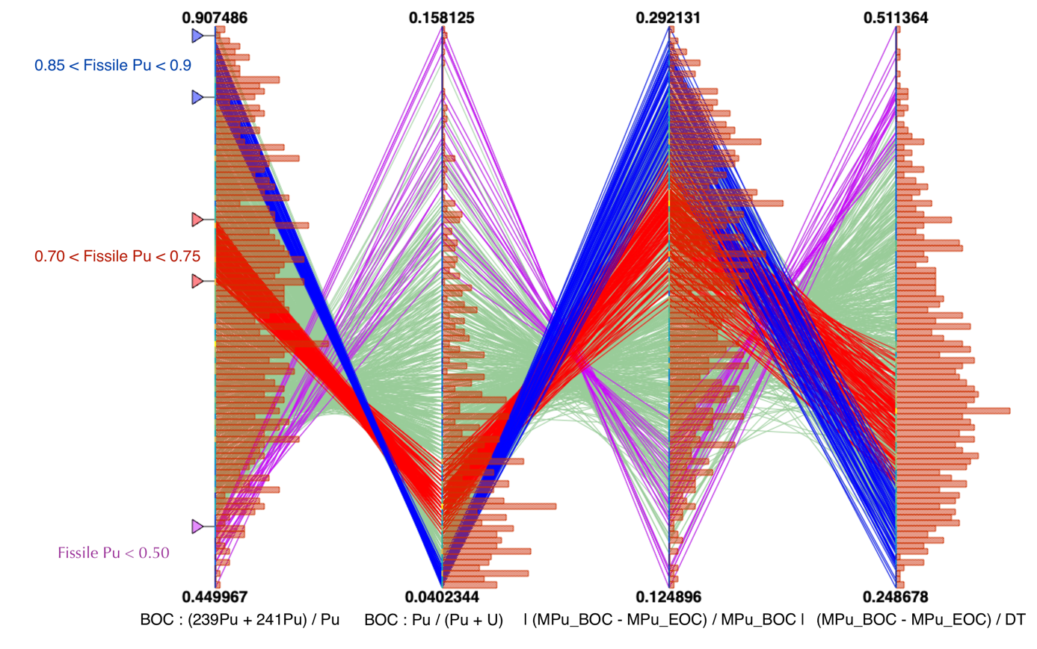

Figure 3: Parametric plot representing Fissile plutonium fraction in Pu, plutonium fraction in the fuel, plutonium relative variation between BOC and EOC and plutonium slope in ton/year. Some specific ranges have been added.

**Output metric**

Here, we present the output metric used to compare FLM and FF simulations. The aim is to build estimators that provide the order of magnitude of the FLM impact compared to FF approach as simply as possible.

Estimator #1

The first estimator is chosen to get the impact on specific facilities of the fuel cycle. For each simulation “i”, the following factor that represents the plutonium fraction at BOC is calculated as follow:

From this parameter, the relative variation of FLM compared to FF approach is calculated as follow:

This parameter shows the relative deviation between the plutonium fraction that feed the reactor at BOC for FLM et FF approach. The higher this parameter is, the higher the impact of FLM compared to FF approach is. This parameter has been calculated for each simulations i if the DOE. The produced distribution for all simulations is represented on Figure 4. For instance, if is 100%, that means that the plutonium fraction required to load the PWR is 100% higher for the FLM compared to FF approach, here 7.05 x 2 = 14.10%. It is possible to retrieve, from the definition of , the boundaries of this plot (i.e. -40% until 120%) from the boundaries of the FLM model which is between 4% and 16% of plutonium in the fuel.

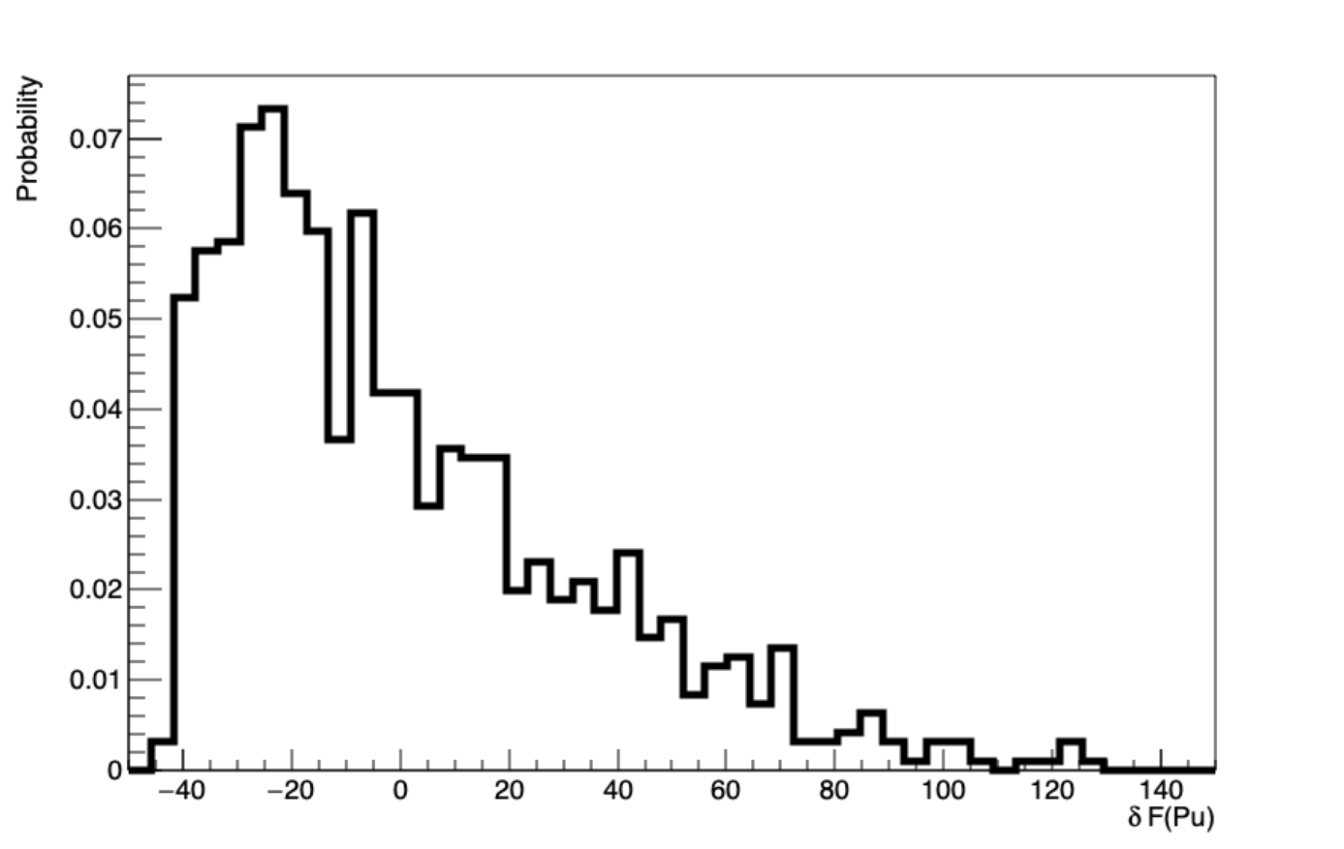

Figure 4: Relative plutonium fraction deviation between FLM and FF approach distribution. The deviation is plotted in %.

The plot on the Figure 4 shows that on a wide range of different plutonium vectors, the FLM is fully required to properly reproduce all the material stock involved in the PWR-MOX cycle. Nevertheless, there is no information related to the impact of the FLM approach on aggregated variables, such as total plutonium production in the nuclear cycle.

Estimator #2

The second estimator aims to take into account the slope of the materials evolution. We focus here on plutonium. There’s two ways to compute an estimator of the slope. The first one, described here, is the relative slope defined as following:

The second way to define an estimator of the slope is to use the derivative of the plutonium mass over time on the reactor cycle. This approach will be described in the next paragraph. From the relative mass variation, we define the following estimator:

This estimator quantifies the relative slope variation between FLM and FF approach. If the estimator is zero, that means that FLM and FF calculations have the same relative slope during the reactor cycle. If the estimator is higher than 0 (resp. lower than 0), the FLM approach burns a higher (resp. a lower) quantity of plutonium in relative terms. The Figure 5 shows for all the simulations of the set the estimator 2 defined above.

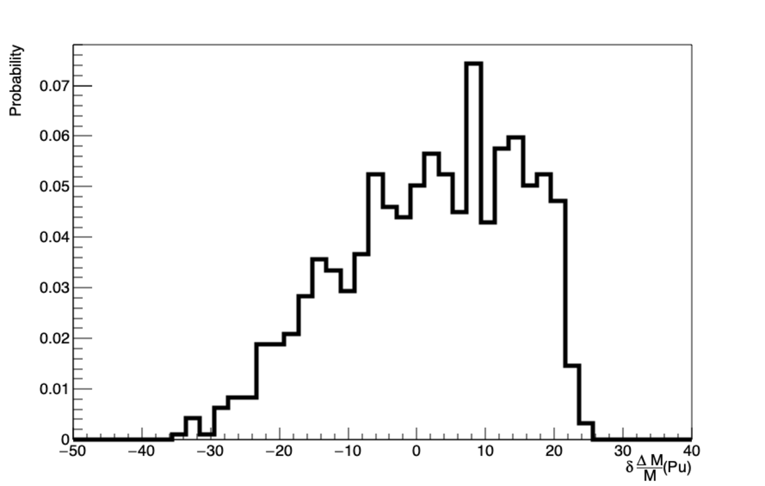

Figure 5: Estimator 2 normalized distribution in % for all the simulations.

Estimator 2 ranges between -35% up to 25%. That means relative mass slope during a reactor cycle may be highly different whether using a FLM or a FF.

Estimator #3

The third estimator is based on the derivative of the plutonium mass over time on the reactor cycle:

Where is the reactor cycle time. The estimator 3 is then computed as follow:

This estimator is an estimation of the slope absolute variations between FLM and FF simulations. The slope represents the plutonium quantity that is consumed in the fuel cycle. The plot representing the distribution of estimator 3 for all simulations is showed on Figure 6:

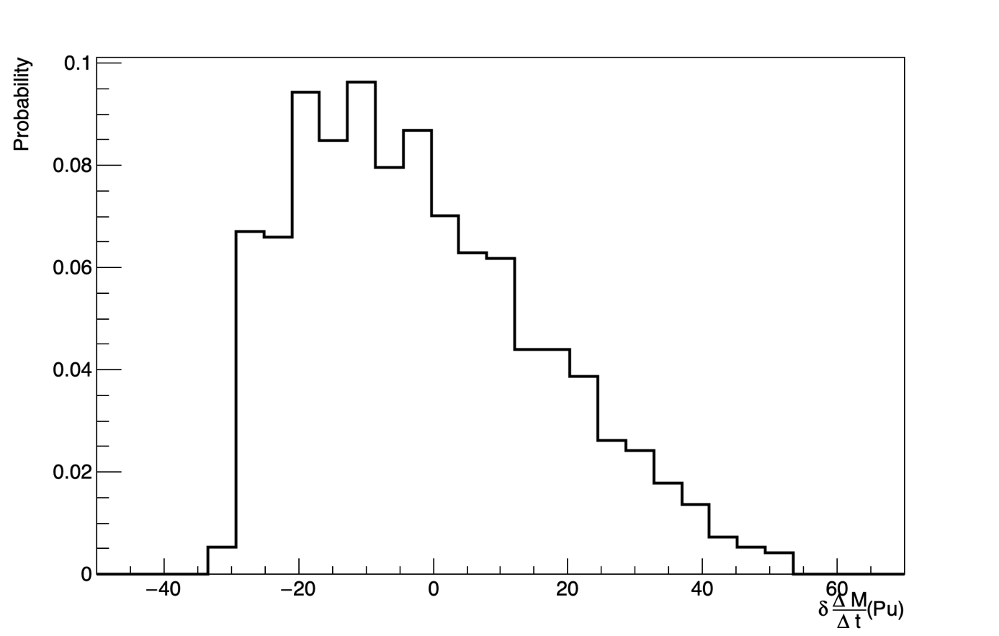

Figure 6: Estimator 3 normalized distribution in % for all the simulations.

Estimator 3 lower limit is -35% which correspond to a simulation for which FLM plutonium slope is 35% smaller than the FF slope. The higher limit is around 50%. This distribution shows that absolute plutonium mass slope during a reactor cycle may be highly different whether using a FLM or a FF. This tends to show that FLM is required if plutonium vector isotopic composition has wide variations.

**Temporary Conclusion**

The results related to feature #1 done by IN2P3 with the CLASS code simulating PWR-MOX fuel aims to show that each estimator distributions are relatively wide. This shows that in the framework of the design of experiment used to solve this exercise, FLM approach seems to have a huge impact on plutonium inventory in the cycle and/or in facilities.