Smart Semaphore Control
  - Implementation parameters and scenario results
Prepared by Olzhas Akimbay and Bekzhan Nigmetulla
2 November 2026
The project implements a fuzzy neural traffic controller in Python. Part A trains it for one intersection, Part B adds downstream feedback in a 3 × 3 grid, and Part C drives both models with traffic patterns derived from METR-LA speeds. [1–3]

Simulation and metrics
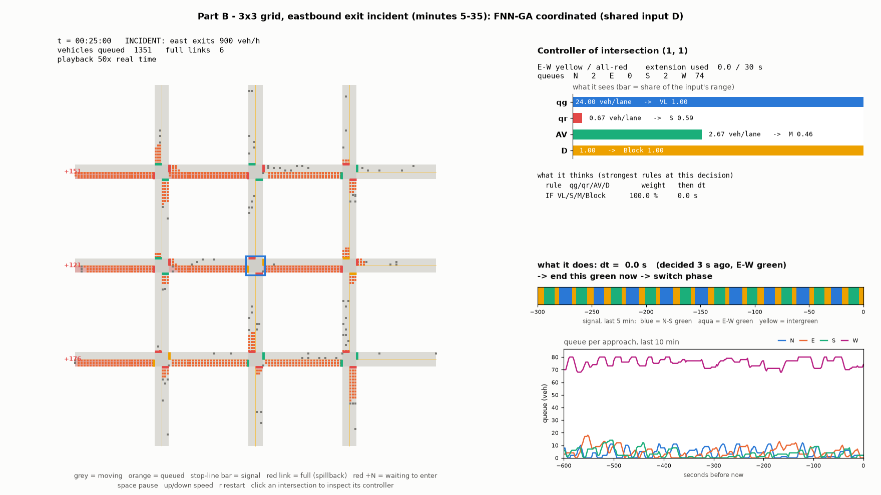
Figure 1 Actual Part B viewer during an incident: the road network is on the left and the selected controller is on the right.
Grey squares are moving vehicles and orange squares are queued vehicles. Stop-line bars show signal states. The right panel shows fuzzy inputs, active rules, the requested extension and recent queues. This illustrative frame is separate from the averaged scenario results.
Common road parameters Four approaches, three lanes per approach, two NS/EW phases, 1 s simulation step, 200 m links, 50 km/h free-flow speed, 7.5 m jam spacing and 80 vehicles of link storage. Saturation discharge is 1800 veh/h/lane.
Metrics Q is mean stop-line queue in veh/approach. W is mean stop-line wait in seconds per passage. P95 is the mean of each run’s 95th-percentile passage wait. Queue metrics exclude boundary buffers and are not full-trip delay.
Reading the scenario charts Every scenario uses the same three panels, controller colors and axis limits across Parts A, B and C. Axes are logarithmic; smaller values lie further left. Dots and labels show means across seeds, without uncertainty intervals.

Part A Implementation and parameters
We implemented a fuzzy controller, an equivalent five-layer FNN, a rollout teacher and a real-coded GA. The isolated simulator uses straight-through traffic and Poisson arrivals. Fixed uses a Webster plan; FLC uses the initial rules; FNN uses the GA-trained model. [1, 3]
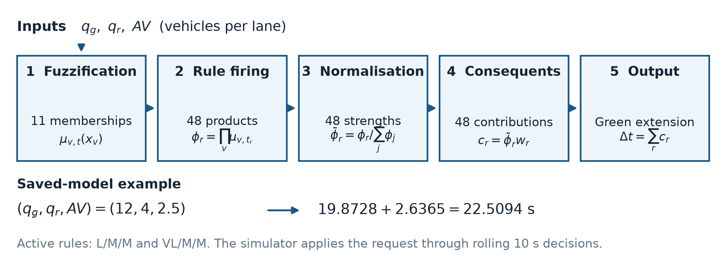
Figure 2 FNN computation and a worked decision. Inputs use the larger approach count of each phase, divided by the number of lanes.
Inputs and rule base qg and qr use Short, Medium, Long and Very Long terms over a nominal 0–20 veh/lane range; AV uses Low, Medium and High over 0–6 veh/lane. AV counts vehicles within 10 s of the green stop line. All 48 rules are covered, including the six source examples; initial output centres are 0, 8, 16 and 26 s.
Inference and trainable parameters Triangular interior sets and shoulder sets, product rule firing and a weighted output average. The genome has 59 values: 48 consequents in 0–30 s and 11 membership shifts bounded to ±15% of each input range.
Signal settings Minimum green 10 s, maximum added green 30 s, decisions at most every 10 s, startup loss 2 s and intergreen 5 s. The calculated Webster cycle is limited to 40–120 s.
Teacher and GA 40 collection scenarios of 1800 s, with nominal demand sampled from 100–850 veh/h/lane; 150 s rollout horizon; four futures; candidates 0, 2, …, 30 s. The 4862 labels use an 80/20 train/validation split. GA population 220, crossover 0.5, mutation 0.01 per gene, tournament size 3, two elites, BLX-0.25 and Gaussian mutation with sigma 10% of gene range. Fitness is 1/(1 + normalized squared error). Stop at 1 − fitness ≤ 0.01 or 200 generations.
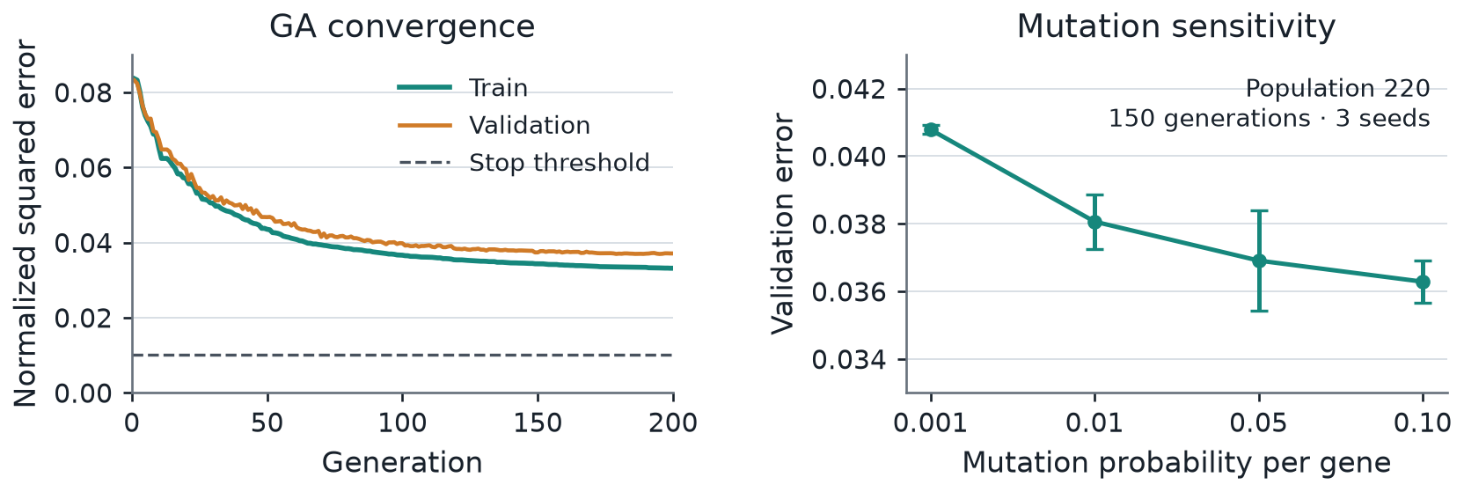
Figure 3 Training convergence and mutation sensitivity. Population 50 / 220 / 500 gives mean validation error 0.0415 / 0.0381 / 0.0375 in the sensitivity study.
Training ends at the generation cap: E = 0.0332, RMSE = 5.46 s and saved-model validation E ≈ 0.0372. Evaluation uses five seeds, 600 s warm-up and 7200 s measurement per scenario. Each scenario’s NS/EW arrival rates are listed in Figure 4, in veh/h/lane.

Part A Scenario results
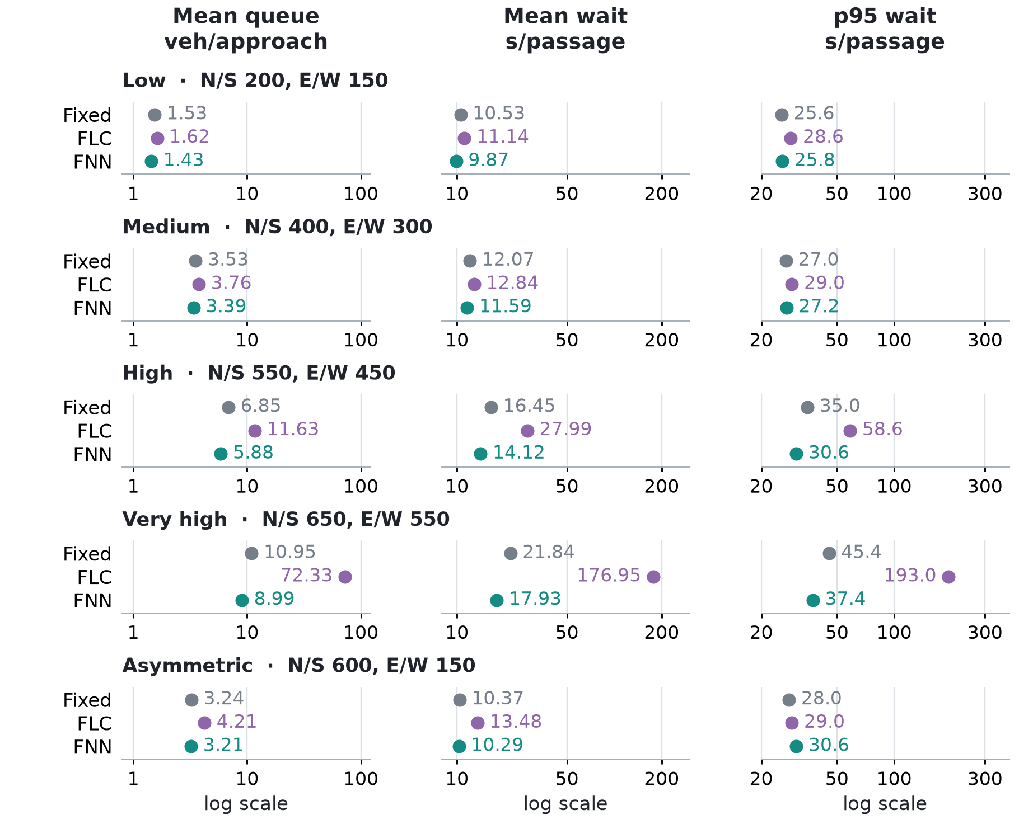
Figure 4 One row per isolated-intersection scenario. Identical metric panels and log scales are reused in Parts B and C. Demand labels are veh/h/lane.
FNN has the lowest mean wait in all five scenarios. The improvement over Fixed is modest at low, medium and asymmetric demand, and grows near saturation. The initial FLC develops severe congestion at very high demand because frequent switching reduces usable capacity. Its high-demand mean also hides substantial variation between seeds.

Part A Overall comparison
Table 1 Each controller cell is Q / W / P95. Queue units are veh/approach; both waiting metrics are seconds per passage. All values are means over five seeds.
Scenario NS/EW | Fixed  Q / W / P95 | FLC  Q / W / P95 | FNN  Q / W / P95 | FNN wait  reduction
Low 200/150 | 1.53 / 10.53 / 25.60 | 1.62 / 11.14 / 28.60 | 1.43 / 9.87 / 25.80 | 6.3%
Medium 400/300 | 3.53 / 12.07 / 27.00 | 3.76 / 12.84 / 29.00 | 3.39 / 11.59 / 27.20 | 3.9%
High 550/450 | 6.85 / 16.45 / 35.00 | 11.63 / 27.99 / 58.60 | 5.88 / 14.12 / 30.60 | 14.2%
Very high 650/550 | 10.95 / 21.84 / 45.40 | 72.33 / 176.95 / 193.00 | 8.99 / 17.93 / 37.40 | 17.9%
Asymmetric 600/150 | 3.24 / 10.37 / 28.00 | 4.21 / 13.48 / 29.00 | 3.21 / 10.29 / 30.60 | 0.8%

Part B Network implementation and scenarios
We implemented a 3 × 3 grid with nine nodes and twelve boundary entries. Fixed uses per-node Webster plans; Naive shares the trained Part A FNN; Coord adds receiving-link occupancy D. [3]
Coordination parameters D is maximum straight-ahead receiving-link occupancy during green. Free (full membership up to 0.5), Congested (peak 0.75) and Blocked (full membership from 0.95) scale consequents by 1, 0.5 and 0 with fuzzy interpolation. This creates 144 rules and 14 membership terms without another GA.
Network settings Turns are 80% straight, 10% right and 10% left; road and signal timings match Part A. Evaluation: three seeds, 600 s warm-up and 5400 s measurement. Exit restrictions are sensed indirectly through spillback; offsets are not coordinated.
Balanced N/S 350 and E/W 300 veh/h/lane, constant demand.
Rush hour N/S 450, E 380 and W 420 veh/h/lane. Demand rises from 1 to 1.9 times base during minutes 15–45 and returns to base by minute 75 after warm-up.
Incident N/S 350, E 300 and W 550 veh/h/lane. Each eastbound exit is capped at 900 veh/h during minutes 20–50 after warm-up.
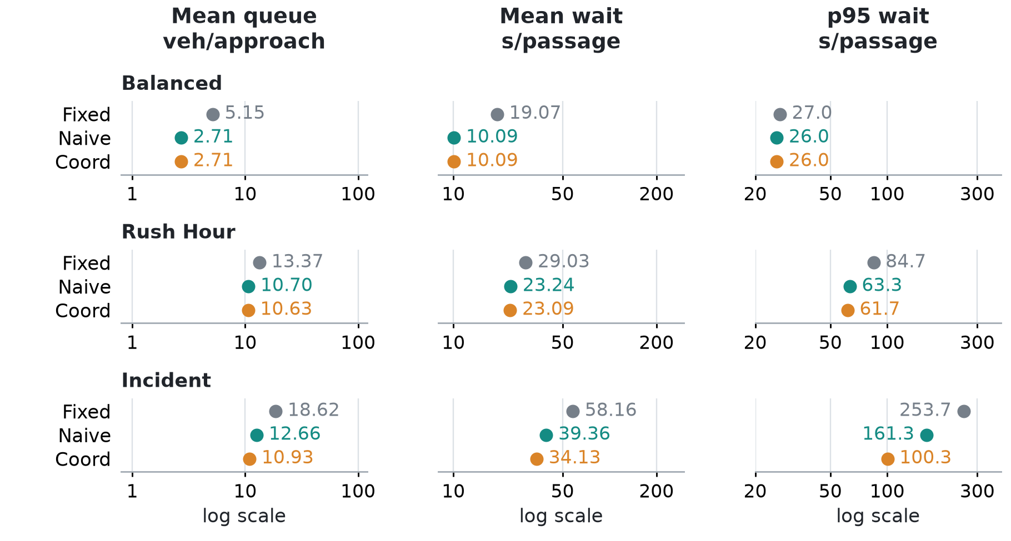
Figure 5 Network results for each scenario. The same axes, metric order and colors are used throughout the report.
Coord and Naive coincide in Balanced. The rush-hour difference is small. During Incident, Coord lowers mean wait by 13.3% and p95 by 37.8% versus Naive. At 20 × 20 nodes, a hypothetical 44,000-simulation GA takes an estimated 47.5 hours on the benchmark machine; sharing weights avoids that cost.

Part B Overall comparison
Table 2 Q / W / P95 per controller, in the same units as Table 1. The last column compares Coord with Naive on mean wait.
Scenario | Fixed  Q / W / P95 | Naive  Q / W / P95 | Coord  Q / W / P95 | Coord wait  reduction
Balanced | 5.15 / 19.07 / 27.00 | 2.71 / 10.09 / 26.00 | 2.71 / 10.09 / 26.00 | 0.0%
Rush Hour | 13.37 / 29.03 / 84.67 | 10.70 / 23.24 / 63.33 | 10.63 / 23.09 / 61.67 | 0.6%
Incident | 18.62 / 58.16 / 253.67 | 12.66 / 39.36 / 161.33 | 10.93 / 34.13 / 100.33 | 13.3%

Part C Data pipeline and parameters
We implemented METR-LA loading, profiling, cleaning, sensor selection and speed-to-demand mapping. The existing simulators replay these rates using the unchanged Part A controller and Part B coordination. An additional isolated FNN is trained on a separate day. [3–5]
Dataset 207 freeway sensors, 34,272 five-minute timestamps, 1 March–27 June 2012, speeds in mph. These are speed observations, not measured intersection queues or arrival counts.
Cleaning 8.109% missing readings with zeros treated as missing. Time interpolation uses a six-sample limit inside gaps; time-of-week medians and final forward/back fill handle the remainder. Cleaned speeds are limited to 1–70 mph; final missing fraction is zero.
Sensor and day selection Completeness ≥92%, weekday speed fifth percentile <45 mph. Twelve sensors are assigned to grid boundary entries by completeness rank; the first four also drive the isolated model. Evaluation day: 13 March 2012; retraining day: 14 March 2012.
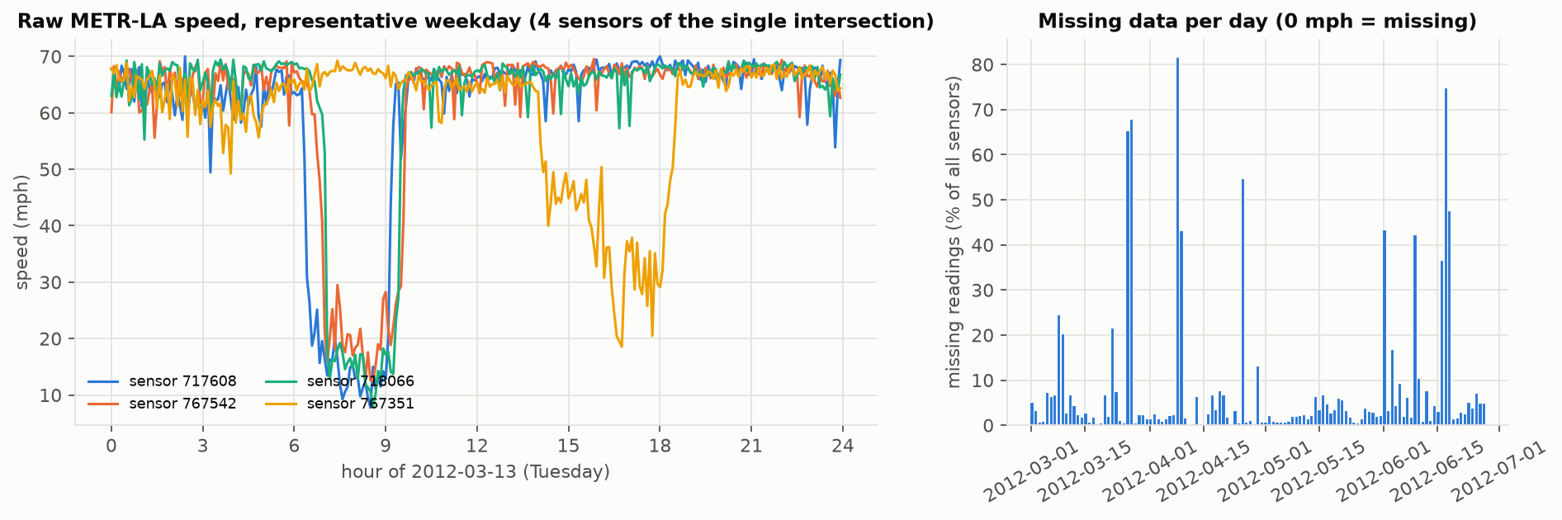
Figure 6 Raw sensor speed profile for the selected evaluation day.
Speed-to-demand parameters Free-flow speed vf is each sensor’s 95th percentile. The dead band is v/vf = 0.85 and the jam threshold is 0.25. The congestion index uses a centered three-sample mean. Arrival rates span 250–750 veh/h/lane and remain constant within each 300 s interval.
$$c = clip(\frac{0.85 - clip(v / vf, 0, 1)}{0.60}, 0, 1)$$
$$λ = 250 + 500 × smooth(c) veh/h/lane$$
Arrivals remain Poisson. qg, qr and AV come from the simulator; a separate speed-derived queue proxy uses jam density 185 veh/mi/lane and a 0.5-mile section only as a check. The constant-input counterpart uses each entry’s daily-mean rate, matching expected daily demand.
Evaluation and retraining 24-hour runs including 600 s warm-up; three isolated seeds and two network seeds. Real-day retraining uses 5671 labels, population 220, crossover 0.5, mutation 0.01 and 200 generations; training E = 0.0261. It starts from the initial fuzzy base, and the network is not retrained.
This is an offline replay: full-dataset preprocessing and centered smoothing can use later readings. The artificial grid and assumed speed-to-demand scale limit conclusions about a real road network.

Part C Scenario results and comparison
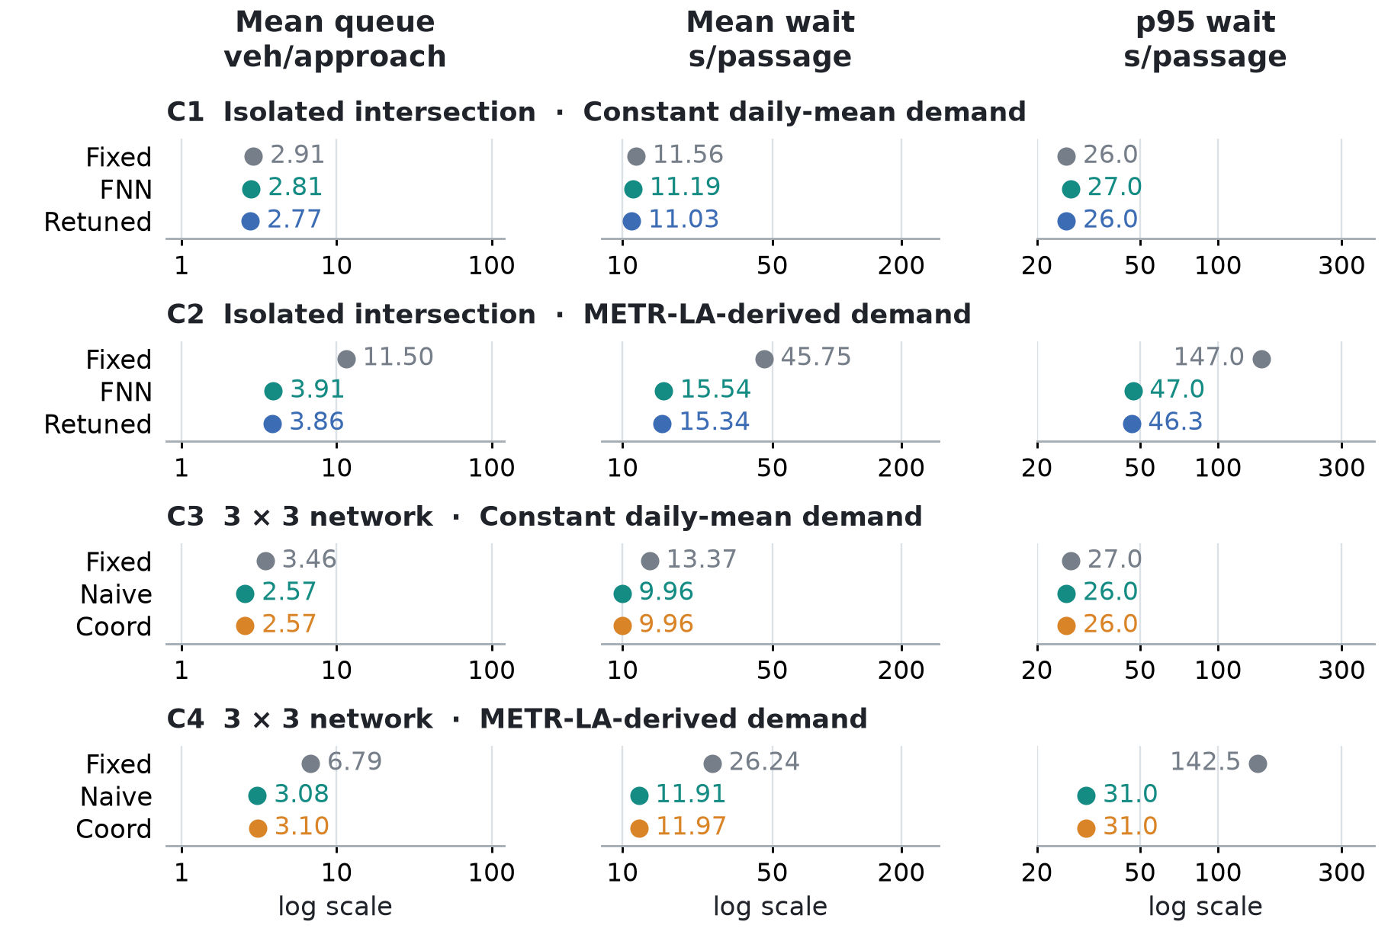
Figure 7 All four cases use the same panels and fixed log scales.
On the first isolated run, qg p99 rises from 1.67 to 18.33 veh/lane and 19 rules cross the 0.1% usage threshold. FNN reduces real-profile mean wait by 66.0% versus Fixed. Retraining adds 1.3%; Coord is 0.5% slower than Naive because blocking is rare.

Part C Overall comparison
Table 3 Q / W / P95. C1/C2: Fixed, FNN, Retuned. C3/C4: Fixed, Naive, Coord. Gain is versus FNN or Naive.
Case | Fixed  Q / W / P95 | FNN or Naive  Q / W / P95 | Retuned or Coord  Q / W / P95 | Additional  wait reduction
C1 | 2.91 / 11.56 / 26.00 | 2.81 / 11.19 / 27.00 | 2.77 / 11.03 / 26.00 | 1.5%
C2 | 11.50 / 45.75 / 147.00 | 3.91 / 15.54 / 47.00 | 3.86 / 15.34 / 46.33 | 1.3%
C3 | 3.46 / 13.37 / 27.00 | 2.57 / 9.96 / 26.00 | 2.57 / 9.96 / 26.00 | 0.0%
C4 | 6.79 / 26.24 / 142.50 | 3.08 / 11.91 / 31.00 | 3.10 / 11.97 / 31.00 | -0.5%
Overall conclusion Training improves local control, and neighbor feedback helps when receiving capacity is constrained. Benefits depend on demand and blocking. Few seeds and one real-data day limit generalization.

Sources
[1] Supplied traffic.pptx. Control of Traffic Light in Isolated Intersections Using Fuzzy Neural Network and Genetic Algorithm.
[2] Supplied Lab3_Smart_Semaphore_Control.docx. Laboratory brief.
[3] Project source, models and saved results/tables. main.py runs all Parts; scripts/clean_metrla.py cleans the data. Five existing correctness checks passed.
[4] Kaggle METR-LA archive. Dataset
[5] Li, Yu, Shahabi and Liu. DCRNN, ICLR 2018. Repository
Software: NumPy, pandas, Matplotlib, h5py, pytest

