Smart Semaphore Control
  - Simplified laboratory report
Prepared by Alex Morgan and Daniel Reed
11 November 2026

Purpose and completed work
We built a Python traffic-light controller, trained it with a genetic algorithm, extended it to a 3 × 3 network, and tested demand patterns derived from real sensor data. Part A studies one intersection, Part B adds coordination, and Part C uses METR-LA speeds. [1–3]

How the FNN works
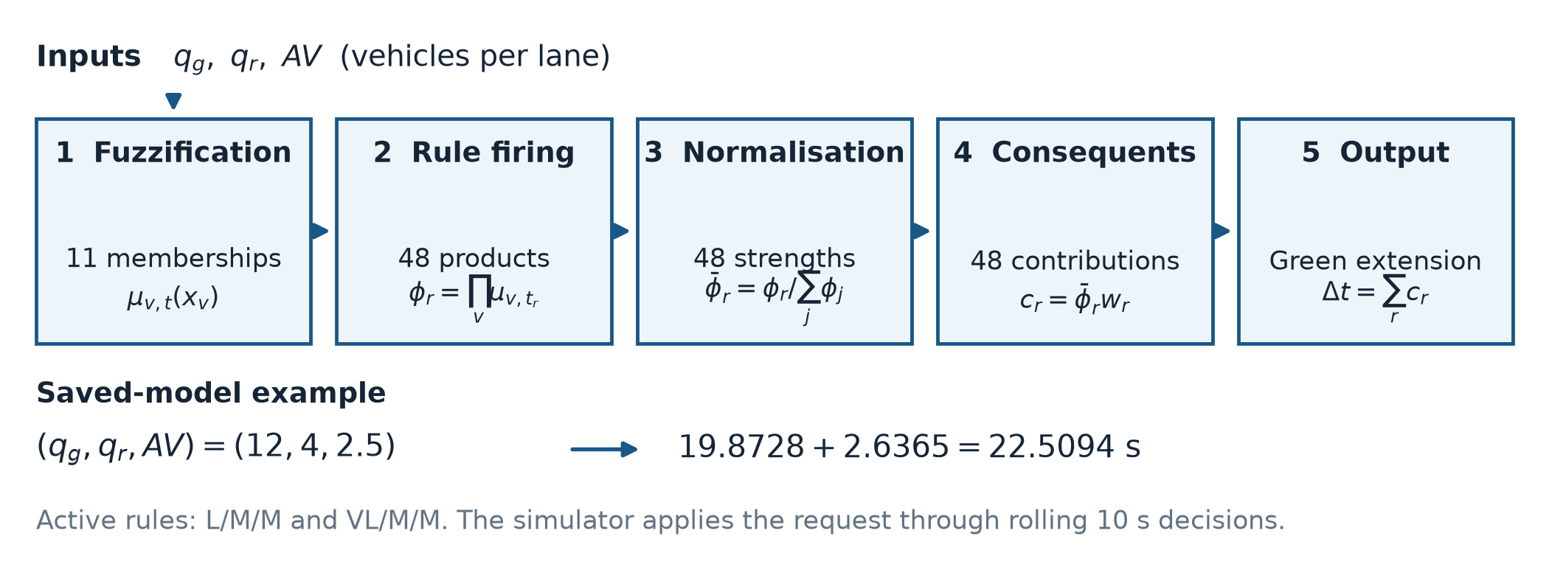
Figure 1 Five-layer fuzzy neural network and a decision from the saved model.
Input or output | Meaning
qg | Queue in the current green phase, in vehicles per lane
qr | Queue in the current red phase, in vehicles per lane
AV | Vehicles reaching the green stop line within 10 s, per lane
Δt | Requested green extension, from 0 to 30 s

Membership functions convert counts into linguistic terms. The 48 rules combine these terms, and their normalized contributions produce one extension. The GA adjusts 48 rule consequents and 11 membership shifts. Before training, the network reproduces the initial fuzzy controller to numerical precision.

Simulation and metrics
Each intersection has four approaches, three lanes per approach and two alternating phases. Minimum green is 10 s; total extension is limited to 30 s, with a new decision at most every 10 s. Links are 200 m long and hold up to 80 vehicles.
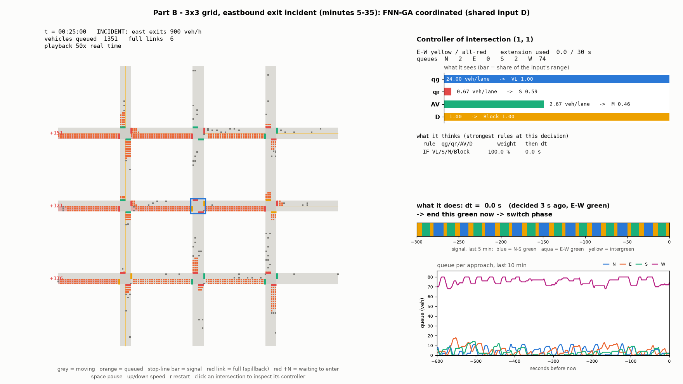
Figure 2 Live visualization snapshot of the coordinated 3 × 3 network during an eastbound exit incident.
Grey squares represent moving vehicles; orange squares are queued vehicles. Stop-line bars show signal states. The right panel displays controller inputs, active rules, the green extension and queue history.
In this frame, the selected node sees a full receiving link (D = 1.00) and requests a zero-second extension, avoiding additional green time toward the blocked link.
Mean queue is measured in vehicles per approach. Mean wait and p95 are stop-line waiting times, not full-trip delay. p95 describes the high-wait tail. Results average multiple seeded runs; graph error bars show sample standard deviation.

Part A Isolated intersection
Queue terms are Short, Medium, Long and Very Long; AV terms are Low, Medium and High. All 48 input combinations have rules, including the six source examples. Product inference and a weighted average of rule outputs determine Δt. [1, 3]
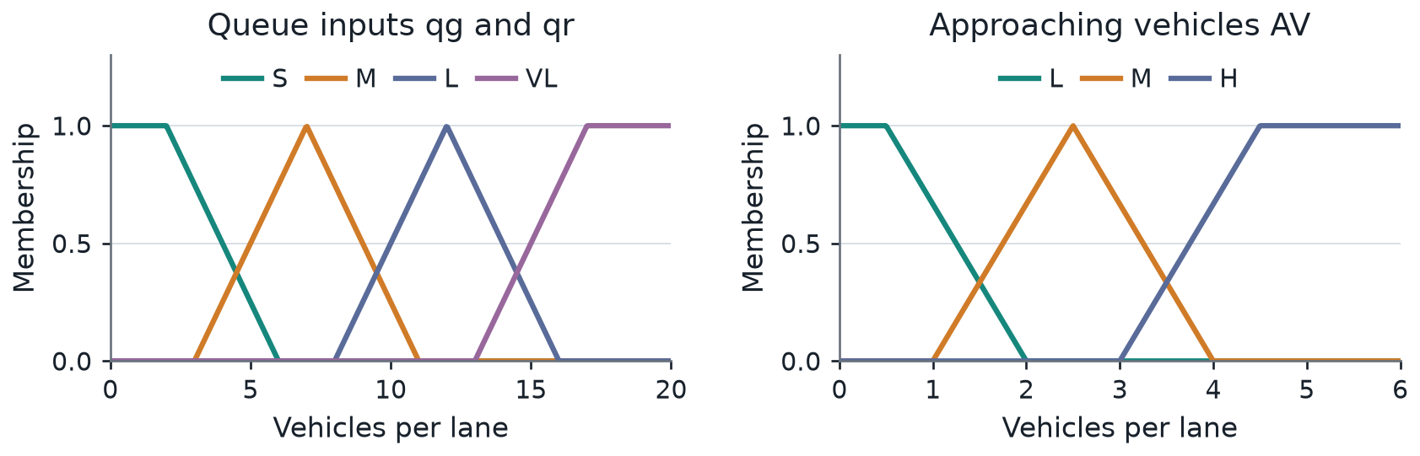
Figure 3 Initial membership functions. Open shoulders also handle values above the plotted range.
The rollout teacher generated 4862 labeled states. The GA used population 220, crossover 0.5, mutation 0.01 and a 200-generation cap. Training error fell from 0.0836 to 0.0332; RMSE was 5.46 s. The run reached the generation cap before meeting its target.
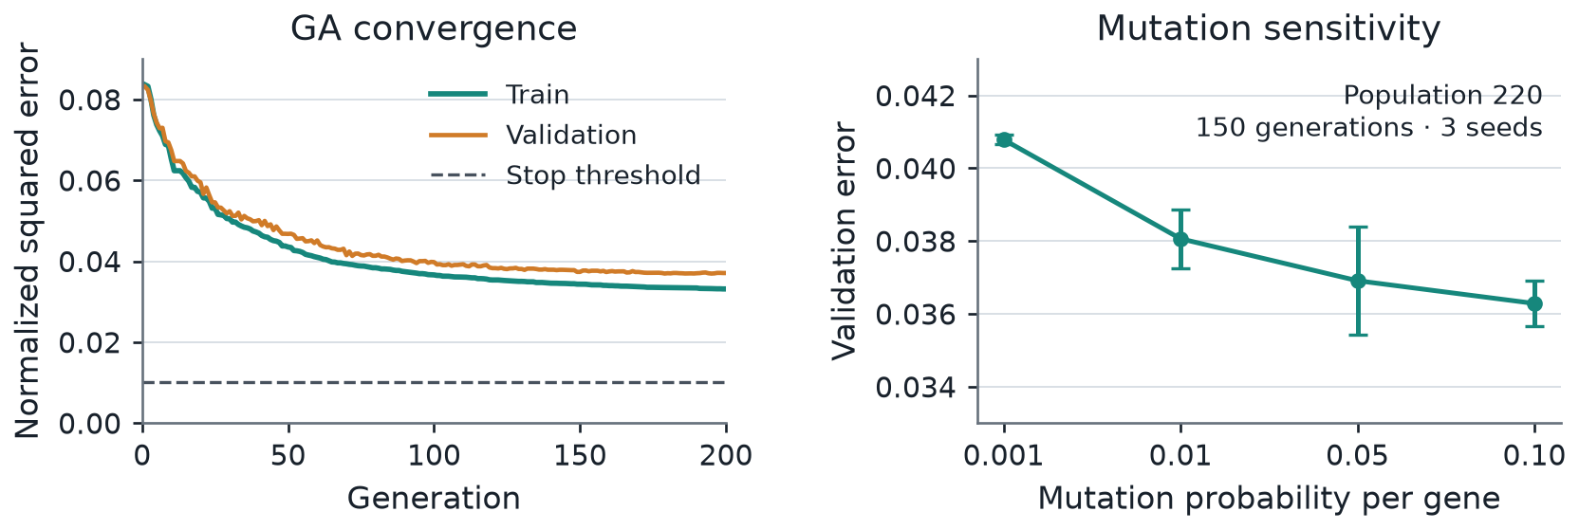
Figure 4 GA convergence and mutation sensitivity. Sensitivity uses three seeds per setting.
Table 1 Mean wait in seconds over five seeds. Fixed uses a Webster plan; FLC is the untrained fuzzy controller.
Demand | Fixed | FLC | FNN-GA
Low | 10.53 | 11.14 | 9.87
Medium | 12.07 | 12.84 | 11.59
High | 16.45 | 27.99 | 14.12
Very High | 21.84 | 176.95 | 17.93
Asymmetric | 10.37 | 13.48 | 10.29

FNN gives the lowest mean wait in all five cases, with a 17.9% reduction versus Fixed at very high demand. There, mean queue falls from 10.95 to 8.99 veh/approach. The untrained FLC performs poorly near saturation because frequent phase changes waste capacity. Larger populations help less beyond 220; higher mutation improves the tested validation scores.

Part B Network and coordination
The network connects nine intersections with finite-storage links. Fixed uses constant Webster plans. Naive copies the trained FNN independently to every node. Coordinated adds D, the occupancy of straight-ahead receiving links. [3]
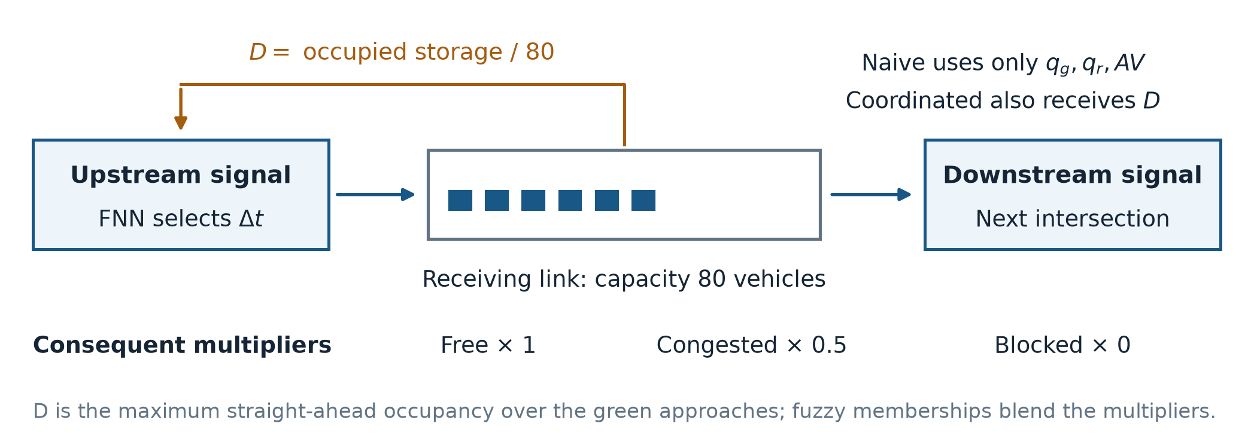
Figure 5 Neighbor occupancy reduces extensions into congested links. The coordinated version adds no new GA training.
Free links retain the learned consequent; Congested links halve it; Blocked links set it to zero. Overlapping memberships blend these factors. This expands 48 rules to 144 and reduces queue spillback. It does not create a green wave.
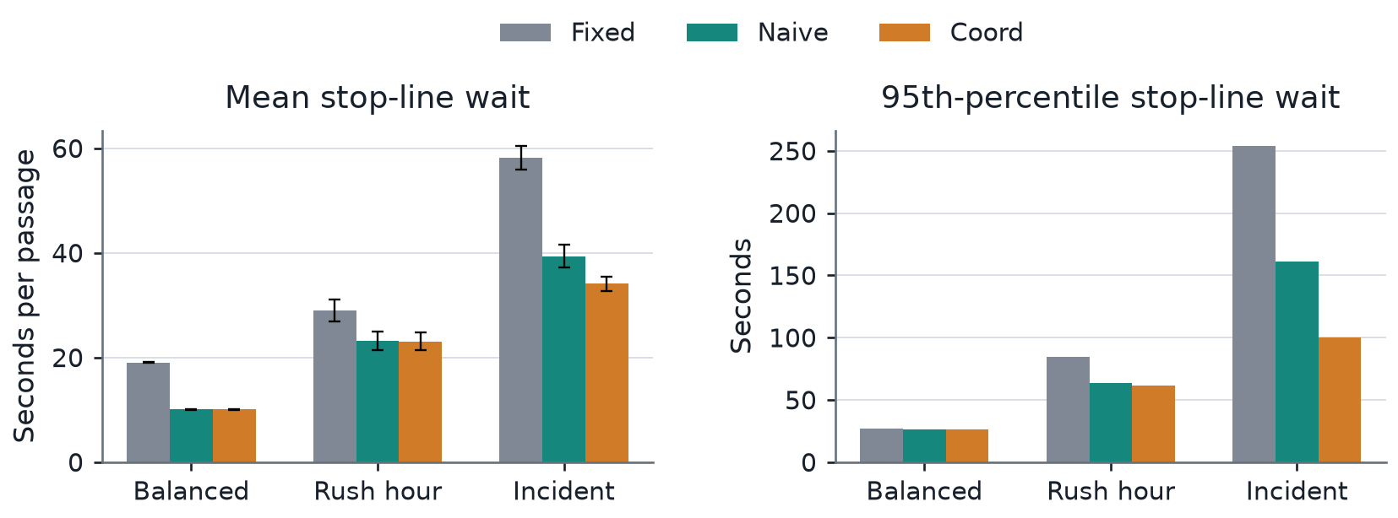
Figure 6 Mean and p95 stop-line wait for the three network scenarios, averaged over three seeds.
Table 2 Exact network results. Values in each cell are Fixed / Naive / Coordinated.
Scenario | Queue veh/approach | Mean wait s | p95 wait s
Balanced | 5.15 / 2.71 / 2.71 | 19.07 / 10.09 / 10.09 | 27.00 / 26.00 / 26.00
Rush Hour | 13.37 / 10.70 / 10.63 | 29.03 / 23.24 / 23.09 | 84.67 / 63.33 / 61.67
Incident | 18.62 / 12.66 / 10.93 | 58.16 / 39.36 / 34.13 | 253.67 / 161.33 / 100.33

During the incident, eastbound exits are limited to 900 veh/h each for 30 minutes. Coordinated lowers mean wait by 13.3% and p95 by 37.8% versus Naive. At balanced demand they are identical; the rush-hour difference is small. Coordination helps most when downstream capacity becomes a constraint.

Part C METR LA sensor data
METR-LA provides speeds from 207 freeway sensors at five-minute intervals, from March to June 2012. We treated zero readings as missing and filled the 8.11% missing values using interpolation and time-of-week medians. Twelve complete, congestion-prone sensors drive the grid entries. Evaluation uses 13 March; separate-day retraining uses 14 March. [3–5]
The mapping compares speed v with each sensor’s free-flow speed vf, then converts the speed drop into demand. A three-sample mean smooths the index. The resulting arrival rate is 250–750 veh/h/lane. Arrivals remain Poisson; qg, qr and AV are measured inside the simulator.
$c = clip(\frac{0.85 − clip(v / vf, 0, 1)}{0.60}, 0, 1)$
$λ = 250 + 500 × smooth(c) veh/h/lane$
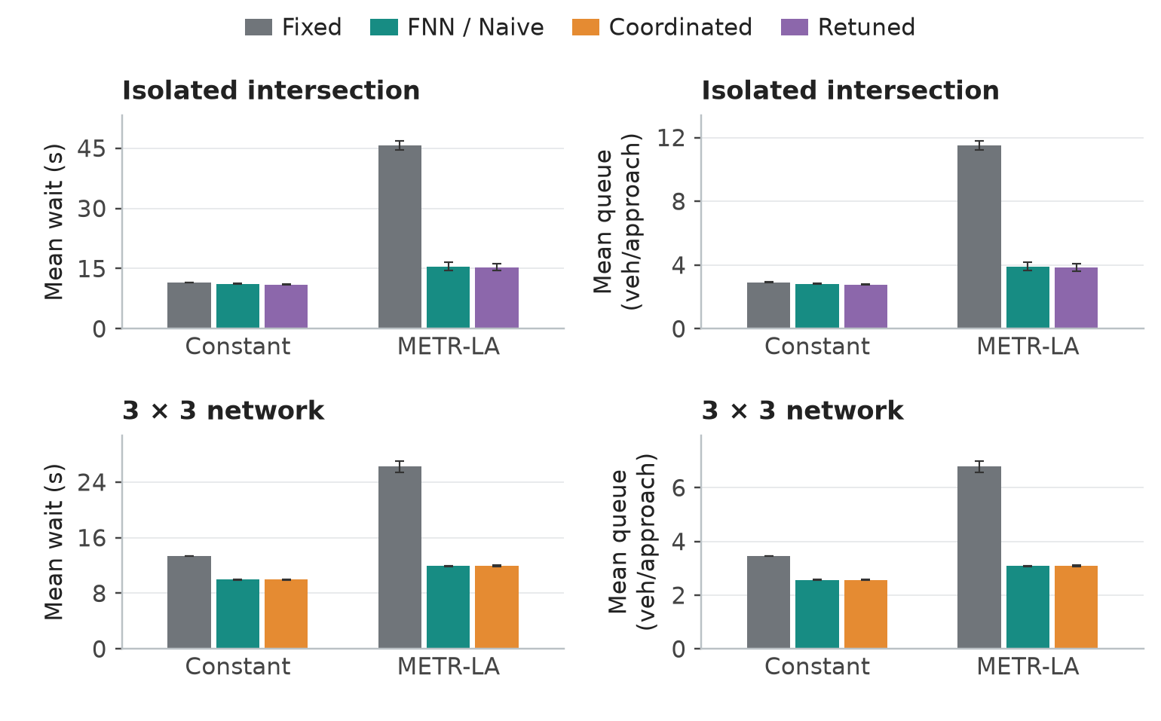
Figure 7 Constant synthetic demand versus METR-LA-derived demand. Isolated results average three seeds and network results two.
Table 3 Mean wait in seconds on METR-LA-derived input
Scale | Fixed | FNN or Naive | Additional variant
Isolated | 45.75 | 15.54 | 15.34 Retuned
3 × 3 network | 26.24 | 11.91 | 11.97 Coord

FNN lowers isolated mean wait by 66.0% versus Fixed. Network Naive lowers it by 54.6%. Coordination adds little here because downstream blocking is rare. Real-day retraining gives only a further 1.3% isolated improvement.

Main findings and conclusions
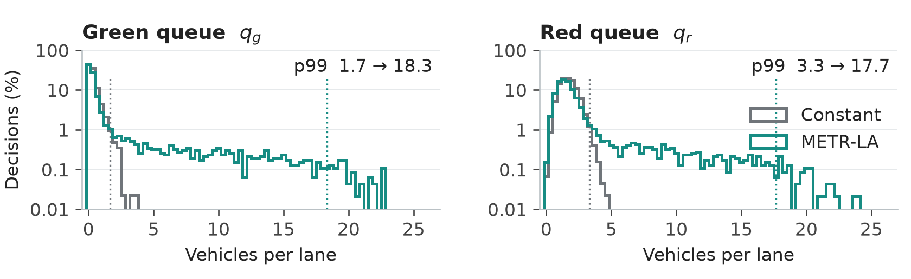
Figure 8 Real temporal profiles expose longer queue tails than the constant-demand comparison.
On the first isolated run, the 99th-percentile green queue rises from 1.67 to 18.33 veh/lane. Nineteen rules cross the 0.1% usage threshold under the real profile. This explains why testing only steady demand misses important controller states.
Table 4 What each part demonstrated
Part | Main outcome
A | GA training improves the initial rules, especially near saturation.
B | Downstream occupancy feedback reduces waiting during an incident.
C | Temporal demand variation makes adaptation valuable; coordination benefits depend on congestion.

Scaling and limits
At 20 × 20 intersections, the saved benchmark estimates 3.89 wall seconds per simulated hour. A GA using 44,000 full-network simulations would take about 47.5 hours on that machine. Training one small model on teacher labels and sharing its weights avoids this cost. Larger systems could add local or regional coordination.
METR-LA speeds are a proxy for intersection demand, so the results describe an offline simulation. Full-dataset preprocessing and centered smoothing can use future readings. One evaluation day and a few seeds limit generalization. The strongest conclusions are improved local adaptation and reduced spillback during the Part B incident.

Sources
[1] Supplied traffic.pptx. Control of Traffic Light in Isolated Intersections Using Fuzzy Neural Network and Genetic Algorithm.
[2] Supplied Lab3_Smart_Semaphore_Control.docx. Laboratory brief.
[3] Project source, trained models and saved results/tables. Entry point main.py; cleaning script scripts/clean_metrla.py. All five existing checks passed.
[4] Kaggle METR-LA dataset. Dataset page
[5] Li, Yu, Shahabi and Liu. DCRNN, ICLR 2018. Source repository
Software: NumPy, pandas, Matplotlib, h5py, pytest

