Smart Semaphore Control
  - Laboratory report on fuzzy neural control and network coordination
Prepared by Alex Morgan and Daniel Reed
11 November 2026

Overview
This project implements a Python traffic signal controller based on the supplied fuzzy neural network presentation and extends it from one intersection to a 3 × 3 road network. Part A builds and trains the controller, Part B adds downstream occupancy feedback, and Part C evaluates traffic patterns derived from METR-LA sensor speeds. The report describes the implemented decisions and the saved full-run results, rather than assuming that all adaptive controllers behave equally well. [1–3]
The trained FNN improves isolated-intersection mean waiting time by up to 17.9% against the fixed Webster plan. During a network incident, coordination reduces mean waiting by 13.3% and the 95th percentile by 37.8% relative to independent FNN controllers. On the selected METR-LA day, adaptation provides the main benefit; coordination adds almost no improvement because downstream blocking is rare.

System and experimental scope
Component | Implemented configuration
Road model | Four approaches per node, three lanes per approach, two NS/EW phases
Network links | 200 m, 50 km/h, approximately 14 s travel, 80 vehicles of storage
Signal timing | Minimum green 10 s, maximum added green 30 s, decisions every 10 s
Discharge and lost time | 1800 veh/h/lane, 2 s startup loss, 5 s intergreen
Part A | One intersection, 5 seeds, 600 s warm-up and 7200 s measurement
Part B | Nine intersections, 3 seeds, 600 s warm-up and 5400 s measurement
Part C | 24-hour replay including 600 s warm-up, 3 isolated and 2 network seeds

Measurement and implementation
Mean queue is the time-average stop-line queue in vehicles per approach across all three lanes. Mean wait and p95 wait describe stop-line passages, including zero waits and elapsed waits for eligible vehicles still queued at the end. They are not complete journey times. The reported p95 is the mean of run-specific percentiles; the worst-node metric is a separate maximum of node means.
The project uses NumPy, pandas, Matplotlib and h5py, with pytest as an optional test runner. All five existing checks passed: example rules, FLC/FNN equivalence, blocked-link response, GA improvement on a known target, and simulator sanity. The full experiment is run through main.py; this report uses the saved tables and models. [3, 6]

Part A Fuzzy controller design
The controller observes the larger queue of the two approaches served by each phase. Dividing by the lane count gives qg for the current green phase and qr for the red phase. AV counts vehicles within 10 seconds of free-flow travel to the green stop line, again per lane. The output Δt requests an extension to the current green phase.
Queues use Short, Medium, Long and Very Long terms over a nominal 0–20 veh/lane range. AV uses Low, Medium and High over 0–6 veh/lane. Triangular interior sets and open shoulder sets give simple, interpretable boundaries. The shoulders continue beyond these plotting ranges, so unusually large inputs are not clipped. This is a deliberate implementation choice; the source presentation illustrates Gaussian membership functions. [1, 3]
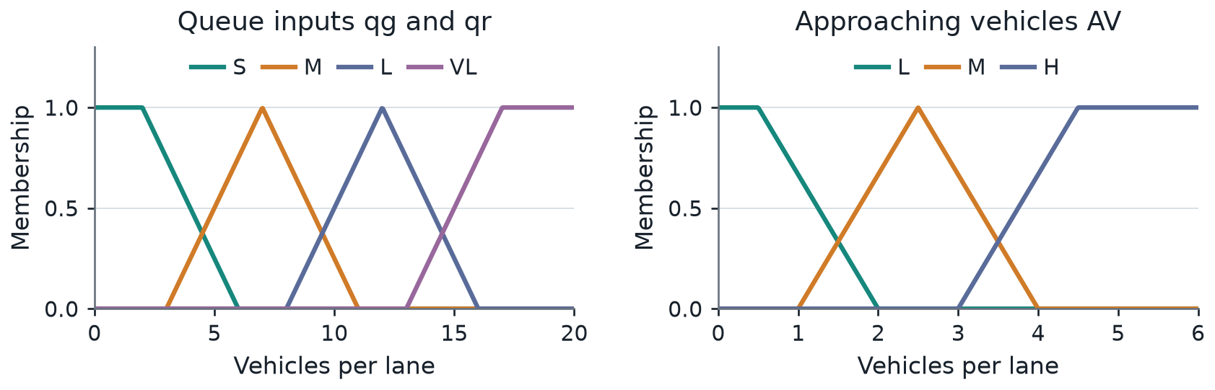
Figure 1 Initial queue and approaching-vehicle membership functions. Queue breakpoints are shared by qg and qr.
Table 1 Complete initial rule base. Each cell lists the output for AV = Low / Medium / High. Z, S, M and L correspond to 0, 8, 16 and 26 seconds.
qg \ qr | S | M | L | VL
S | S / S / M | Z / Z / Z | Z / Z / Z | Z / Z / Z
M | M / M / M | Z / Z / S | Z / Z / Z | Z / Z / Z
L | M / L / L | S / S / S | Z / Z / Z | Z / Z / Z
VL | L / L / L | S / M / M | Z / Z / Z | Z / Z / Z

All 48 combinations are covered. The six examples supplied in the presentation are reproduced exactly, including S/S/L → S and VL/S/L → L. The remaining consequents follow a monotone score: 0.6 times the green-queue term index, plus 0.3 times the AV index, minus 1.5 times the red-queue index, plus 1. The score is rounded to the nearest level using floor(score + 0.5) and limited to levels 0–3.
Rules combine membership degrees by multiplication. Height defuzzification averages their consequent centres using rule firing strengths. This provides an exact match to the FNN computation and is computationally inexpensive. A limitation is the initial strong preference for ending green when the opposite queue is long; under saturation, frequent phase changes can waste capacity.
$Δt = \frac{Σφ_{r}w_{r}}{Σφ_{r}} with φ_{r} = ∏ μ(v, term of rule r)$

Part A FNN operation and genetic learning
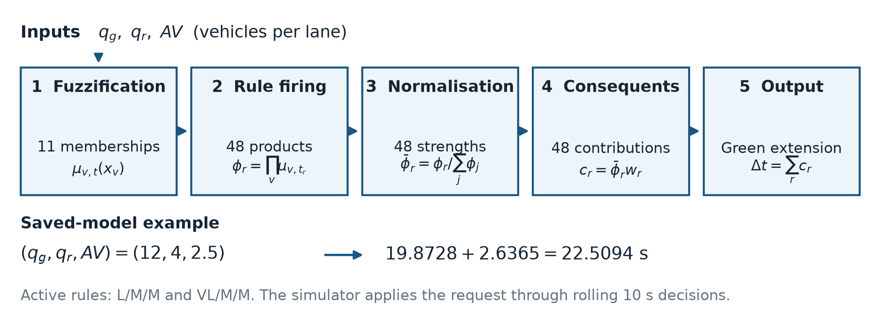
Figure 2 Implemented five-layer FNN. Layer numbering follows the code; raw inputs are external to the five computation layers.
The network has 11 membership terms, 48 product rules, normalized firing strengths, weighted consequent contributions and one summed output. Its 59 genes comprise 48 consequent values bounded to 0–30 s and 11 membership shifts. Queue terms may shift by ±3 veh/lane and AV terms by ±0.9 veh/lane. Before training, its maximum difference from the fuzzy controller is only 7.1 × 10⁻¹⁵ s.
Training labels come from a rollout teacher. For each state, the teacher compares extensions 0, 2, …, 30 s over a 150 s horizon and four sampled Poisson futures. It minimizes accumulated queue time plus a terminal queue penalty. Forty demand scenarios produce 4862 labels, split into 3889 training and 973 validation states. The GA learns this teacher; it does not directly optimize a full-network simulation for every genome.
$E = \frac{1}{N} Σ {(\frac{predicted Δt − target Δt}{30})}^{2} f = \frac{1}{1 + E}$
The real-coded GA uses population 220, crossover probability 0.5 per pair, mutation probability 0.01 per gene, tournament size 3, BLX-0.25 crossover, Gaussian mutation and two elites. Training stops at 1 − f ≤ 0.01 or 200 generations. The target is equivalent to E ≤ 0.010101.
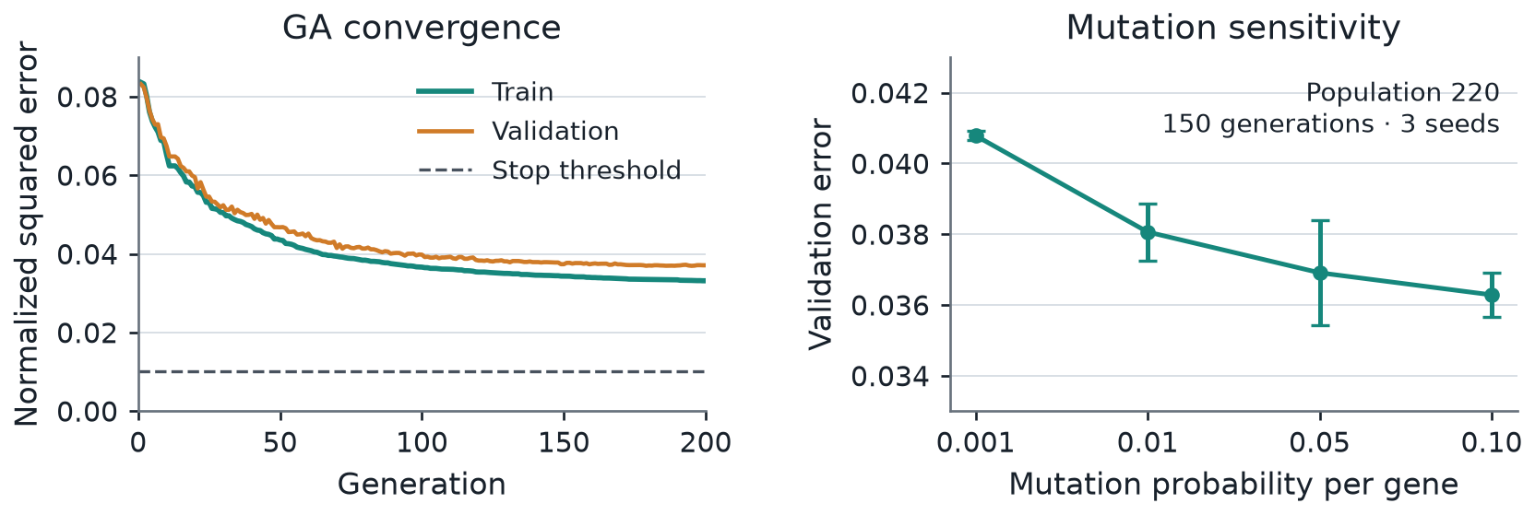
Figure 3 GA learning curve and mutation sensitivity. Sensitivity values average three seeds at 150 generations; error bars show sample standard deviation.
The run reaches the generation cap, not the target: training E falls from the best initial population value 0.0836 to 0.0332, with training RMSE 5.46 s. Validation E is about 0.0372 for the saved model. The logged curve ends near 0.0371 because it records the population before the final reproduction step. With population 50 / 220 / 500, mean validation E is 0.0415 / 0.0381 / 0.0375; mean runtime is 5.64 / 23.44 / 53.07 s. Larger populations give diminishing returns. Higher mutation improves the tested validation scores, but no tested setting meets the stop threshold. [3]

Part A Isolated intersection results
The fixed baseline uses a Webster plan derived from mean demand, with a calculated cycle limited to 40–120 s. The comparison also includes the untrained FLC to separate expert-rule behavior from the effect of learning. All variants use the same seeded boundary-arrival draws within a scenario. The isolated simulator uses straight-through movements only.
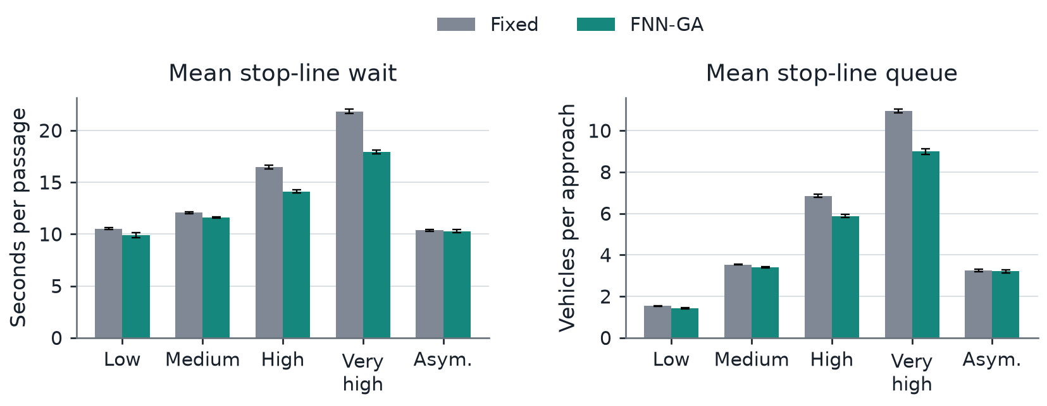
Figure 4 Fixed versus trained FNN at five demand levels. Bars are means over five seeds; error bars show sample standard deviation. The untrained FLC is included in Table 2.
Table 2 Mean stop-line wait and mean queue. Demand is NS/EW in veh/h/lane. FLC is the untrained fuzzy controller.
Demand | Fixed  wait s | FLC  wait s | FNN  wait s | Queue  Fixed / FNN | Wait reduction  vs Fixed
Low  200/150 | 10.53 | 11.14 | 9.87 | 1.53 / 1.43 | 6.3%
Medium  400/300 | 12.07 | 12.84 | 11.59 | 3.53 / 3.39 | 3.9%
High  550/450 | 16.45 | 27.99 | 14.12 | 6.85 / 5.88 | 14.2%
Very High  650/550 | 21.84 | 176.95 | 17.93 | 10.95 / 8.99 | 17.9%
Asymmetric  600/150 | 10.37 | 13.48 | 10.29 | 3.24 / 3.21 | 0.8%

Effect of learning
The trained FNN is best on the reported mean waiting metric in all five cases. Its advantage is largest at high and very high demand, where wait falls by 14.2% and 17.9%. At low and asymmetric demand, the fixed plan already performs well and the remaining improvement is modest. No statistical significance claim is made from these five-seed averages.
The initial FLC becomes unstable near saturation. At very high demand its mean wait reaches 176.95 s and its mean queue 72.33 veh/approach. Throughput falls to 5760 veh/h, versus approximately 7206 for Fixed and 7210 for FNN. Rules that end green when both queues are large cause frequent switching, so startup and intergreen losses consume too much capacity. Training changes the nearest linguistic output term for 29 of 48 consequents and alleviates this behavior.

A concrete FNN decision
For the saved model at (qg, qr, AV) = (12, 4, 2.5), two rules contribute: L/M/M has normalized strength 0.89484 and weight 22.2082 s; VL/M/M has strength 0.10516 and weight 25.0726 s. Their contributions are 19.8728 and 2.6365 s, giving Δt = 22.5094 s. The simulator reassesses after at most 10 s and respects the remaining extension budget, so this output does not force an uninterrupted 22.5 s extension.

Part B Network coordination
The 3 × 3 grid contains nine intersections connected by finite-storage road links and twelve boundary entries. A vehicle leaving one node enters a neighbor’s link, travels for approximately 14 s and joins its stop-line queue. Straight, right and left turns occur with probabilities 0.8, 0.1 and 0.1. The model permits queue spillback but does not resolve detailed lane-changing or conflicting turn movements.
Table 3 Controller variants used in the network experiments
Variant | Available information | Control mechanism
Fixed | Mean demand propagated to each node | A separate constant Webster plan per node; no optimized offsets
Naive | Local qg, qr and AV | The same trained three-input FNN at every node
Coordinated | Local inputs plus downstream occupancy D | Four-input FNN reduces extensions into congested receiving links

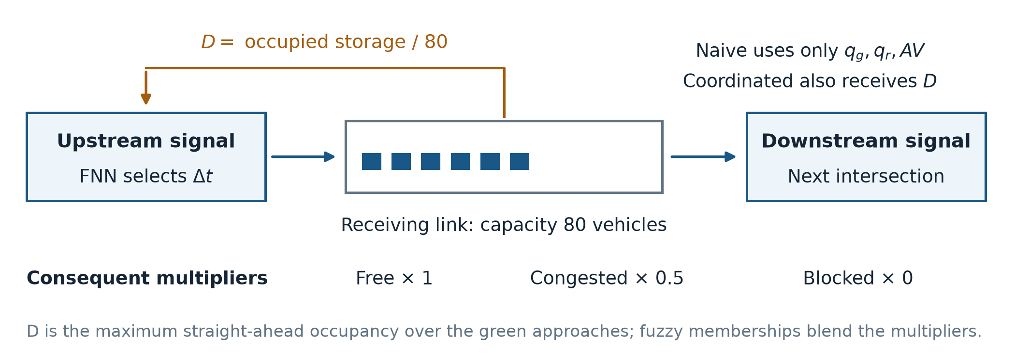
Figure 5 Downstream occupancy feedback. The illustrated link is part of the 3 × 3 grid; storage includes queued and in-transit vehicles.
The fourth input D is the maximum occupancy ratio of the straight-ahead receiving links of the current green approaches. Its terms are Free, Congested and Blocked. Each learned three-input consequent w becomes w, 0.5w and 0 respectively, producing 144 rules and 14 membership terms. The original learned shifts are retained and no additional GA training is performed. Overlapping D memberships interpolate between the three factors.
This choice directly addresses the naive controller’s blind spot: a long local queue can request more green even when the next road has no space. At the example state from Part A, D = 0 / 0.65 / 0.85 / 1 changes the requested extension to 22.51 / 14.56 / 6.75 / 0 s. The mechanism limits feeding of congested links; it does not align signal offsets to create green waves.
Table 4 Network stress scenarios. Incident times are measured after warm-up.
Scenario | Demand and disturbance
Balanced | Constant N/S 350 and E/W 300 veh/h/lane
Rush hour | N/S 450, E 380, W 420; triangular peak reaches 1.9 times base demand
Incident | N/S 350, E 300, W 550; eastbound exits limited to 900 veh/h per approach during minutes 20–50

The feedback uses straight-ahead links and treats external exits as unoccupied. Consequently, the incident is sensed indirectly when the exit queue propagates into internal links. Turning-specific occupancy and explicit exit-capacity feedback remain possible improvements. [3]

Part B Comparison of Fixed Naive and Coordinated
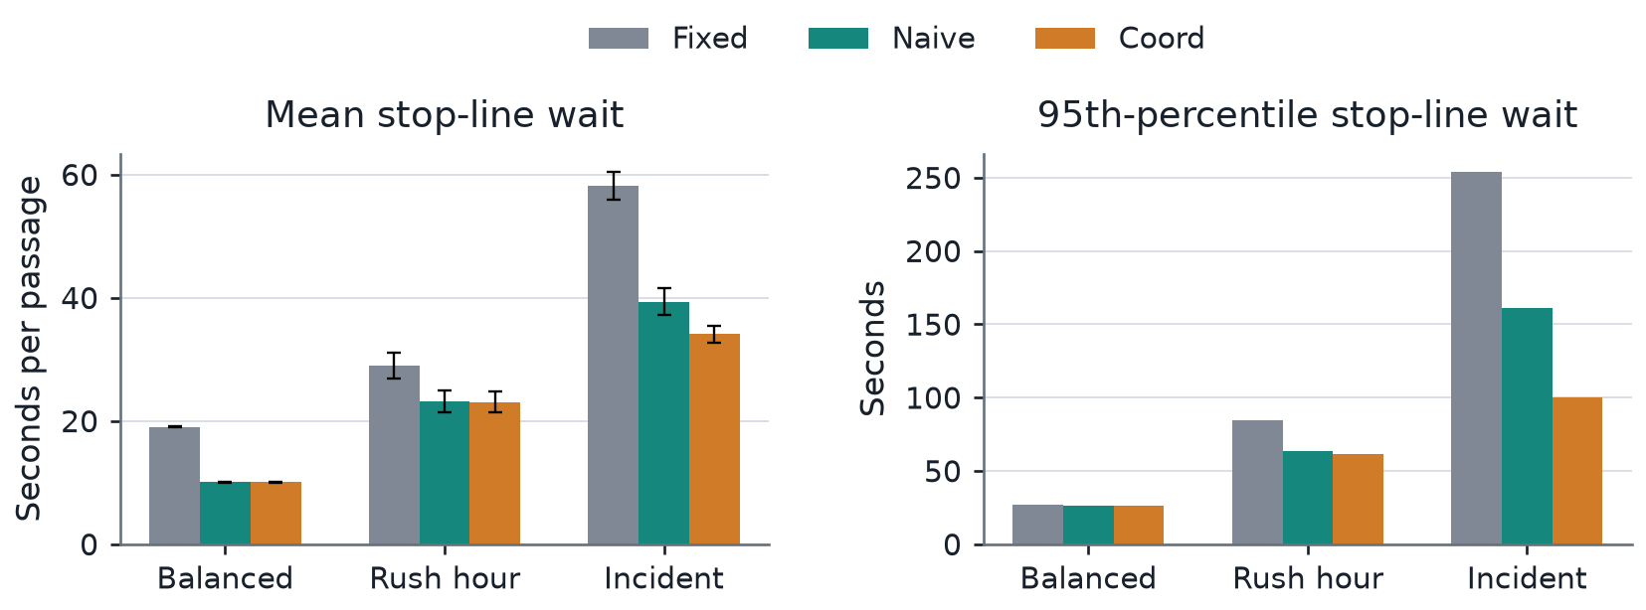
Figure 6 Network mean wait and p95 passage wait over three seeds. Error bars on mean wait show sample standard deviation.
Table 5 Network outcomes. Q is veh/approach; W and p95 are seconds per passage. Block is blocked approach-seconds per intersection-hour.
Scenario | Control | Q | W | p95 | Worst node  mean s | Block
Balanced | Fixed | 5.15 | 19.07 | 27.00 | 22.48 | 0.0
Balanced | Naive | 2.71 | 10.09 | 26.00 | 10.60 | 0.0
Balanced | Coord | 2.71 | 10.09 | 26.00 | 10.60 | 0.0
Rush Hour | Fixed | 13.37 | 29.03 | 84.67 | 33.90 | 0.0
Rush Hour | Naive | 10.70 | 23.24 | 63.33 | 27.54 | 2.5
Rush Hour | Coord | 10.63 | 23.09 | 61.67 | 28.55 | 0.1
Incident | Fixed | 18.62 | 58.16 | 253.67 | 76.91 | 644.1
Incident | Naive | 12.66 | 39.36 | 161.33 | 54.26 | 632.4
Incident | Coord | 10.93 | 34.13 | 100.33 | 39.08 | 448.9

Under balanced demand, Naive and Coordinated are identical. During rush hour the coordinated mean is only 0.65% lower than Naive, while the worst-node mean is slightly higher. Coordination therefore provides no uniform benefit across all nodes and scenarios.
The incident exposes the useful case. Coordinated reduces mean wait by 13.29%, p95 by 37.81%, worst-node mean by 27.98% and blocked approach time by 29.02% relative to Naive. Mean green decreases from 22.08 to 18.76 s, consistent with ending blocked-direction green earlier. Throughput changes little, from 13,845 to 13,852 veh/h, so the main benefit is reduced waiting and faster queue clearance.
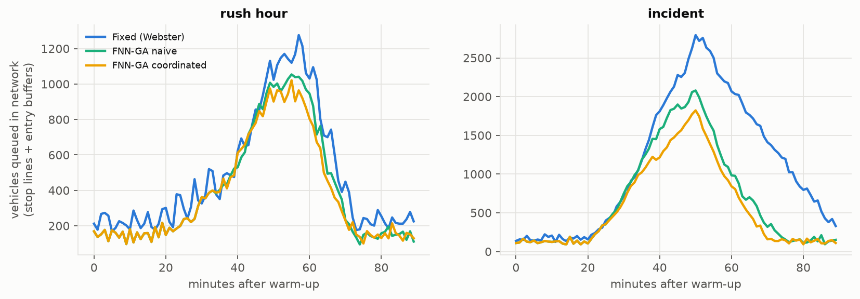
Figure 7 First-seed network queue trajectories from the saved experiment. Summary results in Table 5 average all three seeds.
Stops remain roughly 2.3–2.8 per completed trip, so green-wave coordination is not demonstrated. Also, incident p95 trip delay is 771.3 s for Naive and 774.0 s for Coordinated: the better stop-line p95 does not imply a better journey-level tail. Blocking counts simultaneous blocked approaches separately and includes exit-capacity limits.

Part C Real sensor data and input mapping
METR-LA contains freeway loop-detector speeds rather than intersection arrival counts. The selected Kaggle file has 207 sensors and 34,272 observations per sensor, sampled every five minutes from 1 March to 27 June 2012. The source unit is mph. The data are used to construct time-varying demand for the simulated intersections, not to reconstruct the physical Los Angeles road network. [4, 5]
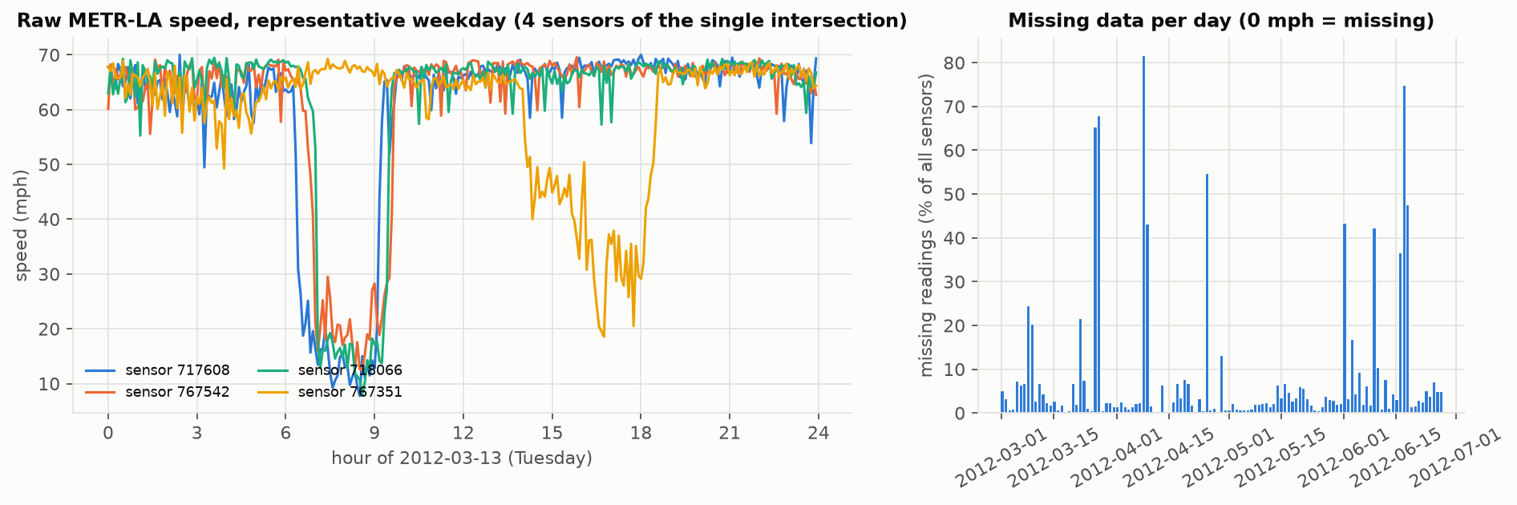
Figure 8 Raw speed profile for the evaluation day from the supplied project. Low-speed periods provide the temporal congestion signal.
Table 6 Dataset profile and cleaning results
Quantity | Result
Missing readings before cleaning | 8.109% of all sensor-time values; zeros treated as missing
Completely missing timestamps | 2148 five-minute timestamps
Filled by interpolation | 1.246 percentage points; limit of six samples inside gaps
Filled by remaining strategy | 6.863 percentage points; time-of-week medians and final forward/back fill
Final missing readings | 0%; speeds restricted to 1–70 mph
Evaluation and retraining days | 13 March 2012 and 14 March 2012 respectively

Sensors require at least 92% completeness and a weekday fifth-percentile speed below 45 mph. Of 93 qualifying sensors, the twelve most complete are used for grid boundary entries; the first four also drive the isolated case. Assignment is by rank, not geography. The two days are the most complete eligible Tuesday–Thursday days.
$x = clip(\frac{v}{v_{f}}, 0, 1) c = clip(\frac{0.85 − x}{0.60}, 0, 1)$
$λ = 250 + 500 × smooth(c) veh/h/lane$
Free-flow speed vf is each sensor’s 95th percentile. A three-sample centered mean smooths the congestion index. Rates are held for 300 s and converted to veh/s using three lanes. Arrivals are still Poisson, but their rates follow the sensor profile. The constant synthetic counterpart uses each entry’s daily mean rate, matching expected demand rather than identical realized vehicle counts.
The FNN still reads simulator qg, qr and AV. A separate speed-derived queue proxy uses density 185(1 − x) veh/mi/lane and a 0.5-mile segment, counting only density above 92.5 veh/mi/lane. This proxy is a sanity check, not a replacement for the closed-loop queue state. The 250–750 veh/h/lane mapping is an explicit modeling assumption. [3]

Part C Comparison under sensor derived demand
For the main comparison, the Part A FNN and the Part B coordination mechanism are reused unchanged. Fixed uses a constant plan based on the evaluation day’s mean demand. Each controller sees the same arrival-rate profile and matched boundary-arrival seeds. A separate real-day retraining experiment is reported alongside the isolated results.
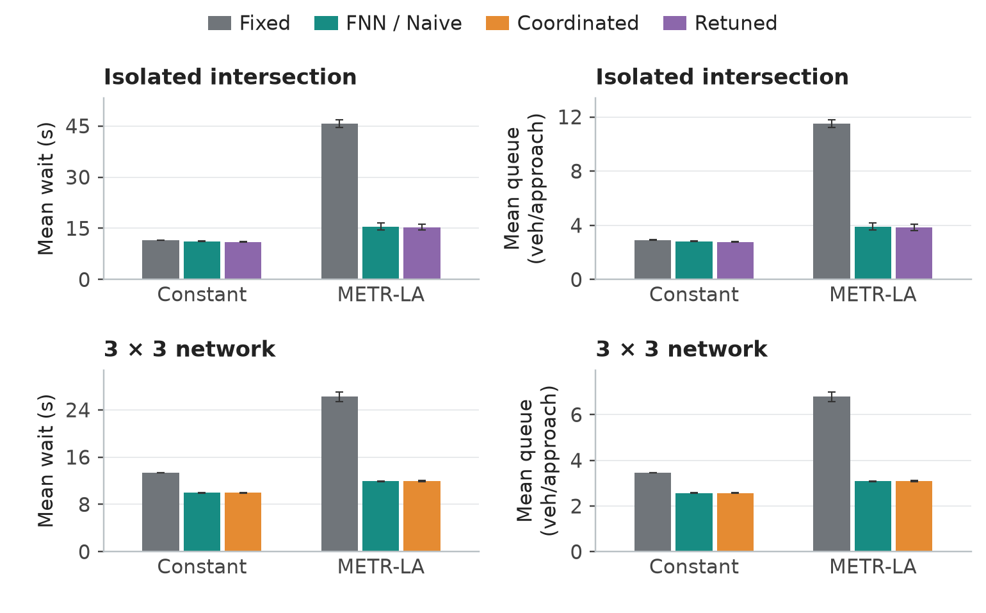
Figure 9 Queue and mean-wait comparison under constant and METR-LA-derived rates. Error bars are sample standard deviations; isolated results use three seeds and grid results two.
Table 7 Exact mean results on METR-LA-derived input. Queue units are veh/approach; wait and p95 are seconds per stop-line passage.
Scale | Controller | Mean queue | Mean wait s | p95 wait s
Isolated | Fixed | 11.50 | 45.75 | 147.00
Isolated | FNN | 3.91 | 15.54 | 47.00
Isolated | Retuned FNN | 3.86 | 15.34 | 46.33
3 × 3 | Fixed | 6.79 | 26.24 | 142.50
3 × 3 | Naive | 3.08 | 11.91 | 31.00
3 × 3 | Coord | 3.10 | 11.97 | 31.00

At the isolated intersection, FNN reduces mean wait by 66.0% and p95 by 68.0% relative to Fixed. On the grid, Naive reduces mean wait by 54.6%. Coordinated is 0.50% slower than Naive and has the same p95. Downstream occupancy reaches the congested region in only 0.212% of first-seed decisions, so this day mainly tests adaptation to varying demand.
Entry buffers are excluded from queue and stop-line wait. Including buffer delay and elapsed delay of unfinished trips gives 272.24 versus 15.55 s/trip for isolated Fixed/FNN, and 244.60 versus 35.71 s/trip for network Fixed/Naive. These broader metrics reveal demand waiting outside finite links; unfinished-trip delay remains a censored lower bound.

Part C Rule behavior and retraining
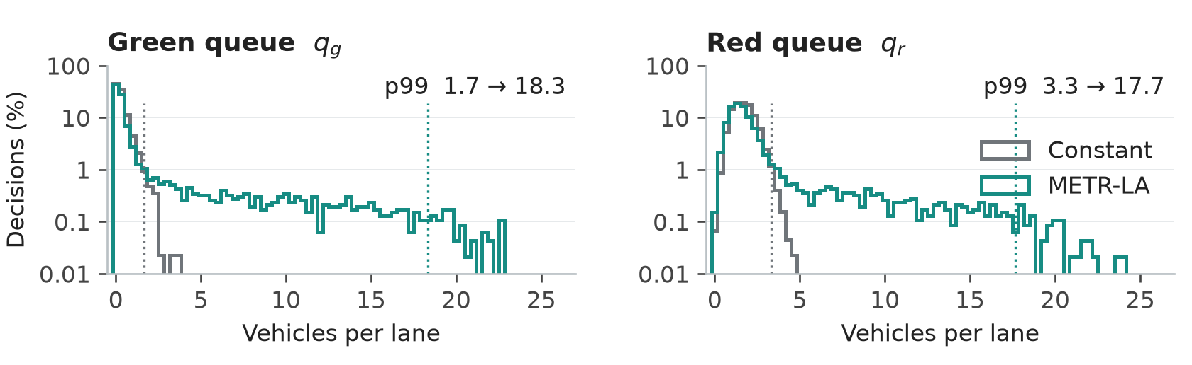
Figure 10 Decision-state queue distributions for the first isolated run. The METR-LA profile exposes substantially longer queue tails than the constant-demand counterpart.
For qg, the 99th percentile rises from 1.67 to 18.33 veh/lane; for qr it rises from 3.33 to 17.67. Red queues at or above 17 veh/lane occur in 1.31% of real-profile decisions and never in the constant-input run. Nineteen of 48 rules move from less than 0.1% to at least 0.1% of total normalized firing strength. This means a substantial increase in use, not necessarily that those rules previously had exactly zero activity.

Retraining on a separate day
The 14 March profile produces 5671 teacher-labeled states. A new three-input FNN is initialized from the fuzzy base and trained with the same population 220, crossover 0.5, mutation 0.01 and 200-generation cap. Thus the code’s “retuned” model is a fresh real-day training run, rather than a warm start from the Part A genome. Its training E is 0.0261 and the stopping target is again not reached. No separate validation error is computed for this retraining run.
Table 8 Selected consequent changes after real-day retraining. Antecedents are qg / qr / AV; values are seconds.
Rule | Part A trained | Real-day trained
L / L / H | 27.8 | 2.2
VL / M / L | 28.2 | 13.0
VL / S / H | 27.0 | 12.7
L / VL / M | 12.9 | 23.3

On the evaluation day, mean wait decreases from 15.54 to 15.34 s, only 1.29%. This 0.20 s difference is small compared with the sample standard deviations of 1.05 and 0.87 s. The rule changes show that learning adapts the control surface, but these limited runs do not establish a reliable additional performance gain. The network model is not retrained in Part C.

Limits of the real data experiment
The evaluation and training days are distinct, but preprocessing medians, sensor selection and free-flow percentiles use the full dataset. Interpolation and centered smoothing can also use later measurements. The experiment therefore represents an offline replay, not a strictly causal or leakage-free deployment evaluation.
The highway-to-intersection mapping imposes demand magnitude and an artificial grid. One day and a small number of random seeds limit generalization. A stronger study would use measured intersection counts, training-only preprocessing, multiple held-out days and a time-of-day fixed baseline. The current results support adaptation to temporal demand variation; the evidence for downstream coordination comes primarily from the incident experiment in Part B.

Scaling limits and overall conclusions
Table 9 Saved scaling benchmark. The GA estimate assumes 44,000 serial one-hour network evaluations, not the teacher-based training actually used in this project.
Grid | Nodes | Wall s per  simulated hour | Hypothetical  GA hours | Genes with a separate  59-gene FNN per node
3x3 | 9 | 0.111 | 1.35 | 531
5x5 | 25 | 0.271 | 3.31 | 1475
10x10 | 100 | 1.005 | 12.28 | 5900
20x20 | 400 | 3.888 | 47.52 | 23600

A 20 × 20 grid has 400 intersections. The saved benchmark estimates 3.888 wall seconds per simulated network hour. A GA that evaluates all 220 individuals for 200 generations by running that network would require about 47.52 hours per optimization, before multiple seeds or scenarios. Giving every node its own three-input FNN would also create 23,600 genes. These machine-specific estimates extrapolate from short, relatively low-demand runs and are not a timing guarantee.
The implemented approach avoids that cost by training a small model on teacher labels and sharing it across nodes. Scaling should preserve shared parameters, use diverse representative scenarios and keep neighbor communication local. More demanding corridors could add offsets or regional control, while independent simulation trials could run in parallel. These extensions would need new network-level validation rather than assuming the isolated optimum remains adequate.

Conclusions
Part A demonstrates that the interpretable rule system can be represented exactly as an FNN and improved by GA training, especially near saturation. Part B shows a concrete failure of independent local decisions and a practical correction using receiving-link occupancy. Part C shows that realistic temporal variability activates longer-queue states and makes adaptation more valuable than a daily-mean fixed plan. Coordination is useful when receiving capacity is constrained; its advantage is conditional, and the selected real-data day does not reproduce the incident stress.

Sources and reproducibility
[1] Supplied presentation. Control of Traffic Light in Isolated Intersections Using Fuzzy Neural Network and Genetic Algorithm. traffic.pptx, especially slides 7–13 and 16.
[2] Supplied lab brief. Lab 3 Smart Semaphore Control From Isolated Intersection to City Scale Traffic Network. Lab3_Smart_Semaphore_Control.docx.
[3] Project source and saved outputs. semaphore, experiments, models and results/tables; main.py runs all parts. scripts/clean_metrla.py reproduces data cleaning. Figures are generated from saved outputs or reused from results/figures.
[4] Kaggle METR-LA archive by annnnguyen. Dataset page
[5] Li Y, Yu R, Shahabi C and Liu Y. Diffusion Convolutional Recurrent Neural Network Data Driven Traffic Forecasting. ICLR 2018. Source repository
[6] Software documentation: NumPy, pandas, Matplotlib, h5py, pytest
Exact input: METR-LA.h5, 57,038,056 bytes. SHA-256:
64784b76d6fb8ec9bff4b6decafb354da2bb37840468fdccee5044e511277c05

