Lab5 Report

Student: 311511010, 310581019, 311505023

* Block diagram

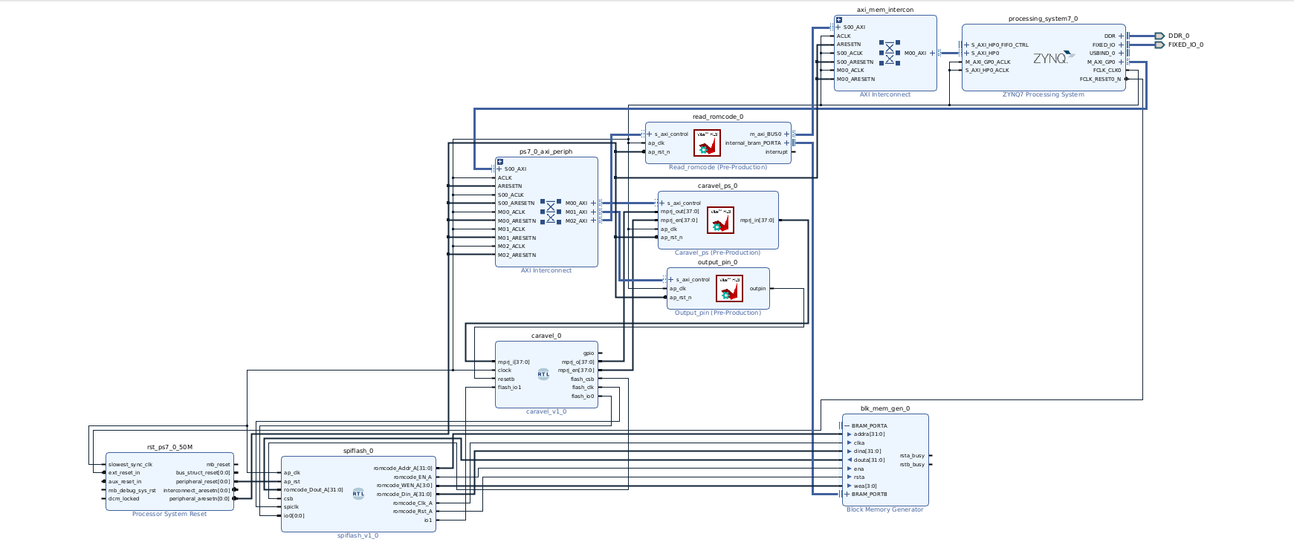

* Utilization

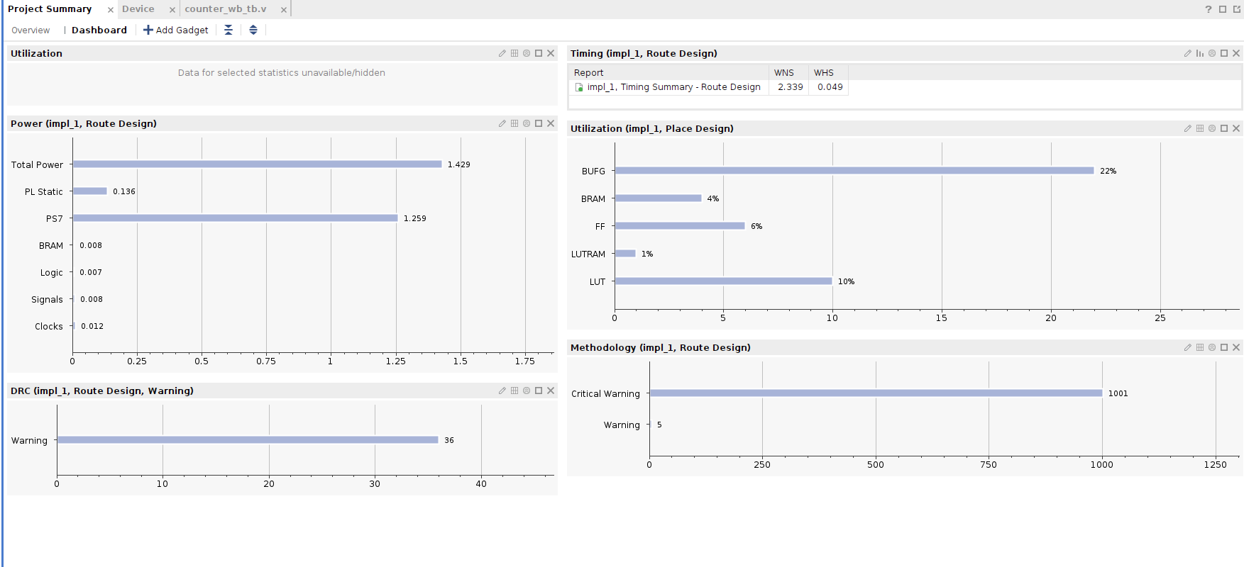

* IP Explanation
  + read_romcode

In an SOC, the function of read_romcode is to allow the system to read pre-stored code from ROM, which is crucial for loading the bootloader, system initialization, and self-testing. This mechanism ensures that the system can boot independently without external intervention and perform basic hardware configuration and diagnostics.

* + ResetControl:

Reset is low active , when reset == 1 , start to fetch code via SPI interface and execute.

* + Caravel_ps:

Establishing communication between the Processor System (PS) and the I/O ports of a Caravel user project. This function enables users to control and monitor the status of Caravel's multi-project I/O ports through the PS.

* + Spiflash:

Storing firmware and the bootloader: Upon SoC startup, the processor first reads the bootloader from the SPI flash memory. The bootloader is then responsible for initializing hardware devices, setting up memory spaces, and loading the operating system or main application from the flash memory or other storage mediums.

- Run different workload on FPGA

1.after run_vivado.sh

counter_wb.hex

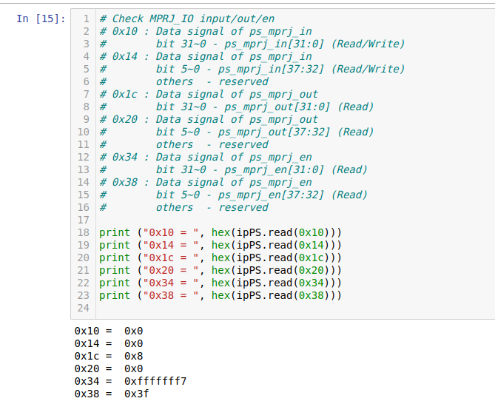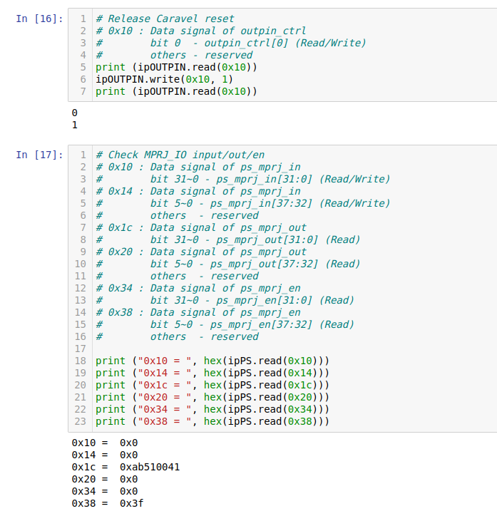

counter_la.hex

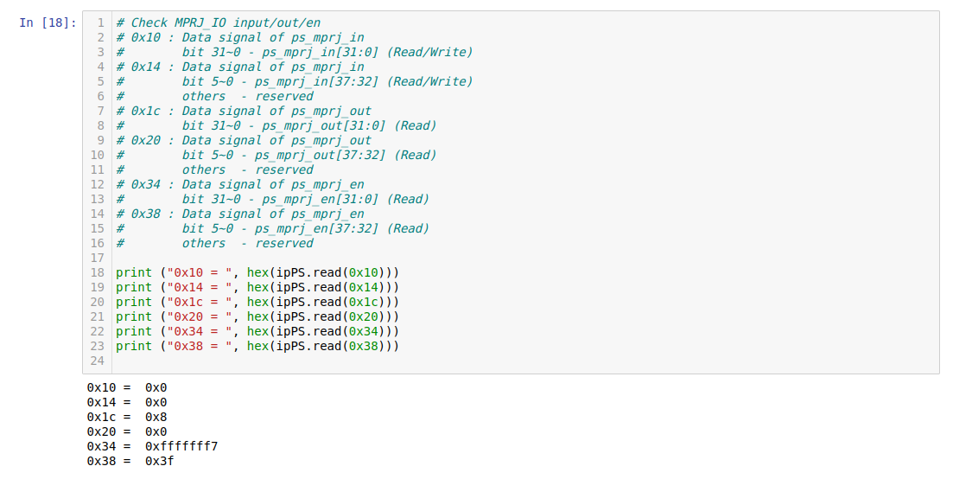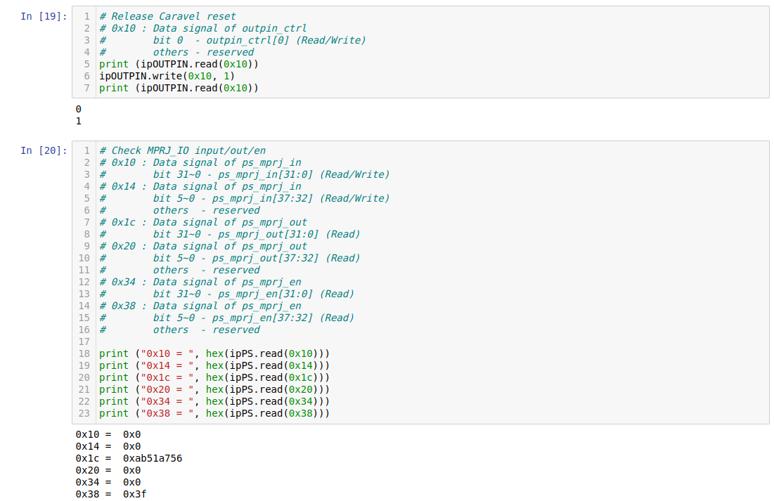

gcd_la.hex:

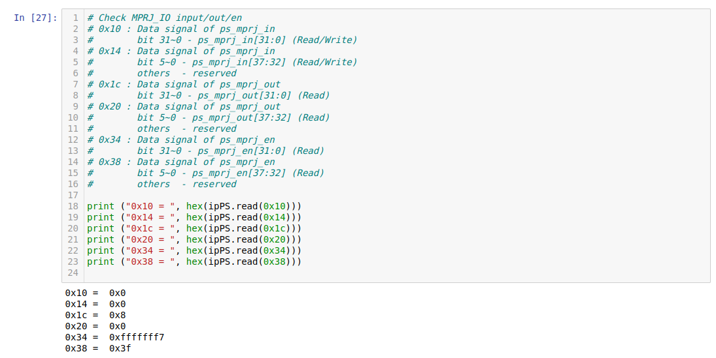

2.after run_vivado_gcd.sh

counter_wb.hex

