**Biometric Authentication Using Electrocardiograms**

A PROJECT SYNOPSIS

SUBMITTED BY

**Satyam Gadpallewar (BE053)**

**Gaurav Soni (BE054)**

**Shubham Dubey (BE055)**

UNDER THE GUIDANCE OF

**Dr. S. Mohan Mahalakshmi Naidu**

**BE (ELECTRONIC AND TELECOMMUNICATION)**



**Department of Electronics and Telecommunication**

**International Institute of Information Technology,**

**Savitribai Phule Pune University**

**Hinjawadi, Pune - 411057**

July 2018

**SYNOPSIS PROJECT 2018-19**

Biometric Authentication Using Electrocardiograms

**Project Introduction:**

**Objective**

To create a biometric authentication system based on ECG signals of the user

**Abstract**

Electrocardiogram (ECG) signals from mobile sensors are expected to increase the availability of authentication in the emerging wearable device industry. However, mobile sensors provide a relatively lower quality signal than the conventional medical devices. This paper proposes a practical authentication procedure for ECG signals that collected via one-chip-solution mobile sensors. We designed a cascading bandpass filter for noise cancellation and suggest eight fiducial features. For classification-based authentication, we use the radial basis function kernel-based support vector machine showing the best performance among nine classifiers through experimental comparisons. In spite of noisy ECG signals in mobile sensors, we achieved 4.61% of the equal error rate (EER) on a single heartbeat, and 1.87% of EER on 15 s testing time on 175 subjects, which is a reasonable result and supports the usability of low-cost ECGs for biometric authentication.

**Project Category**

Digital Signal Processing, Artificial Intelligence and Embedded systems

**Project Description**

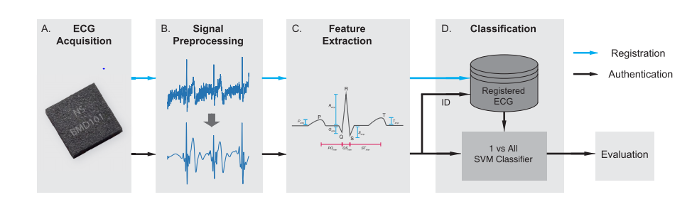

Figure 1 Proposed Framework

Fig1 shows an overall scheme of proposed framework:

(a) acquiring ECG signals via mobile sensor

(b) cancelling noise for robustness

(c) extracting fiducial features in each heartbeat

(d) authenticating an identity through a one-against-all classification. Blue line refers to registration (train) flow and black line refers to authentication (test) flow.

The ECG signal is valid to be used as a strong biometric authentication process according to the following characteristics, which are:

1. The ECG is a noninvasive test and easy to be measured by just placing two fingers on the sensory plates.

2. Although the general ECG morphology for each person contains the same components (P, QRS, and T), the heart’s structure parameters, such as the wall thickness, position, and size, are different for each person; thus, a uniqueness ECG signal will be obtained.

3. Robustness, where the ECG-based authentication systems need limited computational processing power for recognizing individuals.

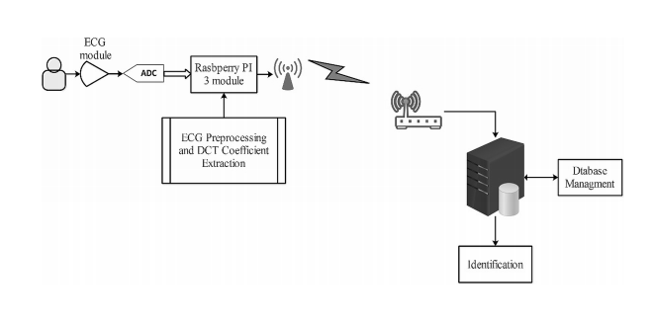

Figure 2 The proposed ECG authentication system components.

This technique is faster and more reliable than other identification techniques like face /voice recognition and a lot of research is still going on this this field.

**Resources and Limitations**

Clean ECG signals can be identified using Pam Tomkins Algorithms, which identifies the QRS part of the ECG. The major challenge we going to face is removal of noise from practical real time ECG signal generated by our body. The other limitation is that the topic is still under research.

**Future scope**

If we are able to implement this, the future of whole biometric authentication will change. Fingerprints, Retinal identification can be replaced with ECG authentication which will be more secured.

**CONCLUSION**

ECG biometric authentication is a topic under research. Based on three or four features of an ECG signal, we can derive whether the person is authenticated or not. Implementation of Pam Tomkins Algorithm along with identification of other features on real time ECG signal will be the POC of the project. A ECG machine giving optimized output signal will be the hardware while the algorithm to detect and recognize the ECG will be the software part of the project.

**References**

[1] *An IoT Real-Time Biometric Authentication System Based on ECG Fiducial Extracted Features Using Discrete Cosine Transform* byAhmed F. Hussein, Biomedical Eng. Dept, AlNahrain University, Baghdad, Iraq

[2] *Biometric Authentication Using Noisy Electrocardiograms Acquired by Mobile Sensors*, Hyun-soo Choi, Byunghan lee, and Sungroh Yoon, Electrical Engineering and Computer Science, Seoul National University, Seoul 08826, South Korea