CODES
1. Thresholding R-R Peaks

for demo = 1:2:3
% Clear our variables
clear ecg samplingrate corrected filtered1 peaks1 filtered2 peaks2 fresult

% Load data sample
switch(demo)
case 1,
plotname = 'Sample 1';
load ecgdemodata1;
case 3,
plotname = 'Sample 3';
load ecgdemodata2;
end

% Remove lower frequencies
fresult=fft(ecg);
fresult(1 : round(length(fresult)*5/samplingrate))=0;
fresult(end - round(length(fresult)*5/samplingrate) : end)=0;
corrected=real(ifft(fresult));

% Filter - first pass
WinSize = floor(samplingrate * 571 / 1000);
if rem(WinSize,2)==0
WinSize = WinSize+1;
end
filtered1=ecgdemowinmax(corrected, WinSize);

% Scale ecg
peaks1=filtered1/(max(filtered1)/7);
% Filter by threshold filter
for data = 1:1:length(peaks1)
if peaks1(data) < 4
peaks1(data) = 0;
else
peaks1(data)=1;
end
end
positions=find(peaks1);
distance=positions(2)-positions(1);
% Returns minimum distance between two peaks
for data=1:1:length(positions)-1
if positions(data+1)-positions(data)<distance
distance=positions(data+1)-positions(data);
end
end
% Optimize filter window size
QRdistance=floor(0.04*samplingrate);
if rem(QRdistance,2)==0
QRdistance=QRdistance+1;
end
WinSize=2*distance-QRdistance;

% Filter - second pass
filtered2=ecgdemowinmax(corrected, WinSize);
peaks2=filtered2;
for data=1:1:length(peaks2)
if peaks2(data)<4
peaks2(data)=0;
else
peaks2(data)=1;
end
end
%% This part of the code between the double comments is added by Surya Penmetsa
positions2=find(peaks2);
distanceBetweenFirstAndLastPeaks = positions2(length(positions2))-positions2(1);

averageDistanceBetweenPeaks = distanceBetweenFirstAndLastPeaks/length(positions2);

averageHeartRate = 60 * samplingrate/averageDistanceBetweenPeaks;

disp('Average Heart Rate = ');
disp(averageHeartRate);
% The code written by Surya Penmetsa Ends here.
%%

% Create figure - stages of processing
figure(demo); set(demo, 'Name', strcat(plotname, ' - Processing Stages'));
% Original input ECG data
subplot(3, 2, 1); plot((ecg-min(ecg))/(max(ecg)-min(ecg)));
title('\bf1. Original ECG'); ylim([-0.2 1.2]);
% ECG with removed low-frequency component
subplot(3, 2, 2); plot((corrected-min(corrected))/(max(corrected)-min(corrected)));
title('\bf2. FFT Filtered ECG'); ylim([-0.2 1.2]);
% Filtered ECG (1-st pass) - filter has default window size
subplot(3, 2, 3); stem((filtered1-min(filtered1))/(max(filtered1)-min(filtered1)));
title('\bf3. Filtered ECG - 1^{st} Pass'); ylim([0 1.4]);
% Detected peaks in filtered ECG
subplot(3, 2, 4); stem(peaks1);
title('\bf4. Detected Peaks'); ylim([0 1.4]);
% Filtered ECG (2-d pass) - now filter has optimized window size
subplot(3, 2, 5); stem((filtered2-min(filtered2))/(max(filtered2)-min(filtered2)));
title('\bf5. Filtered ECG - 2^d Pass'); ylim([0 1.4]);
% Detected peaks - final result
subplot(3, 2, 6); stem(peaks2);
title('\bf6. Detected Peaks - Finally'); ylim([0 1.4]);
% Create figure - result
figure(demo+1); set(demo+1, 'Name', strcat(plotname, ' - Result'));
% Plotting ECG in green
plot((ecg-min(ecg))/(max(ecg)-min(ecg)), '-g'); title('\bf Comparative ECG R-Peak Detection Plot');
% Show peaks in the same picture
hold on
% Stemming peaks in dashed black
stem(peaks2'.*((ecg-min(ecg))/(max(ecg)-min(ecg)))', ':k');
% Hold off the figure
hold off
end

Console Window
>> ecgdemo
Average Heart Rate =
64.8768

Average Heart Rate =
80.3996

WINDOW OUTPUT
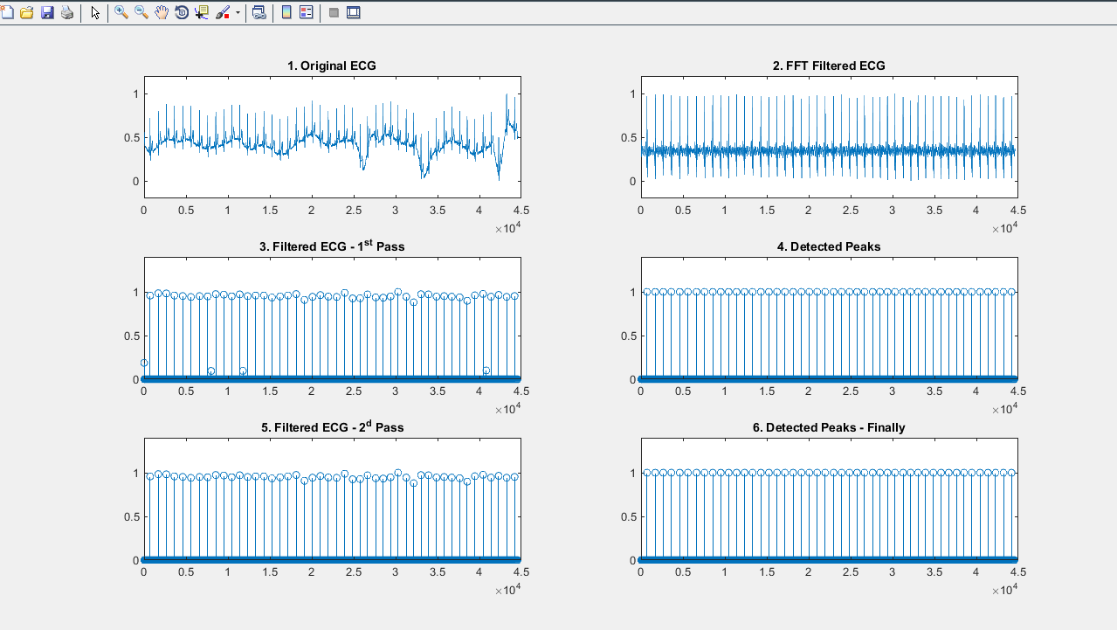
Figure 1 ECG without Noise
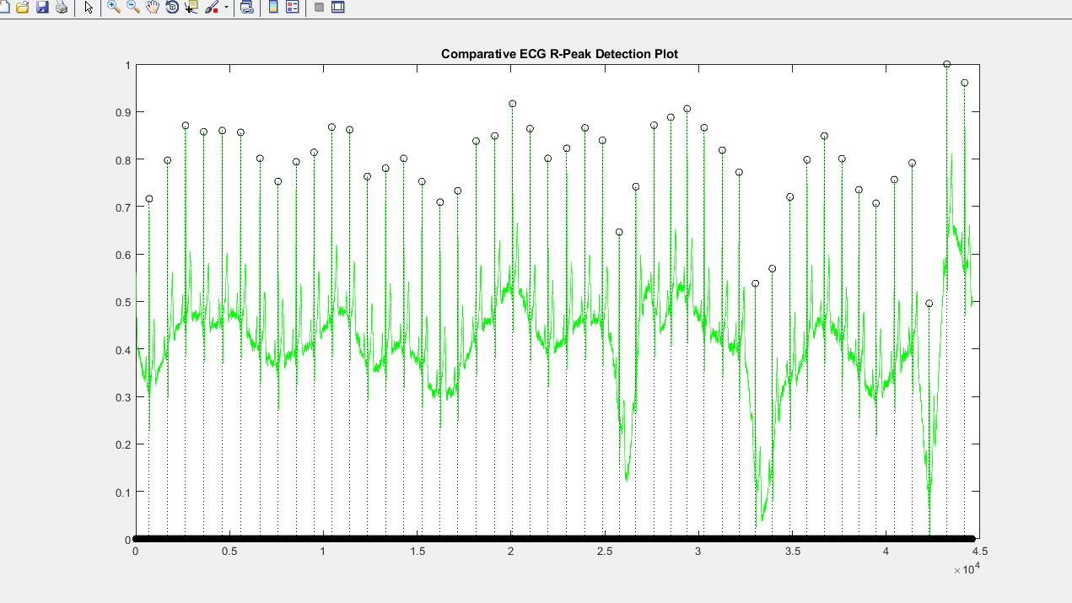
Figure 2 R peak for ECG without noise
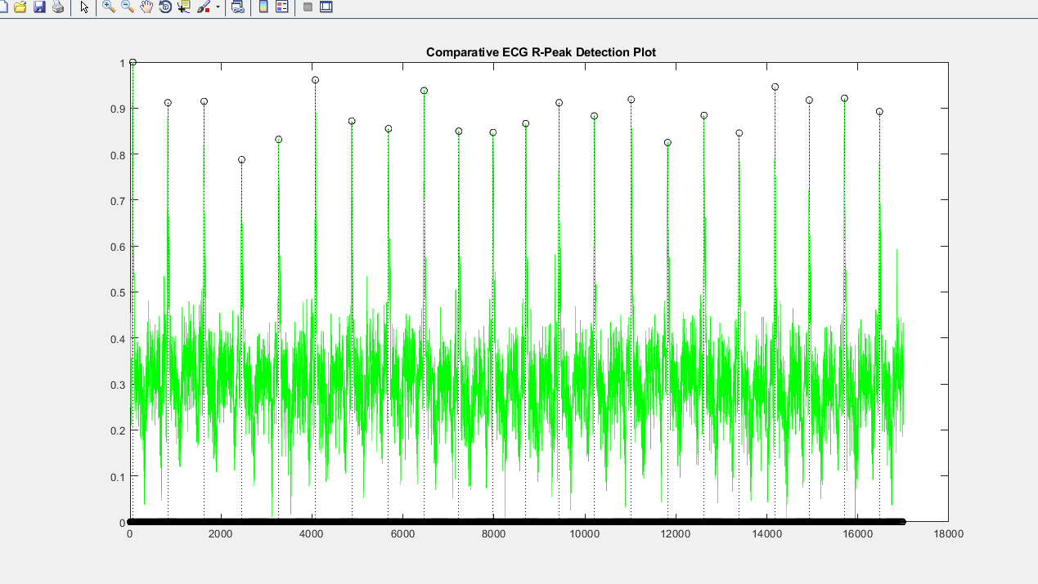
Figure 3 R- Peak for ECG with Noise
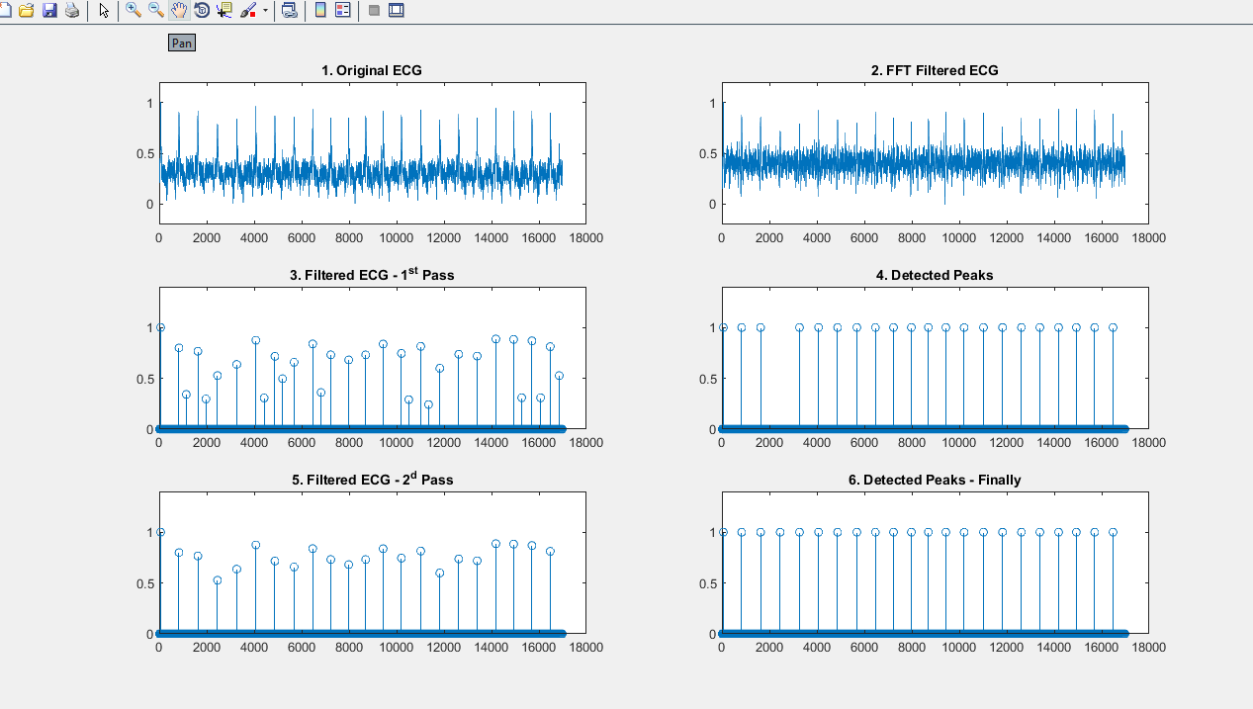
Figure 4 ECG With Noise

2. PAN TOMPKINS

function [qrs_amp_raw,qrs_i_raw,delay]=pan_tompkin(ecg,fs,gr)

ecg = ecg(:);

%% Initialize
qrs_c =[]; %amplitude of R
qrs_i =[]; %index
SIG_LEV = 0;
nois_c =[];
nois_i =[];
delay = 0;
skip = 0; % becomes one when a T wave is detected
not_nois = 0; % it is not noise when not_nois = 1
selected_RR =[]; % Selected RR intervals
m_selected_RR = 0;
mean_RR = 0;
qrs_i_raw =[];
qrs_amp_raw=[];
ser_back = 0;
test_m = 0;
SIGL_buf = [];
NOISL_buf = [];
THRS_buf = [];
SIGL_buf1 = [];
NOISL_buf1 = [];
THRS_buf1 = [];
ax = zeros(1,6);

figure;

if fs == 200
ax(1) = subplot(321);plot(ecg);axis tight;title('Raw signal');
ecg = ecg - mean(ecg);
Wn = 12*2/fs;
N = 3; % order of 3 less processing
[a,b] = butter(N,Wn,'low'); %bandpass filtering
ecg_l = filtfilt(a,b,ecg);
ecg_l = ecg_l/ max(abs(ecg_l));
if gr
ax(2)=subplot(322);plot(ecg_l);axis tight;title('Low pass filtered');
end
Wn = 5*2/fs;
N = 3; % order of 3 less processing
[a,b] = butter(N,Wn,'high'); %bandpass filtering
ecg_h = filtfilt(a,b,ecg_l);
ecg_h = ecg_h/ max(abs(ecg_h));
if gr
ax(3)=subplot(323);plot(ecg_h);axis tight;title('High Pass Filtered');
end
else
ax(1) = subplot(3,2,[1 2]);plot(ecg);axis tight;title('Raw Signal');

f1=5; %cuttoff low frequency to get rid of baseline wander
f2=15; %cuttoff frequency to discard high frequency noise
Wn=[f1 f2]*2/fs; % cutt off based on fs
N = 3; % order of 3 less processing
[a,b] = butter(N,Wn); %bandpass filtering
ecg_h = filtfilt(a,b,ecg);
ecg_h = ecg_h/ max( abs(ecg_h));
if gr
ax(3)=subplot(323);plot(ecg_h);axis tight;title('Band Pass Filtered');
end
end

if fs ~= 200
int_c = (5-1)/(fs*1/40);
b = interp1(1:5,[1 2 0 -2 -1].*(1/8)*fs,1:int_c:5);
else
b = [1 2 0 -2 -1].*(1/8)*fs;
end

ecg_d = filtfilt(b,1,ecg_h);
ecg_d = ecg_d/max(ecg_d);

if gr
ax(4)=subplot(324);plot(ecg_d);
axis tight;
title('Filtered with the derivative filter');
end

ecg_s = ecg_d.^2;
if gr
ax(5)=subplot(325);plot(ecg_s);axis tight;title('Squared');
end

ecg_m = conv(ecg_s ,ones(1 ,round(0.150*fs))/round(0.150*fs));
delay = delay + round(0.150*fs)/2;

if gr
ax(6)=subplot(326);plot(ecg_m);
axis tight;
title('Averaged with 30 samples length,Black noise,Green Adaptive Threshold,RED Sig Level,Red circles QRS adaptive threshold');
axis tight;
end

[pks,locs] = findpeaks(ecg_m,'MINPEAKDISTANCE',round(0.2*fs));

THR_SIG = max(ecg_m(1:2*fs))*1/3; % 0.25 of the max amplitude
THR_NOISE = mean(ecg_m(1:2*fs))*1/2; % 0.5 of the mean signal is considered to be noise
SIG_LEV= THR_SIG;
NOISE_LEV = THR_NOISE;

THR_SIG1 = max(ecg_h(1:2*fs))*1/3; % 0.25 of the max amplitude
THR_NOISE1 = mean(ecg_h(1:2*fs))*1/2; %
SIG_LEV1 = THR_SIG1; % Signal level in Bandpassed filter
NOISE_LEV1 = THR_NOISE1; % Noise level in Bandpassed filter

for i = 1 : length(pks)

%% locate the corresponding peak in the filtered signal
if locs(i)-round(0.150*fs)>= 1 && locs(i)<= length(ecg_h)
[y_i,x_i] = max(ecg_h(locs(i)-round(0.150*fs):locs(i)));
else
if i == 1
[y_i,x_i] = max(ecg_h(1:locs(i)));
ser_back = 1;
elseif locs(i)>= length(ecg_h)
[y_i,x_i] = max(ecg_h(locs(i)-round(0.150*fs):end));
end

end

%% update the heart_rate (Two heart rate means one the moste recent and the other selected)
if length(qrs_c) >= 9

diffRR = diff(qrs_i(end-8:end)); %calculate RR interval
mean_RR = mean(diffRR); % calculate the mean of 8 previous R waves interval
comp =qrs_i(end)-qrs_i(end-1); %latest RR

if comp <= 0.92*mean_RR || comp >= 1.16*mean_RR
% lower down thresholds to detect better in MVI
THR_SIG = 0.5*(THR_SIG);
%THR_NOISE = 0.5*(THR_SIG);

% lower down thresholds to detect better in Bandpass filtered
THR_SIG1 = 0.5*(THR_SIG1);
%THR_NOISE1 = 0.5*(THR_SIG1);

else
m_selected_RR = mean_RR; %the latest regular beats mean
end

end

%% calculate the mean of the last 8 R waves to make sure that QRS is not
% missing(If no R detected , trigger a search back) 1.66*mean

if m_selected_RR
test_m = m_selected_RR; %if the regular RR availabe use it
elseif mean_RR && m_selected_RR == 0
test_m = mean_RR;
else
test_m = 0;
end

if test_m
if (locs(i) - qrs_i(end)) >= round(1.66*test_m)% it shows a QRS is missed
[pks_temp,locs_temp] = max(ecg_m(qrs_i(end)+ round(0.200*fs):locs(i)-round(0.200*fs))); % search back and locate the max in this interval
locs_temp = qrs_i(end)+ round(0.200*fs) + locs_temp -1; %location

if pks_temp > THR_NOISE
qrs_c = [qrs_c pks_temp];
qrs_i = [qrs_i locs_temp];

% find the location in filtered sig
if locs_temp <= length(ecg_h)
[y_i_t,x_i_t] = max(ecg_h(locs_temp-round(0.150*fs):locs_temp));
else
[y_i_t,x_i_t] = max(ecg_h(locs_temp-round(0.150*fs):end));
end
% take care of bandpass signal threshold
if y_i_t > THR_NOISE1

qrs_i_raw = [qrs_i_raw locs_temp-round(0.150*fs)+ (x_i_t - 1)];% save index of bandpass
qrs_amp_raw =[qrs_amp_raw y_i_t]; %save amplitude of bandpass
SIG_LEV1 = 0.25*y_i_t + 0.75*SIG_LEV1; %when found with the second thres
end

not_nois = 1;
SIG_LEV = 0.25*pks_temp + 0.75*SIG_LEV ; %when found with the second threshold
end

else
not_nois = 0;

end
end

%% find noise and QRS peaks
if pks(i) >= THR_SIG

% if a QRS candidate occurs within 360ms of the previous QRS
% ,the algorithm determines if its T wave or QRS
if length(qrs_c) >= 3
if (locs(i)-qrs_i(end)) <= round(0.3600*fs)
Slope1 = mean(diff(ecg_m(locs(i)-round(0.075*fs):locs(i)))); %mean slope of the waveform at that position
Slope2 = mean(diff(ecg_m(qrs_i(end)-round(0.075*fs):qrs_i(end)))); %mean slope of previous R wave
if abs(Slope1) <= abs(0.5*(Slope2)) % slope less then 0.5 of previous R
nois_c = [nois_c pks(i)];
nois_i = [nois_i locs(i)];
skip = 1; % T wave identification
% adjust noise level in both filtered and
% MVI
NOISE_LEV1 = 0.125*y_i + 0.875*NOISE_LEV1;
NOISE_LEV = 0.125*pks(i) + 0.875*NOISE_LEV;
else
skip = 0;
end

end
end

if skip == 0 % skip is 1 when a T wave is detected
qrs_c = [qrs_c pks(i)];
qrs_i = [qrs_i locs(i)];

% bandpass filter check threshold
if y_i >= THR_SIG1
if ser_back
qrs_i_raw = [qrs_i_raw x_i]; % save index of bandpass
else
qrs_i_raw = [qrs_i_raw locs(i)-round(0.150*fs)+ (x_i - 1)];% save index of bandpass
end
qrs_amp_raw =[qrs_amp_raw y_i];% save amplitude of bandpass
SIG_LEV1 = 0.125*y_i + 0.875*SIG_LEV1;% adjust threshold for bandpass filtered sig
end

% adjust Signal level
SIG_LEV = 0.125*pks(i) + 0.875*SIG_LEV ;
end

elseif (THR_NOISE <= pks(i)) && (pks(i) < THR_SIG)

%adjust Noise level in filtered sig
NOISE_LEV1 = 0.125*y_i + 0.875*NOISE_LEV1;
%adjust Noise level in MVI
NOISE_LEV = 0.125*pks(i) + 0.875*NOISE_LEV;

elseif pks(i) < THR_NOISE
nois_c = [nois_c pks(i)];
nois_i = [nois_i locs(i)];

% noise level in filtered signal
NOISE_LEV1 = 0.125*y_i + 0.875*NOISE_LEV1;
%adjust Noise level in MVI
NOISE_LEV = 0.125*pks(i) + 0.875*NOISE_LEV;

end

%% adjust the threshold with SNR
if NOISE_LEV ~= 0 || SIG_LEV ~= 0
THR_SIG = NOISE_LEV + 0.25*(abs(SIG_LEV - NOISE_LEV));
THR_NOISE = 0.5*(THR_SIG);
end

% adjust the threshold with SNR for bandpassed signal
if NOISE_LEV1 ~= 0 || SIG_LEV1 ~= 0
THR_SIG1 = NOISE_LEV1 + 0.25*(abs(SIG_LEV1 - NOISE_LEV1));
THR_NOISE1 = 0.5*(THR_SIG1);
end

% take a track of thresholds of smoothed signal
SIGL_buf = [SIGL_buf SIG_LEV];
NOISL_buf = [NOISL_buf NOISE_LEV];
THRS_buf = [THRS_buf THR_SIG];

% take a track of thresholds of filtered signal
SIGL_buf1 = [SIGL_buf1 SIG_LEV1];
NOISL_buf1 = [NOISL_buf1 NOISE_LEV1];
THRS_buf1 = [THRS_buf1 THR_SIG1];

skip = 0; %reset parameters
not_nois = 0; %reset parameters
ser_back = 0; %reset bandpass param
end

if gr
hold on,scatter(qrs_i,qrs_c,'m');
hold on,plot(locs,NOISL_buf,'--k','LineWidth',2);
hold on,plot(locs,SIGL_buf,'--r','LineWidth',2);
hold on,plot(locs,THRS_buf,'--g','LineWidth',2);
if any(ax)
ax(~ax) = [];
linkaxes(ax,'x');
zoom on;
end
end

%% overlay on the signals
if gr
figure,az(1)=subplot(311);plot(ecg_h);title('QRS on Filtered Signal');axis tight;
hold on,scatter(qrs_i_raw,qrs_amp_raw,'m');
hold on,plot(locs,NOISL_buf1,'LineWidth',2,'Linestyle','--','color','k');
hold on,plot(locs,SIGL_buf1,'LineWidth',2,'Linestyle','-.','color','r');
hold on,plot(locs,THRS_buf1,'LineWidth',2,'Linestyle','-.','color','g');
az(2)=subplot(312);plot(ecg_m);title('QRS on MVI signal and Noise level(black),Signal Level (red) and Adaptive Threshold(green)');axis tight;
hold on,scatter(qrs_i,qrs_c,'m');
hold on,plot(locs,NOISL_buf,'LineWidth',2,'Linestyle','--','color','k');
hold on,plot(locs,SIGL_buf,'LineWidth',2,'Linestyle','-.','color','r');
hold on,plot(locs,THRS_buf,'LineWidth',2,'Linestyle','-.','color','g');
az(3)=subplot(313);plot(ecg-mean(ecg));title('Pulse train of the found QRS on ECG signal');axis tight;
line(repmat(qrs_i_raw,[2 1]),repmat([min(ecg-mean(ecg))/2; max(ecg-mean(ecg))/2],size(qrs_i_raw)),'LineWidth',2.5,'LineStyle','-.','Color','r');
linkaxes(az,'x');
zoom on;
end
end

load('101m.mat');
val= (val-1024)/200;
ECGSignal1= val(1,1:1000);
pan_tompkin(ECGSignal1,200,1);
load('103m.mat');
val= (val-1024)/200;
ECGSignal2= val(1,1:1000);
pan_tompkin(ECGSignal2,200,1);
load('104m.mat');
val= (val-1024)/200;
ECGSignal3= val(1,1:1000);
pan_tompkin(ECGSignal3,200,1);
load('105m.mat');
val= (val-1024)/200;
ECGSignal4= val(1,1:1000);
pan_tompkin(ECGSignal4,200,1);

OUTPUT
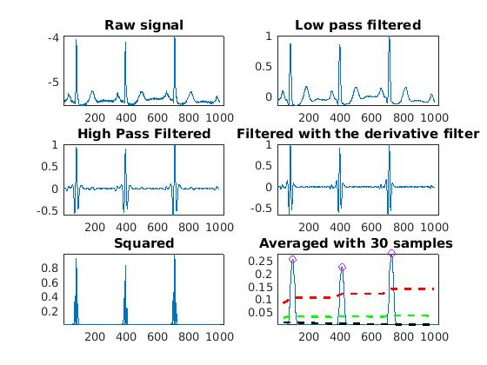
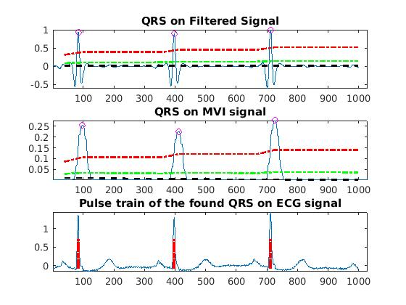

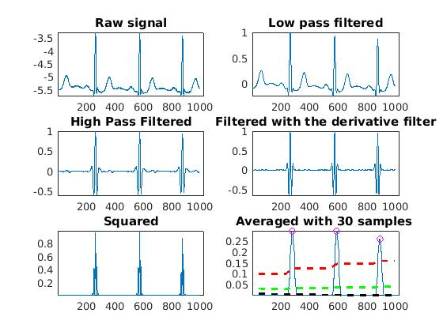
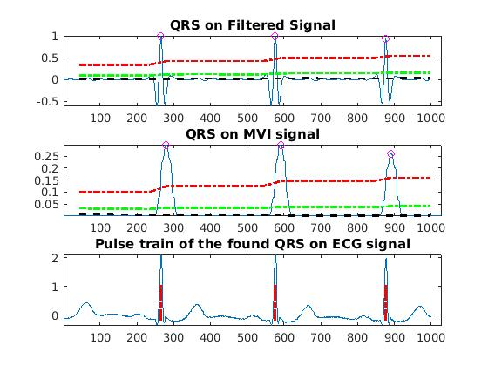

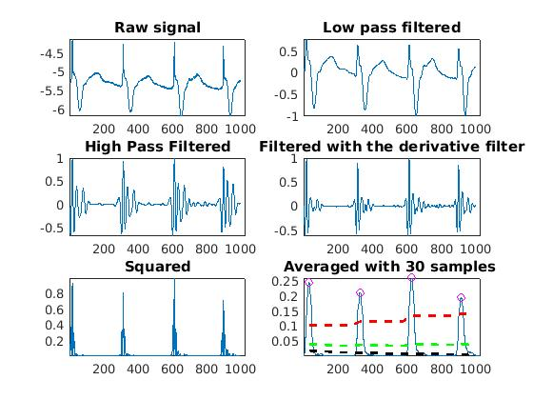

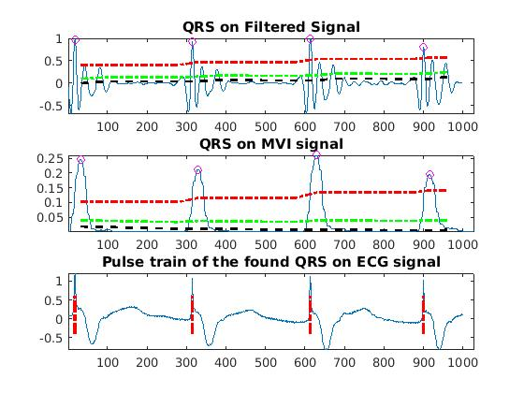

3. ECG Feature Extractor

function []= wavesfinder(sig)

N=length(sig);
fs=200;
t=[0:N-1]/fs;
figure(1);subplot(4,2,1);plot(sig)
title('Original Signal')
%%
% Low Pass Filter
b=1/32*[1 0 0 0 0 0 -2 0 0 0 0 0 1];
a=[1 -2 1];
sigL=filter(b,a,sig);
subplot(4,2,3);
plot(sigL)
title('Low Pass Filter')
subplot(4,2,4);
zplane(b,a);
%
% High Pass Filter
b=[-1/32 0 0 0 0 0 0 0 0 0 0 0 0 0 0 0 1 -1 0 0 0 0 0 0 0 0 0 0 0 0 0 0 1/32];
a=[1 -1];
sigH=filter(b,a,sigL);
subplot(4,2,5);plot(sigH)
title('High Pass Filter')
subplot(4,2,6);zplane(b,a)
%
% Derivative Base Filter
b=[1/4 1/8 0 -1/8 -1/4];
a=[1];
sigD=filter(b,a,sigH);
subplot(4,2,7);plot(sigD)
title('Derivative Base Filter')
subplot(4,2,8);zplane(b,a)
%
% be tavane 2 miresanim
sigD2=sigD.^2;
%%
% normalization
signorm=sigD2/max(abs(sigD2));
%%

h=ones(1,31)/31;
sigAV=conv(signorm,h);
sigAV=sigAV(15+[1:N]);
sigAV=sigAV/max(abs(sigAV));
figure(2);plot(sigAV)
title('Moving Average filter')
%%
treshold=mean(sigAV);
P_G= (sigAV>0.01);
figure(3);plot(P_G)
title('treshold Signal')
figure;plot(sigL)
%%
difsig=diff(P_G);
left=find(difsig==1);
right=find(difsig==-1);
%%
% run cancel delay
% 6 sample delay because of LowPass filtering
% 16 sample delay because of HighPass filtering
left=left-(6+16);
right=right-(6+16);
%%
% P-QRS-t
for i=1:length(left);

[R_A(i) R_t(i)]=max(sigL(left(i):right(i)));
R_t(i)=R_t(i)-1+left(i) %add offset

[Q_A(i) Q_t(i)]=min(sigL(left(i):R_t(i)));
Q_t(i)=Q_t(i)-1+left(i)

[S_A(i) S_t(i)]=min(sigL(left(i):right(i)));
S_t(i)=S_t(i)-1+left(i)

[P_A(i) P_t(i)]=max(sigL(left(i):Q_t(i)));
P_t(i)=P_t(i)-1+left(i)

[T_A(i) T_t(i)]=max(sigL(S_t(i):right(i)));
T_t(i)=T_t(i)-1+left(i)+47

end
%%
figure;plot(t,sigL,t(Q_t),Q_A,'*g',t(S_t),S_A,'^k',t(R_t),R_A,'ob',t(P_t),P_A,'+b',t(T_t),T_A,'+r');
for i=1:((length(P_t))-1)

HRV=P_t(i+1)-P_t(i)
end

end

OUTPUT

R_t =

72

Q_t =

62

S_t =

80

P_t =

43

T_t =

118

R_t =

72 228

Q_t =

62 218

S_t =

80 235

P_t =

43 199

T_t =

118 275

R_t =

72 228 388

Q_t =

62 218 379

S_t =

80 235 396

P_t =

43 199 359

T_t =

118 275 434

HRV =

156

HRV =

160

