Grid InQuest II
Coordinate Transformation Software
for Great Britain and Ireland




Contents

Introduction 3
Welcome to Grid InQuest II 3
Desktop Application 4
Overview 4
Installation 4
Getting Started 5
Interactive Coordinate Transformation 6
Changing Application Options 8
Transforming Text File Coordinates 9
Command Line Programs 13
Overview 13
GIQTrans Operation 13
OSGMUpdate Operation 13
Settings File Format 14
FME Point Transformer 15
Programming with Grid InQuest II 16
Introduction 16
Operating System Scripts 16
Web Server CGI Programming 16
LibGIQ Dynamic Link Library 17
Library Source Code Reuse 19
Technical Information 20
Overview 20
Grid InQuest II's Supported Coordinate Systems 20
British and Irish Transformation Systems 22
GNU General Public License 24
Preamble 24
Terms and Conditions for Copying, Distribution and Modification 24
Glossary 28

Introduction

Welcome to Grid InQuest II
The Grid InQuest II desktop application and command line tools provide a means of transforming coordinates between global geodetic coordinates (ETRS89/WGS84) and the national systems of Great Britain and Ireland. It provides a fully three-dimensional transformation incorporating the latest geoid model (OSGM15) and the appropriate polynomial transformation model (OSTN15 or OSi/OSNI) for each of the projected coordinate systems.
This document is a reference for installing and using the Grid InQuest II package. It is intended as a help to getting started with the software and to implement the preferred methods and procedures involved in accurate coordinate conversions within Britain and Ireland.
The following text is divided into four sections. The first two contain general user information. Section one explains how to install and use the main Grid InQuest II desktop application. It contains a description of all the menu items, options and forms used to operate both the interactive and file processing modes. The second section introduces the more advanced utilities designed for command line use.
The last two sections contain information for programmers and other technicians. The first of these describes how to re-use the system's components within other scripts and programs. The final section contains reference information related to the supported coordinate systems and transformations used within Great Britain, Northern Ireland and the Republic of Ireland.
The Grid InQuest II project was jointly developed by the Land and Property Service of Northern Ireland, the Ordnance Survey of the Republic of Ireland and the Ordnance Survey of Great Britain.

Desktop Application

Overview
The Grid InQuest II desktop application has been designed to be as simple as possible to operate and install. It is a graphical program that can be run on any reasonably modern Microsoft Windows computer, Apple Macintosh computer or Linux desktop system.

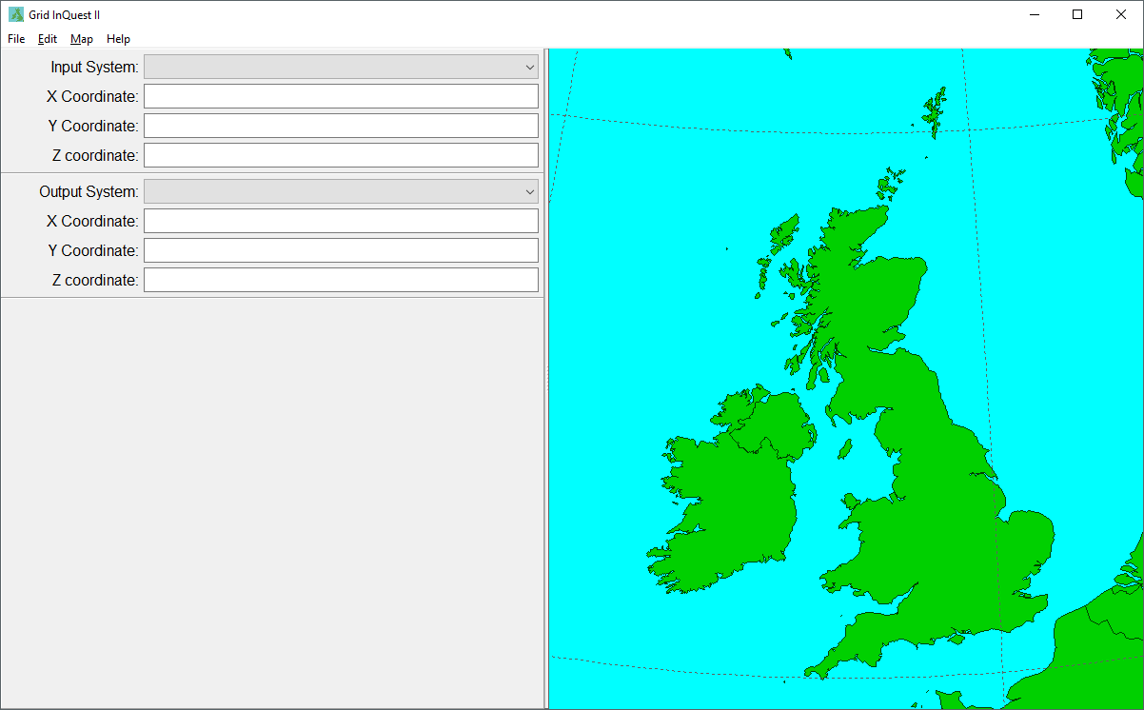Image 1: Grid InQuest II Application

Installation
The application is available for download from the internet as a compressed archive file in zip format. There are individual archives for each of the supported operating systems:
- Microsoft Windows (32 bit Windows XP or later)
- Apple Macintosh OS X (32 bit Snow Leopard or later)
- Linux (32 and 64 bit with GTK2, tested on Ubuntu 12.04+)
Once downloaded, the zip file can be extracted to any folder. The only requirement is that the user has permission to execute programs from that location. The default folder name is GridInQuestII, but this is not essential. However, files within this folder must be kept together for the proper operation of the application, otherwise the program will not be able to perform the national coordinate system transformations.
On Windows there are no special considerations, beyond the permission requirement to execute programs. Grid InQuest II does not make any use of the Windows registry database, nor does it depend on any other software libraries or configuration files. If the software is being installed for the use of all users on a machine, the convention is to copy the GridInQuestII folder into the “Program Files” or the “Program Files (x86)” folders. A link to the application can then be added to the menu or desktop if desired.
On Macintosh systems, the zip archive contains an Apple disc image file (.dmg) this can be mounted to show the Grid InQuest II application. The application can be run directly from the disc image, or it can be installed by dragging it's icon from the image into the OS X Applications folder. Once copied there, the program will be available in the Launch Pad and the dmg and zip files may be safely deleted as they are no longer required.
Linux installation can be performed in three ways. The first two use downloadable zip files as with the Windows and Mac versions. This will only work for Intel CPU based systems and there are two versions of the archive, one for 32 bit systems and the second for 64 bit systems. In both cases the zip file is expanded to create the GridInQuestII folder that contains the application. This folder can be moved anywhere in the user's home folder. The user must grant execute permissions for the programs before they can be run. They should be able to run on any graphical desktop that can support the GTK2 library. Additional operating system packages may be needed depending upon the distribution being used. Ubuntu 12.04 and later will have these pre-installed and so it will run here without any further configuration. The last method of installation on Linux is to perform compilation from the source code. In this way it would be possible to support other platforms (such as the Arm based Raspberry Pi's). Instructions for this procedure are beyond the scope of this manual and should only be attempted by a sufficiently knowledgeable technician.

Getting Started
Once initialised, the Grid InQuest II application will open it's main window and start in interactive mode. In this mode the main window is split into two sections: the left being the interactive coordinate conversion interface and the right an interactive map of the globe that will pinpoint the coordinates the user has entered.
The application is primarily controlled from it's main menu located just below the application's title bar. The first item on this is the File menu. These commands are used in the file I/O mode when processing the contents of a text file except the last, the Exit command, which is used to quit Grid InQuest II. The second Item is the Edit menu. These commands mostly apply to the interactive mode, except for the Options command, which opens the application's global settings form. The Map menu gives commands for basic control over the map display. Lastly, the Help menu gives access to this manual if it can be found in the application's folder. It also contains the About box which displays the copyright details and other information about the application.
In addition to the Map menu commands the map display can be repositioned by dragging the mouse on the map and the zoom level can be adjusted with the mouse scroll wheel. Also note that many of the menu commands have keyboard short-cuts. These are displayed on the menu following the menu's name. For example, the About box has a short-cut of 'Ctrl+A'. This means that holding down the Control key and then pressing A will display the About box as well.

Interactive Coordinate Transformation
The interactive mode of the program is used to perform individual coordinate transformations. The input and output coordinate systems are arranged vertically on the left side of the program window allowing you to easily enter the values you wish to transform and immediately view the corresponding point within the target system.
The first step is to select the input coordinate system type from the drop down list of all the available coordinate systems. Once selected, the appropriate coordinate values may be entered into the coordinate text boxes. Note that the text labels will change to display the usual coordinate names for that system. It is not possible to enter values into the text boxes until an input system has been selected and if the system is changed the text boxes will be cleared.

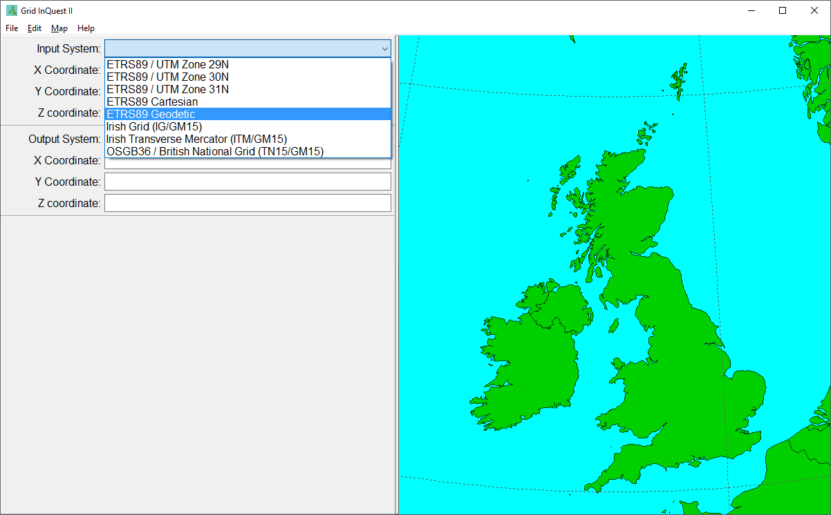Image 2: Selecting a Coordinate System
Coordinate values themselves can be entered as free text in a format that is appropriate to the type of coordinate system selected. For geodetic systems, this would be values of latitude and longitude in decimal or sexigesimal degrees and altitude in metres. Cartesian systems require X, Y and Z coordinates in decimal metres. All projected systems expect values of Eastings, Northings and Elevation in metres.
If a typed value cannot be recognised as valid input for that coordinate the text will be coloured red. Once the value entered is correct the text will turn black. Units do not need to be specified and are assumed for the different value types. Angles may be entered in decimal degrees; degrees and decimal minutes or degrees, minutes and decimal seconds. The program also understands +/-, N/S and E/W to indicate the sign of angle values. Geodetic and projected input systems may be used without entering the vertical component, in which case, it is assumed to be zero and is not displayed in the results.
Underneath the input system display, the output coordinate system can be selected from the output drop down list. This list is filtered to display only the systems which are valid outputs from the selected source system. The new output coordinates will be automatically converted once you have chosen the output system, provided all of the supplied input values are valid. The output values are displayed in blue to indicate that they are valid, but read-only. In addition, a red pinpoint marker will be displayed on the map to the right of the main window indicating the actual point location.
Finally, by using the Copy commands available on the Edit menu it is possible to transfer both the input and output values, as formatted on the display, to the operating system's clipboard. These values can then be pasted directly as text into other applications. The formatting of the output is controlled by the interactive settings available on the Options form as described below.

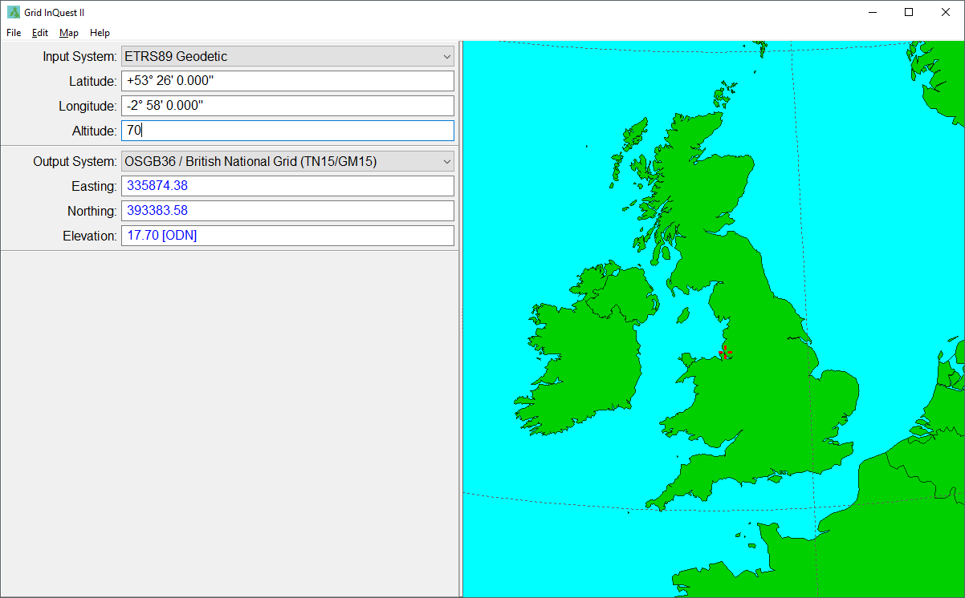Image 3: The Completed Transformation Display

Step-by-Step Example:

A reading from a GPS receiver (GPS values can be used as ETRS89 geodetic coordinates) is to be converted to the British National Grid. With the “Input System” drop down list, select ETRS89 Geodetic, then enter the Latitude, Longitude and Altitude taken from the GPS receiver. Grid InQuest II can accept most text formats commonly used for geodetic coordinates, and in this example the following values have been entered:

N 53 26 (North 53 degrees, 26 minutes)

-2 58 (West 2 degrees, 58 minutes)

70 (70 meters)

Next select “OSGB36 / British National Grid (TN15/GM15)” from the “Output System” drop down list since the point is within the UK mainland. It will automatically be converted into British National Grid eastings, northings and elevation:

335874.381m E

393383.579m N

17.70m [ODN]

The optional [ODN] suffix on the altitude only applies British National Grid coordinate values and indicates the vertical datum in use. In this case ODN stands for Ordnance Datum Newlyn, since this is the system used to express heights above sea level on the British mainland.

Changing Application Options
The various settings used to control the output formatting of Grid InQuest II can be changed on the Options form. This form is displayed by selecting 'Options' from the Edit menu. It is arranged into two tabbed sections, one for the interactive mode and one for the file output mode. These two sets of settings have identical values but govern the output of the two modes of operation of the application. This form is also where Irish users can set their preferred vertical datum for performing conversions to and from Irish projections.

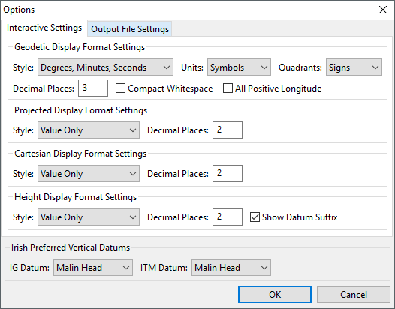Image 4: The Options Form

Using Output Settings
The settings are divided into sections that apply to the system's coordinate types. The first section controls the format of geodetic (angular) latitude and longitude type coordinates with the following values:

Style - Simple decimal or sexigesimal type numeric representation.
Units - If conventional symbols, letter suffixes or no units used.
Quadrants - Use of plus and minus or hemisphere letters to indicate signs.
Decimal Places - The number of decimal places displayed.
Compact Whitespace - Tick to remove the spacing between sexigesimal values.
All Positive Longitude - Tick to display longitudes in the range of 0-360°.

The second section controls projected (horizontal) eastings and northings type coordinates with the following values:

Style - Options for including axis suffix or prefix characters.
Decimal Places - The number of decimal places displayed.

The third section controls cartesian (three dimensional) X, Y and Z type coordinates with the following values:

Style - Options for including axis suffix or prefix characters.
Decimal Places - The number of decimal places displayed.

The fourth section controls height (vertical) Altitude or Elevation type coordinates with the following values:

Style - Option to including a unit suffix.
Decimal Places - The number of decimal places displayed.
Show Datum Suffix - Tick to add a datum abbreviation suffix in parenthesis.

Irish Border Vertical Datum Options
For the areas which are close to the border between Northern Ireland and the Irish Republic, it is possible to select the preferred Vertical Datum to be used to express height values. This can be selected independently for both the Irish Transverse Mercator (ITM) and the Irish Grid (IG) coordinate systems.

Transforming Text File Coordinates
In addition to the program's interactive mode, Grid InQuest II's is capable of performing bulk transformations on data points stored in standard text files. This is the application's file mode. The capacity of this method is only limited by the available free RAM on the host machine. This mode is engaged by opening a data file with the 'Load Data Points' command found on the File menu. Once a file is open, the interactive controls on the left side of the main window are replaced with a display grid containing the data from the loaded file.
Now that the program is in file mode additional items are enabled on the File Menu. The 'Data Settings' command enables the import settings to be adjusted. The 'Transform Data' command will perform the actual process once the settings have been set up properly. 'Save Data Points' enables the transformed data to be saved back to a file and the 'Unload Data Points' command will close the file data grid and return the system to interactive mode.

Loading Text Data Files
When using the load data command, the application will first show a standard open file dialogue box. This is used to select the text file containing the point data to be transformed. This presents a choice of three file extensions that can be selected. The first two suggest a particular type of text file: a CSV extension indicates it will have commas as the field delimiter; a TAB extension that it would use the tab character instead and a file with a TXT extension can contain any delimiter and potentially other formatting settings. Whatever the file extension used, opening the file will present the Data Settings form. Here the input settings can be adjusted if the default values do not suit the given file.

Data Settings
Grid InQuest II only accepts data files in text format. However, it is quite flexible regarding the exact layout that is used for the text. The settings can be adjusted to accommodate all of the most commonly used data arrangements. The main classification is achieved by selection from the 'File Format' list. The choice is between 'Character Delimited Text and 'Fixed Width Text'. Character delimited files use a special character to mark the split between successive data items, such as commas or tabs. The actual character used is selected from the 'Column Delimiter' list. There is also an option to treat two consecutive delimiters as one column break.
Fixed width data has the split between data items based on the count of characters from the beginning of each line. This requires that the items are exactly the same size in every row. This is usually achieved by padding the smaller values with space characters to make them the same length as the longest. The position of these splits is entered in the 'Fixed Column Breaks' text box as a comma separated list. Notice that the application will only allow the use of settings that are appropriated for the selected file format and will disable the other controls.

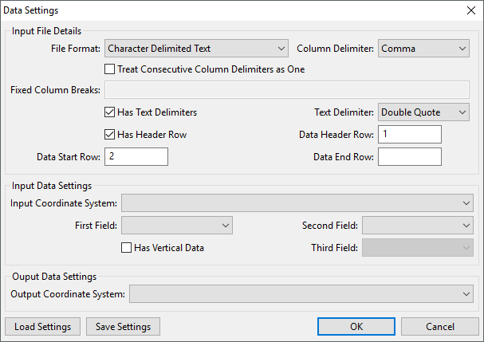Image 5: The File Data Settings Form

Other common text file settings can also be applied from this form. Selecting 'Has Text Delimiters' enables the text items to be enclosed between matching pairs of delimiter characters, usually double quotes. This is useful for handling text that may contain the field delimiter character itself. The 'Has Header Row' enables a particular row in the data (usually the first row) to contain column names for the data items. The 'Data Start Row' and 'Data End Row' boxes enable non-data lines at the start and end of the file to be skipped, if there are any.
Once the input file format settings have been selected, the input and output coordinate systems must be selected. This is very similar to selecting the systems in the interactive mode, with the addition that the columns containing the input data must be selected as well, so that the data processor knows which columns to inspect to find the input coordinate values. Note that the third dimension can be ignored for geodetic and projected coordinate systems if the height is unknown or of no interest in that case.
If a certain set of parameters need to be retained for future use, there is the option to save them as a settings file (SET file extension). They can then be loaded back into Grid InQuest II to quickly convert other similar files. There is no limit on the number of different settings files that can be created. They are stored in XML format and can be manually edited if needed. Settings files are also used by the command line tools to describe input text file formats and using the save settings option is the easiest way to create them. If the settings are not correctly selected during the data file loading, the 'Data Settings' command from the File menu can be used to re-open this dialogue box to make adjustments before actually performing the data transformation.

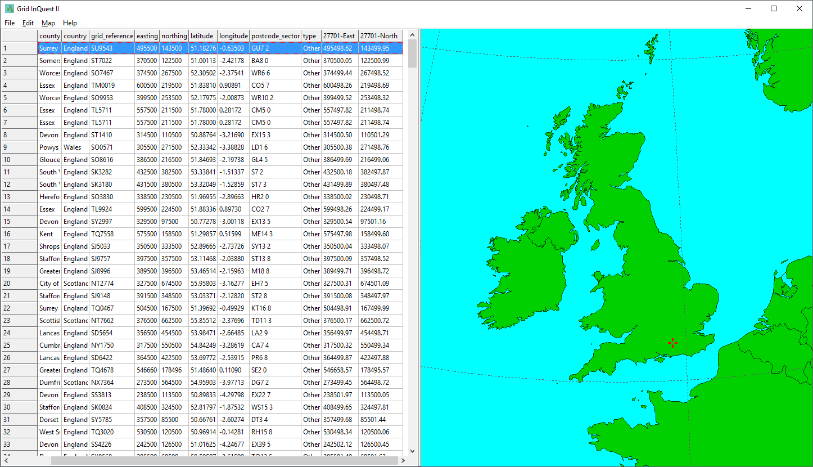Image 6: A Completed File Transformation

Performing the Data Transformation
If the settings are complete the 'Transform Data Points' menu command will be enabled. This will perform the actual transformation process. If the data file will take more than a second to complete, a progress box will be displayed for each stage of the process. Once completed, additional columns are added at the end of the table containing the new output coordinates for each row of the data. Selecting any of these rows will pinpoint the location on the overview map confirming that the transformation has worked.

Saving Data Files
If the data is to be used elsewhere, it may be saved back into a text file with the 'Save Data Points' command. These output files can easily be imported into other programs such as word processors or spreadsheets. They can even be converted into standard GIS files with applications such as QGIS or file conversion tools like Gdal.

Command Line Programs

Overview
Whilst Grid InQuest II is a relatively easy-to-use application, it is not the most efficient way of transforming data in large text files on a regular basis. This kind of task is better handled with simpler utilities that can be integrated with other management processes. For this purpose the project supplies two additional utilities. The first, GIQTrans, provides similar file processing capabilities to the desktop application, but without using a complex graphical display. The second utility is OSGMUpdate. This is used for the special case of generating new national coordinates (BNG, ITM, IG) for files containing coordinates created using the old 2002 OSGM/TN data models.
In addition to these two utilities there is, for FME users, a Point Transformer add-in that will enable FME to use the Grid InQuest II transformation library within an FME workflow for point type geometries.

GIQTrans Operation
GIQTrans is run from the command prompt with the following parameters:
giqtrans <SettingsFileName> <InputFileName> <OutputFileName> [Options]
The first three parameters are required, but the options are not always needed. The first parameter is the settings file name. This identifies the file that describes the structure of the input file, the input coordinate system and the required output coordinate systems. Settings files are discussed in detail in a separate section below. The next two parameters are the names of the input and output text files. The optional parameters may be any, or none, of the following:
--help or -h Display a summary of the available command parameters.
--list or -l List all available coordinate reference systems.
--protect or -p Prevent the output file from being over-written if it already exists.
--silent or -s Suppress all command line output during execution.

OSGMUpdate Operation
OSGMUpdate is designed to update existing vertical coordinates that use OSGM02 as their geoid model to OSGM15. It is almost identical in operation to using GIQTrans, the only practical difference being that the output coordinate system does not need to be supplied in the settings file as this is the same as the source. It can therefore only be used with coordinate systems that make use these geoid models. They are:
British National Grid
Irish Grid
Irish Transverse Mercator
For the result to be valid, the source coordinates must use the OSGM02 geoid model. If they are already in OSGM15, the program has no way of knowing and it will produce inaccurate output.

Settings File Format
The purpose of a settings file is to encapsulate a description of the input file format and the input and output coordinate systems. It is actually a text file that uses the XML data structuring convention. These file may be hand-coded by technicians who understand the layout of XML.
However, the simplest way to create a settings file is by saving one with the desired options from within the Grid InQuest II application. This can be achieved by loading the source file into GridInQuest II and then opening the 'Data Settings' form. From here the 'Save Settings' button will create a settings file containing the required XML for that data and also the selected input and output coordinate systems. Here is the contents of a sample settings file:

<?xml version="1.0" encoding="utf-8"?>
<Settings>
<InputSettings>
<Format Value="Delimited"/>
<FieldTerminator Value=","/>
<ConsecutiveDelimiters Value="False"/>
<TextDelimiter Value="&quot;"/>
<NameRow Value="1"/>
<FirstRow Value="2"/>
<SRIDNumber Value="4937"/>
<XColumn Value="3"/>
<YColumn Value="2"/>
<ZColumn Value="4"/>
</InputSettings>
<OutputSettings>
<SRIDNumber Value="29903"/>
<NameRow Value="1"/>
<IncludeDatum Value="True"/>
<PreferredDatum Value="14"/>
</OutputSettings>
</Settings>

The actual values within the XML are straight forward, except for the coordinate systems codes. They are identified by their European Petroleum Survey Group spatial reference identification (SRID) numbers, which for the currently supported systems are:
4936 ETRS89 Cartesian
4937 ETRS89 Geodetic
25829 ETRS89 / UTM Zone 29N
25830 ETRS89 / UTM Zone 30N
25831 ETRS89 / UTM Zone 31N
27700 OSGB36 / British National Grid
2157 Irish Transverse Mercator
29903 Irish Grid

FME Point Transformer
Installing the Grid InQuest II Point Re-projector Transformer first requires a fully working installation of FME Workbench for Windows on the target system. Then from the unzipped Grid InQuest II folder, copy the 'LibGIQ.dll' file and all of the files with a '.dat' extension to the FME transformers folder which is usually found here:
C:\apps\FME\transformers
Finally copy the 'GridInQuestIIPointReprojector.fmx' file from the 'Examples/FME' subfolder to the FME transformers folder as well. When FME is restarted, the new transformer will be installed in the Coordinate Systems category. Do not confuse this with the GridInQuestReprojector which is the transformer for the first version of GridInQuest that cannot perform OSTN15/OSGM15 based transformations.

Programming with Grid InQuest II

Introduction
The Grid InQuest II system can be reused in other programming environments in several ways. Firstly, the command-line tools can be called from operating system scripts; the utility GIQTrans can be used as a CGI binary and the LibGIQ project can be compiled as a dynamic link library for Windows, or a shareable object on POSIX based systems. Finally, as all of the Grid InQuest II software is fully open source, it is possible to directly change the programs, or even rebuild them for other currently unsupported operating systems. The source code is available for download from the internet in a separate archive file. To use this will also require a functioning Free Pascal compiler and the Lazarus IDE, available from here:
http://www.lazarus-ide.org

Operating System Scripts
The simplest type of programming task that can be performed with Grid InQuest II is to call the command line utilities from within an operating system script. These are batch files (.bat) on Windows or shell scripts (.sh) on Linux or Mac OS X. These scripts are simple text files containing commands as they would be typed in at the command line. They can also contain simple looping and conditional structures, so that, for example, a utility can be executed for every file in a folder that has a certain file type. The syntax for this varies between operating systems and will be documented by the OS supplier.
Grid InQuest II has several examples of this type of programming in the distribution archives. For Windows there are a couple of examples in the 'Examples/BatchFiles' folder showing simple usages of this method. There are also identical examples for Linux shell scripts in the 'Examples/ShellScripts' folder.

Web Server CGI Programming
In addition to it's file processing capability, GIQTrans also contains a Common Gateway Interface (CGI) which is automatically used when a valid parameter list is passed to the program. This enables it to be called as a URL resource from within any web server that supports CGI binary files, such as Apache.
A CGI command is called using the following syntax for any arbitrary number of parameters:
giqtrans?<param1>=<value1>&<param2>=<value2>&..&<paramN>=<valueN>
The input parameters can be supplied in any order and the 'PreferredDatum' is optional for non-Irish coordinate systems. The currently available input parameters are:
SourceSRID Input coordinate system's SRID number.
TargetSRID Output coordinate system's SRID number.
Geometry Input point geometry in GeoJSON format.
PreferredDatum Preferred Irish vertical datum code.

The result of this CGI request is the transformed point geometry in GeoJSON format with an additional attribute, 'datum', that contains the actual OSGM vertical datum used by the transformation when the output coordinate system uses one of the OSGM geoid models. Here is an example of a GeoJSON point for a UTM30N location in England. Note the datum value is zero, as UTM does not use an OSGM model:
{
"type": "Point",
"coordinates": [500000.0000, 5872270.5282, 100.0000],
"datum": 0
}

A returned datum code of zero is also used to indicate an out-of-area error for OSGM based results, in which case the coordinates array may be ignored as invalid.
There is a full example of using GIQTrans as a CGI binary in the 'Examples/Web' sub-folder. This creates a simple web page that uses an AJAX method to invoke the CGI command and process the result. To use this requires a functioning web server where the GIQTrans program, the DAT files and the supporting HTML and Javascript code can be uploaded.

LibGIQ Dynamic Link Library
Grid InQuest II comes with a pre-build Windows 32 bit dynamic link library supplied in the Win32 project archive. For other platforms, it is possible to produce a similar library file, but this would require building the LibGIQ project from source for that platform.
On Windows, to use the supplied DLL on a host system, the library and all of the DAT files must be stored in a folder accessible to that host environment. The DLL can be used with any programming language capable of interfacing with C libraries. Grid InQuest II comes with two examples of this usage, one with Python and one with Visual Basic in Microsoft Access. These examples are described in the following sections.
When using the Library interface it is important to realise that the programmer is completely responsible for ensuring that the input values to the transformation routine are valid. All coordinate systems are identified by their SRIDs as used in the settings files. OSGM vertical datums are identified by an index code as follows:
0 None (Out-of-Area)
1 Ordnance Datum Newlyn
2 St. Marys
3 Douglas (2)
4 Stornoway
5 St. Kilda
6 Lerwick
7 Newlyn
8 Fair Isle
9 Flannan Isles
10 North Rona
11 Sule Skerry
12 Foula
13 Malin Head
14 Belfast
15 Offshore

LibGIQ with Python
The first example uses the Python language's ctypes foreign function library to connect to the LibGIQ.dll with the following code:
# Load the LibGIQ dynamic library.
SourceFolder = os.path.dirname(__file__)
giqdll = WinDLL(os.path.join(SourceFolder, "LibGIQ.dll"))

This code forms the connection as long as the DLL and DAT files are in the same folder as the python program itself. The actual transformation call is defined as follows:
# Define the library coordinate structure.
class coordinates(Structure):
_fields_ = [("x", c_double),
("y", c_double),
("z", c_double)]

# Reference the library convert function.
convert = giqdll.ConvertCoordinates
convert.argtypes = [c_int, c_int, POINTER(coordinates),
POINTER(coordinates), POINTER(c_int)]
convert.restype = bool

The key thing to note here is the definition of the custom structure to contain the axis values of a coordinate point. Two are required, one to hold the source location and the second to receive the transformed result. The first two integer parameters are the source and output SRIDs for the required coordinate systems. The last integer parameter passes the preferred Irish vertical datum (when used with IG or ITM) and receives the actual vertical datum used by any of the OSGM based output coordinate systems.

LibGIQ with Visual Basic
Visual Basic contains a similar method to Python for interface with dynamic link libraries. The language contains a special Declare statement that enables DLL commands to be called from basic code. For LibGIQ the declare looks like this:
' LibGridInQuestII Coordinates record declaration.
Public Type Coordinates
X As Double
Y As Double
Z As Double
End Type

' LibGridInQuestII API declarations.
Declare Function ConvertCoordinates
Lib "LibGIQ.dll" (ByVal SourceSRID As Integer,
ByVal TargetSRID As Integer,
ByRef InputCoordinates As Coordinates,
ByRef OutputCoordinates As Coordinates,
ByRef Datum As Integer) As Boolean

As with Python, The Coordinates data structure must be defined to handle the input and output geometry values. The source and target coordinate systems are identified by SRIDs and the Datum parameter is used to pass a preferred datum for use with Irish coordinate systems. It is also updated on return with the actual vertical datum employed by the transformation, other wise it will be zero for out-of-area or not applicable.
Since the ConvertCoordinates function returns a Boolean value indicating success or failure it can be called within an 'If' statement to branch the code depending upon the outcome. Visual Basic code to perform the conversion in this way looks like this:
If ConvertCoordinates(SourceSRID, TargetSRID, InputCoordinates,
OutputCoordinates, OutputDatum) Then
MsgBox “Conversion OK”
Else
MsgBox “Conversion Failed”
End If

There is a fully worked example of using this method in the 'Examples/MSAccess' sub-folder.

Library Source Code Reuse
The source code to all of the Grid InQuest II applications, utilities and libraries is available for use under the terms of the GNU General Public License Version 2. This permits re-use of the code provided it's source is acknowledged.
All of the core software is written in Free Pascal and the main application uses the Lazarus Class Library to create the cross-platform user interface. It is possible to build this code for more platforms than are provided in the initial release of Grid InQuest II, but this could only be undertaken by an experienced Lazarus/Free Pascal programmer.
Since the Project's source code is highly modular, Pascal programmers are able to take out individual units and directly incorporate them into their own programs written in Free Pascal. Also, since Free Pascal can compile units in a format compatible with the GCC linker, it is also possible for a programmer with the necessary technical competences, to directly combine parts of this system with programs written in C or C++ that are compiled using the GCC compiler.

Technical Information

Overview
Grid InQuest II implements the most commonly used coordinate systems for representing location within Great Britain and Ireland. This section will describe these coordinate systems and the transformation methods used to convert to and from the national projection systems.

Grid InQuest II's Supported Coordinate Systems
This software is capable of bi-directional conversion between the following coordinate systems:
ETRS89 / UMT Zone 29N
ETRS89 / UMT Zone 30N
ETRS89 / UMT Zone 31N
ETRS89 Cartesian
ETRS89 Geodetic
Irish Grid (IG/GM02)
Irish Grid (IG/GM15)
Irish Transverse Mercator (ITM/GM02)
Irish Transverse Mercator (ITM/GM15)
OSGB36 / British National Grid (TN02/GM02)
OSGB36 / British National Grid (TN15/GM15)
In addition, depending on where the coordinates are located, it will convert between ETRS89 ellipsoidal heights and the following orthometric height datums when the conversion involves one of the national projected coordinate systems:

Ordnance Datum Newlyn [ODN]
St Mary's [MAR]
Douglas02 [DOU]
Stornoway [STO]
St Kilda [KIL]
Lerwick [LER]
Newlyn [NEW]
FairIsle [FAI]
Flannan Isles [FLA]
North Rona [NRO]
Sule Skerry [SSK]
Foula [FOU]
Malin Head [MAL]
Belfast [BEL]
Offshore [OFF]

NB: The conversions to Ordnance Survey local vertical datums are only valid for mainland Great Britain, Northern Ireland and the Republic of Ireland. However, for convenience, OSGM15 now incorporates an additional code, not available in OSGM02, to support approximate height values for locations offshore in British coastal waters. This is the purpose of the Offshore [OFF] datum code.

ETRS89 UTM Coordinates
The European Terrestrial Reference System 1989 can be projected using the Universal Transverse Mercator system into various zones of longitude. Three of these zones cover the British Isles and Ireland, Zones 29N, 30N and 31N. When working in Northern Ireland and the Republic of Ireland the only available zone will be 29N. Heights are ellipsoidal and refer to height above the GRS1980 ellipsoid.

ETRS89 Cartesian Coordinates
The European Terrestrial Reference System 1989 locations can be expressed as 3D Cartesian coordinates, where the individual axis values are expressed in metres from the origin, which is located at the Earth's centre of gravity. The Z axis is defined as passing through the Earth's rotational North pole. The X axis passes through the equator on the Greenwich Meridian and the Y axis is orthogonal to these.

ETRS89 Geodetic Coordinates
The European Terrestrial Reference System 1989 locations can be expressed in geodetic coordinates, where the latitude and longitude are given in degrees and the altitude as the height above the GRS1980 ellipsoid in metres.

Irish Grid Coordinates
This system is also a Transverse Mercator projection, but one using the Airy Modified ellipsoid which gives a closer fit to the actual figure of Earth for Ireland than that used for the ETRS89 UTM systems. It also has a central meridian positioned along the middle of the Irish landmass to minimize distortion. Vertical elevations are expressed with respect to the Malin Head datum for the Republic of Ireland and Belfast Lough for use within Northern Ireland. These elevations are now determined by an extension of the OSGM15 geoid model to cover the island of Ireland.

Irish Transverse Mercator Coordinates
The Irish Transverse Mercator projection is a new system, intended to supercede the Irish Grid as it's definition was directly based upon GPS compatibility. This makes it simpler to integrate with modern systems, whilst at the same time preserving many of the characteristics of Irish Grid that make it ideally suited for use within the island of Ireland. To avoid confusion with the older system though, the false origin has been moved further into the Atlantic so as to create substantially different co-ordinates for any given location. As with Irish Grid, the vertical datum in Northern Ireland is fixed to Belfast Lough and to Malin Head within the Republic. It also employs the OSGM15 geoid model to determine elevation values.

OSGB36 / British National Grid Coordinates
The British National Grid was originally defined through classical survey techniques but in 2002 a new definition was introduced that employed direct conversion from ETRS89 to OSGB36 coordinates called the National Transformation OSTN02. In 2015 this method was updated to improve the accuracy and the newer version OSTN15 now replaces OSTN02 as the definitive horizontal transformation for British National Grid. A similar method for determining height values relative to local sea level was also developed. This was known as the National Geoid Model OSGM02. This has similarly been replaced by a newer version in 2015 and this is known as the OSGM15.

British and Irish Transformation Systems
National transformations For Great Britain and Northern Ireland and the Republic of Ireland have been developed to facilitate accurate large scale mapping for each area. Within Great Britain, the National Transformation OSGM15 is used for horizontal positioning. For Northern Ireland and the Republic of Ireland, the OSi/OSNI polynomial transformation is required for horizontal positioning. For both areas the Geoid Model OSGM15 is used for vertical positioning. It should be noted that these transformations are not valid in the Channel Islands as they lie outside the extents of both the British National Grid and the National Geoid Model.

National Transformation Models: OSTN02 and OSTN15
The Ordnance Survey of Great Britain developed a horizontal transformation method in 2002 known as OSTN02. This transformation consists of a 1,250km by 700km grid of translation vectors at 1km resolution. These translations are applied directly to the ETRS89 projected coordinates. To achieve precise values for any location, the corner values for the 1Km grid square containing the position are interpolated. This provides a direct translation between the GPS coordinate system ETRS89 and the OSGB36 National Grid. In 2015, this system was updated to improve the current accuracy and the newer version OSTN15 now replaces OSTN02 as the definitive horizontal transformation for British National Grid.

OSi/OSNI Polynomial Transformation
Ordnance Survey Ireland and Ordnance Survey of Northern Ireland recommend the OSi/OSNI polynomial transformation for all horizontal transformations in the Republic of Ireland and Northern Ireland. This transformation has been developed in association with the Institute of Engineering Surveying and Space Geodesy, University of Nottingham. The transformation is based on 183 points evenly distributed throughout Ireland and Northern Ireland. The precise ETRS89 and Irish Grid coordinates of these points are determined by GPS and terrestrial survey methods, and a one-dimensional 3rd order polynomial individually fitted to the latitude and the longitude. The resulting polynomial allows calculation of the coordinate differences at additional points. The polynomial transformation has an accuracy of 0.4m (95% data).

Ordnance Survey Geoid Models: OSGM02 and OSGM15
To provide the third dimension for the two previous transformations, the Ordnance Surveys have, with others, developed the Geoid models OSGM02 and OSGM15. These models are derived from precise gravity surveys across UK, Ireland, and surrounding waters. Alignment to each regional vertical datum is based on precise GPS observations at Ordnance Survey levelling marks. Within Great Britain these include the Ordnance Survey fundamental benchmark network. The Geoid model consists of a 1km grid with geoid-ellipsoid separation values covering all of Great Britain, Ireland and Northern Ireland. This model can be used with GPS determined positions to establish height above mean sea level, as defined by the respective vertical datums. The Ordnance Surveys now recommend the use of the Geoid Model OSGM15 and the active GPS network to produce orthometric height compatible with national mapping systems. Within the Republic of Ireland and Northern Ireland, OSGM15 returns orthometric heights relative to the Malin Head and Belfast Lough datums respectively.

Transformation Accuracy
Within Great Britain, OSTN15 is the definitive OSGB36/ETRS89 transformation. OSTN15 in combination with the ETRS89 coordinates of the active GPS Network stations, rather than the fixed triangulation network, now define the National Grid. This means that, for example, the National Grid coordinates of an existing OSGB36 point, refixed using GPS from the National GPS Network and OSTN15, will be the correct ones. The original archived OSGB36 National Grid coordinates of the point (if different) will be wrong, by definition, but the two coordinates (new and archived) will agree on average to better than 0.1m standard error.
Within the Republic of Ireland and Northern Ireland, the OSi/OSNI polynomial transformation is recommended for coordinate transformations between ETRS89 and the Irish Grid. Transformed ETRS89 coordinates will agree with Irish Grid coordinates derived from traditional survey control to within 0.4m (95% data).
The heights output by precise GPS positioning in the ETRS89 coordinate system are geometric distance above the WGS84 (GRS80) reference ellipsoid. Note that GPS heights are typically two to three times less precise than horizontal positions. OSGM15 converts ETRS89 ellipsoidal heights to orthometric heights above mean sea level.
In mainland Great Britain, the datum (origin Point) representing mean sea level is Ordnance Datum Newlyn, defined at Newlyn Harbour in Cornwall. In the Republic of Ireland, Northern Ireland and the islands surrounding the British mainland, mean sea level is defined by specific independent vertical datums which are all incorporated into OSGM15 and hence OSGM15 is compatible with the products from each of the Ordnance Surveys. Other Geoid models may give mean sea level heights that are incompatible with the Ordnance Surveys products.
The estimated accuracies of OSGM15 for each regional vertical datum varies by region but are all less than 0.1m standard error and in the case of the British mainland 0.02m. Any discrepancy found between an Ordnance Survey levelled bench mark (OSBM) and a OSGM15 computed orthometric height is likely to be due to bench mark subsidence or uplift and, assuming precise GPS survey has been carefully carried out, the orthometric height given by OSGM15 should be considered correct in preference to archive bench mark heights.

GNU General Public License
Version 2, June 1991
Copyright (C) 1989, 1991 Free Software Foundation, Inc.
51 Franklin Street, Fifth Floor, Boston, MA 02110-1301, USA
Everyone is permitted to copy and distribute verbatim copies of this license document, but changing it is not allowed.

Preamble
The licenses for most software are designed to take away your freedom to share and change it. By contrast, the GNU General Public License is intended to guarantee your freedom to share and change free software--to make sure the software is free for all its users. This General Public License applies to most of the Free Software Foundation's software and to any other program whose authors commit to using it. (Some other Free Software Foundation software is covered by the GNU Lesser General Public License instead.) You can apply it to your programs, too.
When we speak of free software, we are referring to freedom, not price. Our General Public Licenses are designed to make sure that you have the freedom to distribute copies of free software (and charge for this service if you wish), that you receive source code or can get it if you want it, that you can change the software or use pieces of it in new free programs; and that you know you can do these things.
To protect your rights, we need to make restrictions that forbid anyone to deny you these rights or to ask you to surrender the rights. These restrictions translate to certain responsibilities for you if you distribute copies of the software, or if you modify it.
For example, if you distribute copies of such a program, whether gratis or for a fee, you must give the recipients all the rights that you have. You must make sure that they, too, receive or can get the source code. And you must show them these terms so they know their rights.
We protect your rights with two steps: (1) copyright the software, and (2) offer you this license which gives you legal permission to copy, distribute and/or modify the software.
Also, for each author's protection and ours, we want to make certain that everyone understands that there is no warranty for this free software. If the software is modified by someone else and passed on, we want its recipients to know that what they have is not the original, so that any problems introduced by others will not reflect on the original authors' reputations.
Finally, any free program is threatened constantly by software patents. We wish to avoid the danger that redistributors of a free program will individually obtain patent licenses, in effect making the program proprietary. To prevent this, we have made it clear that any patent must be licensed for everyone's free use or not licensed at all.
The precise terms and conditions for copying, distribution and modification follow.

Terms and Conditions for Copying, Distribution and Modification
0. This License applies to any program or other work which contains a notice placed by the copyright holder saying it may be distributed under the terms of this General Public License. The "Program", below, refers to any such program or work, and a "work based on the Program" means either the Program or any derivative work under copyright law: that is to say, a work containing the Program or a portion of it, either verbatim or with modifications and/or translated into another language. (Hereinafter, translation is included without limitation in the term "modification".) Each licensee is addressed as "you".
Activities other than copying, distribution and modification are not covered by this License; they are outside its scope. The act of running the Program is not restricted, and the output from the Program is covered only if its contents constitute a work based on the Program (independent of having been made by running the Program). Whether that is true depends on what the Program does.
1. You may copy and distribute verbatim copies of the Program's source code as you receive it, in any medium, provided that you conspicuously and appropriately publish on each copy an appropriate copyright notice and disclaimer of warranty; keep intact all the notices that refer to this License and to the absence of any warranty; and give any other recipients of the Program a copy of this License along with the Program.
You may charge a fee for the physical act of transferring a copy, and you may at your option offer warranty protection in exchange for a fee.
2. You may modify your copy or copies of the Program or any portion of it, thus forming a work based on the Program, and copy and distribute such modifications or work under the terms of Section 1 above, provided that you also meet all of these conditions:
a) You must cause the modified files to carry prominent notices stating that you changed the files and the date of any change.
b) You must cause any work that you distribute or publish, that in whole or in part contains or is derived from the Program or any part thereof, to be licensed as a whole at no charge to all third parties under the terms of this License.
c) If the modified program normally reads commands interactively when run, you must cause it, when started running for such interactive use in the most ordinary way, to print or display an announcement including an appropriate copyright notice and a notice that there is no warranty (or else, saying that you provide a warranty) and that users may redistribute the program under these conditions, and telling the user how to view a copy of this License. (Exception: if the Program itself is interactive but does not normally print such an announcement, your work based on the Program is not required to print an announcement.)
These requirements apply to the modified work as a whole. If identifiable sections of that work are not derived from the Program, and can be reasonably considered independent and separate works in themselves, then this License, and its terms, do not apply to those sections when you distribute them as separate works. But when you distribute the same sections as part of a whole which is a work based on the Program, the distribution of the whole must be on the terms of this License, whose permissions for other licensees extend to the entire whole, and thus to each and every part regardless of who wrote it.
Thus, it is not the intent of this section to claim rights or contest your rights to work written entirely by you; rather, the intent is to exercise the right to control the distribution of derivative or collective works based on the Program.
In addition, mere aggregation of another work not based on the Program with the Program (or with a work based on the Program) on a volume of a storage or distribution medium does not bring the other work under the scope of this License.
3. You may copy and distribute the Program (or a work based on it, under Section 2) in object code or executable form under the terms of Sections 1 and 2 above provided that you also do one of the following:
a) Accompany it with the complete corresponding machine-readable source code, which must be distributed under the terms of Sections 1 and 2 above on a medium customarily used for software interchange; or,
b) Accompany it with a written offer, valid for at least three years, to give any third party, for a charge no more than your cost of physically performing source distribution, a complete machine-readable copy of the corresponding source code, to be distributed under the terms of Sections 1 and 2 above on a medium customarily used for software interchange; or,
c) Accompany it with the information you received as to the offer to distribute corresponding source code. (This alternative is allowed only for noncommercial distribution and only if you received the program in object code or executable form with such an offer, in accord with Subsection b above.)
The source code for a work means the preferred form of the work for making modifications to it. For an executable work, complete source code means all the source code for all modules it contains, plus any associated interface definition files, plus the scripts used to control compilation and installation of the executable. However, as a special exception, the source code distributed need not include anything that is normally distributed (in either source or binary form) with the major components (compiler, kernel, and so on) of the operating system on which the executable runs, unless that component itself accompanies the executable.
If distribution of executable or object code is made by offering access to copy from a designated place, then offering equivalent access to copy the source code from the same place counts as distribution of the source code, even though third parties are not compelled to copy the source along with the object code.
4. You may not copy, modify, sublicense, or distribute the Program except as expressly provided under this License. Any attempt otherwise to copy, modify, sublicense or distribute the Program is void, and will automatically terminate your rights under this License. However, parties who have received copies, or rights, from you under this License will not have their licenses terminated so long as such parties remain in full compliance.
5. You are not required to accept this License, since you have not signed it. However, nothing else grants you permission to modify or distribute the Program or its derivative works. These actions are prohibited by law if you do not accept this License. Therefore, by modifying or distributing the Program (or any work based on the Program), you indicate your acceptance of this License to do so, and all its terms and conditions for copying, distributing or modifying the Program or works based on it.
6. Each time you redistribute the Program (or any work based on the Program), the recipient automatically receives a license from the original licensor to copy, distribute or modify the Program subject to these terms and conditions. You may not impose any further restrictions on the recipients' exercise of the rights granted herein. You are not responsible for enforcing compliance by third parties to this License.
7. If, as a consequence of a court judgment or allegation of patent infringement or for any other reason (not limited to patent issues), conditions are imposed on you (whether by court order, agreement or otherwise) that contradict the conditions of this License, they do not excuse you from the conditions of this License. If you cannot distribute so as to satisfy simultaneously your obligations under this License and any other pertinent obligations, then as a consequence you may not distribute the Program at all. For example, if a patent license would not permit royalty-free redistribution of the Program by all those who receive copies directly or indirectly through you, then the only way you could satisfy both it and this License would be to refrain entirely from distribution of the Program.
If any portion of this section is held invalid or unenforceable under any particular circumstance, the balance of the section is intended to apply and the section as a whole is intended to apply in other circumstances.
It is not the purpose of this section to induce you to infringe any patents or other property right claims or to contest validity of any such claims; this section has the sole purpose of protecting the integrity of the free software distribution system, which is implemented by public license practices. Many people have made generous contributions to the wide range of software distributed through that system in reliance on consistent application of that system; it is up to the author/donor to decide if he or she is willing to distribute software through any other system and a licensee cannot impose that choice.
This section is intended to make thoroughly clear what is believed to be a consequence of the rest of this License.
8. If the distribution and/or use of the Program is restricted in certain countries either by patents or by copyrighted interfaces, the original copyright holder who places the Program under this License may add an explicit geographical distribution limitation excluding those countries, so that distribution is permitted only in or among countries not thus excluded. In such case, this License incorporates the limitation as if written in the body of this License.
9. The Free Software Foundation may publish revised and/or new versions of the General Public License from time to time. Such new versions will be similar in spirit to the present version, but may differ in detail to address new problems or concerns.
Each version is given a distinguishing version number. If the Program specifies a version number of this License which applies to it and "any later version", you have the option of following the terms and conditions either of that version or of any later version published by the Free Software Foundation. If the Program does not specify a version number of this License, you may choose any version ever published by the Free Software Foundation.
10. If you wish to incorporate parts of the Program into other free programs whose distribution conditions are different, write to the author to ask for permission. For software which is copyrighted by the Free Software Foundation, write to the Free Software Foundation; we sometimes make exceptions for this. Our decision will be guided by the two goals of preserving the free status of all derivatives of our free software and of promoting the sharing and reuse of software generally.
NO WARRANTY
11. BECAUSE THE PROGRAM IS LICENSED FREE OF CHARGE, THERE IS NO WARRANTY FOR THE PROGRAM, TO THE EXTENT PERMITTED BY APPLICABLE LAW. EXCEPT WHEN OTHERWISE STATED IN WRITING THE COPYRIGHT HOLDERS AND/OR OTHER PARTIES PROVIDE THE PROGRAM "AS IS" WITHOUT WARRANTY OF ANY KIND, EITHER EXPRESSED OR IMPLIED, INCLUDING, BUT NOT LIMITED TO, THE IMPLIED WARRANTIES OF MERCHANTABILITY AND FITNESS FOR A PARTICULAR PURPOSE. THE ENTIRE RISK AS TO THE QUALITY AND PERFORMANCE OF THE PROGRAM IS WITH YOU. SHOULD THE PROGRAM PROVE DEFECTIVE, YOU ASSUME THE COST OF ALL NECESSARY SERVICING, REPAIR OR CORRECTION.
12. IN NO EVENT UNLESS REQUIRED BY APPLICABLE LAW OR AGREED TO IN WRITING WILL ANY COPYRIGHT HOLDER, OR ANY OTHER PARTY WHO MAY MODIFY AND/OR REDISTRIBUTE THE PROGRAM AS PERMITTED ABOVE, BE LIABLE TO YOU FOR DAMAGES, INCLUDING ANY GENERAL, SPECIAL, INCIDENTAL OR CONSEQUENTIAL DAMAGES ARISING OUT OF THE USE OR INABILITY TO USE THE PROGRAM (INCLUDING BUT NOT LIMITED TO LOSS OF DATA OR DATA BEING RENDERED INACCURATE OR LOSSES SUSTAINED BY YOU OR THIRD PARTIES OR A FAILURE OF THE PROGRAM TO OPERATE WITH ANY OTHER PROGRAMS), EVEN IF SUCH HOLDER OR OTHER PARTY HAS BEEN ADVISED OF THE POSSIBILITY OF SUCH DAMAGES.

Glossary

A

Accuracy:
The degree of closeness or conformity of an observation to its true value.

D

Datum:
The survey reference system used in a specific country or region. All geographical coordinates will be referenced to a chosen datum. Two principle datum types exist, namely global datums and astrogeodetic datums. A datum is created when a reference spheroid is tied to the earth at a particular point and coordinates are defined for that point. See spheroid, WGS84

E

Ellipsoid:
A closed quadric surface that is a three-dimensional analogue of an ellipse. Often used in geodesy as an alias for spheroid.
(See Spheroid)

ETRS89:
The European Terrestrial Reference System 1989, used as the standard precise GPS coordinate system throughout Europe. In 2000, the difference between the WGS84 and ETRS89 coordinates was about 25 cm, and increasing by about 2.5 cm per year. ETRS89 has been officially adopted as a standard coordinate system for precise GPS surveying by most national mapping agencies in Europe.

G

Geoid:
A model of the level surface which is closest to MSL over the oceans. This surface is continued under the land and acts as the fundamental reference surface for height measurement, as an approximation of MSL on land.

GPS:
Global Positioning System. A satellite based navigation system which in the last five years has become the industry standard survey tool for positioning and navigation.

I

IG:
Irish Grid - The standard two-dimesional grid reference for Irish coordinates. Divided into 25 squares (each measuring 100 square kilometres) they are all represented by letters in alphabetical order excluding 'I'. The letters A, E, P, K, U, Y and Z do not cover any landmass in Ireland.

ITM:
Irish Transverse Mercator - The geographic coordinate system for Ireland. It was implemented jointly by the Ordnance Survey Ireland (OSI) and the Ordnance Survey of Northern Ireland (OSNI) in 2001. The name is derived from the Transverse Mercator projection it uses and the fact that it is optimised for the island of Ireland.

N

National Grid:
The primary coordinate system used in Great Britain.
(See OSGB36)

O

ODN:
Ordnance Datum Newlyn is the national standard vertical reference system for measuring height above MSL in GB. ODN is measured relative to a value taken at Newlyn, Cornwall.

Orthometric height:
Height above mean sea level

OSGB36:
The national standard coordinate system for topographic mapping, including all Ordnance Survey mapping, and for geographically referencing many kinds of information in relation to Ordnance Survey mapping.

OSGM02:
Ordnance Survey National Geoid Model 2002. A gravimetric model used to convert from ETRS89 to ODN heights.

OSGM15:
Ordnance Survey National Geoid Model 2015. A gravimetric model used to convert from ETRS89 to ODN heights.

OSTN02:
Ordnance Survey National Grid Transformation 2002. A horizontal transformation converting from ETRS89 to OSGB36 coordinates and vice versa.

OSTN15:
Ordnance Survey National Grid Transformation 2015. A horizontal transformation converting from ETRS89 to OSGB36 coordinates and vice versa.

P

Precision:
The degree of repeatability or closeness that repeated measurements of the same quantity display. Precision is used to describe the quality of data with respect to random errors. Measurements that are closely grouped are said to have a high precision because their random errors are small.

S

Spheroid:
A mathematical figure used to closely model the geoidal surface of the earth. The figure is described by the semi-major axis (a), semi-minor axis (b) and inverse flattening. Many spheroids are used to describe the figure of the geoid on different parts of the earth. The spheroid will be intrinsically tied to the geodetic datum and once a datum is used in a particular country or region it is unlikely to be changed.

T

Transformation:
A procedure to change from one coordinate system to another. GridInquest II's primary function.

U

UTM:
Universal Transverse Mercator. Special case of the Transverse Mercator projection where by the earth is divided into 60, 6 degree zones. All the zones have identical characteristics with the exception of their central meridians which increase by a factor of 6 degrees between adjacent zones. UTM projections are used extensively in oil exploration and particularly favoured for their ease of use. One down side is that they are not preferable when mapping large extents in an east-west direction.

W

WGS84:
The spheroid and datum used to model the geoidal surface for the entire globe. It has been the principle datum for GPS since January 1987.

