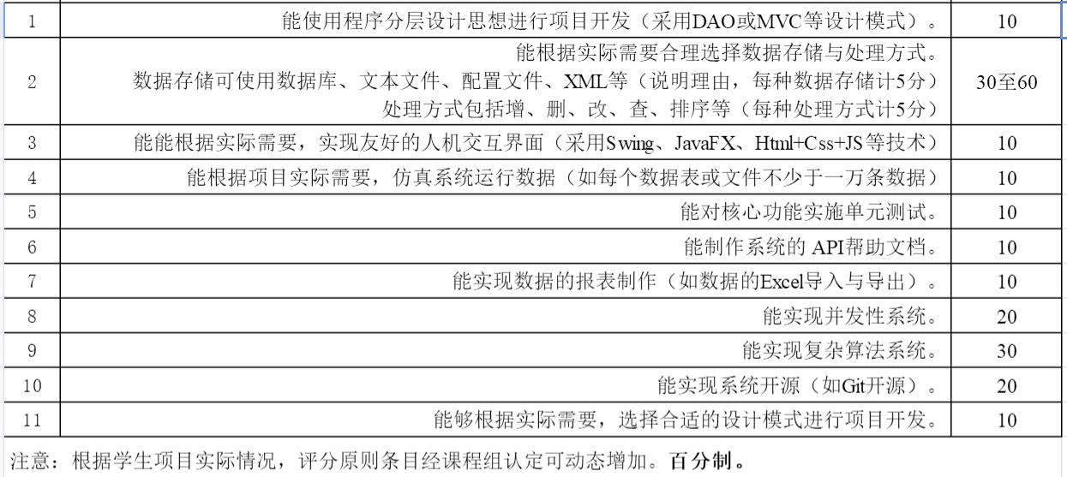

10 35 10 10 10 0 0 0 0 0 10