FS.1 Importance scores of the 46 signaling pathways in 1st split of testing dataset of the 5-fold cross-validation.

FS.2 Importance scores of the 46 signaling pathways in 2nd split of testing dataset of the 5-fold cross-validation.

FS.3 Importance scores of the 46 signaling pathways in 3rd split of testing dataset of the 5-fold cross-validation.

FS.4 Importance scores of the 46 signaling pathways in 4th split of testing dataset of the 5-fold cross-validation.

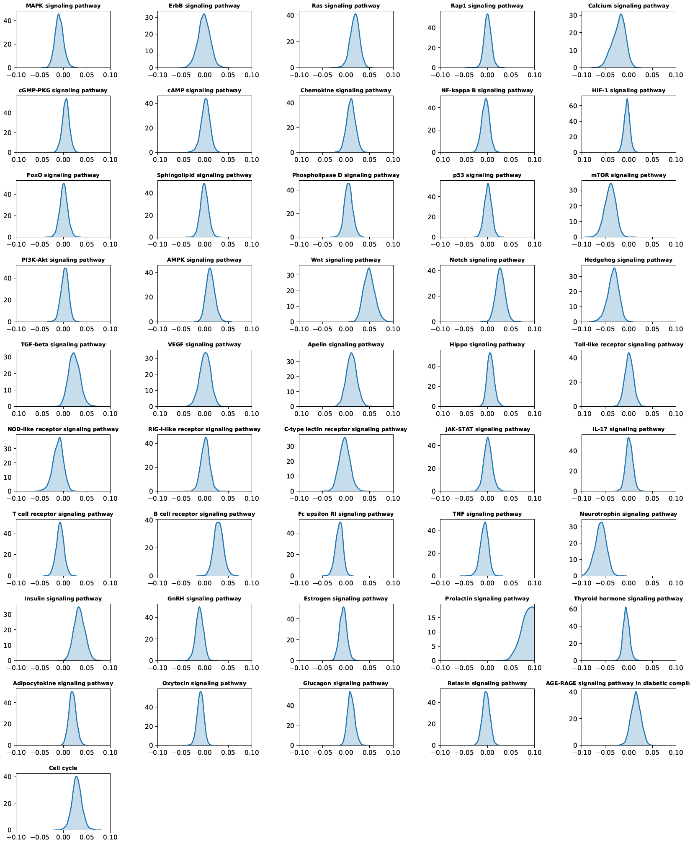

FS.5 Importance scores of the 46 signaling pathways in 5th split of testing dataset of the 5-fold cross-validation.

