The goal of this project was to show the difference between using a 3x3 window and 7x7 window in local histogram equalization and also to show the difference between the local histogram equalization and what the image looks like using the InClass2 histeq function. The image below on the left shows what the local histogram equalization results were when m and n were equal to 3, and the image on the right shows how it looks when m and n were equal to 7. As seen in the images, the results of both of the local histogram equalizations look the same. Either the results were supposed to look the same, or there might have been some errors in my code, but my results were the same for the 3x3 and 7x7 windows.

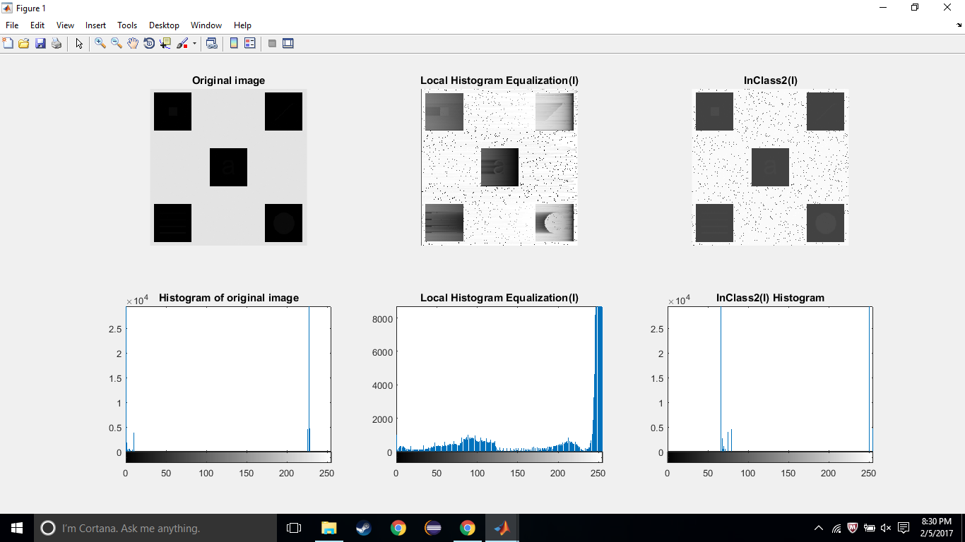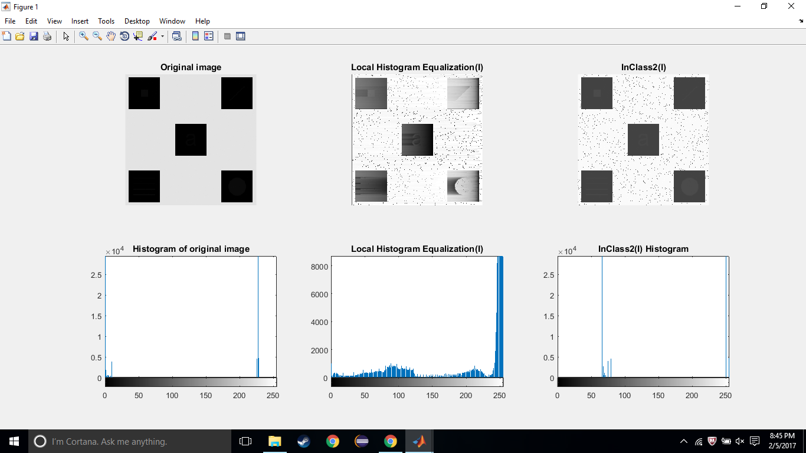

The second goal of this project was to show the differences in the image when using the InClass2 function and the local histogram equalization. In the local histogram image it is very noticeable that there are different objects hidden in the squares and the values in the histogram are a lot more spread out than the values in the histogram of the global histogram image(function InClass2). 

Below is a larger image of a side by side comparison of the same image used in the two different functions. A similarity that both images have is the black dots throughout the white space in the image. Both images also show what is hidden in the boxes. The difference is that the only things seen in the InClass2 image are the general shapes in the boxes, but in the Project1 image you can see the shading of the colors that can not be seen in the InClass2 image.

To summarize, the local histogram equalization allowed us to see a much more enhanced version of what was in the squares. The global histogram equalization revealed that there were some things such as a letter, or shape in the squares, but the local histogram equalization showed the images more clearly and allowed us to see the stripes behind the letter a as well as the shading beside the letter and shapes. The histograms of the two images are a lot different as well. In the Project1 histogram the values are spread throughout, but the Inclass2 histogram only shows the values in a few places.