**Offense Management System**

# CHAPTER I

# INTRODUCTION

* 1. **BACKGROUND OF THE STUDY**

One of the main function of the Disciplinary office of Ateneo De Zamboanga, Office for student services (OSS) for senior high, Office of student affairs (OSA) for college and Office for prefect of discipline (OPD) for junior high and gradeschool, is to promulgate and/or enforce institutional and DepEd policies, rules and regulations. Policies establish rules and regulations to guide acceptable behavior and ensure that the school environment is safe for students, teachers and school staff. School policies also help create a productive learning environment. The Disciplinary office today conducts a specific method of issuing and recording of offenses on students who violates implemented school’s policies, after which for reasonable cases, disciplinary action is given to students to correct, not to punish, unacceptable behaviors. The office for student services issue offenses by report basis, these reports can be done by any school stakeholders whether would it be the administrators, teachers, staff members, students, parents and etc. Once verified a student’s offense can be classified as one of the three, minor offense, major offense, and serious offense. Currently to record an offense, Disciplinary offices make use of a book specifically for recording of these offenses. An authorized administrator would manually write down the student’s name, ID number, year level and section, with the offense done by the student. The record of offenses will be kept until it will be transferred to a Microsoft Excel software where it will be encoded one by one. For Disciplinary action, each offense committed by the student have an equivalent penalty sanctioned by the office depending on the gravity of the offense committed. Where only minor offense constitutes to a community service within or outside the institution’s campus. At the end of the semester for a student to be issued a clearance from the Disciplinary office, the student must have no unserved penalty and clear his/her records from the Disciplinary office.

**1.2. PROBLEM STATEMENT**

**1.2.1 No Backup storage for Records of offenses**

Records of offenses are stored in a local hard drive of the computer as a Microsoft Excel File. The Disciplinary offices of ADZU currently has no means of backing these files, and if ever cases such as corruption of files occur retrieving of the said file will be unattainable.

**1.2.2 Limited Accessibility of Records**

The records of offenses is only stored in a single computer of the office, therefore the accessibility of the file is only limited to the said computer, in order to share the files the office have several methods of sharing it such as Flash drives and such. This would possibly expose the files and be subjected to data privacy invasion. Since these files are confidential there is a need of secured accessing and managing.

**1.2.3 Difficulty in Recording Tardiness**

Tardiness is the most common violation of school policies. Students of Senior High School must be within the school complex at 7:50AM for the morning assembly and attending class fifteen (15) minutes at the start of the class is considered late and will be marked absent for the first subject in the morning. The same thing for the Junior High School and Grade School but instead of 7:50AM, JHS and GS student’s class will start at 7:30 in the morning. According to the office for student services of different departments of ADZU, the first day of the week or Monday has the most number of students who comes to the school late therefore recording the offense is a huge challenge. Recording of Tardiness in all departments is with the use of log books. The students are instructed to pass by the Disciplinary office and fill up the book with their information. With this method certain problems arises such as the fraudulence of their identity on the record or not writing their name due to the high number of students who are late and that the office cannot keep track and accommodate everyone. Tardiness is also tasked to be recorded by the beadle of a class and is to be surrendered to the Office for student services for recording. This also imposes the risk of fraudulence due to the relationship these students have.

**1.2.4 Difficulty in Recording Violations of Curfew Policy**

Students of the Senior High School department are only allowed within the complex of the Fr. Salvador campus before 6:30PM and student of the JHS and GS of the Tumaga campus before 6:00PM. Currently disciplinary offices has no any means of identifying students who are still in the campus therefore cannot fully give sanctions of this kind of offense.

**1.2.5 Difficulty in Recording Truancy**

A student who stays away from school without leave or explanation, once verified by the office will be sanctioned with a suspension as it is considered as a major offense against the school’s policies. In the SHS department even with the RFID and turnstile implemented, apprehending students who commits truancy is still a challenge since their only way of identifying this offense is through the display monitor where the gate security officer, upon the tap of the student will check whether or not the student is a SHS or not. The security guard will then report the case to the Disciplinary office and the student will be issued the offense after verification of violation. This method is too manual based of checking where it only relies on the attentiveness of the guard.

**1.3. CONCEPTUAL FRAMEWORK**

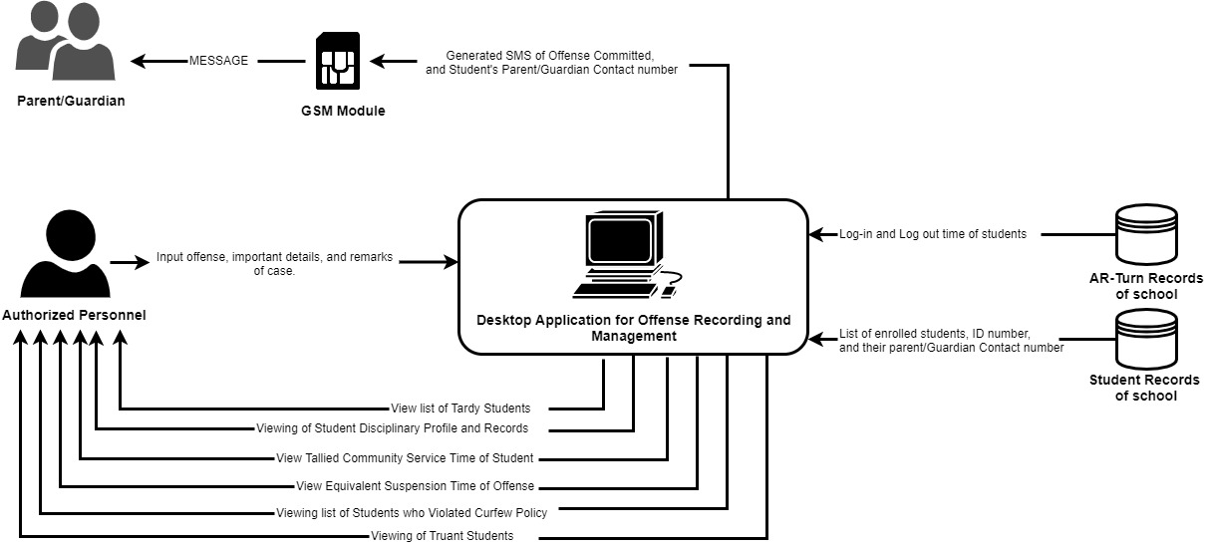

*Figure 1-1. General Concept of Offense Management System*

**1.3.1 Recording of School Offenses for ADZU Students.**

**-** When a student commits an offense that is stated in the Student handbook, there will be punishments according to the weight of the offense made. The school’s Disciplinary office is responsible in taking actions in this situations such as recording of cases and giving an equivalent disciplinary action to the student who committed an offense. Currently, all disciplinary offices of all department simply use a log book to record all committed offenses with a legend of what offense was done. The data will then be encoded in Excel by an authorized personnel. Students with unserved community service or committed a serious offense will not be cleared and therefore won’t be allowed to proceed to grade 12 or graduate senior high. The proposed system is to record committed offense without the need of log books and excel. The authorized personnel need only to input the Student’s Identification number, the offense done, and a remark. The proposed system would automatically record the data and generate the equivalent consequence of the student’s violation. The proposed system as well will notify the student’s parent/guardian of the act and be informed of the punishment that the student will be given.

**1.3.1.1 Tardiness Offense**

- All students are expected to be in their respective classroom by 7:50AM for SHS students, 7:30 for JHS and GS. Fifteen (15) minutes at the start of the class, all incoming students are considered Tardy. He/She should go directly to the Disciplinary office to present his/her Student Handbook inclusive of the OSS card for signature so that he/she can be admitted to attend the class. Tardiness is considered as a minor offense and each late is equivalent to 30 minutes of community service. Currently, to record this kind of offense a student must list their names, year and section, time, and signature, then the disciplinary offices will fill up their handbook with their signature. The proposed system is to incorporate a system within the RFID system so that when the student enters the school premises late, it will automatically record the student’s offense in a database, calculate the total community service time and notify the parents of the offense with the time of Log.

**1.3.1.2 Violation of Curfew Policy**

- Students are not allowed to stay within the premises of the Fr. Salvador Campus beyond 6:30PM for SHS students, and the Tumaga Campus beyond 6:00PM for JHS and GS students unless permitted by school authority, this is also one of the minor offense a student can be accounted for. The College department on the other hand does not have any curfew policy considering the varying schedules of college students. Disciplinary offices have no means of determining where or not there is a student within the campus beyond the curfew. The system proposed will give a notification to the Disciplinary office and Parent/Guardian of the student who have not yet exit the school after the curfew via the RFID turnstile that the School currently use.

**1.3.1.3 Truancy Offense**

Staying out of school without valid reason or leaving the school premises without permission from a school official, is called Truancy. Truancy is considered a serious offense by all ADZU departments. With the RFID live Server, the Offense Management System is capable of detecting students who exits the school premises unauthorized. For Senior High School Students of Grade 11, exiting school premises before 4:30 on (MWF) Monday. Wednesday, and Fridays will be considered truant. Junior high school and grade school students should only leave school premises on or after 4:00Pm unless authorized by the school. The College and grade 12 students of ADZU are allowed to leave the school complex at will and so are excluded from this violation.

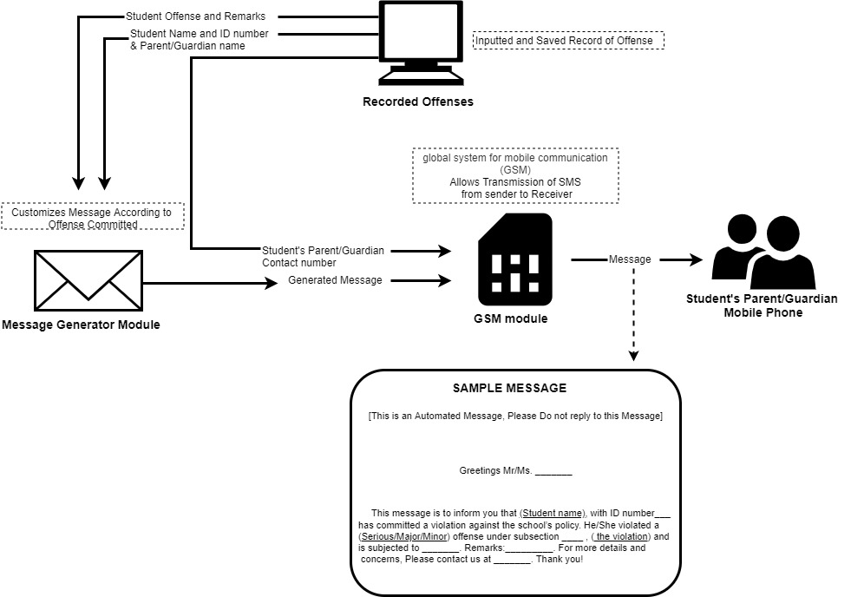

*Figure 1-2. SMS Notification for Parent/Guardian*

**1.3.2 Parent/Guardian Notification of Any Offense Committed**

the proposed system is to use a GSM module that is to be connected in a Computer to automatically send a generated SMS by the system. This is to notify the student’s parent/guardian of the committed offense of the student and to inform them the consequences to be given to the student. The concept of sending an SMS notification for Parent/Guardian is show in Figure 1-2.

**1.3.3 Calculation of Time for Community Service**

- Only minor offenses are subject to Community service, the length of time of service to be done by the student will depend on the number and kind of offense committed as well as the department the student is in. The proposed system will calculate the total time of community service required for the student depending on their recorded data from the database.

**1.4. OBJECTIVE**

**1.4.1. GENERAL OBJECTIVE**

**-** This study aims to develop a Desktop application to record and manage offenses committed by students of Ateneo De Zamboanga University.

**1.4.2. SPECIFIC OBJECTIVE**

**1.4.2.1-** to develop a module that will allow the user to input offense records of students.

**1.4.2.2** -to develop a module that will identify Tardy students for SHS, JHS & GS.

**1.4.2.3** -To develop a module that will detect violation of Curfew Policy.

**1.4.2.4** -To develop a module that will detect Truancies by students.

**1.4.2.5** -to develop a module that will send a notification to the Disciplinary ofice and parent/guardian of a student who committed an offense.

**1.4.2.6** –To develop a module that will allow user to search, filter, and view information of all recorded offenses.

**1.5. SCOPE AND LIMITATION**

The System will be limited and is specifically designed for Ateneo De Zamboanga University as they have their own unique school rules and regulations. The System will consider disciplinary offices of all school departments where this includes the College, Senior High, Junior High, and the Grade School department. The system can only be accessed by authorized ADZU personnel which Is the Director himself and his secretary as it contains confidential information of students. The Offense Management System will require an internet connection to store and access records online but will still be accessible by authorized personnel offline, and offline activities will be updated when an internet connection is reconnected.

The system will only automate the recording of RFID associated offenses, this includes Tardiness, Truancy, and Curfew violations. Recording of other offenses stipulated in the student’s handbook will be by inputting directly on the Desktop application of the system proposed. The Automated recording of RFID related offenses are dependent on the RFID live server/ AR-turn system, for which the server is down the automated recording of these RFID related offenses will also halt. The GSM module to be used for the system will require a SIM card and will operate and have limitations according to the mobile network operator chosen. (e.g network range, network signal, load balance, etc).

**1.6. SIGNIFICANCE OF THE STUDY**

The system is designed to replace the current tedious process of recording a student’s violation of any school’s rules and regulations. With the system, Ateneo’s disciplinary offices no longer need the use of log books and Excel to manually write and encode each offense that occurs, instead, the office will be able utilized the desktop application to directly input the student’s information and offense alongside with a remark in the system with graphical user interface to allow minimum effort from the user and achieve maximum productivity in recording. The system will also automate the recording of any RFID associated offenses. This will be of big help especially in apprehending students for offenses such as Tardiness, Truancy, and violations of the Curfew policy, the system would recognize these offenses with the factors of time and the student’s RFID logs after which the system will automatically record the violation. The system also offers an automated SMS sender to a registered parent/guardian contact of a student that commits an offense. This would allow the parent/guardian to have a quick notification of the offense committed.

---------------------------------------------------------------------------------------------------------------------