**“Offense Management System”**

**Dummy system concept.**

Desktop Application with four (4) users.

With username and passwords for authentication.

*For College Department’s Department of Student Affairs (DSA)

*For Senior high Department’s Office for Student Services (OSS)

*For Junior High Department’s Office for Prefect of Discipline (OPD)

*For Grade School Department’s Office for Prefect of Discipline (OPD)

**Features for College Department.**

* +ADD an offense record
* Input ID number, ex: (150561)
* Input Offense

Example list:

(1.1) for minor offense, inappropriate grooming.

(1.2) for minor offense, No ID

(2.1) for major offense, cutting classes

(3.1) for serious offense, Truancy

* Remarks
* View list of all Offenses for guidelines, ( follow the student handbook)
* Save added or recorded offense on a student profile,

(List of enrolled students will be taken from the school’s student records [database] )

* Generate a penalty for committed offense, follow the guidelines on the student’s handbook

Ex:

* 1 grooming attire offense = 30min community service
* 1 cutting classes= half day suspension
* 1 No ID= 1hr community service
* Truancy= subject to expulsion ( sanction will depend on the case and the director himself)
* View list of offenses committed by a specific student by inputting ID number, ex (150561)
* View total and pending penalties
* Allow user to edit/ reduce penalty upon serving of the student

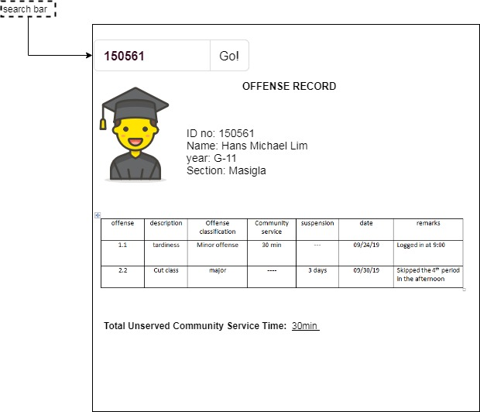

* Generate a message to be sent to parent/Guardian
* Name & Contact No., of parent/guardian will be taken from the Student records of the school
* Ex:

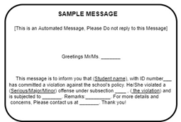

* Send this Generated msg to parent/guardian of the student using a GSM module to be connected to the PC.

**Features for Senior High School (SHS), JHS & GS**

* All with Similar Features with College but different Offense list, (follow handbook for guidelines)
* ***Automate recording of Tardiness ( this automation will be used by all departments except the college dept.)***
* (Future concept is to Connect system with the RFID live server of the school (AR-turn Records) turnstile )
* Detect Login time of student

EX:

Student logs in 8:15, which is late!

* Student must visit the Office to record offense of student
* Confirmed late student will automatically be recorded (TARDINESS) with -time of log in.
* Generate the equivalent community service.
* Send sms to parent/guardian
* ***Automate Recording of Curfew Violation***
* Detect log out time of student

EX:

Student fails to log out on curfew, 6PM for JHS & GS. 6:30 for SHS.

* System will automatically record the offense as curfew violation (e.g 1.3 for curfew violation) without the need of confirmation from the disciplinary office as the office closes at 4pm.
* Generate community service time
* Send sms to parent/guardian of the violation.
* **Create a feature for exempting a student from being recorded the said offense for cases of exemption**

***Automate Recording of Truancy***

* Detect log out time of student

EX:

Student logs out (unauthorized) before the dismissal time, before 4pm

* System will notify the office

|  |  |
| --- | --- |
| NOTIFICATION FOR TRUANCY | |
| ID number | Time of log out |
| 150561 | 3:00pm |

* System will automatically record the offense (e.g 3.1 for Truancy) without the need of confirmation from the disciplinary office.
* As a serious offense, penalty will be sanctioned by the director
* Send sms to parent/guardian of the violation.
* **Create a feature for exempting a student from being recorded the said offense for cases of exemption**