**chapter 3 diagrams**

1. 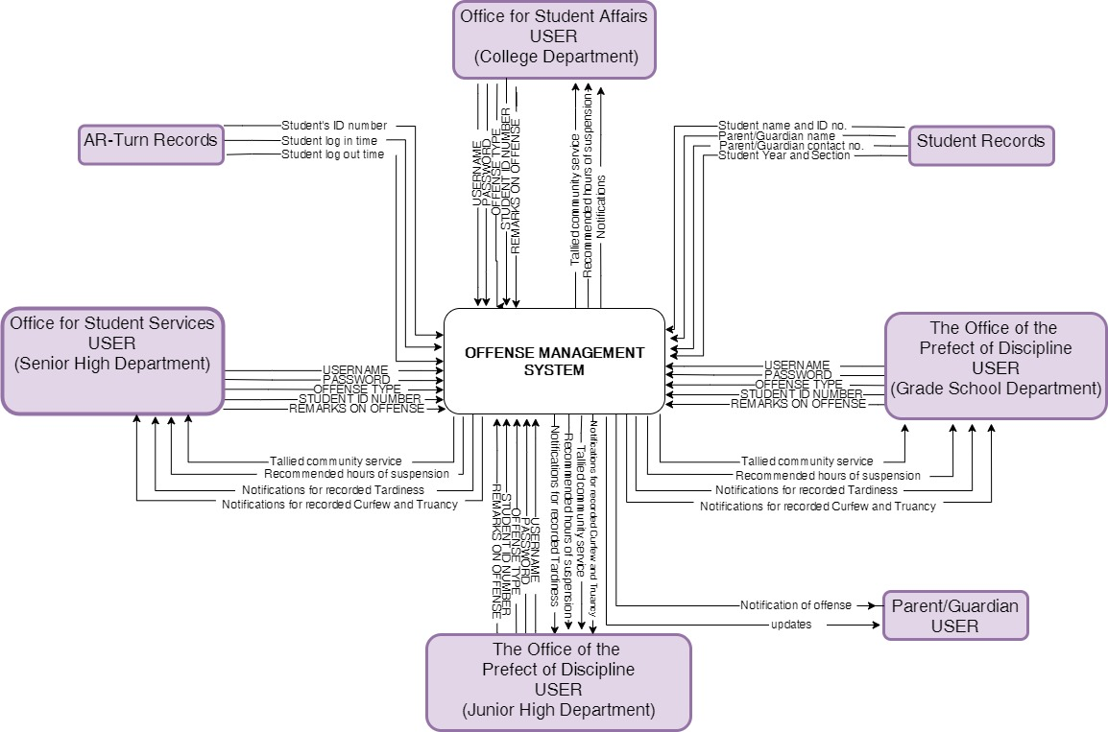**CONTEXT DATA FLOW DIAGRAM**

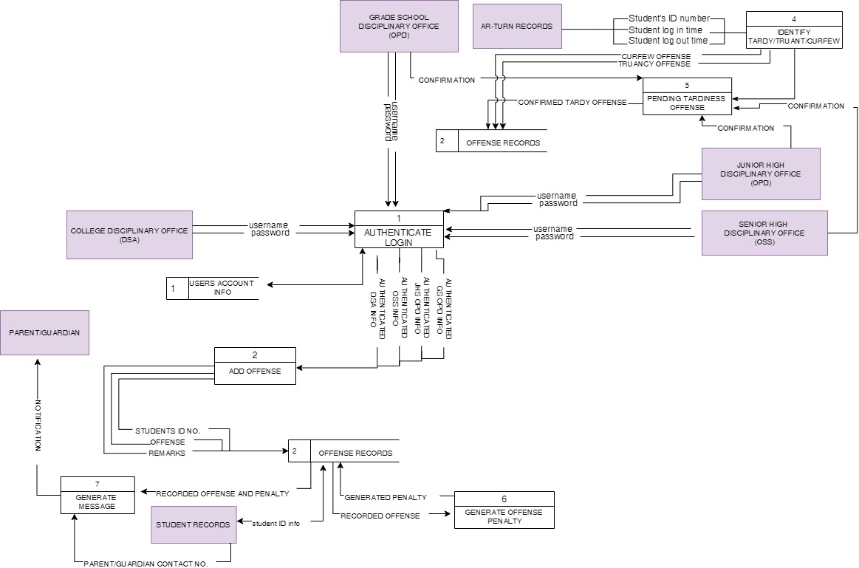**ii. DATA FLOW DIAGRAM (LEVEL 0)**

**iii. FLOW CHART**

1. **AUTHENTICATION**

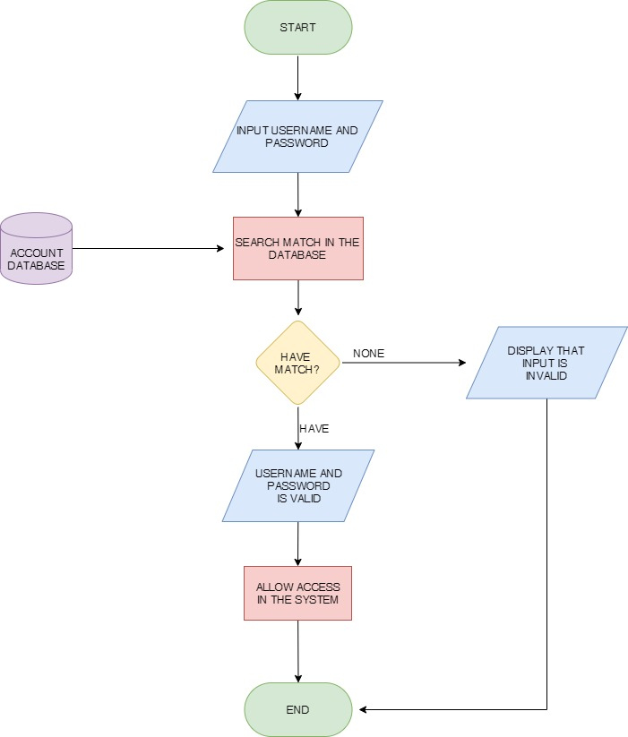

1. **INPUTTING OF OFFENSE**

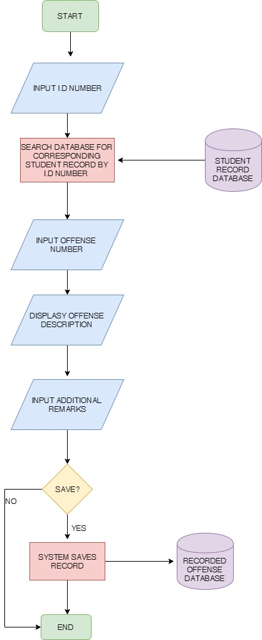

1. **IDENTIFICATION/RECORDING OF TARDINESS**

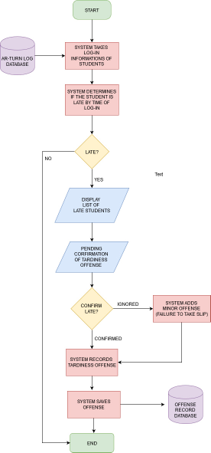

1. **IDENTIFICATION/RECORDING OF TRUANCY**

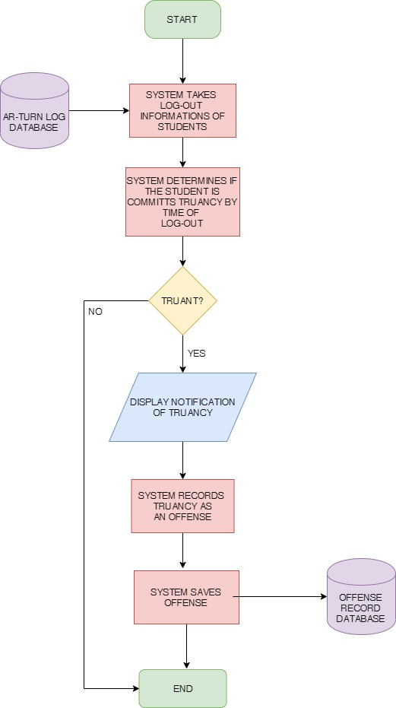

1. **IDENTIFICAION/RECORDING OF CURFEW VIOLATION**

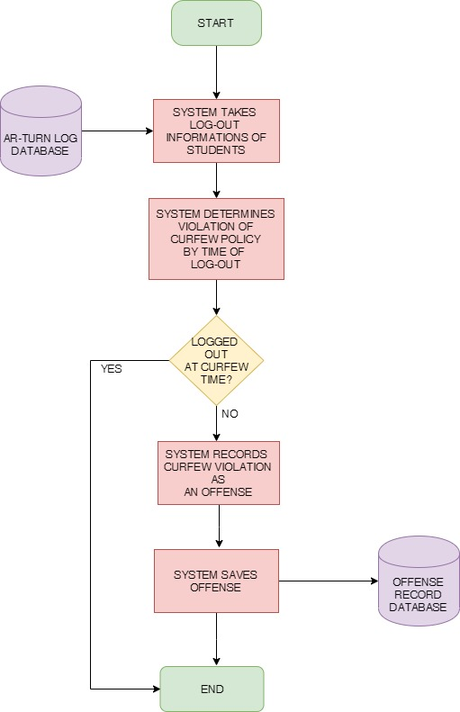

1. **GENERATION OF OFFENSE PENALTY**

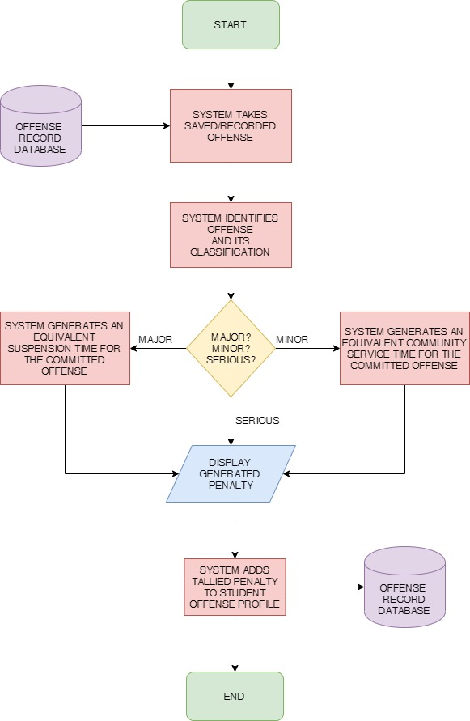

1. **AUTOMATIC SMS SENDING TO PARET/GUARDIAN**

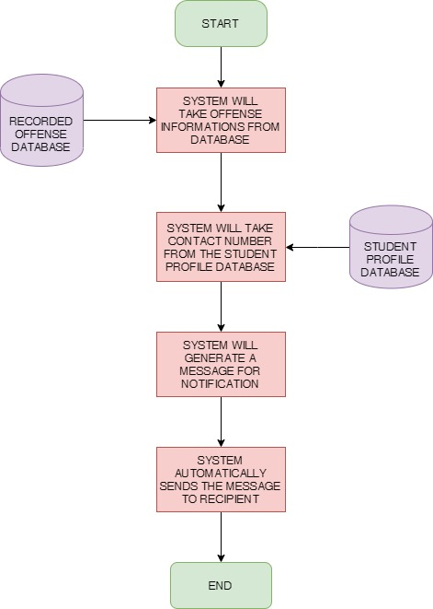

1. **VIEWING OF STUDENT PROFILE**

