ADD:

1. **Policy module** - for conditions of automatic offense recording. (dynamic).
2. Send SMS to Parent & **Student as well**

* Add student contact number on student records db

1. **Notify office/user** of student/s that has alarming counts of offenses and etc. The ff are:

Example:

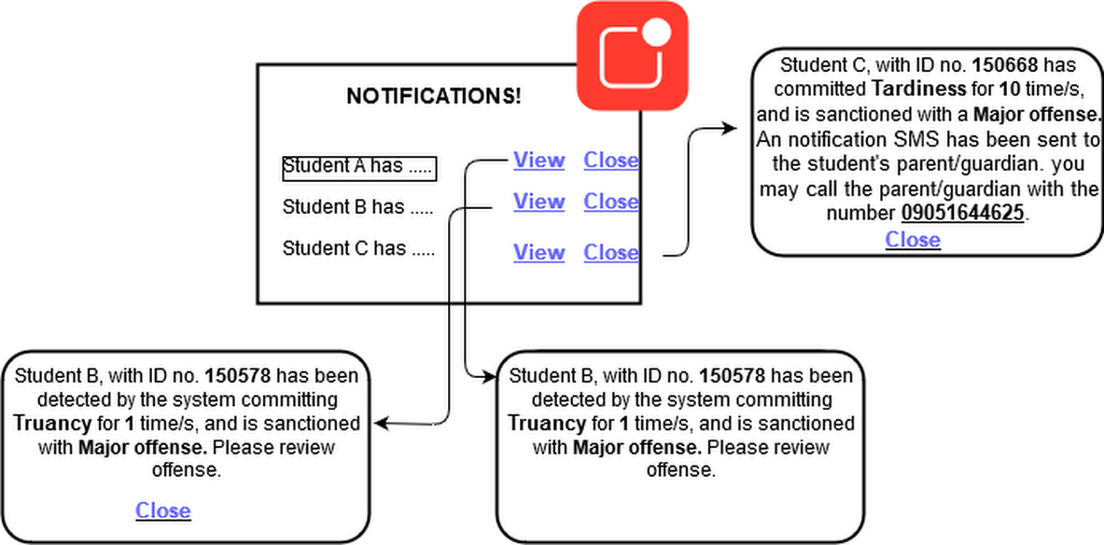

* For college department:
  + When student commits the same minor offense twice (notify of community service and what happens when student commits the same offense again)
  + When student commits the same minor offense thrice (notify of suspension and what happens when student commits the same offense again)
  + When student commits the same minor offense for the fourth time (notify major offense)
* For SHS:
  + When student commits the same minor offense for the 9th time ( notify user what happens when student commits the same offense again)
  + When student commits the same minor offense for the 10th time (notify for major offense equivalent)
  + When system detected curfew offense committed.
  + When system detected Truancy offense committed
* For JHS
  + When student commits the same minor offense for the 9th time ( notify user what happens when student commits the same offense again)
  + When student commits the same minor offense for the 10th time (notify for major offense equivalent)
  + When system detected curfew offense committed.
  + When system detected Truancy offense committed
* For GS
  + When student commits “Tardiness” offense for the 5th time ( notify user what happens when student commits the same offense again)
  + When student commits “Tardiness” offense for the 6th time (notify for major offense equivalent and ask user to review and give sanction student with community service or suspension)
  + When system detected curfew offense committed.
  + When system detected Truancy offense committed