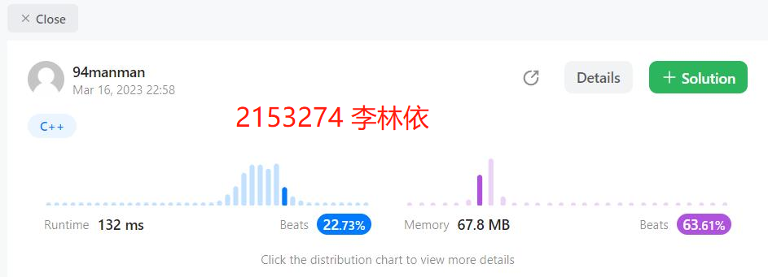

源代码如下：

struct Sum {

 int iSum;

 int lSum;

 int rSum;

 int mSum;

};

class Solution {

private:

 Sum summation(vector<int>& nums, int left, int right)

 {

  Sum sum;

  if (left == right) {

   sum.iSum = nums[left];

   sum.lSum = nums[left];

   sum.rSum = nums[left];

   sum.mSum = nums[left];

   return sum;

  }

  int medium = (left + right) / 2;

  Sum left_sum = summation(nums, left, medium);

  Sum right_sum = summation(nums, medium + 1, right);

  sum.iSum = left_sum.iSum + right_sum.iSum;

  sum.lSum = max(left_sum.lSum, left_sum.iSum + right_sum.lSum);

  sum.rSum = max(left_sum.rSum + right_sum.iSum, right_sum.rSum);

  sum.mSum = max(max(left_sum.mSum, right_sum.mSum), left_sum.rSum + right_sum.lSum);

  return sum;

 }

public:

 int maxSubArray(vector<int>& nums) {

  int left = 0;

  int right = nums.size() - 1;

  Sum sum = summation(nums, left, right);

  return sum.mSum;

 }

};