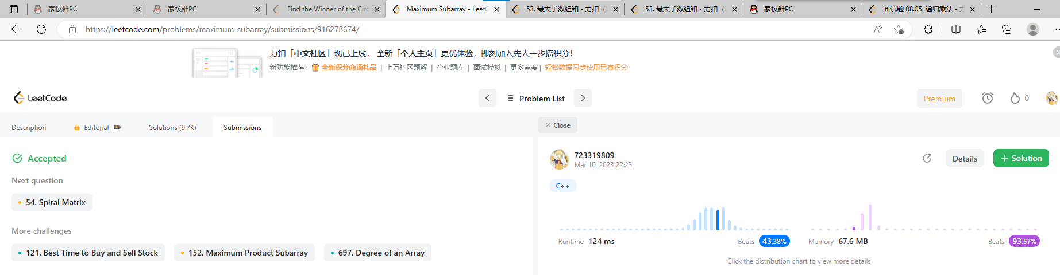

源代码如下：

#include<iostream>

2153067 王灏博

#include<vector>

using namespace std;

struct subSums {

    int lSum, rSum, mSum, iSum;

};

class Solution {

private:

    subSums update(subSums left,subSums right) {

        subSums res;

        res.iSum = left.iSum + right.iSum;

        res.lSum = max(left.lSum, left.iSum + right.lSum);

        res.rSum = max(right.rSum, right.iSum + left.rSum);

        res.mSum = max(max(left.mSum, right.mSum), left.rSum + right.lSum);

        return res;

    }

    subSums get(vector<int>& arr, const int left, const int right) {

        subSums res;

        if (left == right) {

            res.lSum = arr[left];

            res.rSum = arr[left];

            res.mSum = arr[left];

            res.iSum = arr[left];

            return res;

        }

        int mid = (left + right) / 2;

        subSums leftSub=get(arr, left, mid);

        subSums rightSub=get(arr, mid + 1, right);

        return update(leftSub,rightSub);

    }

public:

    int maxSubArray(vector<int>& nums) {

        int s = nums.size() - 1;

        subSums ans = get(nums, 0, s);

        return ans.mSum;

    }

};

int main()

{

    Solution test;

    vector<int>arr = { -2,1,-3,4,-1,2,1,-5,4 };

    cout << "The max sum of sub string is: " << test.maxSubArray(arr) << endl;

    return 0;

}