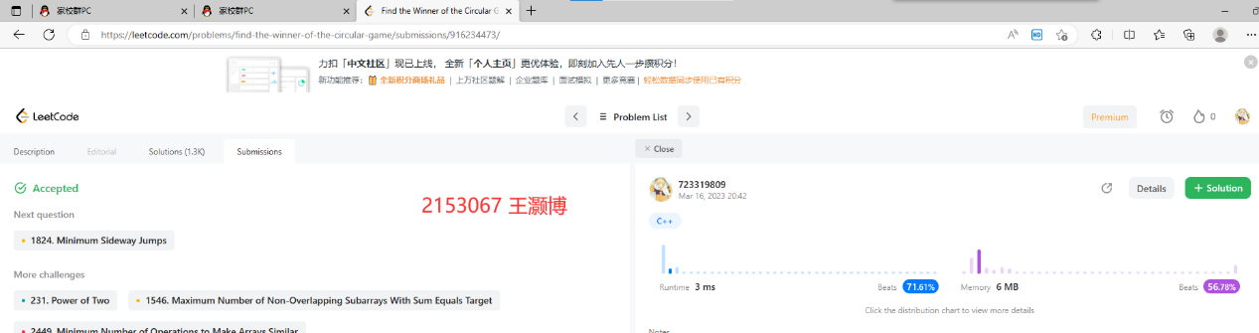

源代码如下：

#include<iostream>

#include<vector>

using namespace std;

class Solution {

private:

    int lastNumber(const int n,const int m) {

        if (n == 0)

            return 0;

        return (lastNumber(n - 1, m) + m) % n;

    }

public:

    int findTheLastFriend(const int n,const int m) {

        return lastNumber(n, m);

    }

};

int main()

{

    Solution test;

    int friendsNum = 10,

        friendsGap = 3;

    cout << "The last reamaining friend is: " << test.findTheLastFriend(friendsNum, friendsGap) << endl;

    return 0;

}