July 2021
Overview
FUJITSU Software
Cloud Monitoring Manager V2.0.14
Contents
About this Manual 2
1 What is CMM? 5
1.1 Key Features 6
1.2 Components 7
1.3 Users and Roles 8
1.4 Extensions and Add-Ons 9
2 Monitoring 11
3 Log Management 14
Glossary 17

About this Manual
This manual describes how service providers on OpenStack platforms can monitor their applications with FUJITSU Software Cloud Monitoring Manager - hereafter referred to as Cloud Monitoring Manager (CMM).
The manual is structured as follows:
Chapter | Description
What is CMM? | Introduces CMM, its key features, components, users, and possible add-ons.
Monitoring | Describes the basic concepts and features of monitoring.
Log Management | Describes the basic concepts and features of log management.
Glossary | Defines the central terms relevant for CMM.

Readers of this Manual
This manual is written for everybody interested in CMM. It offers an introduction for readers who do not know CMM and for those who have already started using it. The manual does not require any special knowledge.

Notational Conventions
This manual uses the following notational conventions:
Notation | Description
Add | Names of graphical user interface elements.
init | System names, for example command names and text that is entered from the keyboard.
<variable> | Variables for which values must be entered.
[option] | Optional items, for example optional command parameters.
one \| two | Alternative entries.
{one \| two} | Mandatory entries with alternatives.

Abbreviations
This manual uses the following abbreviations:
Abbreviation | Description
CMM | Cloud Monitoring Manager
IaaS | Infrastructure as a Service
ICMP | Internet Control Message Protocol
OS | Operating System
OSS | Open Source Software
PaaS | Platform as a Service
SaaS | Software as a Service

Available Documentation
The following documentation on CMM is available:
- Overview: A manual introducing CMM. It is written for everybody interested in CMM.
- System Operator’s Guide: A manual for system operators describing how to install, operate, and maintain CMM. The manual also describes how to prepare the OpenStack platform for CMM and how to use the CMM monitoring functions.
- Application Operator’s Guide: A manual for application operators describing how CMM supports them in monitoring their services and virtual machines in OpenStack.

Related Information
The following links provide information on open-source offerings integrated with CMM:
- OpenStack : Documentation on OpenStack, the underlying platform technology.
- OpenStack Horizon : Documentation on the OpenStack Horizon dashboard.
- Monasca : Information on Monasca, the core of CMM.
- Grafana : Documentation on Grafana, the open-source application used for visualizing metrics data.
- Kibana : Documentation on Kibana, the open-source application used for visualizing log data.
Links to more detailed information provided in this manual are subject to change without notice.

Trademarks
LINUX is a registered trademark of Linus Torvalds.
The OpenStack Word Mark and OpenStack logo are registered trademarks/service marks or trademarks/service marks of the OpenStack Foundation in the United States and other countries and are used with the OpenStack Foundation’s permission. FUJITSU LIMITED is not endorsed or sponsored by the OpenStack Foundation, or the OpenStack community.
Red Hat is a trademark or a registered trademark of Red Hat Inc. in the United States and other countries.
Java is a registered trademark of Oracle and/or its affiliates.
Python and PyCon are trademarks or registered trademarks of the Python Software Foundation.
Other company names and product names are trademarks or registered trademarks of their respective owners.

Copyright
Copyright FUJITSU ENABLING SOFTWARE TECHNOLOGY GMBH 2021
All rights reserved, including those of translation into other languages. No part of this manual may be reproduced in any form whatsoever without the written permission of FUJITSU ENABLING SOFTWARE TECHNOLOGY GMBH.

High Risk Activity
The Customer acknowledges and agrees that the Product is designed, developed and manufactured as contemplated for general use, including without limitation, general office use, personal use, household use, and ordinary industrial use, but is not designed, developed and manufactured as contemplated for use accompanying fatal risks or dangers that, unless extremely high safety is secured, could lead directly to death, personal injury, severe physical damage or other loss (hereinafter “High Safety Required Use”), including without limitation, nuclear reaction control in nuclear facility, aircraft flight control, air traffic control, mass transport control, medical life support system, missile launch control in weapon system. The Customer shall not use the Product without securing the sufficient safety required for the High Safety Required Use. In addition, FUJITSU (or other affiliate’s name) shall not be liable against the Customer and/or any third party for any claims or damages arising in connection with the High Safety Required Use of the Product.

Export Restrictions
Exportation/release of this document may require necessary procedures in accordance with the regulations of your resident country and/or US export control laws.

1 What is CMM?
As more and more applications are deployed on cloud systems and cloud systems are growing in complexity, managing the cloud infrastructure is becoming increasingly difficult. Cloud Monitoring Manager (CMM) helps mastering this challenge by providing a sophisticated Monitoring as a Service solution that is operated on top of OpenStack-based cloud computing platforms.
CMM allows enterprises to control, track, and optimize their cloud infrastructure and the services they provide to end users. It offers a suite of monitoring and analytics tools aimed at improving the health and performance of cloud systems.
CMM assembles and presents metrics and log data in one convenient access point. It offers an integrated view of cloud resources, based on its seamless integration with OpenStack. While being flexible and scalable to instantly reflect changes in the cloud infrastructure of an enterprise, CMM provides the ways and means required to ensure multi-tenancy and data security. The high availability architecture of CMM ensures an optimal level of operational performance eliminating the risk of component failures and providing for reliable crossover.

Enterprise-Grade Monitoring
CMM is an out-of-the-box solution for monitoring OpenStack-based cloud environments. It is made available to users as a cloud service. As an enterprise-grade solution, CMM provides the reliability, performance, and service levels required for cloud environments in productive use. It meets a variety of challenges, ranging from small-scale to high-availability deployments and deployments with high levels of scalability.
The core of CMM is Monasca, an open-source Monitoring as a Service solution that integrates with OpenStack. The key features of CMM form an integral part of the Monasca project. CMM extends the source code base of the project through active contributions.
Compared to the Monasca community edition, CMM provides the following added value:
- Packaging as a commercial enterprise solution
- Enterprise-level support

1.1 Key Features
The key features of CMM address public as well as private cloud service providers. They include:
- Monitoring
- Log management
- Integration with OpenStack

Monitoring
CMM is a highly scalable and fault tolerant monitoring solution for OpenStack-based cloud infrastructures.
The system operator of the cloud infrastructure and the service providers do not have to care for system monitoring software any longer. They use CMM to check whether their services and servers are working appropriately.
CMM provides comprehensive and configurable metrics for monitoring the status, capacity, throughput, and latency of cloud systems. CMM users can set their own warnings and critical thresholds and combine multiple warnings and thresholds to support the processing of complex events. Combined with a notification system, these alerting features enable them to quickly identify, analyze, and resolve problems in the cloud infrastructure.
For details, refer to Monitoring on page 11.

Log Management
With the increasing complexity of cloud infrastructures, it is becoming more and more difficult and time-consuming for the system operator to gather, store, and analyze the large amounts of log data manually. To cope with these problems, CMM provides centralized log management features.
CMM collects log data from all the services and servers the cloud infrastructure is be composed of. The log data can then be accessed from a single dashboard. Integrated search, filter, and graphics options enable system operators to isolate problems and narrow down potential root causes. CMM thus provides valuable insights into the log data, even with large amounts of data resulting from highly complex environments.
Based on CMM’s alerting features and notification system, users can configure warnings and critical thresholds for log data. If the number of critical log entries reaches a defined threshold, the users receive a warning and can instantly analyze their logs and start troubleshooting.
For details, refer to Log Management on page 14.

Integration with OpenStack
CMM is integrated with OpenStack core services. These include:
- OpenStack Horizon dashboard for visualizing metrics and log data
- OpenStack user management
- OpenStack security and access control

1.2 Components
The following illustration provides an overview of the main components of CMM:
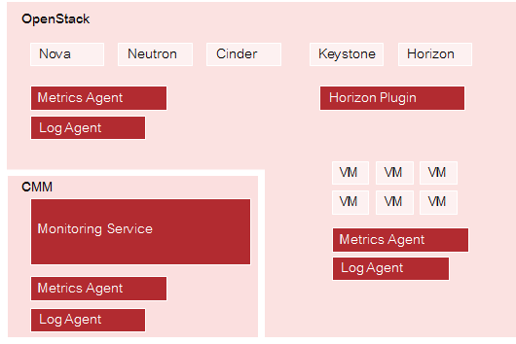
Components

OpenStack
CMM relies on OpenStack, a technology for building cloud computing platforms for public and private clouds. OpenStack consists of a series of interrelated projects delivering various components for a cloud infrastructure solution and allowing for the deployment and management of Infrastructure as a Service (IaaS) platforms.
For details on OpenStack, refer to the OpenStack documentation.

Monitoring Service
The Monitoring Service is the central CMM component. It is responsible for receiving, persisting, and processing metrics and log data, as well as providing the data to the users.
The Monitoring Service relies on Monasca. It uses Monasca for high-speed metrics querying and log management, and integrates the streaming alarm engine as well as the notification engine of Monasca.
For details, refer to Monasca.

Horizon Plugin
CMM comes with a plugin for the OpenStack Horizon dashboard. The plugin extends the main dashboard in OpenStack with a view for monitoring and log management. This enables CMM users to access the CMM functionality from a central Web-based graphical user interface. For details, refer to the OpenStack Horizon documentation.
Based on the Monitoring Service, metrics and log data are visualized on convenient and user-friendly dashboards which fully integrate with the following applications:
- Grafana (for metrics data). An open-source application for visualizing large-scale measurement data.
- Kibana (for log data). An open-source analytics and visualization platform designed to work with Elasticsearch.

Metrics Agent
A Metrics Agent is required for retrieving metrics data from the host on which it runs and sending the data to the Monitoring Service. The push-based agent supports metrics from a variety of sources as well as a number of built-in system and service checks.
A Metrics Agent can be installed on each virtual or physical server to be monitored.
The agent functionality is fully integrated into the source code base of the Monasca project. For details, refer to Monasca.

Log Agent
A Log Agent is needed for collecting log data from the host on which it runs and forwarding the data to the Monitoring Service for further processing. It can be installed on each virtual or physical server from which log data is to be retrieved.
The agent functionality is fully integrated into the source code base of the Monasca project. For details, refer to Monasca.

1.3 Users and Roles
CMM users can be grouped by their role. The following user roles are distinguished:
- An application operator acts as a service provider in the OpenStack environment. An application operator books virtual machines in OpenStack to provide services to end users or to host services required for own development activities. CMM helps application operators to ensure the quality of their services in the cloud. For details on the tasks of the application operator, refer to the Application Operator’s Guide.
- The OpenStack operator is responsible for administrating and maintaining the underlying OpenStack platform and ensures the availability and quality of the OpenStack services (e.g. Heat, Nova, Cinder, Swift, Glance, or Keystone). For details on the tasks of the OpenStack operator, refer to the System Operator’s Guide.
- The Monitoring Service operator is responsible for administrating and maintaining CMM. A Monitoring Service operator provides the cloud monitoring services to the other users and ensures the quality of the Monitoring Service. For details on the tasks of the Monitoring Service operator, refer to the System Operator’s Guide.
Depending on the distribution of tasks in your environment, the tasks of the Monitoring Service operator and the OpenStack Operator are performed by a single person or shared by different system operators.

User Management
CMM is fully integrated with Keystone, the identity service which serves as the common authentication and authorization system in OpenStack.
The integration with Keystone requires any CMM user to be registered as an OpenStack user. All authentication and authorization in CMM is done through Keystone. If a user requests monitoring data, for example, CMM verifies that the user is a valid user in OpenStack and allowed to access the requested metrics.
CMM users are created and administrated in OpenStack:
- Each user assumes a role in OpenStack to perform a specific set of operations. The OpenStack role specifies a set of rights and privileges.
- Each user is assigned to at least one project in OpenStack. A project is an organizational unit that defines a set of resources which can be accessed by the assigned users. Application operators in CMM can monitor the set of resources that is defined for the projects to which they are assigned.
For details on user management, refer to the OpenStack documentation.

1.4 Extensions and Add-Ons
Based on Monasca as an open-source core technology, CMM offers the value proposition of speedy development, high productivity, and maximum transparency. It takes full advantage of the open-source community while at the same time driving the quality of implementation and the usability of features.
As a major contributor to Monasca, CMM enhances Monasca’s value proposition and comes with additional expertise that enables product customizations and solutions. To meet specific customer requirements, specialist know-how is available in the following areas:
- Interfaces with other services. CMM can be used as part of a service bundle, for example in combination with OpenStack CloudKitty for rating and pricing.
- Cluster support. CMM can be operated in cluster mode to ensure high availability and fully exploit its scalability potential.
- Multi-cloud monitoring. CMM addresses the requirements of multi-cloud platforms. Event platforms hosting a mixture of public and private clouds can be monitored.
Contact your FUJITSU support organization for further information.

2 Monitoring
The monitoring solution of CMM addresses the requirements of large-scale public and private clouds where high numbers of physical and virtual servers need to be monitored and huge amounts of monitoring data need to be managed. CMM consolidates metrics, alarms, and notifications, as well as health and status information from multiple systems, thus reducing the complexity and allowing for a higher level analysis of the monitored data.
CMM covers all aspects of a Monitoring as a Service solution:
- Storage of monitoring data in a resilient way.
- Multi-tenancy architecture for submitting and streaming metrics. The architecture ensures the secure isolation of metrics data.
- Horizontal and vertical scalability to support constantly evolving cloud infrastructures. When physical and virtual servers are scaled up or down to varying loads, the monitoring solution can be adapted accordingly.

Basic Usage Scenario
The basic usage scenario of setting up and using the monitoring features of CMM looks as follows:
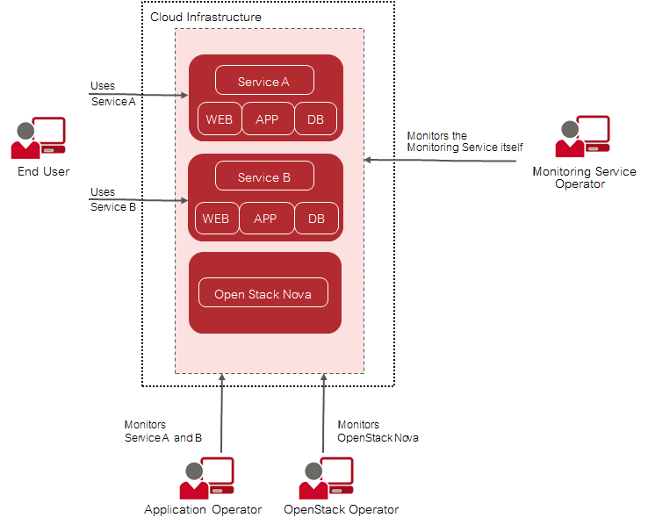
Basic Usage Scenario
The Monitoring Service operator is responsible for providing the CMM monitoring features to the application operators and the OpenStack operator. This enables the application operators and the OpenStack operator to focus on operation and ensure the quality of their services without having to carry out the tedious tasks implied by setting up and administrating their own system monitoring software. The Monitoring Service operator uses the features for monitoring the operation of CMM.
Application operators monitor the virtual machines on which they provide services to end users or services they need for their own development activities. They ensure that the physical and virtual servers on which their services are provided are up and running as required.
The OpenStack operator monitors physical and virtual servers, hypervisors, and services of the underlying platform. In addition, an OpenStack operator is responsible for the middleware components, for example the database services.

Metrics
A Metrics Agent can be installed and configured on each physical and virtual server where cloud resources are to be monitored. The agent is responsible for querying metrics and sending the data to the Monitoring Service for further processing.
Metrics are self-describing data structures that are uniquely identified by a name and a set of dimensions. Each dimension consists of a key/value pair that allows for a flexible and concise description of the data to be monitored, for example region, availability zone, service tier, or resource ID.
The Metrics Agent supports various types of metrics including the following:
- System metrics, for example CPU usage, consumed disk space, or network traffic.
- Host alive checks. The agent can perform active checks on a host to determine whether it is alive using ping (ICMP) or SSH.
- Process checks. The agent can check and monitor a process, for example the number of instances, memory size, or number of threads.
- HTTP endpoint checks. The agent can perform up/down checks on HTTP endpoints by sending an HTTP request and reporting success or failure to the Monitoring Service.
- Service checks. The agent can check middleware services, for example MySQL, Kafka, or RabbitMQ.
- OpenStack services. The agent can perform specific checks on each process that is part of an OpenStack service.
- Log metrics. The agent can check and monitor the number of critical log entries in the log data retrieved from the cloud resources.

Data Visualization and Analysis
All CMM user groups work with a graphical user interface that is seamlessly integrated into their cloud infrastructure. Based on OpenStack Horizon, the user interface enables access to all monitoring functionality and the resulting large-scale monitoring data.
Convenient dashboards visualize the health and status of the cloud resources, for example:
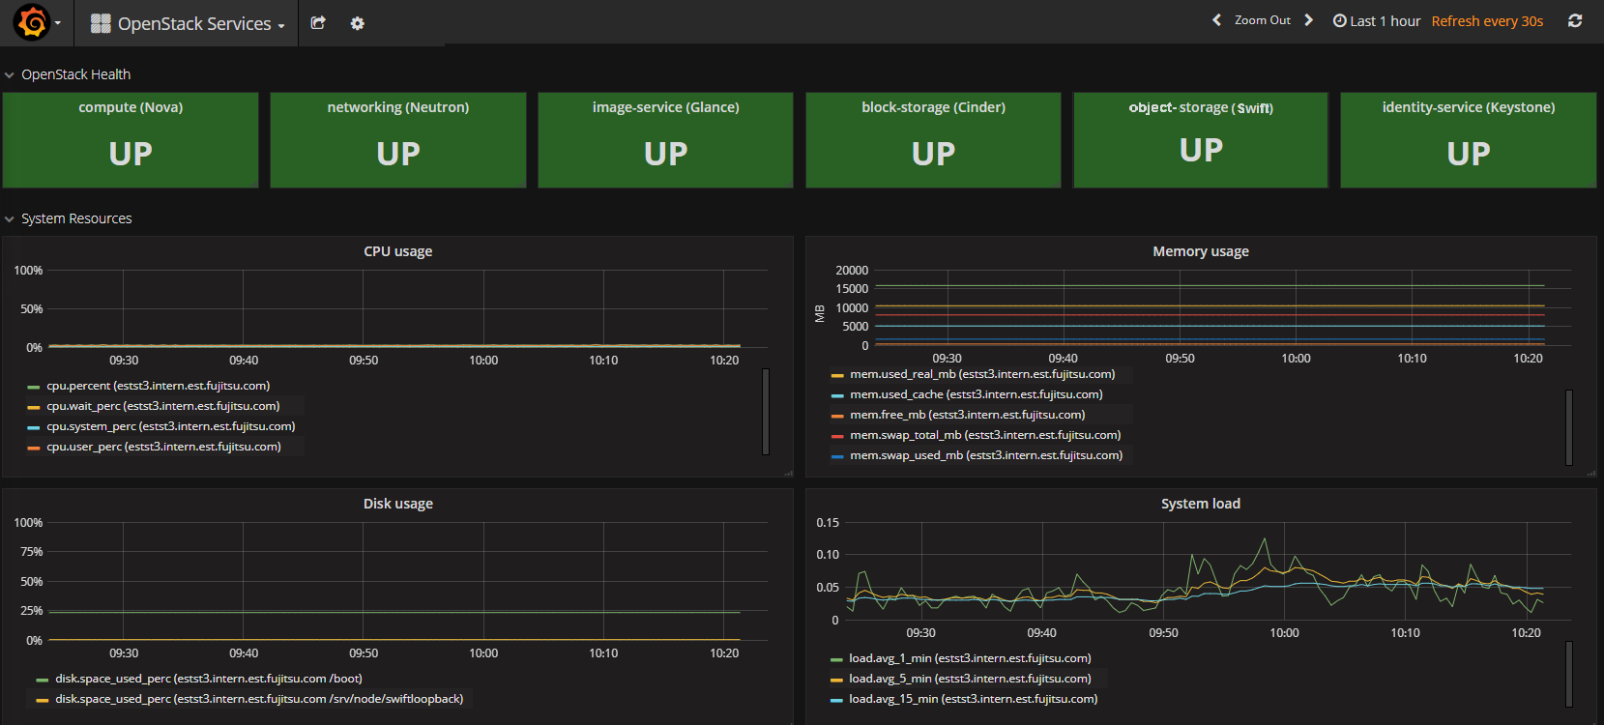
Data Visualization and Analysis
The dashboards allow CMM users to experiment with many ways of analyzing the performance of their cloud resources in real-time. They cannot only view but also share and explore visualizations of their monitoring data.

Alarms and Notifications
CMM supports GUI-based alarm and notification management. Template-based alarm definitions allow for monitoring a dynamically changing set of resources without the need for reconfiguration. While the number of underlying virtual machines is changing, this ensures the efficient monitoring of scalable cloud services. Alarm definitions allow CMM users to specify expressions that are evaluated based on the metrics data that is received. Notifications can be configured in order to inform CMM users when an alarm is triggered. For details on alarm definitions and notifications, refer to the Application Operator’s Guide.

3 Log Management
Services and servers in a cloud infrastructure generate huge amounts of log data, ranging from simple announcements that everything is healthy to detailed information on events or processes. The logs are distributed over many physical and virtual servers. CMM collects, stores, and queries these logs and makes them accessible to CMM users in one central place.
CMM covers all aspects of an enterprise-class log management solution:
- Central management of log data from medium and large-size OpenStack deployments.
- Buffered exchange of log data to provide high data throughput.
- Logical isolation of log data through multi-tenancy.
- Scalable architecture capable of mastering the data load from a large number of nodes in OpenStack environments. The log management solution can be horizontally and vertically adapted to constantly changing data loads.

Basic Usage Scenario
The basic usage scenario of setting up and using the log management features of CMM looks as follows:
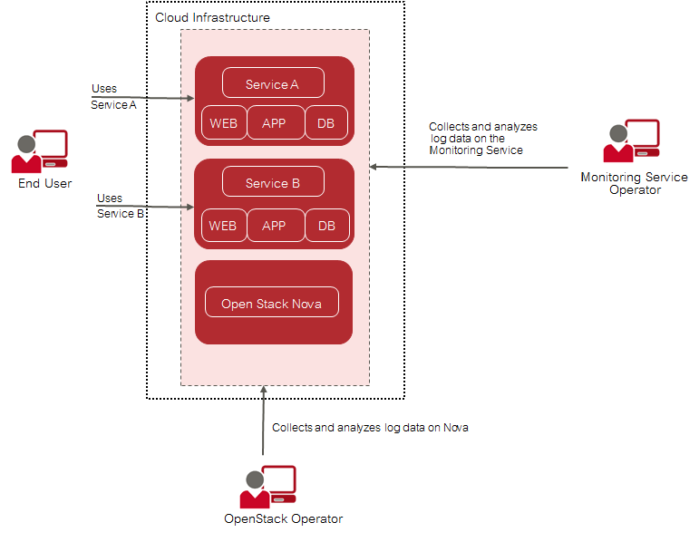
Logs Basic Usage Scenario
The Monitoring Service operator is responsible for providing the CMM log management features to the OpenStack operator. A Monitoring Service operator uses the features for retrieving log data on CMM.
The OpenStack operator uses the log management features for retrieving log data on the OpenStack services and the middleware components that make up the underlying OpenStack platform.

Data Collection
A Log Agent can be installed and configured on each physical and virtual server where log data is to be retrieved. The agent is responsible for collecting the log data from the cloud resources and sending it to the Monitoring Service for further processing.
CMM stores the log data in a central database. The central database forms the basis for visualizing the log data for the CMM users.

Data Visualization and Analysis
CMM supports advanced data visualization and analysis of the log data in a variety of charts, tables, or maps. Visualizations can easily be combined in dynamic dashboards that display query results in real-time, for example:
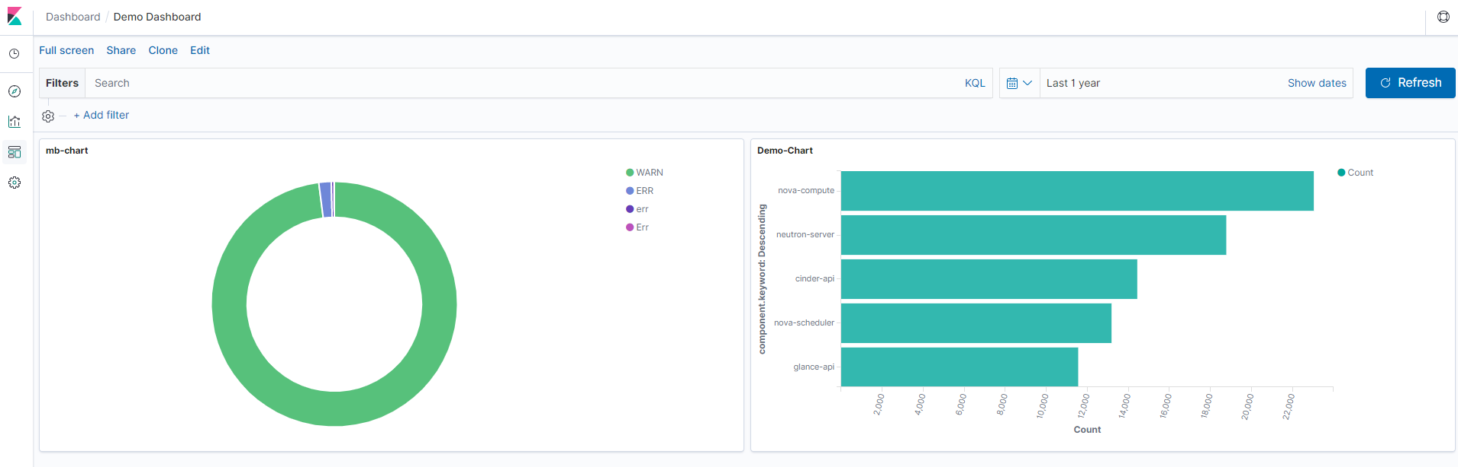
Data Visualization and Analysis
Based on OpenStack Horizon, the customizable dashboards are seamlessly integrated into the cloud infrastructure. They enable user access to all log management functionality.

Alarms and Notifications
GUI-based alarm and notification management is supported for the log data. Based on a template mechanism, CMM allows system operators to configure alarms and notifications for monitoring the number of critical log events over time. When the number of critical log entries exceeds a defined threshold, a corresponding notification is sent. For details on alarm definitions and notifications, refer to the Application Operator’s Guide.
The template mechanism is not limited to a single cloud resource but can be used to analyze a scalable set of resources.
The automation of log handling guarantees that system operators identify problems in their infrastructure early and find the root cause of these problems quickly.

Glossary

Application Operator
A person responsible for providing services to end users or hosting services for development activities. An application operator has limited access to cloud resources in OpenStack.

Dimension
A key/value pair that allows for a flexible and concise description of the data to be monitored, for example region, availability zone, service tier, or resource ID. Each dimension describes a specific characteristic of the metrics to be monitored.
In CMM, metrics are uniquely identified by a name and a set of dimensions. Dimensions can serve as a filter for the monitoring data.

Elasticsearch
An open-source application that provides a highly scalable full-text search and analytics engine. CMM uses Elasticsearch as the underlying technology for storing, searching, and analyzing large volumes of log data.

Grafana
An open-source application for visualizing large-scale measurement data. CMM integrates with Grafana for visualizing the monitoring data.

InfluxDB
An open-source time-series database that supports high write loads and large data set storage. CMM uses InfluxDB as the underlying technology for storing metrics and the alarm history.

Infrastructure as a Service (IaaS)
The delivery of computer infrastructure (typically a platform virtualization environment) as a service.

Kibana
An open-source analytics and visualization platform designed to work with Elasticsearch. CMM integrates with Kibana for visualizing the log data.

Logstash
An open-source application that provides a data collection engine with pipelining capabilities. CMM integrates with Logstash for collecting, processing, and outputting logs.

MySQL
An open-source relational database that provides an SQL-compliant interface for accessing data. CMM uses MySQL as the underlying technology for storing configuration information, alarm definitions, and notification methods.

Metrics
Self-describing data structures that allow for a flexible and concise description of the data to be monitored. Metrics values represent the actual monitoring data that is collected and presented in CMM.

Monasca
An open-source Monitoring as a Service solution that integrates with OpenStack. It forms the core of CMM.

Monitoring Service Operator
A person responsible for maintaining and administrating CMM.

OpenStack Operator
A person responsible for maintaining and administrating OpenStack, the underlying platform technology of CMM.

Platform as a Service (PaaS)
The delivery of a computing platform and solution stack as a service.

Software as a Service (SaaS)
A model of software deployment where a provider licenses an application to customers for use as a service on demand.

