Software Platform and Interview Control Technical Report
Report date 6 October 2026
Scope: frontend and backend software, interview control and speech answer completion. Timing behavior describes the current local implementation. Server business measurements refer to release 0024583 with AI behavior review disabled.
Abstract The platform connects profile management, adaptive interviews and result delivery through version binding, persistent sessions and controlled state transitions. Speech input uses a lightweight semantic classifier followed by language model confirmation to detect answer completion while limiting premature termination. The server enforces access rights, time budgets and persistence constraints; the client displays the resulting question, answer and progress. The tested state invariants and a limited set of live model workflows have been verified. Microphone performance and the comparability of interview scores require separate evaluation.

1 Technical Objectives and System Architecture
The system supports interviews in which subsequent tasks adapt to the candidate's answers, while evaluation evidence remains traceable to the actual response. The platform manages interaction, sessions and result delivery; question selection and scoring are supplied by their respective technical modules. Its central challenge is to keep interview stages, source profiles and displayed results consistent when model latency varies, requests are duplicated or connections are interrupted.
The browser handles profile review, answer capture and feedback. Django and Django REST Framework manage session identity and profile requests, while ASGI supports asynchronous interaction. Profile operations and history queries use HTTP; questions, stage updates and speech events use WebSocket. Persistent connections reduce polling, and independent profile operations retain explicit request and authorization boundaries. Asynchronous execution allows other events to proceed during a wait; it does not accelerate model computation.
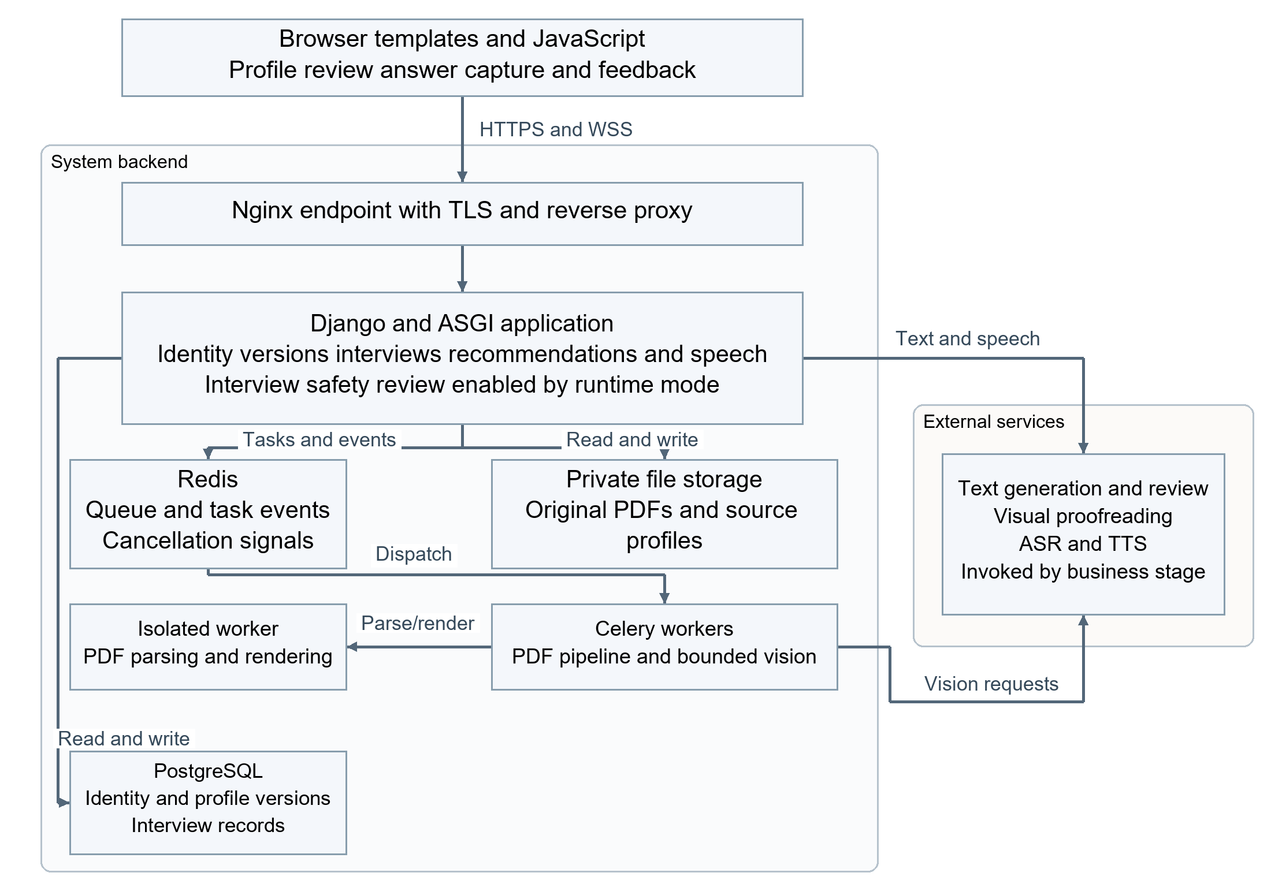
Figure 1 Platform responsibilities and principal interactions
Long-running document processing is separated from real-time interviews. Redis coordinates Celery workers for production PDF tasks. Workers invoke isolated parsing and optional vision services, and return progress and cancellation information through short-lived task streams. The real-time application hosts interview, recommendation and speech agents. PostgreSQL stores identities, profile versions and interview records; private file storage retains originals. Queuing reduces document-processing pressure on real-time processes, but does not remove model latency or guarantee automatic task recovery. Arrows in Figure 1 denote calls or reads and writes; return paths are omitted for clarity. Safety review is an application capability enabled conditionally.

2 Interview Control and Real Time Interaction

2.1 State Transitions and Effective Time Budget
An interview proceeds through profile binding, question delivery, answer retention, evaluation, next-action selection and final delivery. Answers are retained before evaluation, so submitted content survives an evaluation failure. Once a next action has been determined, evaluation, context and action records are committed consistently in a transaction. Request identity detects duplicate submissions, and state versions reject stale transitions, preventing one answer from producing two concurrent next steps.
For planning-enabled interviews, effective elapsed time is the wall-clock duration since timing began at the first question, minus accumulated question-construction time, with a lower bound equal to the previously recorded elapsed time. The question-construction pause covers question planning, retrieval, generation and validation. Separate interview replanning, answer evaluation and candidate interaction still consume the budget. The first question is constructed before formal timing begins. Accumulated durations retain fractional precision and are persisted with the session, preventing repeated short pauses from being lost through rounding.
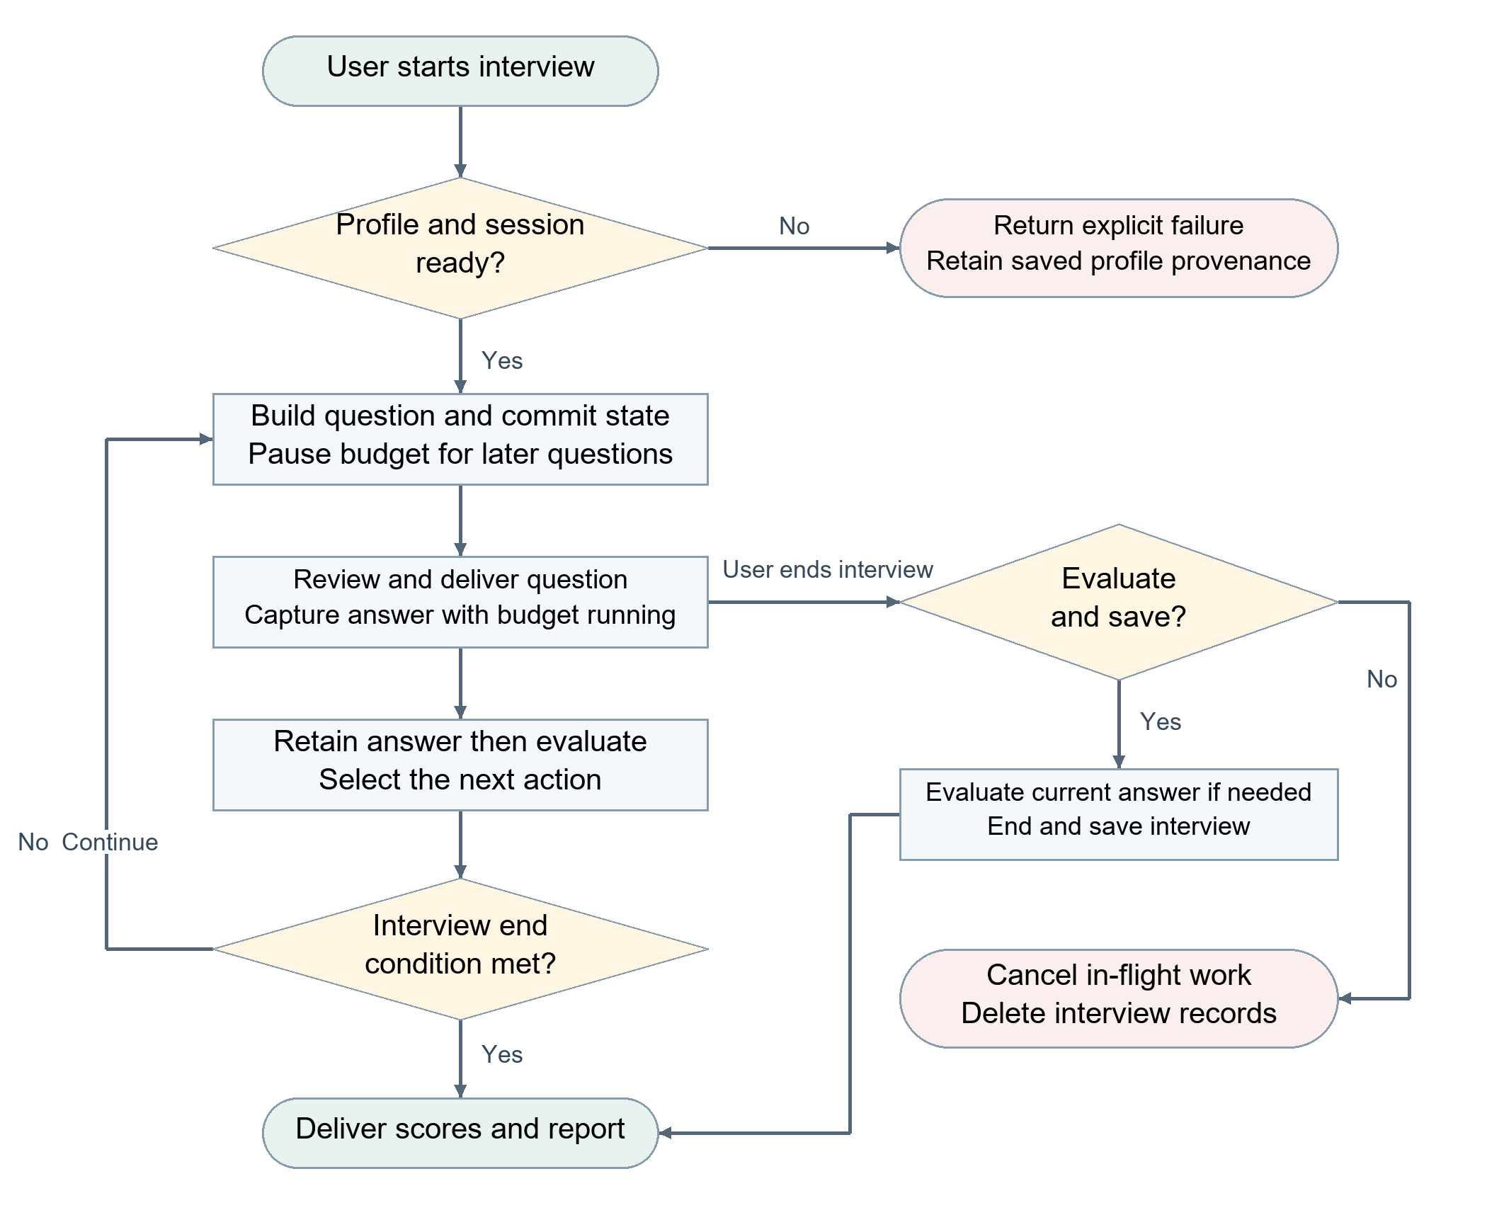
Figure 2 Interview control and timing boundaries for subsequent questions
In Figure 2, continuing the interview returns to question construction. When the user confirms early termination, the evaluate-and-save path processes a valid current answer if needed and then saves the results. The discard path cancels in-flight work and deletes records for that interview. Dismissing the termination dialog resumes interaction. The diagram shows normal turns and explicit termination choices; safety denials, provider failures and independent stage changes follow their own state handling. Pausing the interview budget during question construction does not change model deadlines, scoring rules or question-count safeguards.

2.2 Two Stage Semantic Detection of Answer Completion
The browser captures microphone audio through a Web Audio worklet, converts it to 16 kHz PCM and streams it continuously. Interim transcripts support captions, while only the complete final transcript is submitted as an answer. Detection asks whether the user has finished answering the current interview question, rather than whether a sentence or a referenced project is complete. A fine-tuned multilingual MiniLM encoder with a binary classification head screens transcript fragments locally on the server, followed by confirmation from Qwen Flash. A positive first-stage result cannot end an answer by itself. The encoder produces a 384-dimensional representation and runs on the CPU after quantization to limit per-fragment processing cost.
The first stage encodes the transcript tail into token representations, takes the attention-masked mean to exclude padding and applies L2 normalization to obtain a 384-dimensional vector. A linear classification head produces one logit, which a sigmoid maps to a completion score. Training uses binary cross-entropy with positive-class weighting based on the negative-to-positive sample ratio, so the less frequent positive class receives sufficient gradient contribution. This is supervised learning of textual completion intent; it does not analyze raw acoustic features.
The second stage uses Qwen Flash with fixed task instructions to determine whether the fragment ends the current answer. It distinguishes statements such as "the project has ended" from "that concludes my answer" and accounts for negation. This stage uses inference from an existing model, with no project-specific fine-tuning. A below-threshold first-stage score continues capture; a score at or above the threshold only triggers confirmation. Final termination remains subject to transcript consistency, audio activity and the current recording generation.
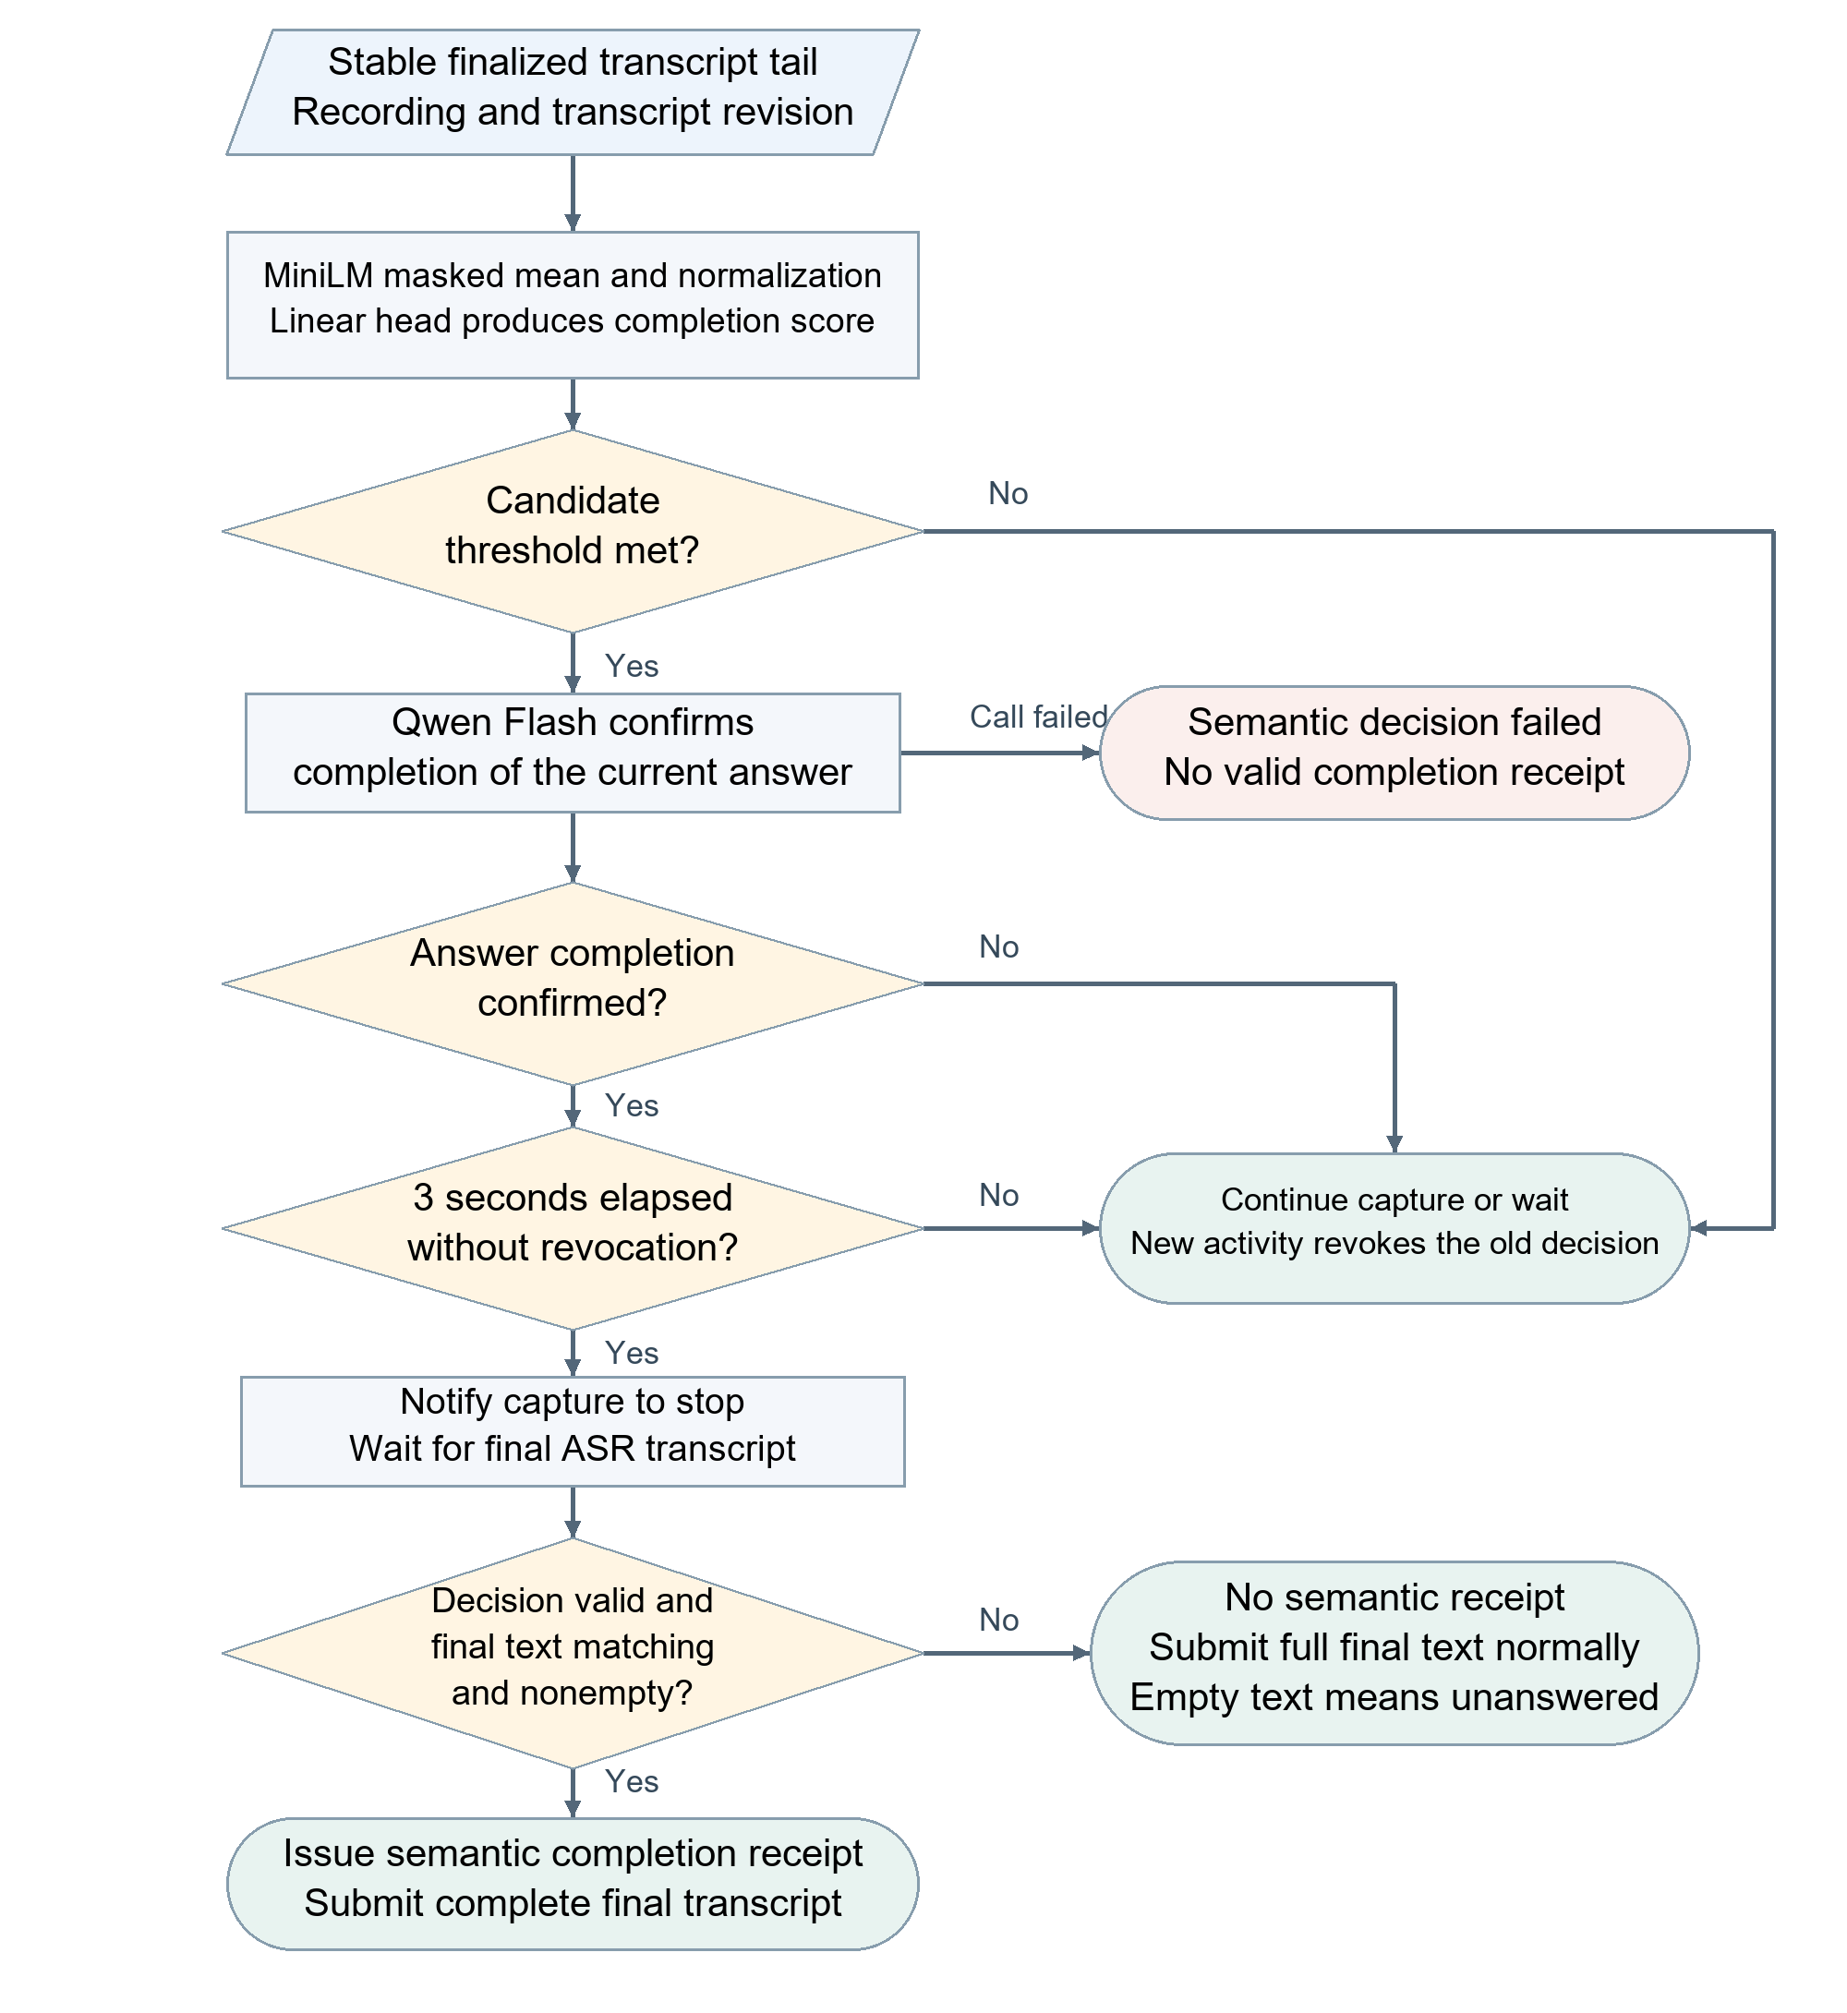
Figure 3 Semantic termination and final transcript submission paths
Only finalized transcript segments enter classification. Dispatch requires at least 0.5 seconds of transcript and speech stability, and uses at most the last 400 characters and 128 tail tokens. Each recording permits one in-flight classification request, with at least 1 second between request starts; identical fragments are not resent. If a new transcript arrives during a request, the latest fragment is retained and the older result is invalidated. These controls bound request volume and prevent an outdated completion decision from truncating an extended answer.
Semantic confirmation overlaps a 3-second wait measured from finalization of the classified fragment. Before the stop-capture notification, new text or audio activity satisfying the energy condition revokes the earlier decision. After notification, a semantic completion receipt is issued only if the decision remains valid and the nonempty final transcript matches the confirmed text. If the final text differs, recording has already stopped and the client submits the complete final transcript through the ordinary answer path; an empty result is recorded as unanswered. The page's 5-second silence cutoff and 120-second recording limit are independent capture controls. Energy detection supplies a revocation signal, not a trained voice activity detector.

3 Design Tradeoffs and Data Consistency
The frontend uses server-rendered page templates and native JavaScript, organizing profile management, interviews and review into separate task pages. Switching profile sections preserves interface state without saving or clearing drafts. Leaving unsaved edits triggers an explicit warning. The main interview area concentrates the question, captions and speech controls, while stage, time and error information remain visible. Asynchronous work becomes complete only when the server confirms a persisted terminal state. HTTP 200 or a processing indicator cannot substitute for complete success, preventing displayed progress from diverging from actual results.
Table 1 Interaction states and consistency requirements
Scenario | State rule | Purpose
Profile sections and language selection | Preserve drafts; language selection changes only the display of returned reasons | Avoid implicit saves and duplicate billable calls
Parsing and model waits | Progress identifies a stage; availability requires the complete result to be saved | Separate transport success, ongoing work and completion
Duplicate or late responses | Check request identity, state version and current interaction generation | Prevent duplicate transitions and stale interface updates
Early termination | Evaluate the current answer or discard the interview; unfinished speech is not ability evidence | Keep termination choices consistent with evaluation evidence
Errors and disconnection | Clear interface timers and in-flight state; retain saved history | Make the failure boundary explicit without claiming automatic resumption

Centralized session control reduces conflicts caused by independent client and server progression. Persistence binds the selected resume version and actual input to the interview; later edits or changes to the current version do not alter an interview already in progress. Ownership checks restrict profile and history reads to the owner. Results are saved before delivery, so a network transmission failure must be distinguished from a successful business commit.
Exact matches can reuse parsing results for existing profiles; the current page starts interviews from a ready version selected in the personal workspace. Final numerical scores are delivered before the narrative report, using the same aggregation method, so report generation does not hide an already completed result. These measures reduce duplicate work or expose available results earlier. The evidence does not support a single end-to-end speedup percentage.
The speech design prioritizes recall of completion intent and uses the second-stage model to reduce false endings. A lower screening threshold sends more non-completion fragments for confirmation and increases invocation cost; aggregate accuracy alone can conceal missed positive cases. Once a screening model is configured, artifact-loading or inference failures are reported explicitly rather than silently bypassed. The platform does not currently resume execution automatically after disconnection. Readable history does not imply a recoverable live session.

4 Validation Results and Technical Analysis

4.1 State Control and Live Service Validation
Table 2 Platform validation evidence and measurement scope
Condition | Result | Interpretation
Controlled state and timing tests | 695 root-suite tests plus 5 subtests; 70 backend tests; 36 client tests passed | Model and clock doubles; state, timing and persistence checks
Release 0024583; two live text interviews | First question 30.77 to 31.36 s; answer to report 37.70 to 38.15 s | One-question interviews using synthetic profiles; safety review disabled; live model services
Mixed server profile reads at concurrency 4 | 2,235 reads; 37.11/s; P95 148.64 ms | Fixed application-layer concurrency; not model interview throughput
Server identity and persistence constraints | Cross-user history 404; duplicate UUID rejected; report readback consistent | Contracts of the tested cases; not long-term availability or assessment validity

State correctness, read capacity and model-dependent waiting time answer different questions and must be interpreted separately. Server waits for the first question and final report are substantially longer than profile reads. The demonstrated benefit is continuous feedback, explicit stages and consistent delivery. No end-to-end comparison against an earlier configuration under identical conditions is available. The software testing report provides the complete load and business measurement methods.

4.2 Synthetic Data and Server Semantic Regression
The speech model uses 2,400 synthetic training fragments, 200 validation fragments, 200 test fragments and a separate set of 80 semantic contrast cases. Chinese and English examples are split by generation-source group so that variants from the same source do not cross the training, validation and test sets. Only the training portion of earlier samples is reused. Labels are produced through model-based blind labeling and rule checks; they are not an independent human gold standard.
The fixed backbone is multilingual MiniLM-L12, with joint fine-tuning of the encoder and classification head. Training uses batch size 16, encoder learning rate 0.00002, head learning rate 0.01, AdamW weight decay 0.01 and seed 42. Of five epochs, epoch 2 is selected by the lowest validation weighted cross-entropy. After INT8 export, validation scores are recomputed using actual single-input inference. The threshold 0.02858497041739284 is the highest validation threshold meeting the 99% completion-recall target for each language. The test set does not participate in selection. The low threshold serves candidate recall; it is not a calibrated probability boundary for completion intent.
Table 3 Screening holdout and contrast results
Set | Cases | Completion recall | Non-completion filtered
New synthetic test | 200 | 100.00% 76/76 | 72.58% 90/124
New semantic contrast | 80 | 97.50% 39/40 | 10.00% 4/40
Known server two-stage regression | 80 | 97.50% 39/40 | 100.00% 40/40

The first two rows of Table 3 evaluate the screening model; the last row evaluates screening combined with live Qwen confirmation. Only 4 of 40 non-completion cases are filtered out in the semantic contrast set, showing that many difficult negations and project references reach the second stage. The server regression set contains known cases and cannot be subtracted directly from independent holdout results to claim better generalization. A further 20 synthetic cases involving project references and negation all match their expected labels.

4.3 Latency and Complete Workflow Observations
Table 4 Recorded latency and workflow observations
Observation | Result | Measurement scope
Local CPU screening | P50 3.27 ms; P95 4.63 ms | Fixed model and synthetic text; single-input inference
Server CPU screening | P95 approximately 10.93 ms | Known server regression
Live Qwen candidate confirmation | P95 476.10 ms | Candidate calls in known server regression
8.88 s synthetic English recording | Stop notification 3.025 s after the last incremental transcript | Production HTTPS, ASR, screening, confirmation and silence wait
Same audio workflow | Stop notification 7.103 s after PCM transmission ended | Includes ASR finalization delay

An 8.88-second synthetic English recording completes termination through live HTTPS, ASR, screening and confirmation services. A separate synthetic interview completes answer submission, score persistence and next-question generation. These observations do not cover real microphone noise or device differences and cannot establish a production end-to-end P95. The 55% of synthetic test fragments sent to the confirmation model describes only the offline candidate rate.

5 Limitations and Applicability
The evidence supports continuous interviews, consistent state and two-stage completion confirmation under the stated session and synthetic-speech conditions. Real microphone noise, ASR errors, revocation by audio activity across devices and long-session experience still require device evaluation. Automatic recovery after disconnection is not implemented. Fairness in adaptive interviews and score comparability across different question paths require separate research; neither follows from a responsive interface or passing state tests.
Further evaluation should use human-labeled device recordings stratified by language, noise and answer type, reporting premature cutoff, missed completion and end-to-end waiting-time distributions. First-question, evaluation, next-question and report durations should be recorded under identical profiles, models and policies. Integration with scoring and question-generation modules should verify state prerequisites and the meaning of input evidence while preserving the comparability of scoring and experimental conditions.

