Resume Extraction and Multimodal Proofreading Technical Report
Report date 6 October 2026
Scope: PDF text extraction and the visual proofreading agent. Structured candidate understanding is a downstream task; successful extraction and correct profile interpretation are evaluated separately.
Abstract Resume extraction uses conventional text parsing as a baseline and optionally adds visual proofreading of the original pages. Only source-supported local corrections are permitted. Resource isolation, complete-success validation and version retention limit error propagation. Evidence includes omission recovery and latency observations for one resume, together with a synthetic multi-page concurrency check. It does not establish general accuracy on a representative resume population.

1 Technical Objectives and Design Rationale
The visible reading order of a PDF may differ from its internal text order. Multiple columns, tables, scanned pages and special characters can cause omissions, ordering errors or empty extraction. The module aims to recover the information actually supplied by the user, rather than invent experience, polish wording or assess ability. Unsupported additions can be more harmful to interviews and recommendations than explicit missing information, so extraction and structured understanding are separate tasks.
The default conventional mode extracts text in an isolated environment and does not send pages to a model provider. When the user explicitly selects advanced mode, the original page image and conventional text are submitted together for visual proofreading. The model proposes necessary differences, and unchanged content remains identical to the baseline. The user then reviews the text and uncertainties before downstream interpretation, separating page recovery from inference about candidate ability.
The processing chain comprises the original PDF, a conventional extraction baseline, optional visual proofreading, a user-edited snapshot and downstream input. Version relationships distinguish the final extracted text from user edits, but cannot reconstruct every intermediate advanced-mode correction. Recommendation field suggestions parse only labels and lists explicitly present in the text and retain field evidence. Conflicting or unsupported formats remain unknown, and unsaved suggestions do not participate in recommendation. Interview startup separately interprets the confirmed text; text readiness does not mean that a structured candidate profile is complete.

2 Multimodal Extraction and Evidence Constraints

2.1 Text Baseline and Page Proofreading
Conventional parsing retains layout cues and handles explicit ligatures, line breaks and trailing whitespace. Page rendering supplies visible text and positional evidence to the vision model. Images can recover omitted text and clarify within-page reading order, but a model may also misread characters or rewrite content unnecessarily. Advanced mode therefore applies local corrections to a baseline rather than asking the model to regenerate the entire resume.
The vision agent uses inference from an existing multimodal model; the project does not train its weights. Each request processes one page, supplying its PNG image and conventional text with consecutive line numbers. Fixed instructions allow only image-supported corrections to omissions, character errors and reading order. Page text remains extraction material, and instructions contained within it cannot redefine the proofreading task. Single-page input limits cross-page speculation, at the cost of being unable to resolve every reference using other pages.
The model returns a page number, a list of local corrections and a list of uncertainties. Each correction specifies a start and end line, replacement text and a reason. The program validates locations and application order, while the model determines the image-supported change. Inference must end in a complete state: refusal, truncation, empty output or a structurally invalid response cannot produce success. This division restricts generation to an explicit scope, but does not prove character-level fidelity.
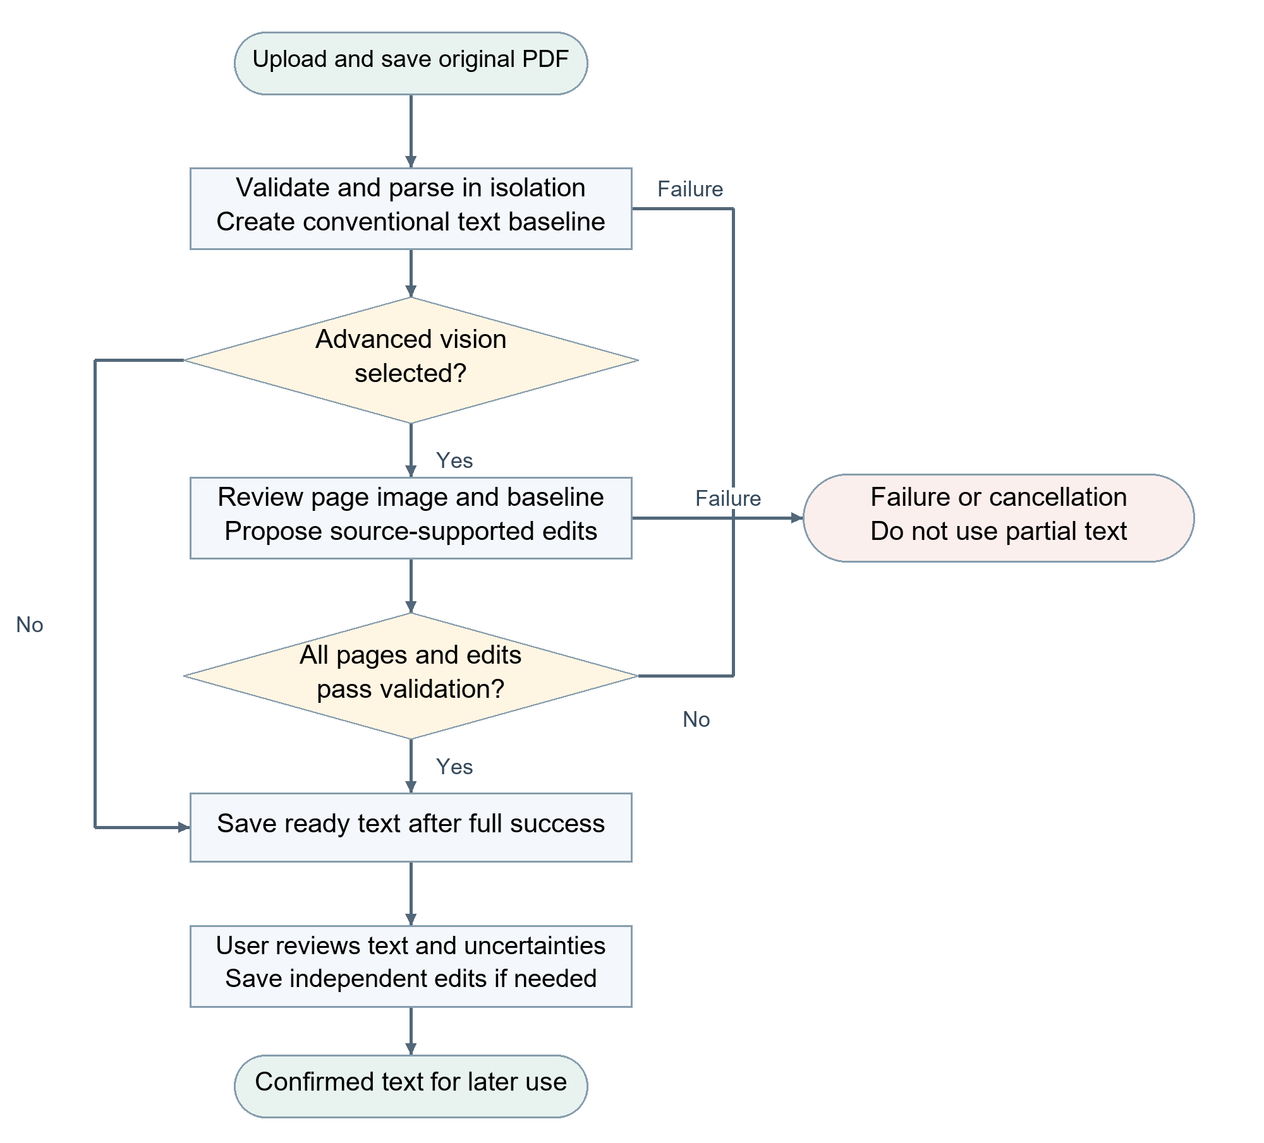
Figure 1 Complete success through conventional extraction or visual proofreading
The conventional branch in Figure 1 produces extracted text directly. The advanced branch must finish proofreading and correction validation for every page. Page images support recovery of source text; they do not justify additional timelines, cross-page experience claims or qualification judgments. A ready state means that text has been saved, not that structured information is correct or facts have been independently verified.

2.2 Local Corrections and Uncertainty
The backend fixes line numbers for each page. Corrections refer to explicit contiguous line ranges; the model supplies replacement text and reasons rather than repeating source text for fuzzy matching. The system maps line ranges to original positions, checks page identity, bounds, non-overlap of effective changes and accidental deletion of the entire page, then applies replacements from the end backwards. Unselected characters are retained verbatim, and no-op suggestions are not counted as edits. Empty extraction pages permit bounded insertion of visible text.
For example, if the original page clearly contains "Python, SQL" but baseline line 8 contains only "Python", the model may replace line 8 with "Python, SQL" while leaving every other line unchanged. If date characters are unclear, it records an uncertainty for user review instead of guessing a date from context. This example explains the correction mechanism and is not part of the measured sample.
A valid location does not prove that replacement text is faithful to the image. The model must retain uncertainties, and users should pay particular attention to names, contact details, dates and numbers. An absence of reported uncertainties does not imply an absence of errors. A failed page, invalid response structure or out-of-bounds edit fails the entire advanced operation. Intermediate pages cannot be assembled into a successful result, and processing does not automatically switch to conventional success.

3 Isolated Execution and Data Provenance
Untrusted PDFs are parsed and rendered in an isolated Linux or WSL environment with restrictions on file visibility, networking, child processes and resources. The parser does not receive model credentials; advanced vision requests are sent in a separate controlled stage. Isolation shares the host kernel. Resource limits reduce the potential impact, but do not replace security validation against all malicious files.
Table 1 Resource and scheduling limits
Resource | Configured limit | Purpose
Uploaded document | 10 MiB; at most 10 pages | Bound input size
Parsing worker | 768 MiB address space; 20 CPU seconds; 30 seconds wall time | Limit resource consumption
Page image | Longest side 1,800 pixels | Bound vision input size
PDF processing on one host | At most 2 concurrent documents | Covers upload, extraction and vision stages
Vision window per document | At most 3 concurrent pages | Refill as tasks complete; merge in source order

Windowed concurrency permits pages to finish out of order, while final text is merged strictly in original page order and progress follows the number of completed pages. On failure or cancellation, no further tasks are scheduled; in-flight cleanup completes before the shared client closes. Client cancellation cannot guarantee that a provider stops computation or billing. Table 1 describes configuration and processing limits, not measured throughput. Rendering and network proofreading are scheduled separately. PDFium cannot be called concurrently across threads, so pages are rendered sequentially in the controlled document stage before vision requests use a bounded asynchronous window.
The original version stores both the source PDF and the final extraction produced by the selected mode. User revisions are saved as independent snapshots with provenance links to the original version and edit baseline. Later edits do not alter profiles already bound to interviews. Conventional baselines, page-level corrections and uncertainties are used during processing but are not separately persisted as a complete audit trail. A usable result requires completed processing and successful saving; partial page events cannot substitute for complete success. Ownership constraints keep both originals and extracted text private.
Production tasks pass through a Redis queue to Celery. PDF content is claimed once per task, while results, heartbeats and cancellation signals occupy short-lived task streams. A 1-hour expiry limits retention after abnormal termination. The business layer saves the final version after receiving a complete result. Worker disappearance or client interruption does not trigger implicit replay. Logs record request identifiers, stages, page counts, elapsed times and limited error codes, excluding resume text, images and credentials.

4 Measurements and Validation Analysis

4.1 A Limited Case with a Complex Text PDF
In one private PDF whose conventional extraction contained 3,118 characters, visual proofreading recovered a visible passage omitted by the baseline. The case used qwen3-vl-flash with explicit thinking disabled, a 90-second per-page request timeout, zero retries, a maximum image side of 1,800 pixels and at most three concurrent pages. Table 2 reports two model-stage observations and one complete processing time for the current line-range correction method.
The 90-second limit applies to each page's model request. Complete processing also includes parsing, rendering, page scheduling, correction validation and merging. The conventional pipeline, model stage and complete operation in Table 2 have different timing boundaries and cannot be subtracted directly to infer a speedup. Private pages and personal content are not reproduced in the report.
Table 2 Single PDF latency and model output volume
Processing condition | Duration | Output and scope
Complete conventional pipeline; warm start | 0.522 s | 3,118 characters; no vision model
Vision model stage; observation 1 | 39.586 s | 2,046 output tokens
Vision model stage; observation 2 | 35.417 s | 2,097 output tokens
Complete advanced processing; observation 2 | 44.06 s | Includes process initialization and isolated-environment startup

Local correction concentrates model output on changed passages while the program preserves unchanged text verbatim. Both observations produced approximately 2,000 output tokens. Nonrandom observations of one document cannot represent the distribution of complex resumes. No human character-level annotation set is available, so neither general accuracy nor a percentage of recovered omissions is reported.

4.2 Concurrency and Constraint Validation
One recorded live vision run processed a short three-page synthetic PDF. Pages completed in the order 3, 2, 1, while the final page sequence and complete text remained 1, 2, 3. Total duration was approximately 5.83 seconds, with no proposed corrections. This verifies out-of-order completion and ordered merging, not complex-resume throughput or a threefold speedup. Isolation checks also verified that host directories were invisible, networking and child processes were denied, memory limits blocked excess allocation, and damaged, encrypted or over-limit documents were rejected.
Table 3 Recorded server cases with simple PDFs
Condition and sample size | Duration | Completion evidence
Conventional mode; 2 one-page synthetic PDFs | 0.71 to 2.02 s | Original bytes identical; text checks; complete result matches saved text
Advanced mode; 1 one-page synthetic PDF | 3.47 s | Live vision call; complete result matches ready version
Damaged PDF; 1 file | 0.61 s | Failure state saved; prohibited as interview input

Table 3 uses release 0024583, the Linux production queue and live services. Durations include upload, original-file readback, queued processing and terminal-state confirmation. These boundaries differ from the private complex document, process startup and model-stage observations in Table 2. The results cannot be pooled into an average latency or used to calculate a protocol speedup. A single page offers no inter-page concurrency, and successful extraction of a simple text PDF does not validate recognition of complex scanned documents.

5 Limitations and Applicability
Current evidence supports baseline preservation, bounded local corrections, page scheduling and complete-success control, together with omission recovery in limited documents. Position validation cannot establish semantic correctness. Scan quality, complex layouts, cross-page relationships and low-resolution characters require representative evaluation. Advanced mode adds external model latency and disclosure of page images; its use should depend on document quality and user choice.
Further evaluation should use human-annotated text PDFs, scans, multi-column documents and tables. On identical source documents, comparisons should measure character errors, omissions, ordering errors, unsupported edits, human correction effort, cost and failure rate. Failed documents must remain in the statistics. Version relationships support comparison of final extraction with user-confirmed text; evaluating individual visual corrections additionally requires dedicated retention of the corresponding intermediate results.

