Job Recommendation and Missing Data Robustness Technical Report
Report date 6 October 2026
Scope: deployed structured first-stage ranking and language model reranking, plus separate research on semantic representations and missing-data robustness. Model scores are relative ranking signals, not hiring probabilities.
Abstract The recommendation system uses a structured learning-to-rank model to shortlist jobs, then a language model compares that set and explains its recommendations. The first-stage model learns relative order from labeled candidate-job pairs, preserves unknown profile values and uses missing-data augmentation. The integrated model has not passed the predefined overall quality gate, and the API reranker has no demonstrated offline quality gain. Separate semantic representation and residual adaptation experiments inform research choices; their data and objectives are distinguished from the product recommendation workflow.

1 Recommendation Objectives and Technical Approach
Candidate-to-job recommendation and job-to-candidate selection are distinct ranking tasks. The preference model learns the relative order of jobs for one candidate. The job-side model learns the relative order of candidates for one job. Job-side training labels identify within-job winners in synthetic data; they do not represent real hiring events or an absolute qualification judgment.
Personal recommendation uses two stages. It computes structured features for every job in the configured catalog and ranks the full pool, then sends the top 20 jobs to one text-model comparison and returns at most five. Here, screening means selecting a candidate set by score. There is no additional hard keyword filter and no vector-database nearest-neighbor retrieval. The demonstration catalog contains 100 jobs and is explicitly described as non-live recruitment information.
Semantic embeddings, a dedicated reranker and adaptation with missing-data augmentation are separate offline research methods and are not integrated into the personal recommendation path. They evaluate job-to-resume ranking within an external labeled pool and must not be treated as the same experiment as candidate-to-job preference ranking in the product.

2 Training and Inference for Structured First Stage Ranking

2.1 Input Representation and Interpretable Features
Users review and save skills, interests, major, GPA, experience in months, academic stage, available hours per week, consecutive commitment in months, publication count, work mode and summer availability. These fields and job requirements produce a fixed 11-dimensional feature vector for each candidate-job pair. Tree models can learn nonlinear combinations of skill, time and experience requirements while individual inputs retain interpretable matching meanings.
Table 1 Structured matching features and unknown values
Feature group | Computation | Interpretation
Skill coverage; 1 feature | Count of confirmed skills shared with required skills divided by required skill count | If Python and SQL are required but only Python is confirmed, coverage is 0.5
Categorical matches; 3 features | Interest contains job industry; majors overlap; work modes match | Known match 1 and mismatch 0; exact text matching
Numeric margins; 6 features | Candidate value minus job minimum for GPA, experience months, academic stage, weekly hours, commitment months and publications | Positive means above the stated requirement, not overall suitability
Summer availability; 1 feature | Confirmed yes or no maps to 1 or 0 | Candidate-side feature; no inferred job summer requirement
Unknown dependencies | A feature remains NaN if a required value on either side is unknown | Zero, false and known empty sets retain their meanings

A known required-skills list must be nonempty to avoid a zero denominator. Academic stages UG1 to UG4, MS1 to MS2 and PhD1 to PhD5 are encoded consecutively from 1 to 11. This ordinal scale is a training convention, not an equal-interval measure of educational value. Inputs exclude identities, complete resume text, interview scores and the source data's generative matching scores. The model does not infer unrecorded experience, convert GPA scales or expand skill synonyms.
For example, six months of candidate experience against a three-month requirement gives a margin of 3. Unknown experience gives NaN; an explicit zero months gives a margin of -3. LightGBM learns how missing samples are routed at tree splits, allowing unknown and known-insufficient evidence to follow different paths. It does not recover the missing facts and can still fail when missingness patterns change.

2.2 Label Construction and Data Splits
First-stage training uses a fixed synthetic snapshot of DualOptimization_jobrec with 5,000 candidate profiles and 100 jobs. Deduplicating consistent preference labels reduces 117,833 original rows to 44,739 unique pairs. The job-side task has 4,491 unique pairs, and the union across both label types contains 47,029 pairs. A pair may be labeled in only one direction. An absent label in the other direction remains missing; it is neither converted into a negative nor supplemented by automatically sampling negatives from all possible combinations.
Job-side labels use the source data's rule-based matching score. The highest-scoring candidate for each job is positive; identifier order selects one winner in a tie. Observed negatives come from a filtered pool of positive preference pairs and indicate that the candidate did not win that job, not that the candidate fails its requirements. This objective therefore reconstructs a rule-selected winner within a given pool and differs from real employer hiring preferences.
With seed 42, the 100 jobs are split into 70 training, 15 validation and 15 test jobs. Every pair follows its job's assignment. A job never crosses splits, but a candidate may appear in several splits. The experiment therefore evaluates ranking on unseen jobs, not simultaneously on unseen candidates. Table 2 gives the observed labels available to each task; job-side training covers only the 68 training jobs with labels.
Table 2 Observed labels for the two training objectives
Task and split | Pairs | Positives | Meaning
Preference training | 31,776 | 6,358 | Compare jobs in 644 candidate query groups
Preference validation | 6,356 | 822 | Select the tree count
Preference test | 6,607 | 1,012 | 501 queries with positives support ranking evaluation
Job-side training | 3,051 | 68 | Compare candidates in 68 labeled job groups
Job-side validation | 725 | 15 | Select the job-side tree count independently
Job-side test | 715 | 15 | 15 job queries with positives

2.3 How LambdaRank Learns an Ordering
Both models use gradient-boosted decision trees with the LambdaRank objective. Within a query group, the model compares the scores of labeled relevant and non-relevant objects. The update signal reflects the ranking gain affected by swapping their positions, giving greater emphasis to consequential ordering errors. Each tree fits the current ranking error and contributes to the accumulated score at the specified learning rate. The objective learns relative within-group order rather than fitting binary labels as calibrated probabilities.
The preference task groups by candidate and learns from that candidate's job pairs. The job-side task groups by job and learns from its candidate pairs. The same 11-dimensional representation enters two independent models, with separate labels, query groups and selected tree counts. Their raw scores have different scales and objectives. Personal recommendation sorts only by the preference score and does not add the two scores.

2.4 Missing Data Augmentation and Model Selection
The current B model uses a stable hash of candidate identity to assign a training profile view: 50% original, 25% randomly incomplete and 25% with a bundle of optional fields hidden. These are assignment probabilities, not enforced exact proportions in each finite set. The random view independently hides each of 11 candidate field blocks with probability 30%. The optional bundle hides GPA, weekly availability, consecutive commitment, publication count and summer availability together.
Masking applies to raw fields before features are recomputed. All pairs for one candidate share the same mask, preventing hidden values from being recovered through another pair. Each training pair retains one assigned view without additional sample copies. Masks depend on identity and seed, not labels. This augmentation addresses candidate-side missingness; missing job requirements are a separate evaluation scenario. The complete-profile control A uses the same fitting and validation procedure to help isolate the effect of missing-data training.
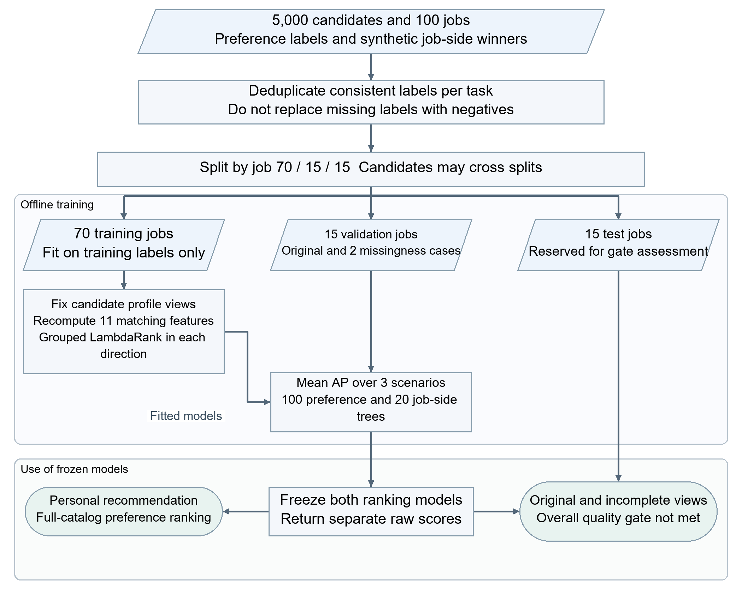
Figure 1 Data splits, training and frozen inference for first stage models
Table 3 Structured ranking training and selection settings
Item | Setting | Role
Model | LightGBM 4.6.0; LambdaRank; 11 features | Fit directions separately without shared labels or trees
Tree capacity | At most 200 trees; 15 leaves; minimum leaf sample parameter 20 | Bound individual trees and ensemble size
Updates and regularization | Learning rate 0.05; L2 coefficient 1.0; seed 42 | Fix reproducible fitting conditions for both directions
Computation | Two CPU threads; deterministic column-wise training | No GPU tree training in this experiment
Validation selection | 20 to 200 trees in steps of 20; equally weighted mean AP over three scenarios | Original, random 30% block deletion, optional-bundle deletion; fewer trees break ties
Current artifacts | 100 preference trees; 20 job-side trees | Selected independently on validation; test labels excluded

Each direction is fitted to 200 trees. For every candidate tree count, average precision (AP) is evaluated across three validation profile scenarios, and the selected model is trimmed and saved. The chosen preference model has 100 trees and mean validation AP 0.59047; the job-side model has 20 trees and AP 0.21984. AP-based selection and the top-five nDCG acceptance criterion have different objectives. Maximizing mean validation AP does not guarantee that the top-five ranking gate passes.

2.5 Online Candidate Selection and Language Model Reranking
The service loads fixed 11-feature model artifacts and computes both raw scores for the full job pool in CPU batches. Personal recommendation uses a stable descending preference sort, retaining catalog order for ties. Pairs with all features unknown are not sent to the trees; they are marked as insufficient evidence and placed last. Reranking takes the first 20 list entries without an additional filter for insufficient evidence. Such entries can therefore enter reranking when fewer than 20 jobs have scores, retaining their unscored and unknown status. An entirely unknown user profile is rejected before recommendation starts.
Reranking uses inference from an existing text model with no project-specific training. Input includes only saved, confirmed fields, candidate job descriptions and structured requirements, first-stage ranks, skill overlap and unknown-field indicators. Account contact details and complete resume text are not sent. Instructions prioritize structured requirements over descriptions, distinguish unknown values from explicit zero and negation, prohibit jobs outside the 20 candidates and prohibit adding scores with different objectives.
The model returns job identifiers in recommendation order with Chinese and English reasons, each language using one or two sentences and at most 240 characters. The program checks count, identifier uniqueness, candidate membership and output structure. Reasons must reflect known matching evidence and key gaps. Structural validation does not establish factual faithfulness or improved ranking. No offline gain has yet been measured for API reranking on identical profiles and catalogs. A relevant job excluded from the top 20 cannot be recovered by the reranker.
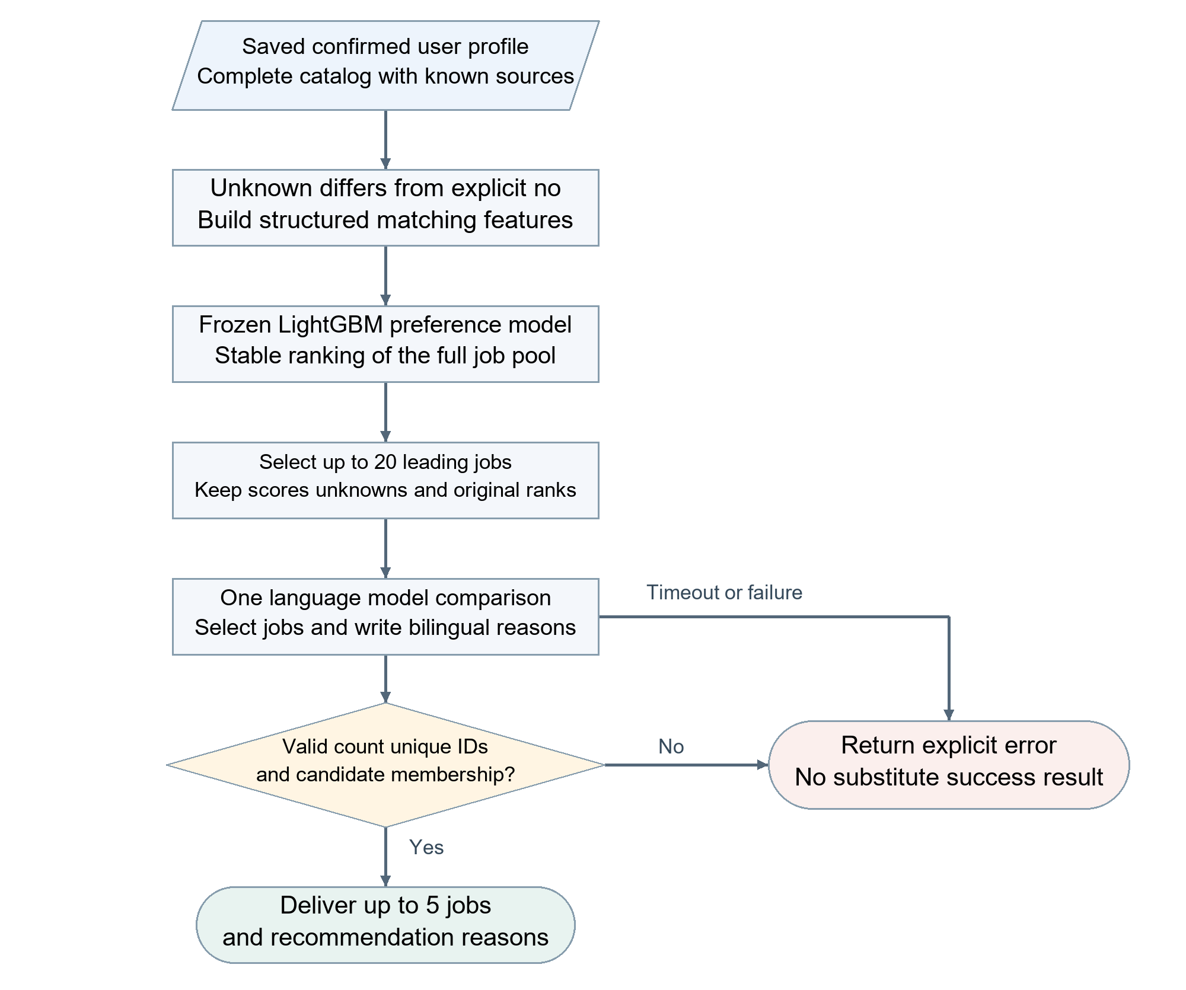
Figure 2 Full pool ranking, candidate reranking and recommendation delivery

3 Research on Semantic Representations and Missing Data

3.1 Frozen Text Representations and a Dedicated Reranker
Text methods independently encode job descriptions and resume text into a shared semantic space, then compare normalized vectors by cosine similarity to accommodate different wording of duties, experience and skills. The experiment uses frozen Qwen3-Embedding-0.6B to produce 1,024-dimensional vectors, with a 384-token input limit, FP16 and batch size 8. The backbone is not trained in this experiment. Job queries and resumes are encoded separately, and the candidate pools and labels remain fixed across comparisons.
Job text is prefixed with a retrieval task instruction. Inputs are left-padded; the last valid token's hidden state is extracted and L2-normalized. Jobs and resumes are encoded independently. After L2 normalization, their dot product equals cosine similarity. Vectors can be reused across pairs, while joint processing of two long texts is reserved for the smaller reranking pool.
The equal-budget TF-IDF baseline uses word unigrams and bigrams, minimum document frequency 2 and at most 20,000 terms, fitting its vocabulary on all unlabeled resume text. It therefore observes the evaluation text distribution without using supervised labels; the result applies to that retrieval setting. The dedicated Qwen3-Reranker-0.6B jointly reads the job and candidate text for the top 10 results, with budgets of 160 job tokens, 320 resume tokens and 768 total tokens, at batch size 4. Its function differs from the product text API reranker that generates reasons.
The dedicated reranker combines job text, resume text and a relevance instruction into one input. It normalizes the next-token logits for yes and no into a relative score, reranks the top 10 semantic results and leaves the remaining order unchanged. Joint attention can compare details across the two texts. The score still serves relative ranking for the specified task, not a hiring probability.

3.2 Missing Fields and Low Rank Residual Adaptation
Missing-field experiments delete registered fields from the original resume and then rebuild its vector with the same frozen encoder. Deletion changes both information availability and the content retained after 384-token truncation. An occasional score increase after deletion therefore does not imply that a field is useless. Text without valid content receives no reliable matching score, and coverage gaps must be reported separately from ranking quality.
Residual adaptation learns a shared transform on frozen 1,024-dimensional vectors: z = normalize(x + W_up W_down x). W_down maps 1,024 dimensions to 16 and W_up maps back to 1,024, giving 32,768 parameters without biases. The up-projection starts at zero, so the initial representation equals the original vector. Jobs and resumes share the transform. It adjusts the matching space using available information without generating or inferring missing resume content.
Each update uses the labeled candidate pool for one job and a softplus((negative score - positive score) / 0.05) loss over every positive-negative pair. A uses two original-profile views. B uses one original view and one entity-level mixed view. The mixed view has eight types: the original and all seven nonempty deletion combinations of skills, education and work experience. Each entity cycles through them across epochs from a fixed assignment code, so every type occurs twice in 16 epochs. Valid view losses are averaged equally. The original view must contain both positive and negative examples; the mixed-view term is skipped if either class is absent. Pairs without valid content remain unscored.
Grouping by original job title yields 252 training jobs, 72 validation jobs and 72 development-report jobs, preventing same-title groups from crossing splits. A and B share initial weights and job order, use AdamW at learning rate 0.001 and seed 42, and train for 16 epochs with only the last epoch reported. This small adapter is a separate approach from the structured missing-data tree model; the experiment does not modify deployed first-stage artifacts.

4 Controlled Experiments and Core Results

4.1 Acceptance Criteria for Structured Ranking
For nDCG@5, relevance at each of the first five ranks is divided by log2(rank + 1), summed and normalized by the ideal gain for that query, then macro-averaged over evaluable queries. Recall@5 is the fraction of all positives in the labeled pool found in the first five positions. Structured preference testing includes 501 queries with positives in its ranking mean and excludes 143 all-negative queries. The job-side task has 15 positive-containing queries. AP summarizes precision-recall behavior over observed pairs and differs from query-macro ranking metrics.
Table 4 compares the frozen complete-profile baseline H with the current missing-data-trained B. H uses 200 preference trees and 180 job-side trees; validation selects 100 and 20 respectively for B. The overall H-to-B difference therefore includes both training views and model selection and is not a single-factor causal effect. The three main missingness scenarios are random removal of 30% of profile blocks, removal of the full optional-field bundle, and removal of that bundle for 50% of candidates.
Table 4 Principal structured ranking results
Direction and scenario | H historical | B augmented
Preference; complete profiles; nDCG@5 | 0.9435 | 0.9354
Preference; mean of main missingness scenarios; nDCG@5 | 0.8013 | 0.8029
Job-side; complete profiles; nDCG@5 | 0.5890 | 0.4720
Job-side; mean of main missingness scenarios; nDCG@5 | 0.3942 | 0.3425

The original gate requires complete-profile AP and nDCG losses no greater than 0.02, and a mean nDCG gain of at least 0.03 across the main missingness scenarios, judged independently for both directions. The preference missingness gain is only 0.00153, with a paired 95% interval from -0.00609 to 0.00929. Complete-profile job-side nDCG falls by 0.1171. The current B model fails this gate; AP improvements in selected scenarios do not establish an overall improvement in top-five ranking.

4.2 Semantic Representation Results on an External Labeled Pool
The external text experiment uses a fixed Multiview Job-Resume Matching snapshot containing 396 IT jobs and 3,962 resume pairs, with 1,980 positives and 1,982 negatives. There are 394 jobs with 10 candidates and two with 11; every job has five positives. Evaluation ranks candidates for each job only within its observed labeled pool, without adding unlabeled negatives. The data contain synthetic and template effects, and the observed dataset counts differ from those described in the paper.
Table 5 Text representations and reranking on the same external pool
Method | Macro nDCG@5 | Recall@5
TF-IDF at the same 384-token budget | 0.38638 | 0.41313
Frozen Qwen semantic vectors | 0.84396 | 0.83333
Semantic vectors with dedicated top-10 reranking | 0.82440 | 0.81566

Semantic vectors improve nDCG over equal-budget TF-IDF by 0.45758. A paired job bootstrap with 2,000 resamples and seed 42 gives a 95% interval of 0.42864 to 0.48550. Dedicated reranking changes nDCG by -0.01956 relative to the vector baseline, with an interval of -0.03852 to -0.00023; the current setting shows no overall benefit. Recall@10 of 1 in this small labeled pool does not imply full-catalog recall.
Cross-dataset findings limit generalization. In the RJDB synthetic pair task, Qwen and equal-budget TF-IDF both achieve 87.0% pair accuracy and the interval for their difference crosses zero. On JTH, enhanced LightGBM improves job-macro nDCG@5 over the manual-field baseline by 0.00215, with an interval of -0.03180 to 0.03473. Different labels, candidate pools and ranking directions prevent direct comparison of these scores with Table 5.

4.3 Missing Field Sensitivity and Adaptation Results
With labels for all 396 jobs and the frozen encoder unchanged, deleting work experience reduces nDCG@5 from 0.84396 to 0.77187, with 197 jobs declining. Figure 3 shows paired differences from complete profiles and 95% intervals for each single-field deletion. The small mean increase after skill deletion is also affected by changes in truncated content and does not justify removing skills from the product.
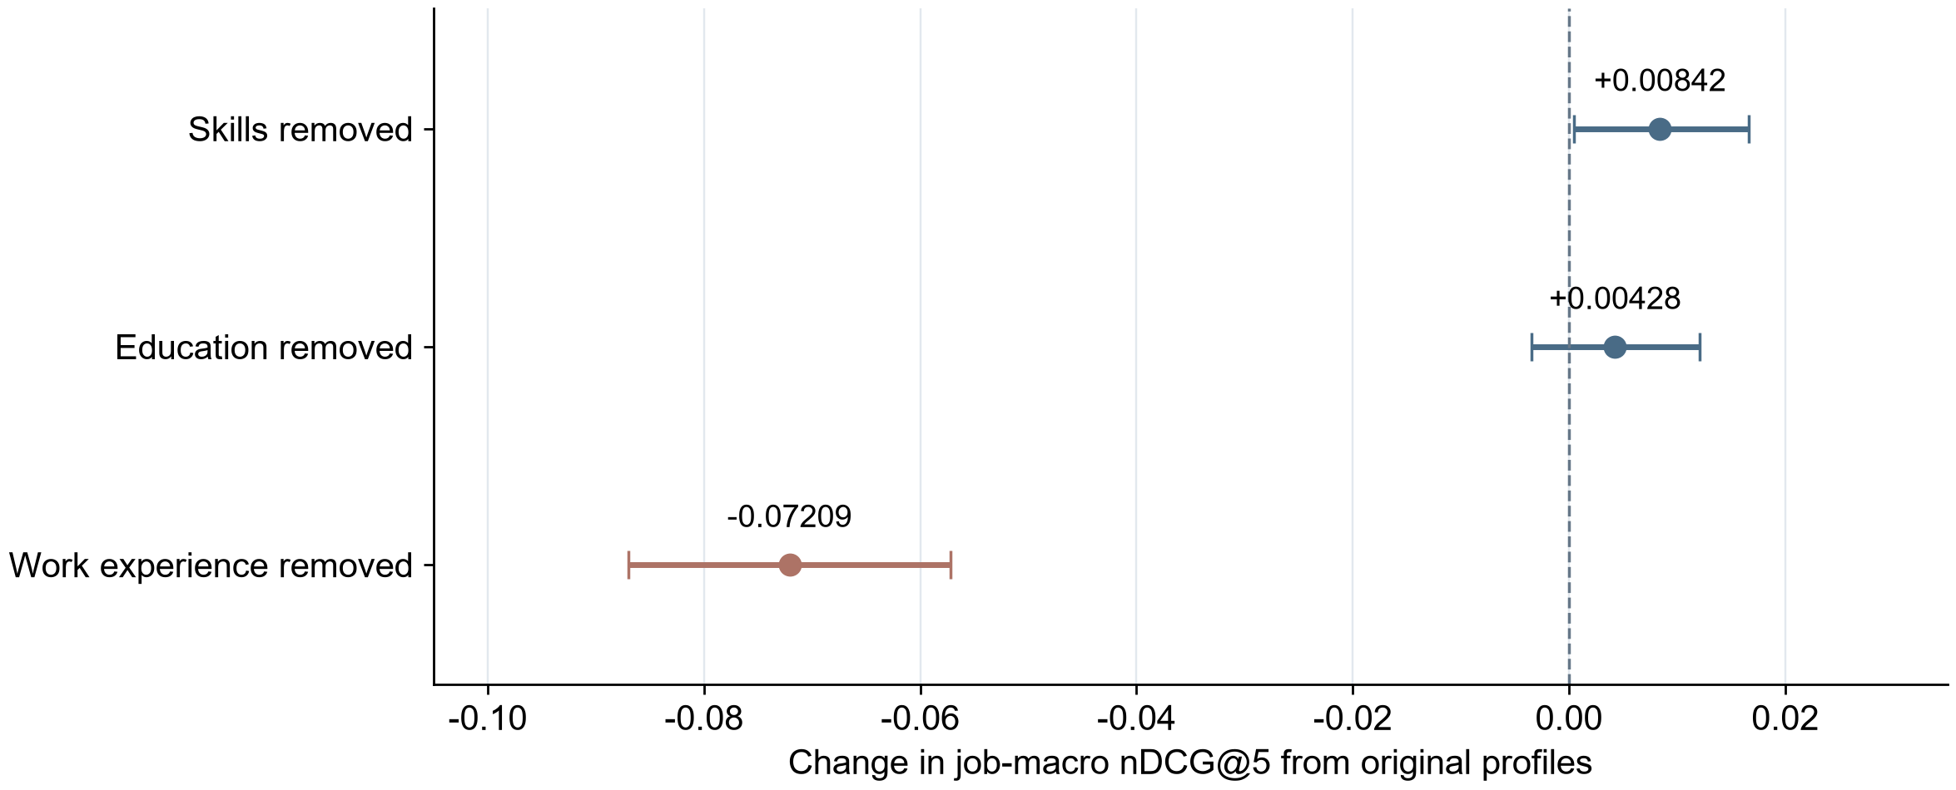
Figure 3 Changes in nDCG@5 after field deletion with paired job 95% intervals
Table 6 reports macro nDCG@5 on the residual adapter development-report set. H uses frozen vectors, A trains on original profiles and B trains on original and incomplete views. Candidate pools are identical within a row, but the number of fully scoreable jobs differs across scenarios.
Table 6 Residual adaptation on the development report set
Scenario and scoreable jobs | H frozen | A original | B augmented
Original profiles; 72 jobs | 0.87962 | 0.99636 | 0.99615
Eight-view mixture; 45 jobs | 0.77222 | 0.96356 | 0.98748
Work experience removed; 72 jobs | 0.79465 | 0.93373 | 0.98907

In the eight-view mixture, B improves over A by 0.02393. The job-level 95% interval is -0.00344 to 0.06080 and crosses zero. Although the job-title-group interval is 0.00922 to 0.03859, the estimate is based on only four title groups; selecting the more favorable interval would not establish stable generalization. Only 45 of 72 jobs are fully scoreable. Thirty-one pairs lack scores, including 19 positives. Near-perfect scores may also depend on data-construction cues, and no new independent confirmation set is available.

5 Limitations and Applicability
The product implements a recommendation chain comprising confirmed profiles, full-pool first-stage ranking, limited-candidate reranking and evidence-constrained explanations. The catalog comes from synthetic research data, the structured model has not passed its quality gate, and gains from text-model reranking, real user utility and explanation faithfulness have not been independently verified. Model output is not suitable for automated hiring decisions, and profile completeness is not a confidence score.
Semantic representation and missing-data augmentation results support further evaluation of richer matching representations, but do not replace conclusions about current product quality. Evaluation should jointly report candidate coverage, top-five ranking, unscored positives, profile-completeness subgroups and explanation consistency with facts. Interview evidence is not currently included in recommendation features.

