Server Software Testing and Performance Validation Technical Report
Test date 6 October 2026
Scope: recorded server measurements for release 0024583. Synthetic data combined with live services validate functionality. Software contracts, model quality and long-term service quality are interpreted separately.
Abstract Testing covers the deployed server application, including profile access, PDF processing, version protection, recommendations, live text interviews, session invalidation and connection capacity. Sixteen business-case scenarios and the existing access constraints meet their assertions. All 7,996 profile reads preserve status and content consistency. At concurrency 4, throughput is 37.11 completions per second and P95 is 148.64 ms. Model-dependent waits are evaluated separately from read-only endpoints. AI behavior review is disabled, so passing functionality does not demonstrate effective safety review.

1 Test Scope and Acceptance Basis
Tests cover profile reads, PDF processing, version editing and export, recommendation output, text interviews, login and logout, and capacity constraints in the deployed service. Profiles and interview history must be visible only to their owner. Edits must create independent versions, and originals and referenced sources must be protected. Parsed text becomes available for interview use only after the complete result is saved. Recommendation and interview outputs must satisfy identity, count, state and persistence contracts.
Profile endpoint performance is described by complete-response latency, valid completion throughput and error count. P95 approximately marks the latency at or below which 95% of observed requests finish, and is interpreted together with throughput and resource usage. Business cases use actual queues, isolated processing and model services to check workflow and output contracts. Latency ranges from a few model requests are not treated as long-run performance percentiles.

2 Server Environment and Workload
Table 1 Tested server configuration
Item | Configuration
System and resources | Ubuntu 22.04.5 LTS 2 vCPU 3.5 GiB visible memory
Application and database | Python 3.12.14 Django 5.2.17 PostgreSQL 14.24
Service endpoint | Nginx 1.18.0 HTTPS and WSS; ASGI workers 1
Review mode | AI behavior review disabled; authentication and CSRF protection enabled
Release | 0024583
Load and duration | 16 synthetic accounts; 100 versions each; 4 concurrency levels; 3 runs of 20 s per level
Test date | 6 October 2026

The read workload uses 16 dedicated synthetic accounts, each with 100 ready profile versions. Requests repeat a list, list, detail sequence, with 50 entries per list page. Application-layer load reaches the actual ASGI process from inside the server while retaining production authentication and PostgreSQL access. Public-path sampling uses an independent external Windows client through HTTPS. Results are reported separately to avoid attributing public-network waits to application-layer processing. Business scenarios use two separate test identities, simple one-page synthetic PDFs and fixed text profiles through the actual HTTPS and WSS endpoints, without model doubles.
Application-layer load uses 1, 4, 8 or 16 concurrent simulated users. Each user waits for the complete current response before sending another request, so concurrency bounds the number of outstanding requests. This is a closed-loop fixed-concurrency workload. Each condition has three 20-second repetitions with rotated condition order. Statistics exclude 32 warm-up requests. Connections are reused, client timeout is 5 seconds and business requests are not retried.
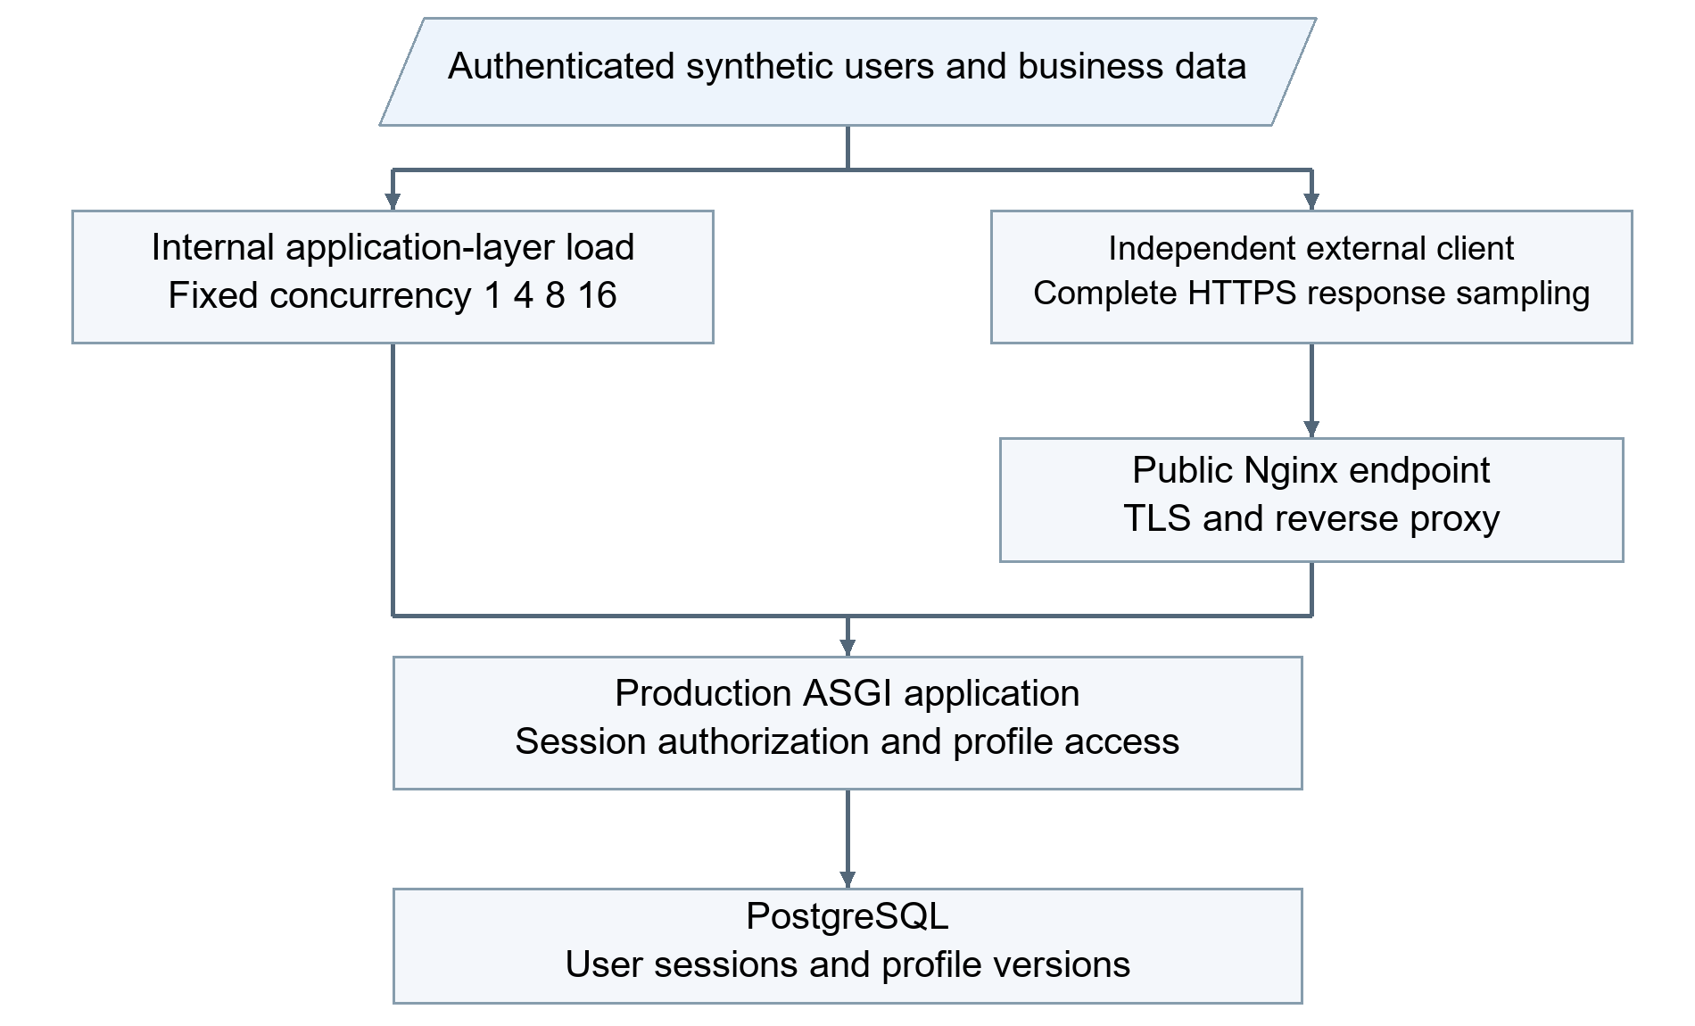
Figure 1 Application layer and public network measurement paths
Latency runs from request dispatch to complete response-body reading, excluding subsequent content assertions. P50 and P95 use linear interpolation on the pooled raw samples from three repetitions. Throughput is valid completions divided by cumulative duration, including tail draining. Server resources are sampled approximately once per second, reporting host CPU usage and ASGI resident memory. Host CPU also includes the load generator running on the same server. CPU estimates use valid adjacent intervals of at least 0.5 seconds to reduce short-tail noise. Memory peaks retain every sample, and this resource-interval rule does not exclude request samples.
Selected application-layer and external public-path samples must occupy non-overlapping time windows, retaining three 20-second runs for each concurrency level. Repetition 1 at concurrency 8 and 16 uses an independent window with the same configuration; the other ten runs retain their original observations. Overlapping original windows are excluded from application-layer aggregation. Cache and background load can differ between windows. Selection follows sampling independence rather than response performance.
A valid completion requires the expected HTTP status, resource ownership and response content. Errors include request exceptions, timeouts, unexpected status and body mismatches. Failed-attempt latency must also be retained; HTTP 200 alone is not success. The final 7,996 reads contain no such errors, so all-attempt and successful-request percentiles coincide. Under fixed concurrency, slower responses lower the arrival rate of subsequent requests. These results do not validate sustained-arrival or burst-load capacity.

3 Functional and Capacity Validation Results
Table 2 Server functionality and constraint checks
Validation item | Scale | Observed result
Authenticated profile reads | 7,996 | All HTTP 200; ownership and content consistent
Access and CSRF boundaries | 3 categories; 10 checks each | Anonymous 401; cross-user 404; writes without CSRF 403
Interview capacity and release | 5 cycles | 4 connections admitted; extra connection rejected; admission restored after release
Account login and session invalidation | 2 accounts; 3 logout cycles | Access after login; old cookie returns 401; old WSS closes with 1008
Conventional PDF processing | 2 one-page files | Original bytes identical; 4 text checks; result matches ready state
Multimodal PDF proofreading | 1 one-page file | Live vision service completes; returned and saved text match
Damaged PDF handling | 1 case | Error returned; failed state saved; blocked from interview input
Immutable versions and protected snapshots | 1 version chain | PATCH on original returns 405; edits create a version; consistent export; deletion of referenced source returns 409
Unknown versus explicit zero | 1 saved profile | GPA remains unknown; experience retains 0 months
Unconfirmed recommendation profile | 1 case | Unsaved fields reject recommendation with 422 even when text mentions skills
Live recommendation workflow | 3 skill profiles | 100 jobs ranked to 20; reranking returns 5 unique jobs with bilingual reasons
Live interviews and persistence constraints | 2 one-question interviews | Consistent answer and report readback; cross-user history 404; duplicate UUID rejected; scores delivered first

Profile reads and access denials behave as expected. Valid PDFs produce complete results in conventional and multimodal modes, preserving original bytes. The damaged case is saved in a failed terminal state rather than interpreted as success. Version-chain checks verify immutable originals, independent edits, consistent text export and deletion protection for referenced sources. The findings cover the simple PDFs and version scenarios used, not general recognition accuracy on complex scans.
Live recommendation requests read only saved, confirmed fields. Unconfirmed profiles return 422, while unknown values and explicit zero retain distinct meanings. All three skill profiles complete full-pool ranking of 100 jobs, reranking of 20 candidates and delivery of five unique jobs with bilingual reasons. Two live text interviews complete one question and answer each, with consistent answer, final-report and terminal-request readback. Numerical scores arrive before the complete report. Cross-user access is isolated and a used request UUID cannot execute again.

4 Response Performance and Resource Analysis
Table 3 Application layer profile read performance
Concurrency | Valid reads | Completions/s | P50 ms | P95 ms | Mean host CPU
1 | 1,339 | 22.30 | 43.11 | 59.48 | 54.4%
4 | 2,235 | 37.11 | 104.16 | 148.64 | 79.8%
8 | 2,224 | 36.84 | 206.36 | 310.32 | 82.0%
16 | 2,198 | 36.29 | 420.12 | 668.45 | 80.6%

Table 4 Observed ranges across three runs per condition
Concurrency | Per-run throughput range in completions/s | Per-run P95 range in ms
1 | 21.84 to 22.96 | 58.03 to 61.07
4 | 36.64 to 37.85 | 142.66 to 151.53
8 | 35.28 to 38.36 | 296.53 to 341.42
16 | 35.11 to 38.61 | 597.26 to 698.37

Table 3 pools complete request samples for percentiles; Table 4 retains variation between the individual 20-second runs. A range across runs is not a 95% confidence interval. Approximately one minute of observation per condition identifies a throughput plateau for this read workload, but is insufficient to establish long-term stability, a capacity ceiling or a service-level agreement.
At concurrency 1, P95 is 59.48 ms. Valid throughput at concurrency 4 is 37.11 completions per second, compared with 36.84 and 36.29 at concurrency 8 and 16. Throughput plateaus near concurrency 4, while P95 rises to 668.45 ms at concurrency 16. Additional outstanding requests mainly lengthen tail waits. The workload includes list responses containing metadata for 50 versions, so its throughput should not be interpreted as that of a lightweight health endpoint.
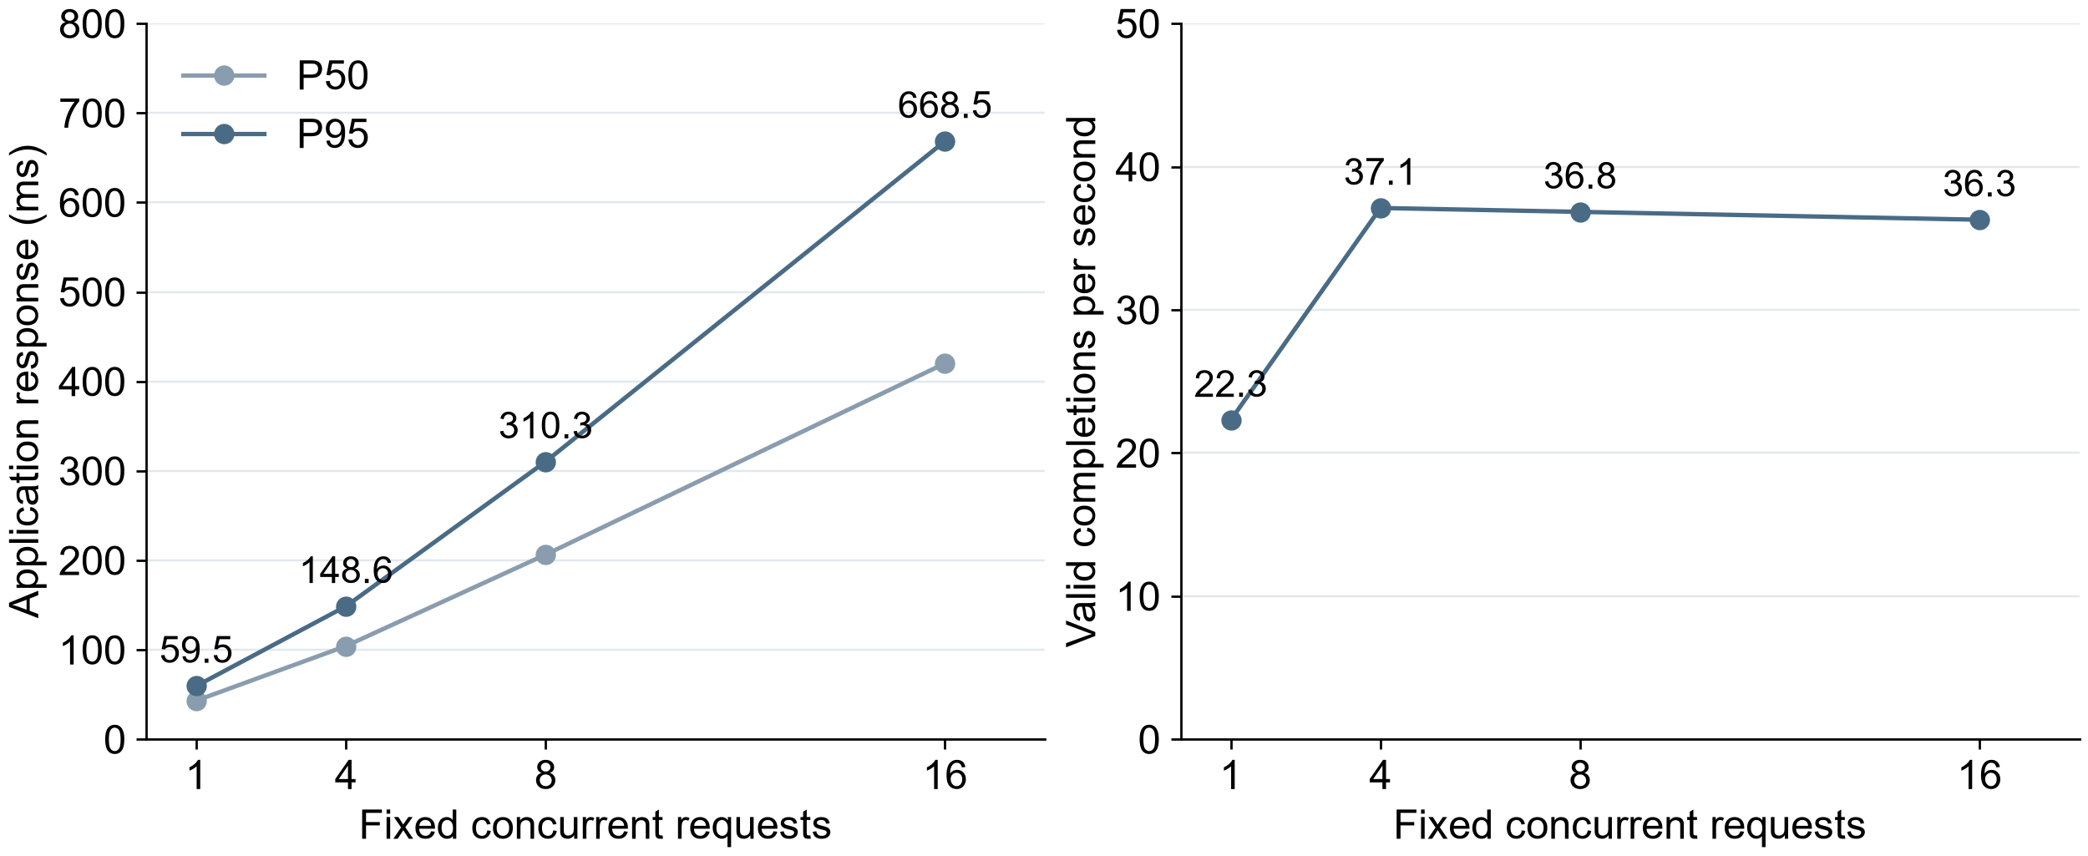
Figure 2 Application layer response percentiles and valid completion throughput
At higher concurrency, mean host CPU usage is approximately 80.8% and peak usage is 88.1%. The single ASGI worker averages up to approximately 0.99 CPU cores. Peak resident memory is 198.3 MiB, well below visible server physical memory. CPU usage and response tails rise together, supporting the interpretation that processing capacity and request queuing constrain this workload. These observations alone cannot separate application computation time from database access time.
Public-path sampling comprises 60 sequential reads of saved profile details from one client without additional read load, excluding five warm-ups. All meet status and body assertions. Complete HTTPS responses have P50 70.13 ms and P95 84.29 ms. These measurements include the external network, TLS endpoint, proxy and application, describing experience on that client path. Public detail requests and mixed server reads differ in both route and workload; subtracting them does not isolate network latency.
Table 5 Timing boundaries for live business cases
Business observation | Cases | Duration s | Scope
Conventional PDF workflow | 2 | 0.71 to 2.02 | Upload, original readback, queue processing and terminal-state confirmation
Multimodal PDF workflow | 1 | 3.47 | Same one-page text case; live visual proofreading
Complete recommendation API response | 3 | 9.21 to 13.82 | Full ranking of 100 jobs and model reranking; no ranking-quality assessment
Interview startup to first question | 2 | 30.77 to 31.36 | Includes profile understanding, planning and question construction
Answer submission to complete report | 2 | 37.70 to 38.15 | Excludes user thinking; scores delivered before complete report

PDF timings include upload, original-file readback, queued processing and terminal-state confirmation. Recommendation timing spans dispatch to complete response. Interview timings separately span startup to first question and answer submission to complete report. Model-dependent waits are substantially longer than profile reads and require a separate user-experience metric. Table 5 gives ranges for a small number of cases and does not establish a stable speedup, general accuracy or service-level agreement.

5 Technical Conclusions and Applicability
The tested profile, version, recommendation, interview, session and capacity scenarios satisfy their corresponding software contracts. After logout, old cookies are rejected and existing WSS connections become invalid. Connections above capacity are rejected, and admission succeeds after resources are released. The current read configuration plateaus near concurrency 4; more concurrency mainly increases tail waits. Higher capacity requires further evaluation of process parallelism and database access overhead.
Results apply to the stated server, release snapshot, synthetic data and sampling scope. Simulated concurrency is not equivalent to real online-user capacity. AI behavior review was disabled during testing, and interview readback explicitly indicates unreviewed content. Functional success therefore does not demonstrate prompt-attack protection. Recommendation responses still identify the model as experimental and its quality gate as unmet; valid API output cannot establish ranking quality. Speech hardware and long-term stability require separate evaluation.

