IntelliHire AI User Guide
Using the interview practice system
Version 1.1 | 21 October 2026
This guide takes you from your first sign-in to a saved interview review. You will import and check a resume, practise spoken answers, read evidence-based feedback, and optionally explore job matches. It is intended for people using an already running system.
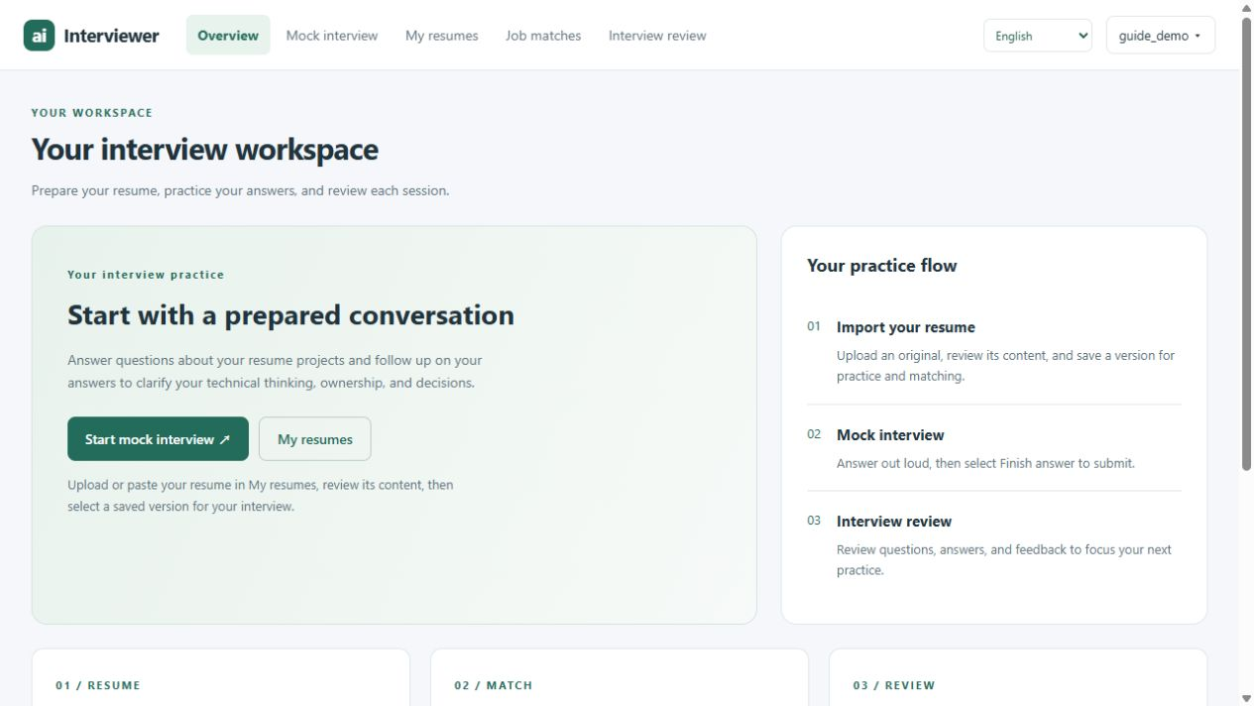
Figure 1. The Overview page links to the four main workspaces.

Your first practice session
1. Sign in. Use your own account so that your resumes and interview records stay together.
2. Prepare a resume. Open My resumes, import your content, check it and save an edition.
3. Set up an interview. Choose a ready resume, enter a target role and confirm the duration.
4. Answer aloud. Follow the preparation countdown and recording status for each question.
5. Review your results. Save the session and open Interview review to revisit answers and feedback.
Reading the screenshots: red outlines and numbered markers identify key controls. Each figure has a matching marker key; use the numbered instructions to complete the task.
Find a task: account access on page 2; resume import on page 3; editing and versions on page 4; interview setup on page 5; the interview workspace on page 6; answering and ending on page 7; reports on page 8; job matches on page 9; common problems on page 10.

1 Sign in and get ready
Open the system address supplied by your project team or administrator. Select English in the Language menu to match the labels in this guide. Chinese and Follow system are also available; this setting changes interface wording, not the scoring rules.
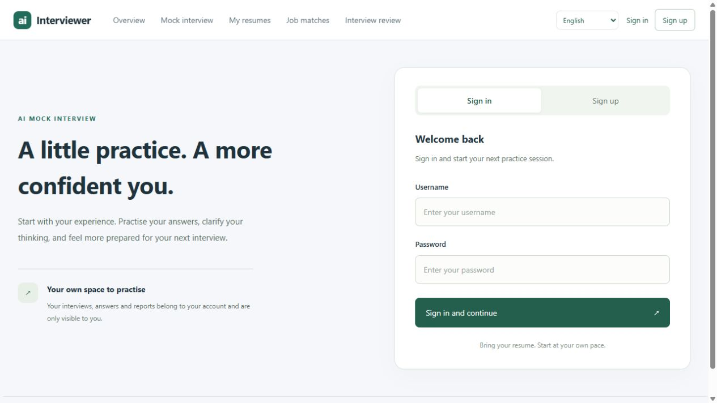
1
2
3
Figure 2. Use the Sign in and Sign up tabs to access your account.
Markers: 1 Choose Sign in or Sign up. 2 Enter your username and password. 3 Sign in and continue.
1. Create an account if needed. Select Sign up, enter a unique username and password, then select Create account. The current form does not require an email address.
2. Sign in. Enter the same username and password and select Sign in and continue. An incorrect combination leaves you on the form with an error.
3. Use the top navigation. My resumes manages your materials; Mock interview runs a session; Interview review opens saved sessions; Job matches opens recommendations.

Before starting a voice interview
Have a microphone, a way to hear the questions and a stable connection. Use a quiet space and allow the browser to access the microphone when prompted. A camera is optional: Enable camera shows a local self-preview and does not record or upload that video.
Your resume and spoken answers are processed by the model services configured for the system. Use material you are comfortable submitting, and remove confidential information that is not needed for practice.
To sign out, open the account menu at the top right and select Sign out. Signing out does not delete your saved resumes or interviews.

2 Import your resume
Open My resumes and select Attachments. Give each version a useful name under Custom name so you can recognise it when selecting a resume for an interview.
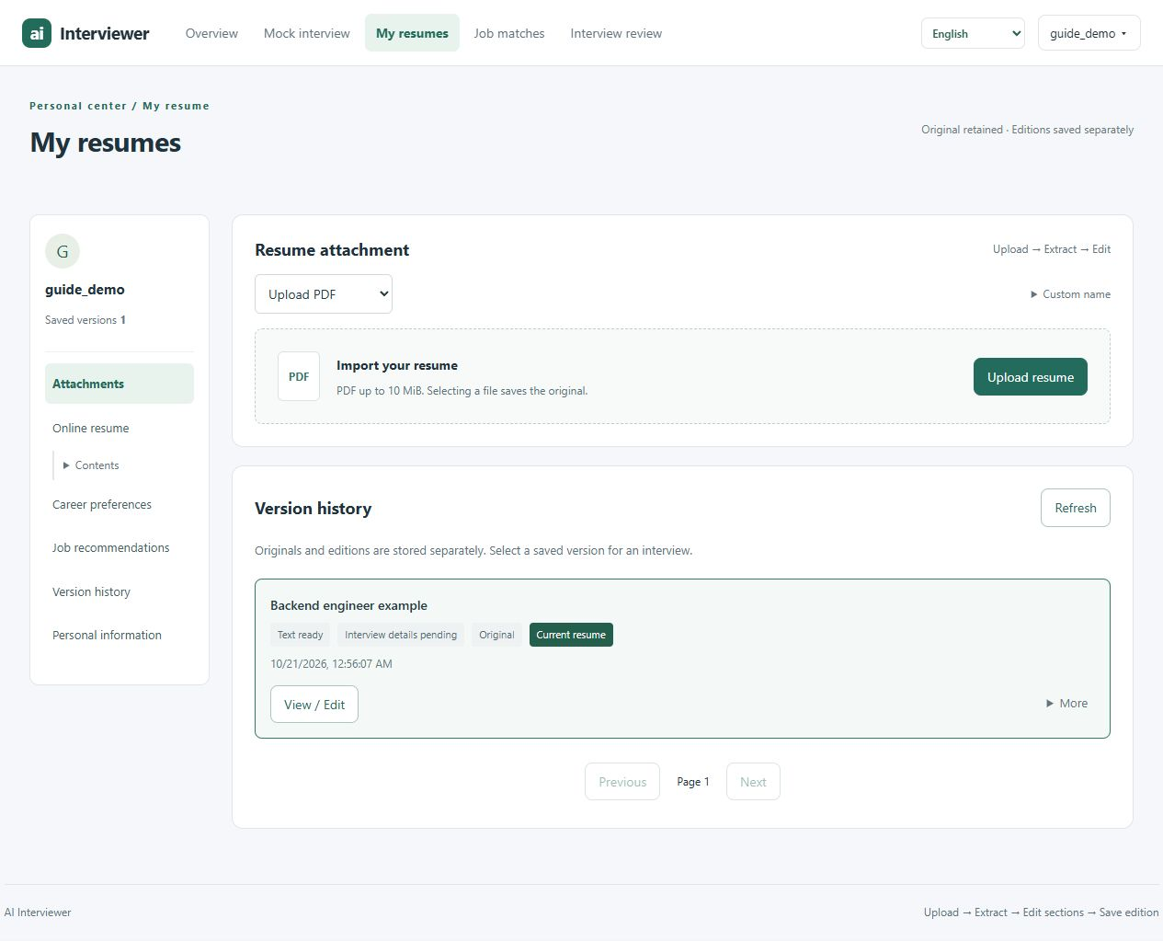
1
2
3
Figure 3. Resume attachment and version history with an example resume.
Markers: 1 Choose the import method. 2 Upload resume. 3 View / Edit a saved version.

Upload a PDF
1. Choose Upload PDF. Select Upload resume and choose a nonempty PDF no larger than 10 MiB. Selecting the file saves the original.
2. Extract its content. Below the uploaded attachment, choose Traditional (default) or Advanced · Multimodal LLM, then select Extract resume. To reopen an earlier upload, select View / Edit in Version history. Advanced extraction sends page images to the model and takes longer.
3. Check the result. Wait for Text ready, then open View / Edit. Check the extracted content against the original, especially dates, project details and skills.

Paste text instead
Choose Paste text in Import method, paste your resume and select Save text. The text must be nonempty and contain at most 200,000 characters. A text version does not need PDF extraction; continue by reviewing its sections.
After a cancelled or interrupted extraction, select Refresh to check the saved status. If the version is Failed or Interrupted, upload a new copy. A completed upload alone does not mean the PDF has been extracted successfully.

3 Review content and manage versions
Select View / Edit beside a saved version to open Online resume. The editor groups content into sections such as Education, Internships and employment, Projects, Skills and Career preferences.
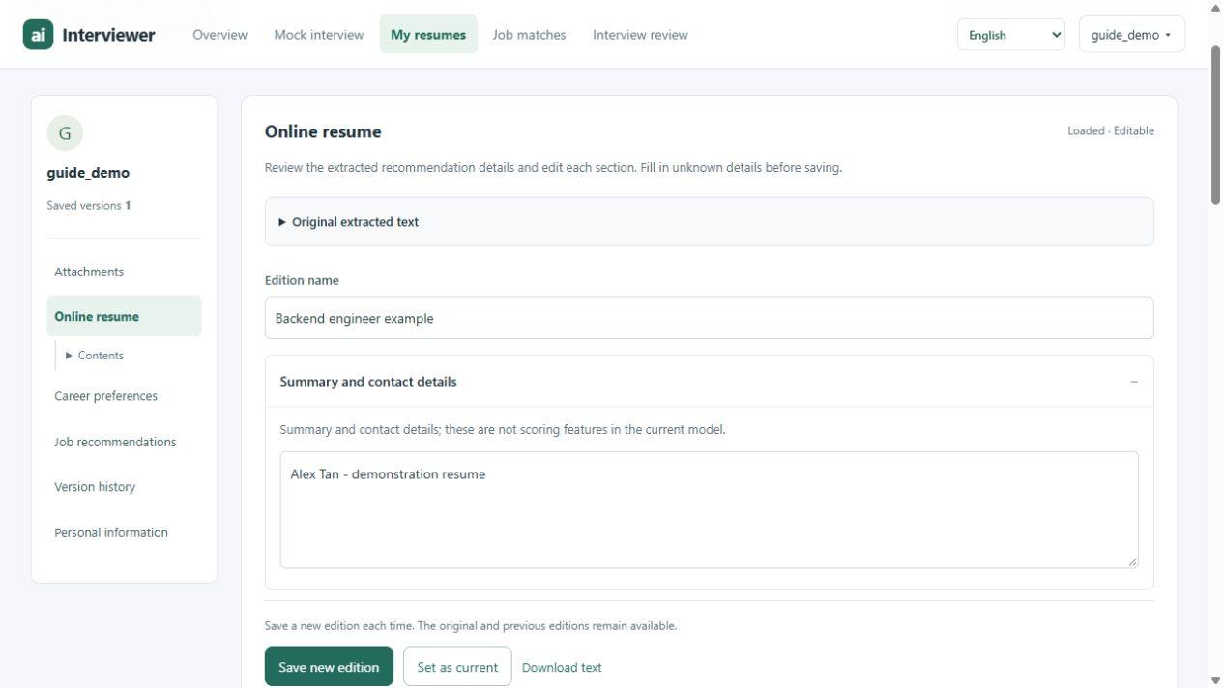
1
2
3
Figure 4. Review section text and save changes as a separate edition.
Markers: 1 Compare Original extracted text. 2 Edit the selected section. 3 Save new edition.
1. Check the original. Expand Original extracted text (marker 1) to compare the read-only source with the editable sections. Move misplaced text to the correct section and correct extraction errors.
2. Edit your content. Update the section text (marker 2) with your own contribution, technical decisions and outcomes. Use Edition name to distinguish the version you are preparing.
3. Confirm recommendation details. If you want job matches, review the optional fields under the relevant sections. Keep unknown values unspecified. Use months for experience and the original grading scale for GPA.
4. Select Save new edition. Use marker 3 to create a separate version. The original and earlier editions remain available. Save before switching versions or leaving the editor.
5. Choose the version to use. Use Set as current for your preferred version. Still check the selected resume in the interview or recommendation picker. Download text exports the saved text edition.
Text ready and Ready for interview are different states. After text is saved, the system must also prepare the project and skill details used for interviews. If preparation is pending or fails, the saved resume remains available; use Prepare interview details / retry or the preparation control in Mock interview.
Version history also provides original-file download and deletion controls where applicable. Deletion is permanent and requires confirmation. A version used by an interview, referenced by an edition or currently being parsed cannot be deleted.

4 Prepare a mock interview
Open Mock interview and select Start interview or Interview settings. The preparation dialog lets you select a saved resume and set the session parameters before any interview begins.
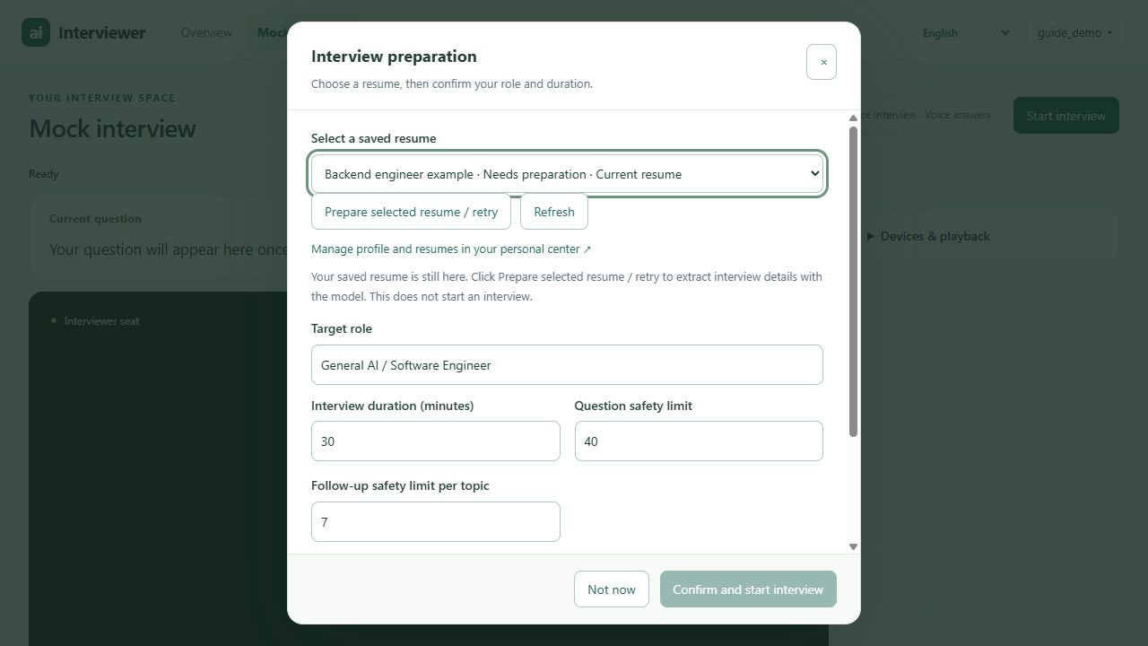
1
2
3
Figure 5. A resume marked Needs preparation must be prepared before confirmation.
Markers: 1 Select and prepare a resume. 2 Set the role and time limits. 3 Confirm when the resume is ready.
1. Select a saved resume. In marker 1, choose a version. If it says Needs preparation, select Prepare selected resume / retry. Wait, then use Refresh to update the status. Preparation does not start an interview.
2. Set the role and duration. In marker 2, enter a meaningful Target role, such as Backend Software Engineer, and choose Interview duration (minutes).
3. Confirm the session. When the resume is ready, select Confirm and start interview (marker 3). Not now closes the dialog without starting.
Setting | Initial value | Meaning
Target role | General AI / Software Engineer | The role the interview should focus on.
Interview duration | 30 minutes | Time budget, including answers and model processing.
Question safety limit | 40 | Upper limit rather than a promised number of questions.
Follow-up safety limit per topic | 7 | Limit on follow-ups within a topic.

Timing starts when the first question is ready. The estimated number of questions can change as the plan adapts. A low question limit can finish the session before its time budget is used.

5 Use the interview workspace
The question panel, interviewer area and voice status form the main workspace. Keep this page open during the session. The screen below shows the workspace before the first question; the digital-human area is still a placeholder.
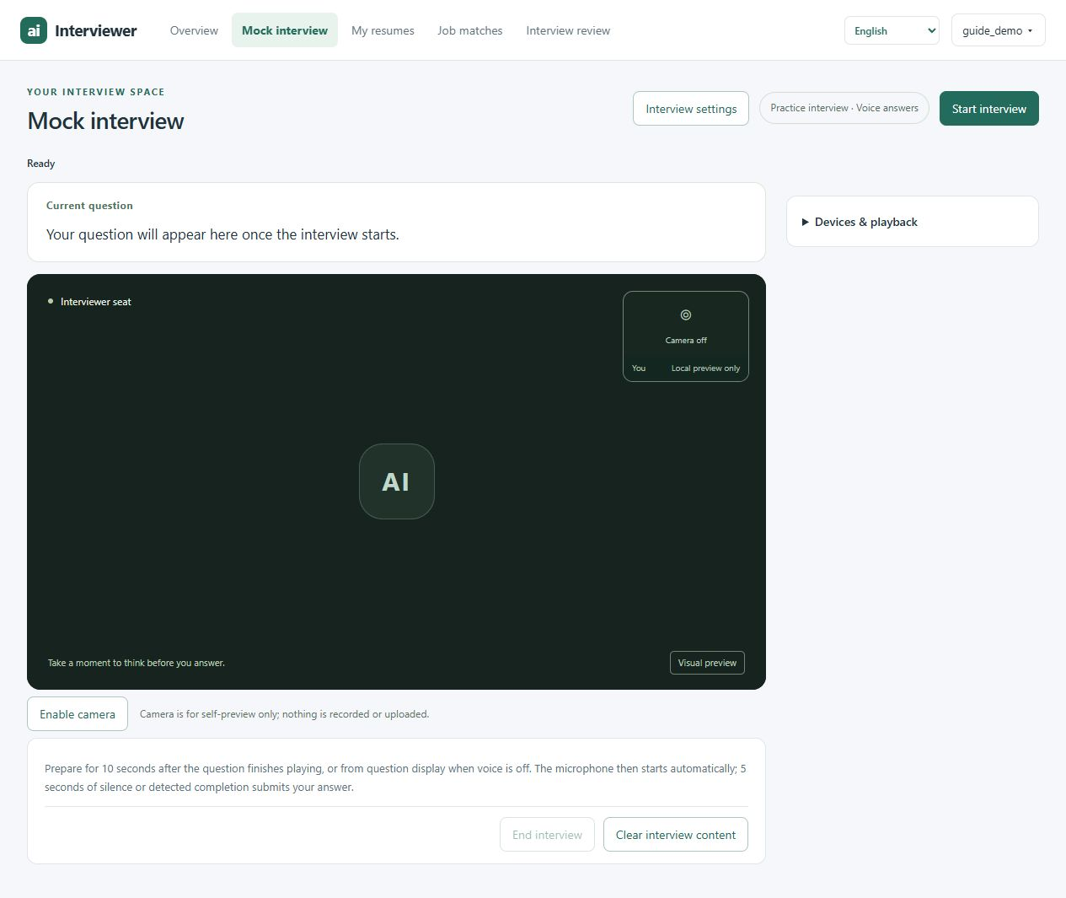
1
2
3
Figure 6. The interview workspace before a session begins.
Markers: 1 Read Current question. 2 Open Devices & playback. 3 Follow voice status and end controls.

What to watch during a session
Current question (marker 1) shows the prompt to answer. The voice status and end controls are in marker 3. Once a session is active, Time remaining, Current stage, Question progress and Topic progress help you follow its progress.
The system can ask follow-up questions based on your answer and move between project, technical and behavioural topics. Answer the current prompt and explain concrete actions and evidence from your own experience.

Playback and optional camera
Expand Devices & playback (marker 2) to find Read English questions aloud, Replay question, Interrupt speech and Connect / play interviewer. The system attempts the digital-human connection when an interview starts; its availability depends on the deployed renderer. Camera access is optional and used only for your local preview.

6 Answer questions and end the session

Follow the automatic answer cycle
1. Read or listen to the question. If automatic playback is enabled, wait until the question finishes. You can use Replay question to hear it again or Interrupt speech to stop playback.
2. Prepare during the countdown. You have 10 seconds after playback ends. With playback off, preparation starts when the question appears. Replay pauses the preparation countdown and resumes the remaining time afterwards.
3. Speak when recording starts. The microphone opens automatically after preparation. Follow the voice status and live transcript; the displayed draft is not yet the final submitted answer.
4. Finish naturally. Continuous silence of 5 seconds ends recording and submits the completed transcript. If answer-completion detection is enabled, the system may also recognise that you have finished. Recording also ends at 120 seconds.
5. Wait for the next step. The system finalises transcription, processes your answer and then presents a follow-up, another question or the end of the interview.
Answer submission is automatic in the current interview page. There is no Start answer or Finish answer button, even if older overview text mentions one. The current page does not provide a typed-answer input.
A long pause can submit your answer, so avoid unintended silence while you are still speaking. An empty final transcript is recorded as unanswered and does not receive a competency score. If transcription fails, the interface stops with an error rather than submitting the draft text.

Choose how to end
Select End interview to open the end-choice dialog. Opening the dialog pauses automatic answer submission while you decide.
Choice | Result
Evaluate and save to history | Completes any current transcription, evaluates completed answers and saves the session for review. Wait for confirmation; a request already in progress may need to finish.
End without saving | Ends this session and removes it from interview history after the server confirms the operation. Your resume remains saved.
Continue interview | Closes the end-choice dialog and restores the current session's automatic answering.

Clear interview content resets the local page once the session is no longer connected. It does not delete history. Closing, refreshing or leaving the interview page interrupts the session; saved interrupted sessions cannot currently be resumed.

7 Review your interview and report
After a saved interview ends, use View saved interview reviews or select Interview review in the top navigation. The page lists sessions associated with your account, including saved incomplete or failed sessions.
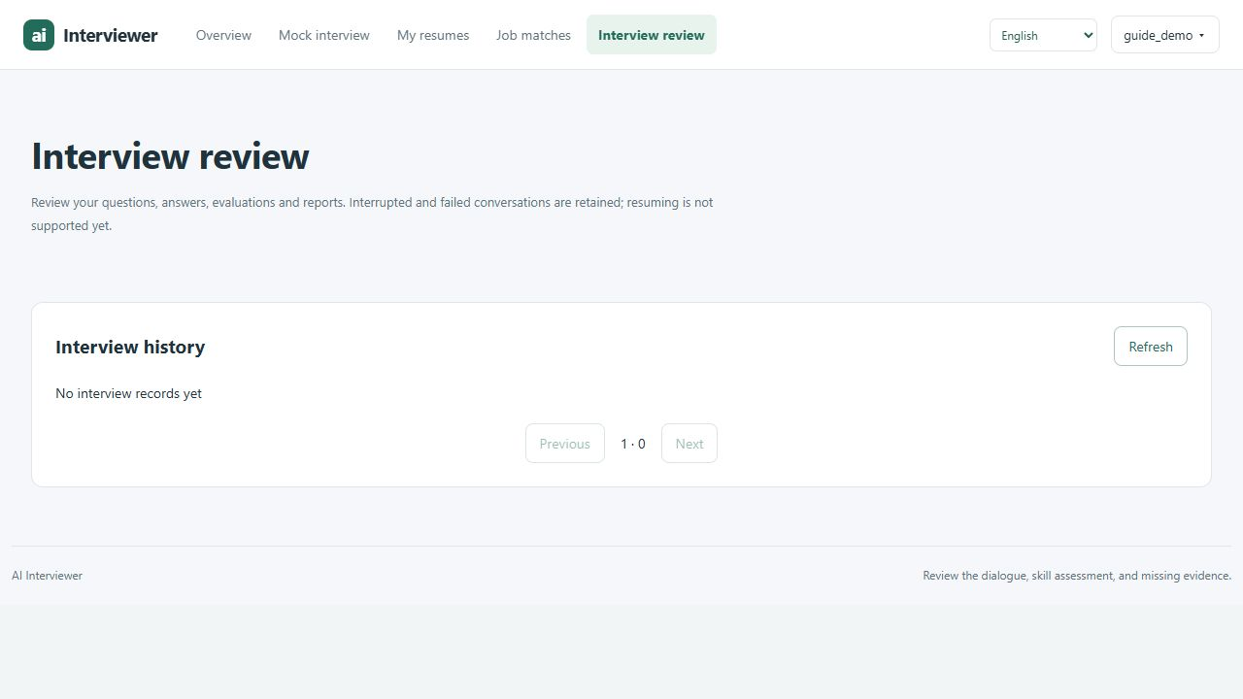
Figure 7. Interview review before the account has saved any sessions.
1. Find a session. Use its role and date, then select View review. Use Refresh, Previous and Next to navigate the saved list.
2. Read the dialogue. Compare each question with your recorded answer and any available feedback. Missing evaluation is shown separately; an introductory self-introduction does not contribute to the competency score.
3. Inspect the report. When available, review Overall score / 5, Evidence coverage and Unscored answers. Expand Inspect evidence to see the source excerpts supporting a competency.
4. Keep a copy. Select Download readable report (HTML) within an available report. Open the downloaded HTML in a browser to read it. If evaluation is still running, allow the report to update before treating it as final.
Score label | How to interpret it
Published | A score is available under the system's evidence and evaluation rules.
Provisional | Use the completed assessments for practice; evidence or evaluation limitations remain.
Unavailable | A valid score is not available. Read the recorded answers and the stated limitations.

Competencies include technical depth, ownership, decision making, debugging, evaluation and adaptability. Evidence coverage describes support for an assessment; missing evidence is not a zero score or proof of low ability. Results are practice feedback, not hiring probabilities or a ranking against other candidates.

8 Explore job matches
Select Job matches in the top navigation. Job matching uses the confirmed recommendation details of a saved resume and is separate from your interview scores.
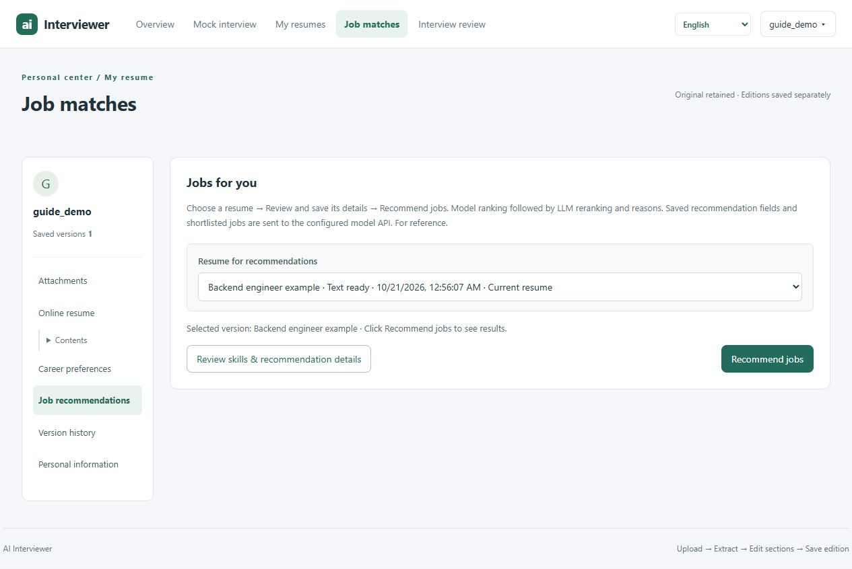
1
2
3
Figure 8. Select and review a saved resume before requesting job recommendations.
Markers: 1 Choose a saved resume. 2 Review and save its details. 3 Recommend jobs.
1. Choose a resume. Use Resume for recommendations (marker 1) to select the exact saved version you want to use.
2. Check recommendation details. Select Review skills & recommendation details (marker 2). Confirm skills, experience and relevant education or availability fields; leave unknown information unspecified.
3. Save changes. Select Save new edition, then confirm that the recommendation picker points to the intended saved version. Unsaved edits are not the recommendation input.
4. Select Recommend jobs. Use marker 3, then wait while the system ranks jobs and generates reasons. If it reports an error, follow the message rather than assuming results were created.
5. Read the results. Review the recommended order, skills and reasons. Use View job description where available to inspect a role.
Recommendations depend on the job catalogue and model services configured by the operator. Results marked Research data, not current vacancies are experimental examples. A match does not confirm an open vacancy, employer interest or an offer.
Confirmed recommendation fields and shortlisted job information are sent to the configured model service for ranking and explanations. Interview report scores are not required to request job matches.

9 Resolve common problems
What you see | What to do
Sign-in is rejected | Check the username and password. At sign-up, choose a different username if the existing one is already taken.
Upload is rejected | Use a nonempty PDF no larger than 10 MiB. For Paste text, enter nonempty content within 200,000 characters.
PDF extraction fails or stops | Select Refresh to inspect the saved status. Re-upload failed or interrupted versions; do not treat an uploaded original as extracted text.
Confirm and start interview is disabled | Choose a saved resume. If text is not ready, return to My resumes. If interview details are pending, select Prepare selected resume / retry, wait and refresh.
No question audio | Check device volume and browser sound settings; use Replay question. If playback is unavailable but recording still works, read Current question and follow the countdown.
No digital-human video | Open Devices & playback and try Connect / play interviewer. If the renderer is unavailable, use the displayed question and available speech controls; contact the operator if needed.
Microphone or transcription fails | Check browser microphone permission, the selected device and whether another application is using it. Follow the displayed error. Do not assume draft subtitles were submitted.
Connection is lost or the page was closed | Open Interview review to inspect what was saved. The system cannot resume the interrupted conversation; start a new session when ready.
Report has no score or is still processing | Wait if evaluation is pending, or reopen the saved review. Read the coverage and limitation messages. An incomplete report does not establish a low score.
Job matches are unavailable | Confirm and save recommendation fields first. For missing catalogue or model-service errors, contact the operator; use manual retry only after addressing the problem.

Keep track of your saved data
Saving an edition preserves the original and earlier versions. Ending without saving removes only the current interview when confirmed. Clearing the page and signing out do not delete stored records. Avoid leaving an active interview until you have chosen how to end it.
When contacting the operator, describe the page, action, displayed error and approximate time. Do not include passwords or unnecessary resume details.

