1. Opening MVC application folder
   1. Open Command prompt
   2. Go inside Grocery directory
   3. Type [code .] and press enter. Example C:\Desktop\GroceryStore> code .
   4. This should open VS Code with your GroceryStore project files.
2. Creating GroceryItem Model
   1. Right click on [Models Folder]
   2. Click [New File]
   3. Type [GroceryItem.cs] and press enter. This will create empty C# file.
   4. Type following code.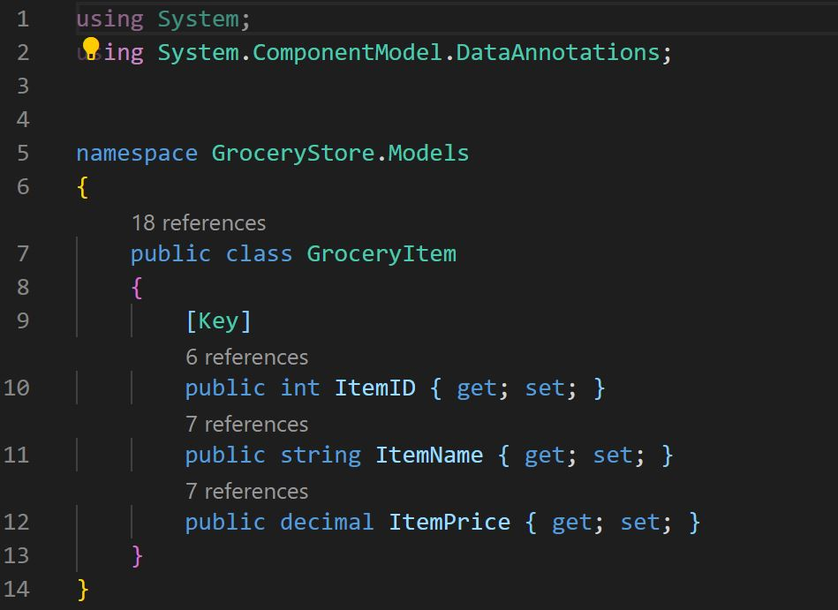
3. Create a class that derives from DbContext
   1. Hover over GroceryStore project folder and click [new folder]

Type [Data] and press enter.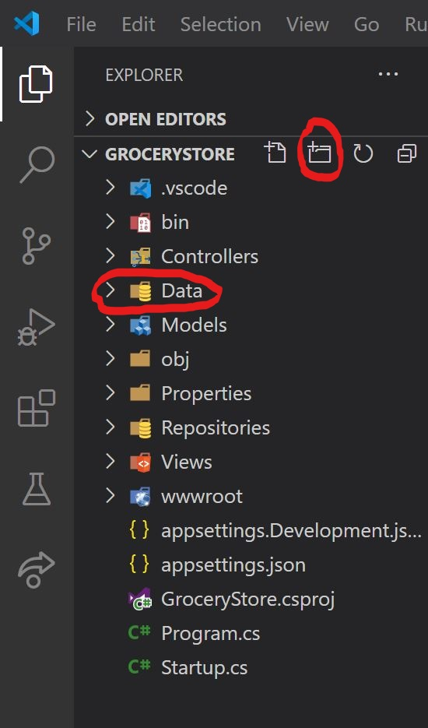

* 1. Right click on the [Data Folder] and click [New File].
  2. Type GroceryStoreContext.cs and press enter.
  3. Type following code.

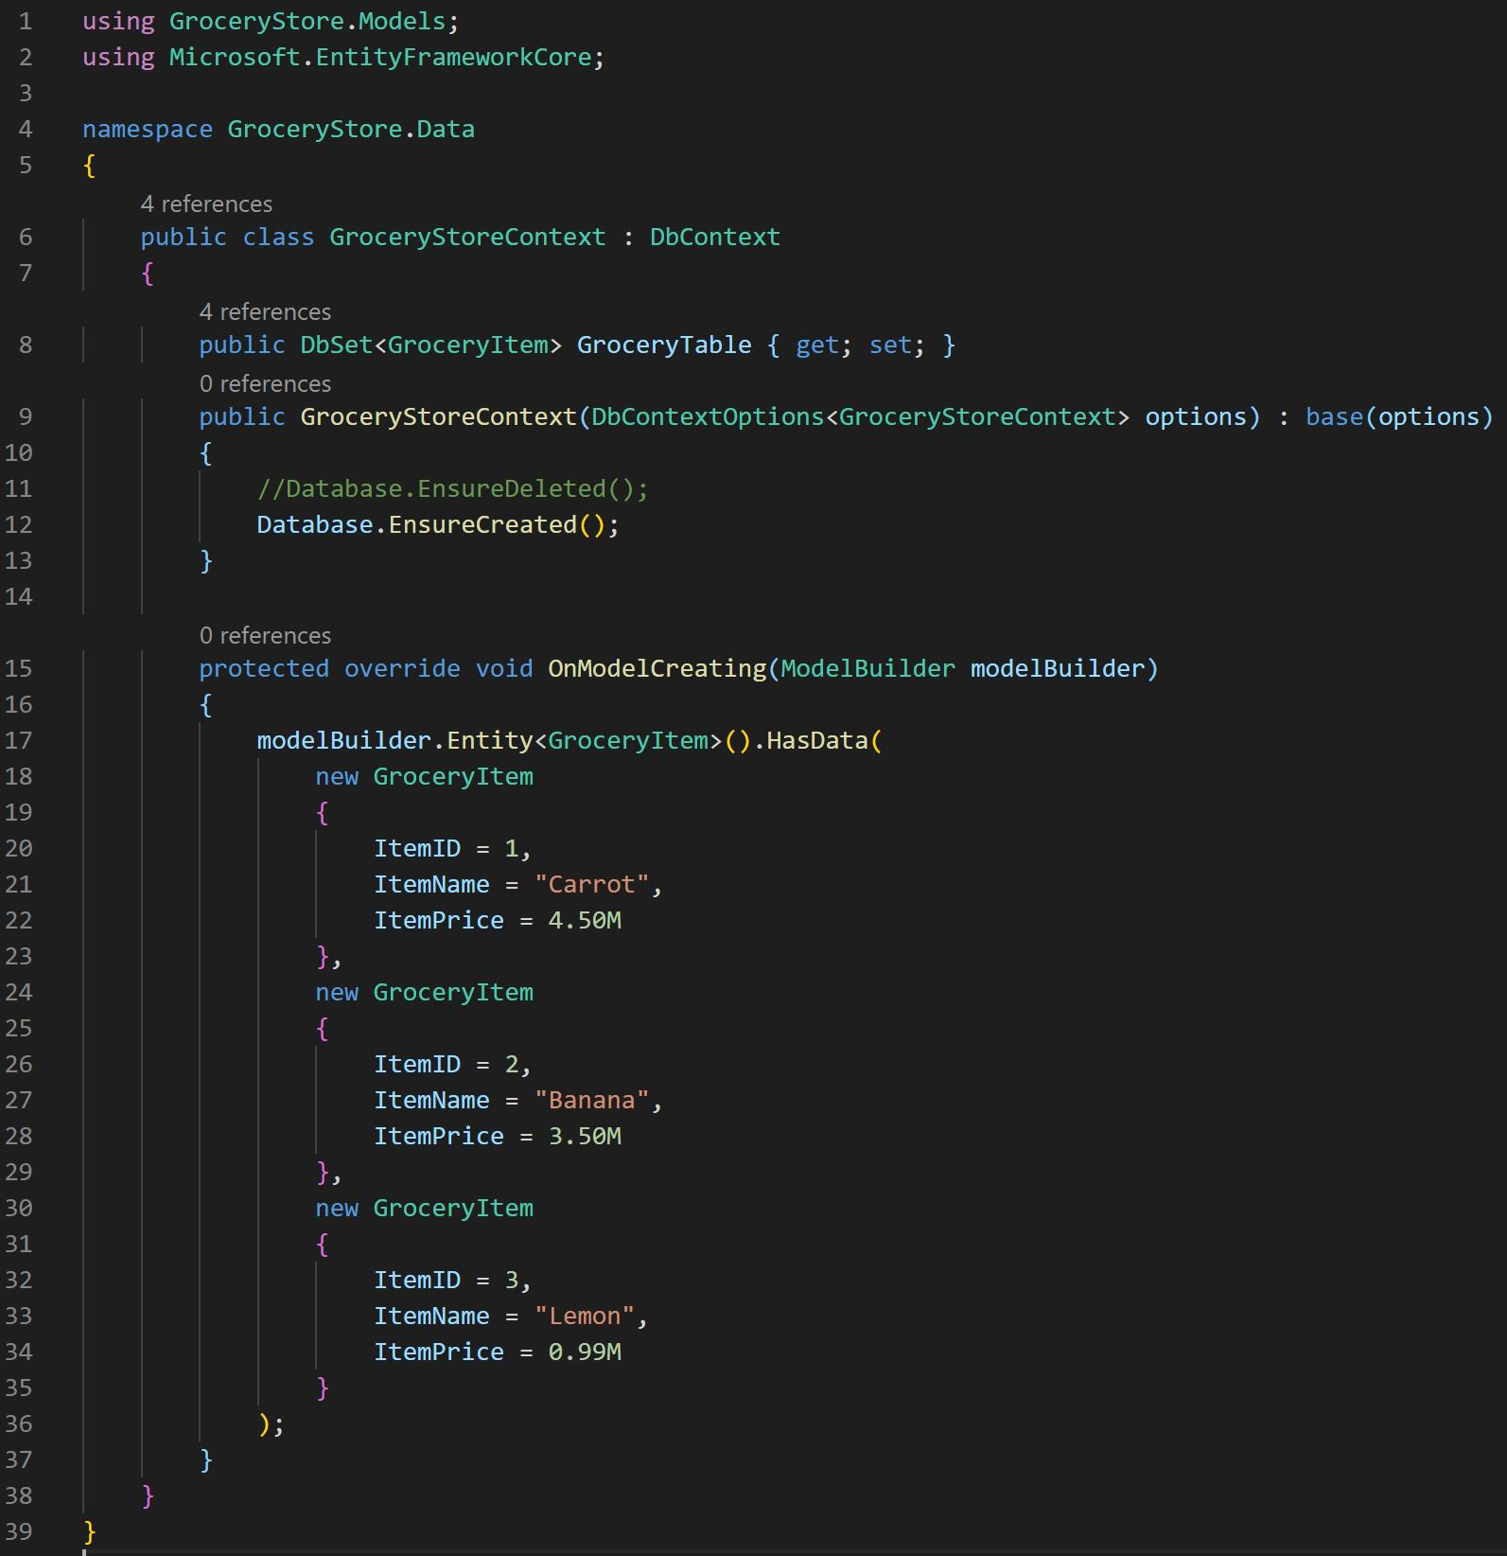

1. Set up Entity Framework Core to use SQLite
   1. Lets install Microsoft.EntityFrameworkCore.Sqlite v2.1.0
   2. Click [View menu] on the top. Click Terminal.
   3. Inside Terminal Type [dotnet add package Microsoft.EntityFrameworkCore.Sqlite -v 2.1.0] and press enter
2. Use Entity Framework Core to Retrieve and Store Data
   1. Hover over GroceryStore Folder and click [New Folder]
   2. Type [Repositories]
   3. Right click on the [Repositories Folder] and click [New File]
   4. Type IGroceryRepository.cs. This will create interface file.
   5. Type following code.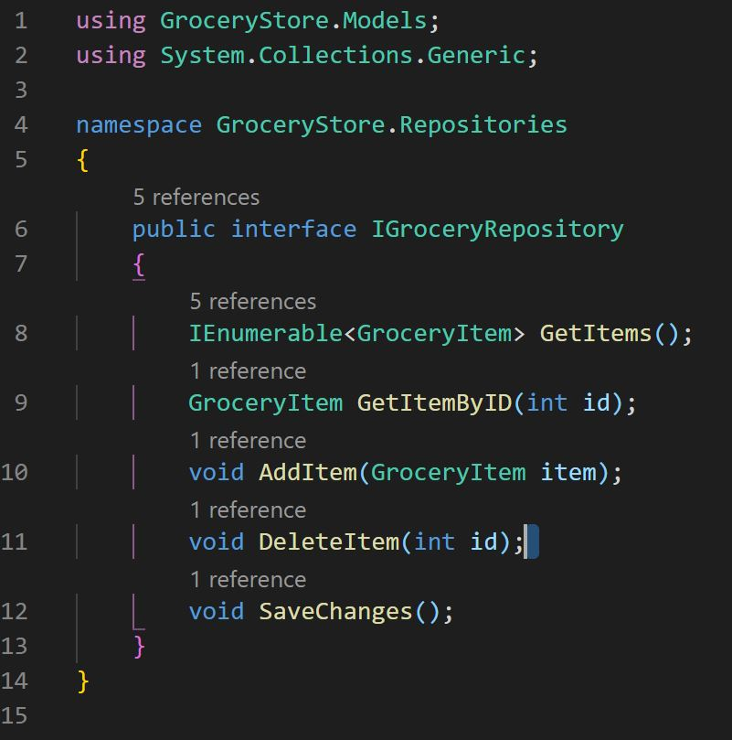
   6. Right click on [Repositories Folder]. Click [New File]
   7. Type GroceryRepository.cs
   8. Type following code inside the file.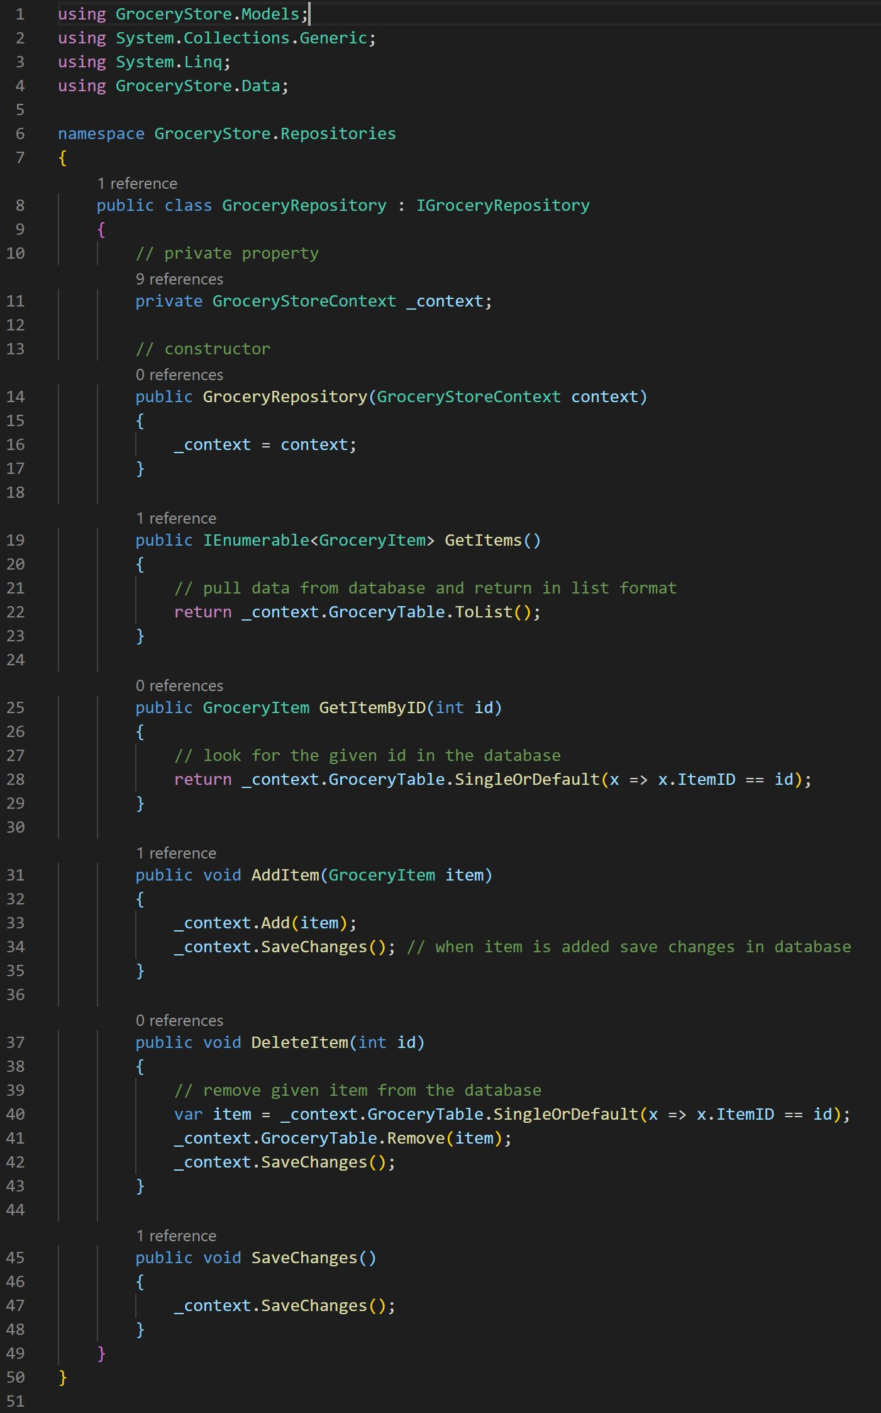
3. Lets add new Controller to use a repository
   1. Right click on [Controllers Folder]. Click [New File]
   2. Type GroceryController.cs
   3. Type following code inside.

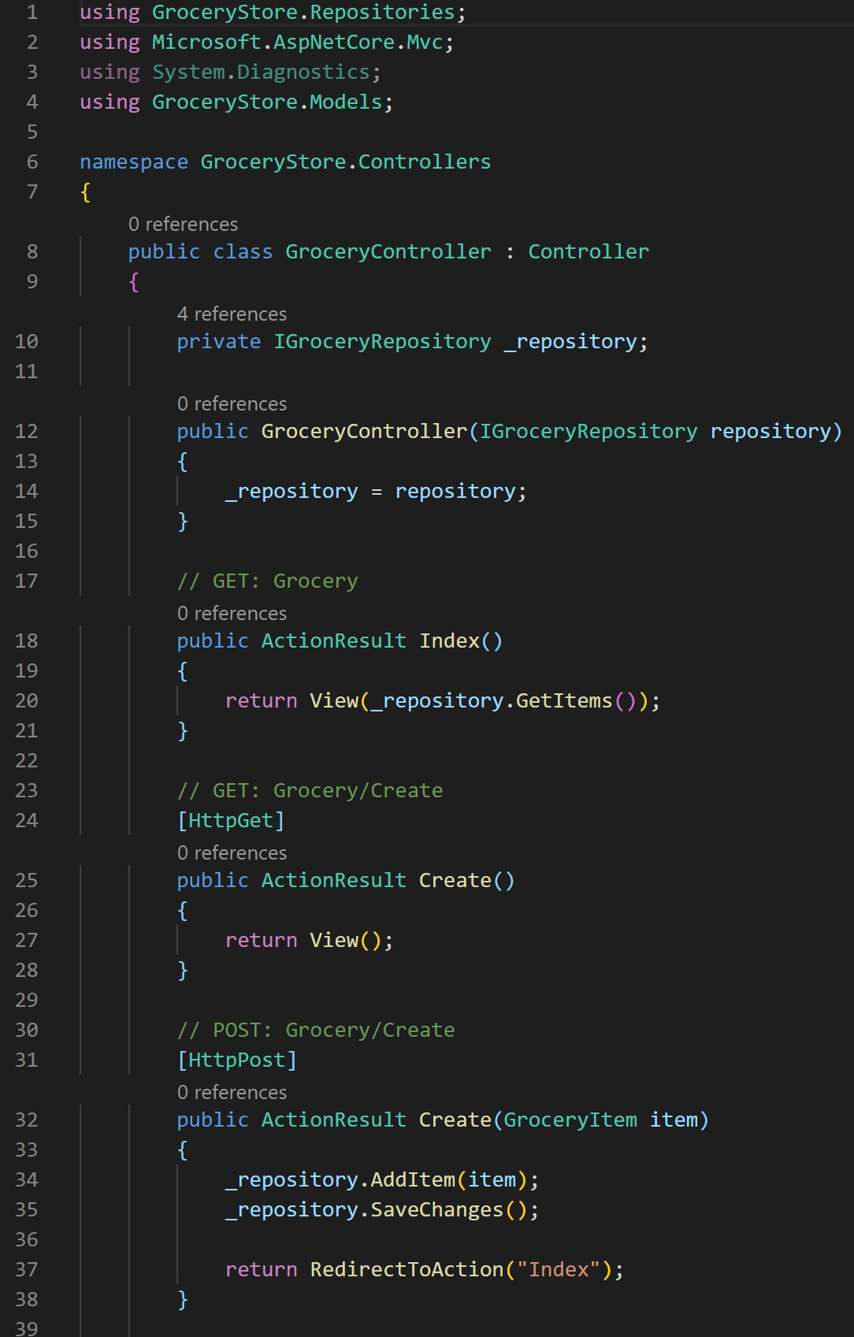

1. Now lets work on the HTML portion
   1. Right Click on [Views Folder] inside GroceryStore Folder. Click [New Folder].
   2. Type [Grocery] and press enter.
   3. Right Click on [Grocery Folder] and click [New File].
   4. Type [Index.cshtml] and press enter.
   5. Right Click on [Grocery Folder] and click [New File].
   6. Type [Create.cshtml] and press enter.
   7. Your Folder should look like this.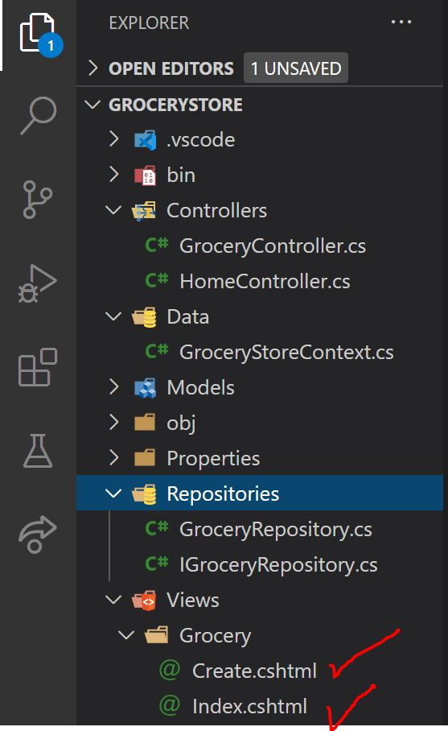
   8. Click on [Index.cshtml]
   9. Type following code inside

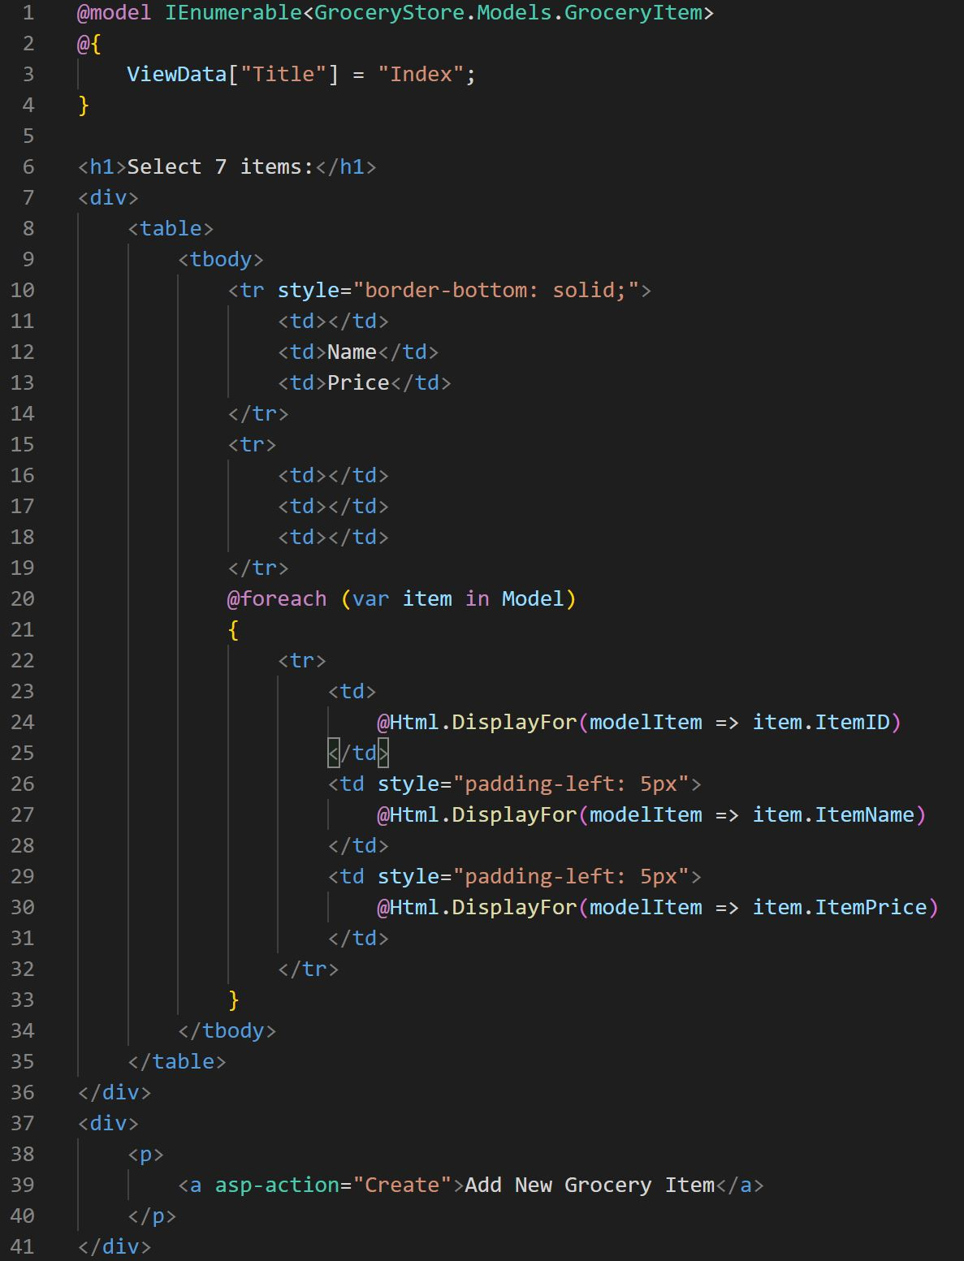

* 1. Click on [Create.cshtml]
  2. Type following code inside

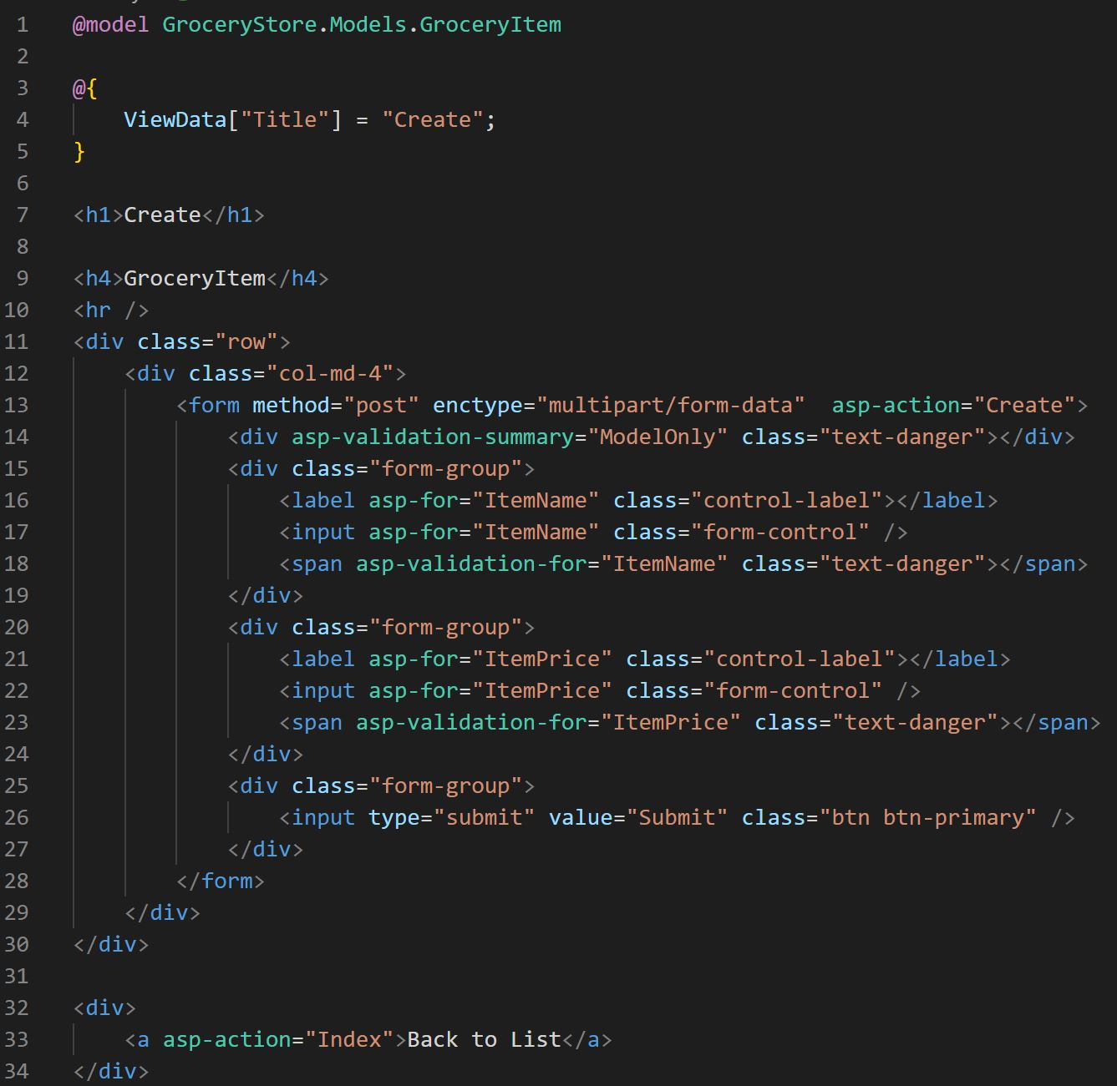

1. Use Entity Framework Core to connect to Microsoft SQL Server
   1. Click [Startup.cs] inside GroceryStore Folder.
   2. Update the existing code.

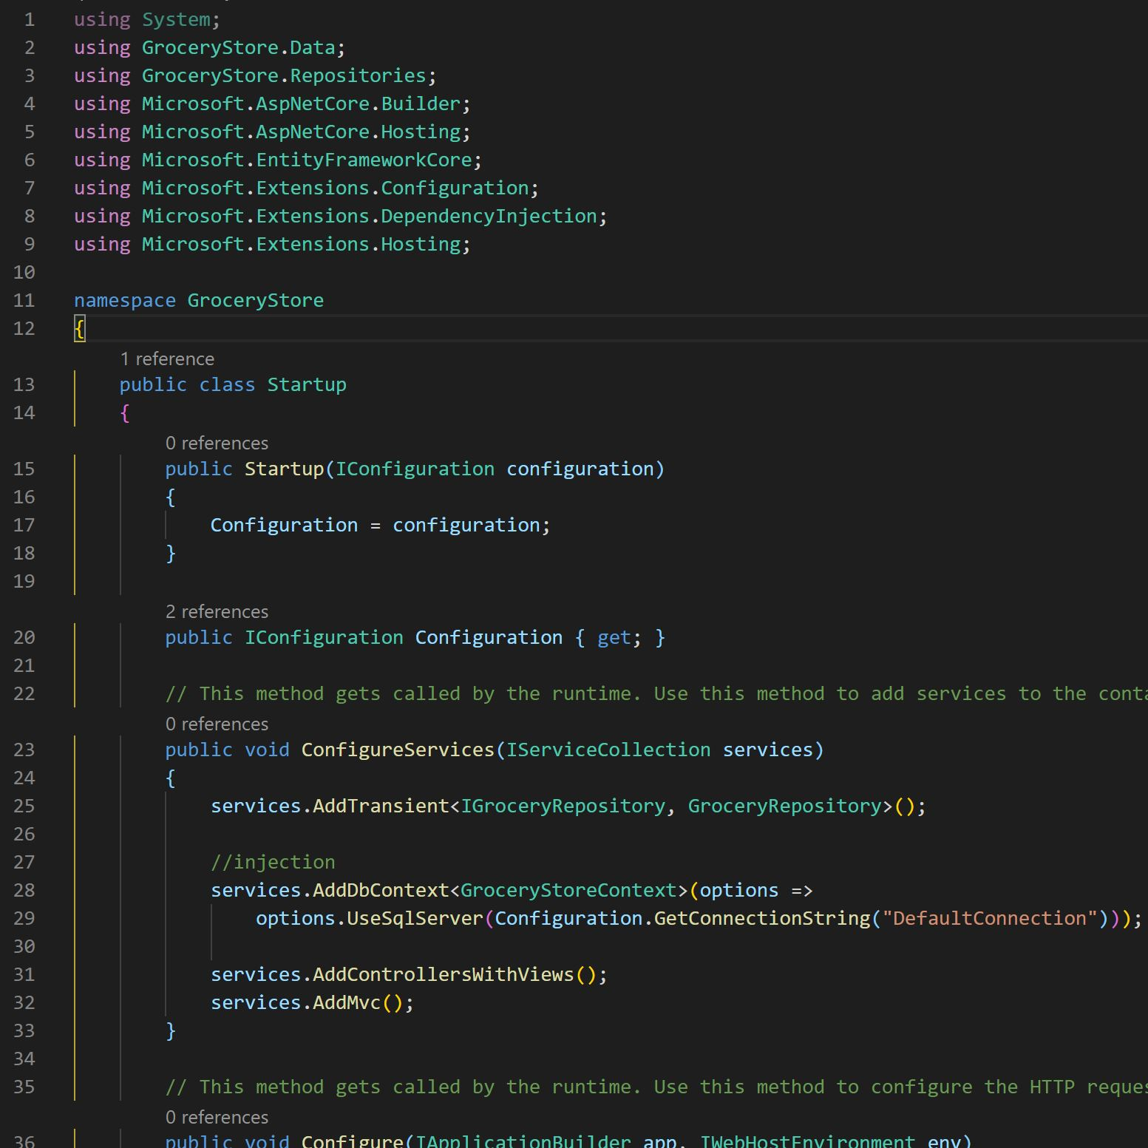

1. Specify a connection string in a configuration file
   1. Click [appsettings.json] inside GroceryStore Folder.
   2. Update existing file.

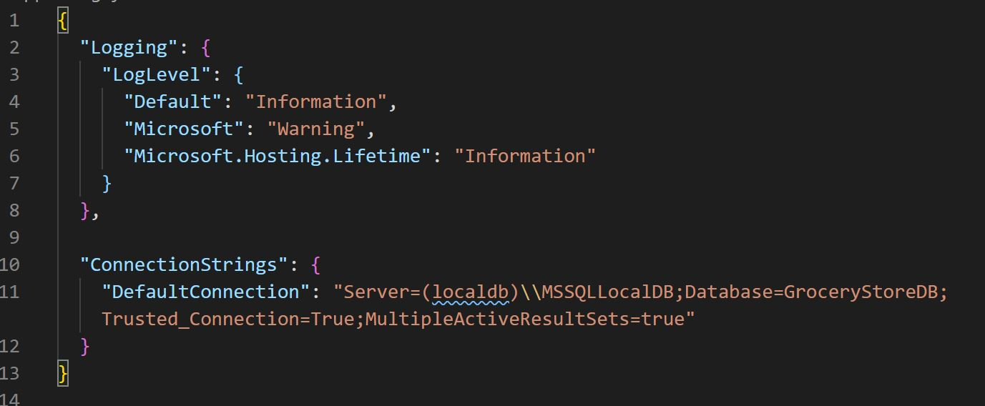

1. Finally, in order to create database in Microsoft server, we need to add MIGRATION pacakage.
   1. Click [View Menu] on the top and click Terminal
   2. Inside terminal Type [dotnet ef migrations add GroceryItemList - -context GroceryStoreContext] and press enter.
   3. If you see inside GroceryStore Folder, VS Code has just added Migrations Folder
   4. Inside terminal Type [dotnet ef database update - -context GroceryStoreContext] and press enter.
   5. This should add the table inside the database.
2. Time to run the application
   1. Inside Termina Type [dotnet run] and press enter.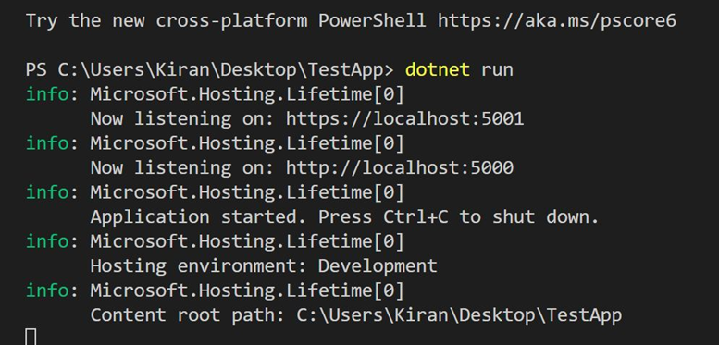
   2. Open a web browser and in the address bar Type [ localhost:5001 ]
   3. More then likely, it is going to give you an error because 5001 is a secure line and we don’t have certificate created yet.
   4. Click on the [ Advance button ] and click [ continue ]
   5. You should get a web page that looks like this. (see image below)

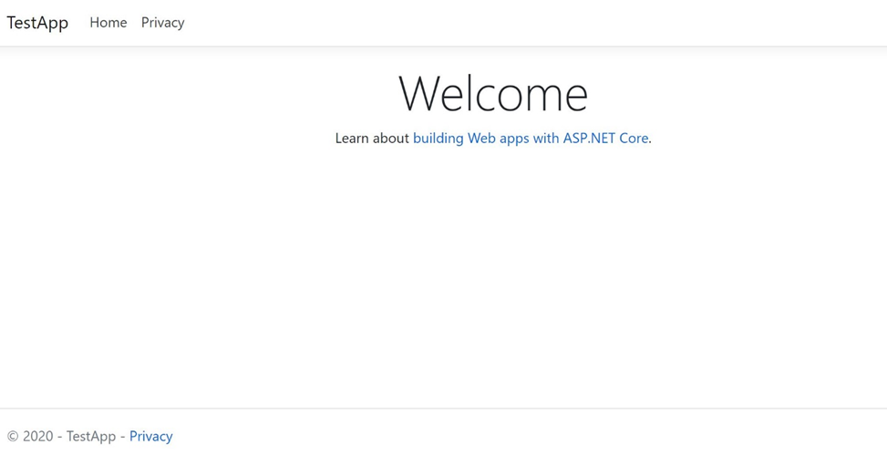

* 1. Go to the address bar and add [localhost:5001/Grocery] and press enter
  2. You should get this.