Prömpeln

Ein Bild, das Cartoon, Clipart, Kunst enthält.
Players: 2-7, Time: 20-30 min, Age: 4+

Prömpeln was introduced in the movie "Werner - Gekotzt wird später" and is about placing swing top bottle caps so that the most points are earned.

# Prömpeln is played with 0.33-liter swing top bottles. Originally, the game was used to determine the next regent and king over the current society. However, Prömpeln can also be played as a pastime and free from politically motivated backgrounds. The game is played with 7 bottles, whereby a maximum of 3 points per bottle can be scored in a regular round. Over 7 rounds, certain special moves must be played which can earn additional points.

# Rules

# The seven swing-top bottles are lined up so that all the bungs face one side. The flat side of the bottle is placed against the bottle and the nipple points towards the player.

# Seven rounds are played. In each round, the player plunges all the bottles in turn. The player touches the bottle cap from below with only one finger and moves it upwards in a pulling motion. Pushing the bottle cap results in an invalid attempt. The bottles themselves may not be touched during the move.

# Before rounds 1-6, a player may announce one of his three one-time special moves. Only if this was announced correctly, the corresponding special rules apply. If a player claims to have fulfilled any passive conditions, he must mention them directly after his turn. Afterwards, the points from this round are noted.

# By the end of round 6, all special moves must have been played. In the seventh round, all players play a double listener to conclude the game.

# The winner and king is the player with the highest score. If a playoff occurs, a pawn is played at the same time. This is repeated until one player gains more points than the other.

# Points

Ein Bild, das Text, Softdrink, Flasche enthält.
A score is defined for each end position of a played bottle cap:

Bottle caps that do not lie correctly as shown above do not count. Unclear positions always count as zero points. The points are determined after all the bottle caps in a round have been played. If, for example, a borderline 1-point bottle cap slips before the end of the turn, it is recorded as zero points.

In the case of the special move "Kniffel" it must be pointed out directly which bottle caps do not count. Points are noted immediately after a player's turn by adding up the previous points.

# Special moves

**Active special moves** must be announced by the player before the start of the round and then executed. Except for the double listener in round 7, no player is obliged to play special moves. Each special move can only be played once per player per game.

* **Lampenlörer** (L) is playable once in rounds 1-6 and is announced with "Guys, I'm doing a lamplörer", with the playing hand raised in the air. In a Lamplörer, zero points of Prömpel count -3 and three points of Prömpel count +6 points.
* **Kniffel** (K) is playable once in rounds 1-6 and is announced with "Time to Kniffel!" followed by broad grins. When playing Kniffel, the player may replay any number of Prömpel twice after the round. If there are seven 3s, the king's move does not apply in this case.
* **Pash-7** (P) is playable once in rounds 1-6 and is announced with "Yeah... so then this is a Pash-7 special" in indifferent voice pitch. In Pash-7, pairs are rewarded. There are 10 points per pair. With 7 bottles, up to 30 points can be scored. 4x 1 point makes two couples and would be valued at 20 points.
* 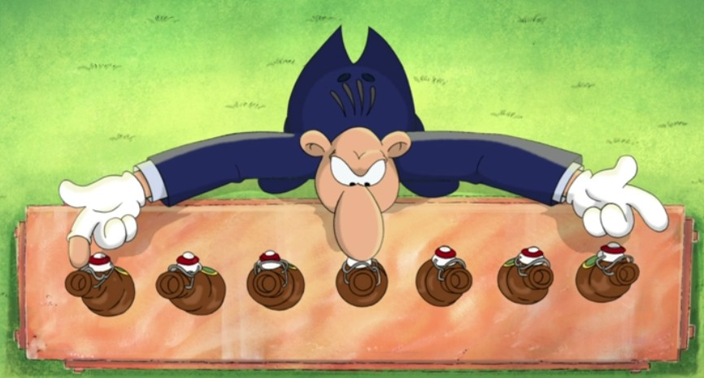**Doppellörer** (D) is obligatory in round 7. It is played with both hands parallel from outside to inside. The last, seventh, and centered jumper determines the point multiplier. It must be announced at the beginning whether the centered bottle is played with the left or the right hand: "Doppellorer links" or "Doppellörer rechts". The point multiplier itself does not count in the score. The other bottle cap points are added and multiplied by the points of the center bottle cap (0-3). A multiplicator of zero makes this round pointless.

**Passive special moves**must be **mentioned** and able to be traced before points are scored.

* **Meier** (M) is valid in rounds 1-7. The pronunciation of the phrase "There is still Meier" asserts the claim to this combination. Meier is valid when a mixture of 1s and 2s (no zero points and no three points) have been played. For example, there can be only one 1 and six 2s. A is a Meier is valid with 21 points. Meier is also valid for a Kniffel. In the case of a double Meier, the point multiplier must also be a 1 or 2. In this case, 21 points are taken times 1 or 2, depending on the multiplier.
* **King move**(King) applies in rounds 1-7 and applies in a perfect game where all seven bottle caps give three points each. With the pronunciation of "I am king" this is declared the winner of the game and the game is over. The king move does not apply in Kniffel. Even in round 7, with a double player, the king move can still decide the game early.