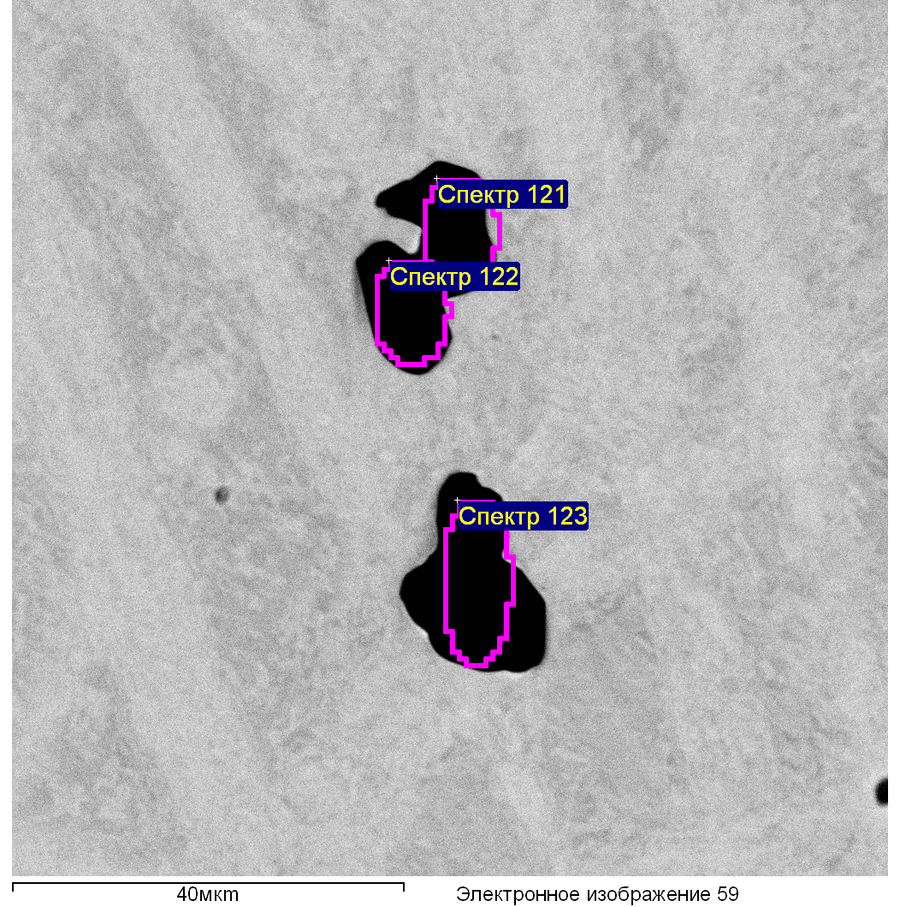

|  |  |  |  |  |  |  |  |  |  |
| --- | --- | --- | --- | --- | --- | --- | --- | --- | --- |
| Спектр | O | Mg | Al | S | Ca | V | Cr | Mn | Fe |
|  |  |  |  |  |  |  |  |  |  |
| Спектр 121 | 45.74 | 0.09 | 41.66 | 2.43 | 0.31 | 0.09 | 0.28 | 2.39 | 7.01 |
| Спектр 122 | 50.73 |  | 44.40 | 0.38 | 0.15 | 0.04 | 0.45 | 0.31 | 3.58 |
| Спектр 123 | 50.45 | 0.12 | 46.01 |  | 0.28 |  | 0.20 |  | 3.10 |
|  |  |  |  |  |  |  |  |  |  |

Все результаты в весовых %

Образец: 174

Тип: Установка по умолчанию

№:

01.03.2021 17:29:16

Ефимчук

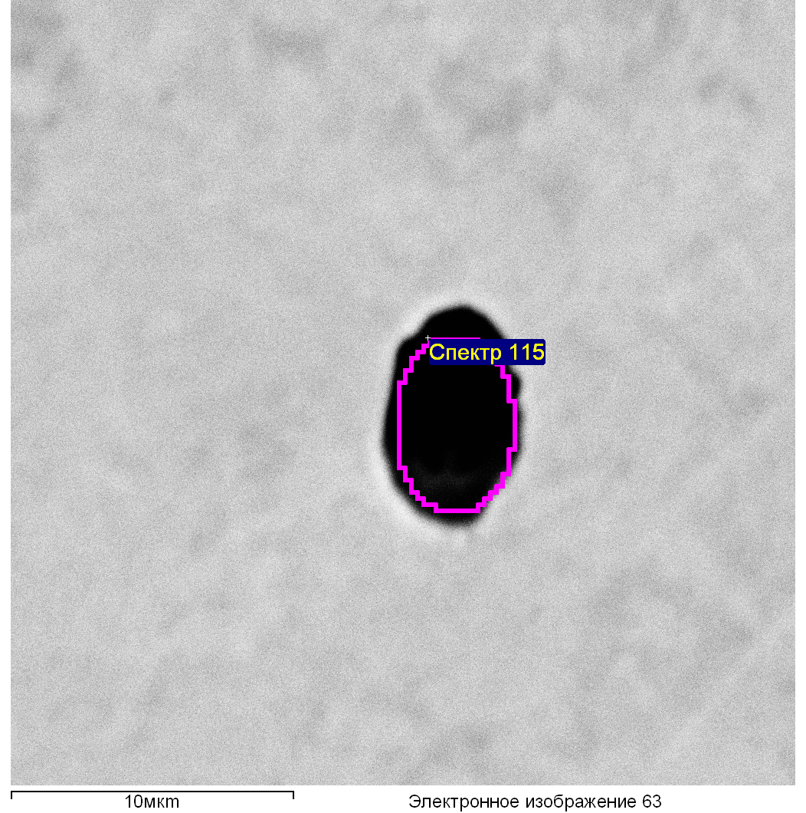

|  |  |  |  |  |  |  |  |  |  |  |
| --- | --- | --- | --- | --- | --- | --- | --- | --- | --- | --- |
| Спектр | O | Mg | Al | S | Ca | Ti | Cr | Mn | Fe | Zr |
|  |  |  |  |  |  |  |  |  |  |  |
| Спектр 115 | 33.22 | 1.37 | 21.54 | 10.87 | 3.18 | 0.93 | 1.17 | 11.96 | 14.49 | 1.27 |
|  |  |  |  |  |  |  |  |  |  |  |

Все результаты в весовых %

Образец: 174

Тип: Установка по умолчанию

№:

01.03.2021 17:32:33

Ефимчук

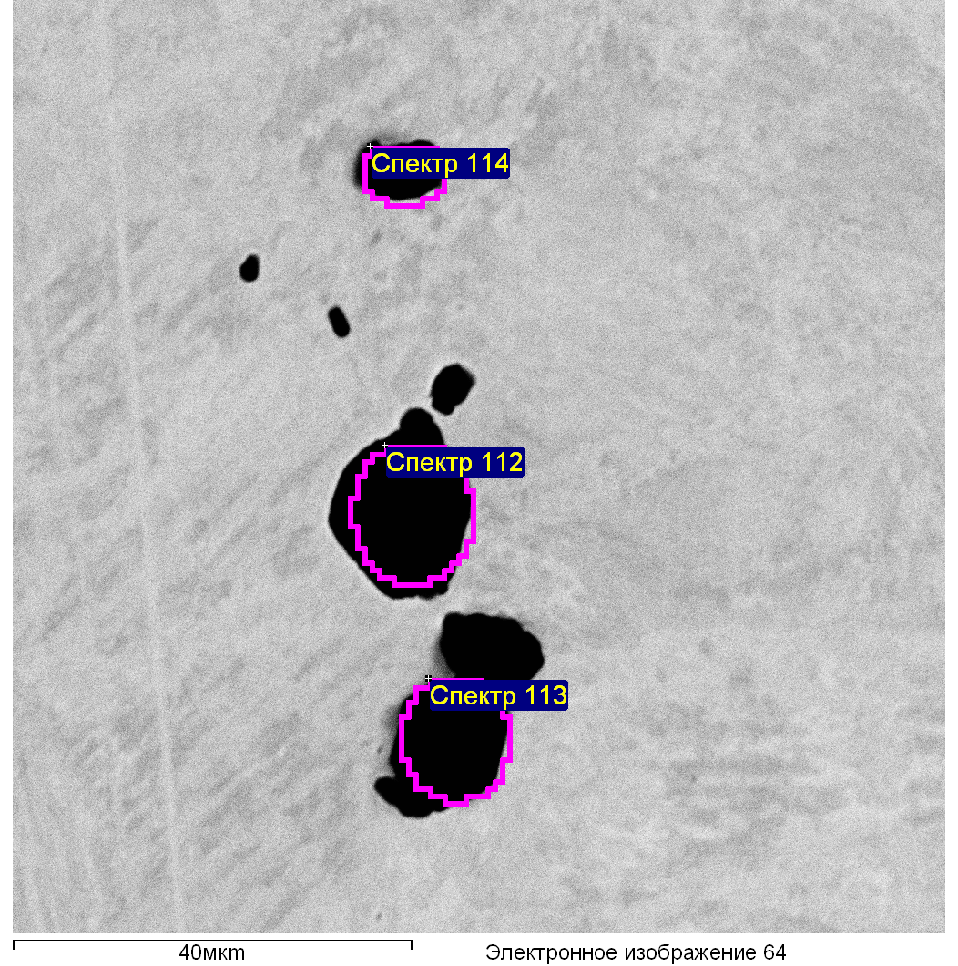

|  |  |  |  |  |  |  |  |  |  |  |
| --- | --- | --- | --- | --- | --- | --- | --- | --- | --- | --- |
| Спектр | O | Mg | Al | S | Ca | Ti | V | Cr | Mn | Fe |
|  |  |  |  |  |  |  |  |  |  |  |
| Спектр 112 | 50.33 | 0.08 | 46.96 | 0.01 | 0.01 |  |  |  |  | 2.77 |
| Спектр 113 | 47.55 | 0.06 | 43.23 | 0.11 | 0.20 |  | 0.11 | 0.35 | 0.32 | 8.17 |
| Спектр 114 | 41.59 | 0.22 | 35.18 | 0.47 | 0.00 | 0.43 | 0.32 | 0.94 | 0.26 | 20.59 |
|  |  |  |  |  |  |  |  |  |  |  |

Все результаты в весовых %

Образец: 174

Тип: Установка по умолчанию

№:

01.03.2021 17:33:52

Ефимчук