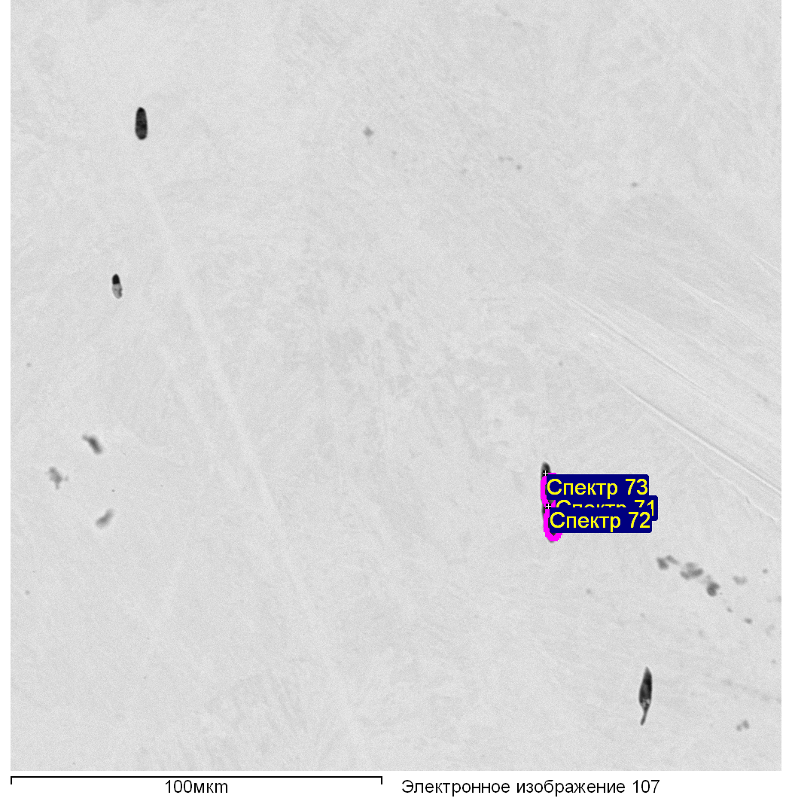

|  |  |  |  |  |  |  |  |  |  |  |
| --- | --- | --- | --- | --- | --- | --- | --- | --- | --- | --- |
| Спектр | O | Mg | Al | Si | S | Ti | V | Cr | Mn | Fe |
|  |  |  |  |  |  |  |  |  |  |  |
| Спектр 71 | 30.66 | 0.66 | 3.58 | 7.83 | 0.13 | 6.06 | 6.93 | 1.92 | 6.27 | 35.97 |
| Спектр 72 | 42.03 | 0.35 | 16.48 | 13.24 | 0.20 | 1.95 | 1.76 | 1.56 | 2.44 | 19.99 |
| Спектр 73 | 41.62 | 0.19 | 4.81 | 21.54 | 0.57 | 1.35 | 1.38 | 1.07 | 6.04 | 21.42 |
|  |  |  |  |  |  |  |  |  |  |  |

Все результаты в весовых %

Образец: 40

Тип: Установка по умолчанию

№:

01.03.2021 18:10:22

Ефимчук

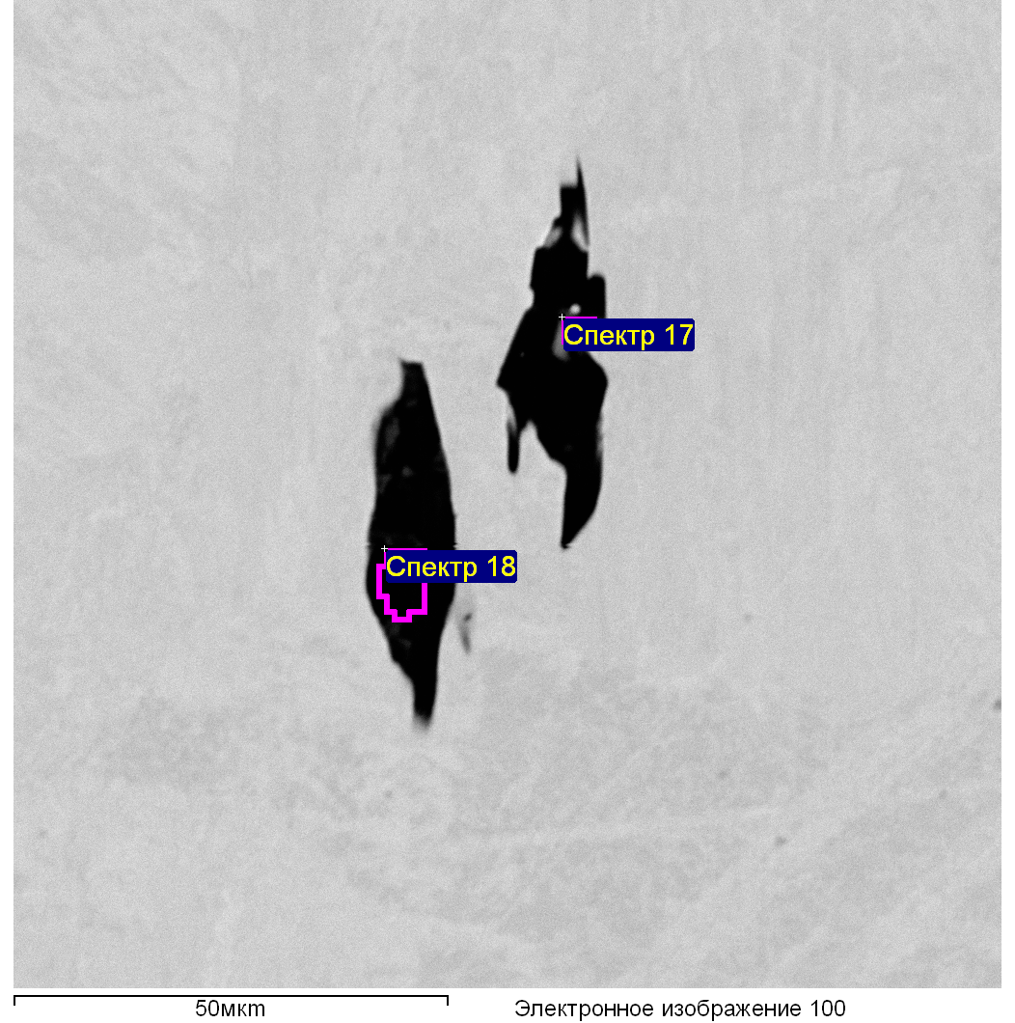

Образец: 40

Тип: Установка по умолчани

№:

01.03.2021 18:11:09

|  |  |  |  |  |  |  |  |  |  |
| --- | --- | --- | --- | --- | --- | --- | --- | --- | --- |
| Спектр | O | Mg | Al | Si | S | Ca | Cr | Mn | Fe |
|  |  |  |  |  |  |  |  |  |  |
| Спектр 17 | 28.82 | 1.20 | 6.55 | 9.17 | 17.17 | 0.88 |  | 33.14 | 3.08 |
| Спектр 18 | 52.79 |  | 42.70 | 2.11 | 0.04 | 0.23 | 0.92 | 0.26 | 0.96 |
|  |  |  |  |  |  |  |  |  |  |

Все результаты в весовых %

Образец: 40

Тип: Установка по умолчанию

№:

01.03.2021 18:13:39

Ефимчук