Nginx官网下载nginx

<https://nginx.org/>

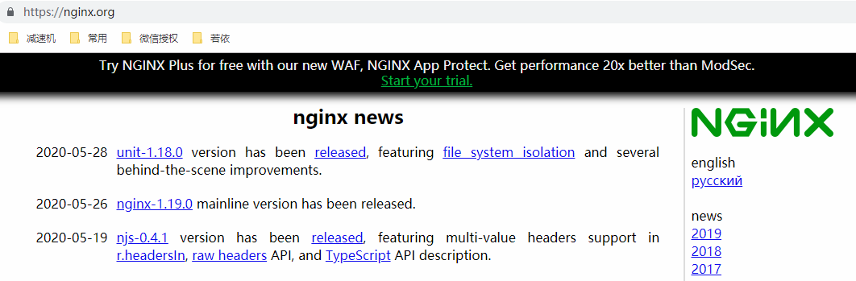

下载windows 和linux版

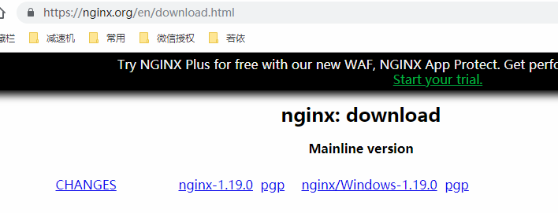

上传服务器并解压

[agree@vm10-0-0-3 ~]$ tar -zxvf nginx-1.19.0.tar.gz

执行编译

[agree@vm10-0-0-3 nginx-1.19.0]$ ./configure

报错

./configure: error: the HTTP rewrite module requires the PCRE library.

You can either disable the module by using --without-http_rewrite_module

option, or install the PCRE library into the system, or build the PCRE library

statically from the source with nginx by using --with-pcre=<path> option.

[agree@vm10-0-0-3 nginx-1.19.0]$ yum list pcre-devel*

Loaded plugins: fastestmirror, security

Loading mirror speeds from cached hostfile

Available Packages

pcre-devel.i686 7.8-7.el6 base

pcre-devel.x86_64 7.8-7.el6 base

切换root用户安装

[root@vm10-0-0-3 ~]# yum install pcre-devel.x86_64

Loaded plugins: fastestmirror, security

Loading mirror speeds from cached hostfile

Setting up Install Process

Resolving Dependencies

--> Running transaction check

---> Package pcre-devel.x86_64 0:7.8-7.el6 will be installed

--> Processing Dependency: pcre = 7.8-7.el6 for package: pcre-devel-7.8-7.el6.x86_64

--> Running transaction check

---> Package pcre.x86_64 0:7.8-6.el6 will be updated

---> Package pcre.x86_64 0:7.8-7.el6 will be an update

--> Finished Dependency Resolution

Dependencies Resolved

===================================================================================================================================================

Package Arch Version Repository Size

===================================================================================================================================================

Installing:

pcre-devel x86_64 7.8-7.el6 base 320 k

Updating for dependencies:

pcre x86_64 7.8-7.el6 base 196 k

Transaction Summary

===================================================================================================================================================

Install 1 Package(s)

Upgrade 1 Package(s)

Total download size: 516 k

Configuration summary

+ using system PCRE library

+ OpenSSL library is not used

+ using system zlib library

安装完成后再次执行

[agree@vm10-0-0-3 nginx-1.19.0]$ ./configure

nginx path prefix: "/usr/local/nginx"

nginx binary file: "/usr/local/nginx/sbin/nginx"

nginx modules path: "/usr/local/nginx/modules"

nginx configuration prefix: "/usr/local/nginx/conf"

nginx configuration file: "/usr/local/nginx/conf/nginx.conf"

nginx pid file: "/usr/local/nginx/logs/nginx.pid"

nginx error log file: "/usr/local/nginx/logs/error.log"

nginx http access log file: "/usr/local/nginx/logs/access.log"

nginx http client request body temporary files: "client_body_temp"

nginx http proxy temporary files: "proxy_temp"

nginx http fastcgi temporary files: "fastcgi_temp"

nginx http uwsgi temporary files: "uwsgi_temp"

nginx http scgi temporary files: "scgi_temp"

分别执行

[agree@vm10-0-0-3 nginx-1.19.0]$ make

[root@vm10-0-0-3 nginx-1.19.0]# make install

在默认安装目录启动nginx

[root@vm10-0-0-3 sbin]# ./nginx

配置开机启动

vi /etc/rc.d/rc.local

/usr/local/nginx/sbin/nginx

直接输入地址连接成功

