Fun-Time Phonics Edits 1.6.15
Unresolved issues:
- Throughout lessons: There should be a fraction of a second longer pause between the audio “Touch the word that begins with /t/” and when the graphics appear on the screen and the audio begins. Some of the audio is so close together that it almost overlaps. I should be able to add delays wherever we need them. I'll need more specific info about which lesson/sublessons/activities/feedbacks need them though. The easiest way to provide this is with the browser URL such as: “lesson/1/activity/9” or just “lesson/1 activities” for all activities in a lesson . I've increased the delay after “Touch the word that begins with /t/”.

This needs to be applied to all activities. There's a 250ms pause between before the graphics appear in every activity. I can increase it if necessary.

- Add highlight to upper box, lesson box, and activity to show which is the current activity. The section and lesson navigations both have highlights. There is no activity navigation.
Can activity navigation be added?

- We will always use one of three different sets of text on the Admin/Score page green arrow.
Return to Lesson X
Play Lesson X
Replay Lesson X
I'm not sure where this text should be. There is no difference between playing a lesson and replaying a lesson.
The text will be inside the arrow. There may be no difference in functionality as far as Play/Replay, but “Replay” is how parents/users know that lessons may be attempted again.

- Change “Section 4 Review” to “Consonant With Vowel Review.” ***Make same change as necessary in other reviews.
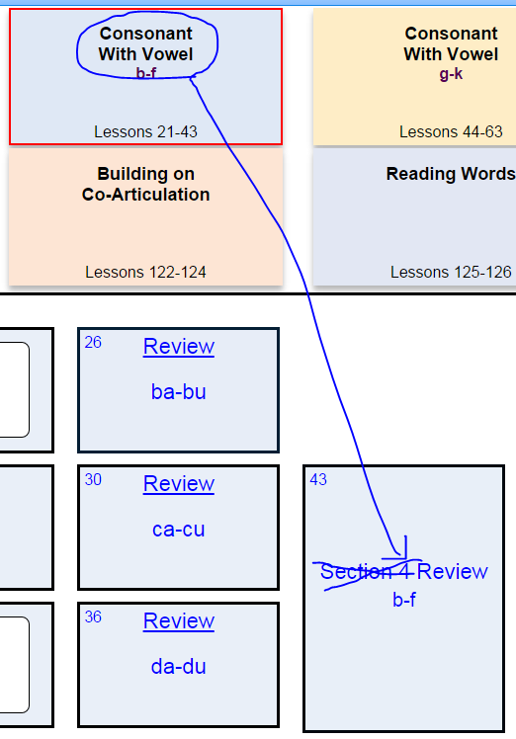

- Need to make this page look more “fun”; different font and some color. What font? What color?
Use Comic Sans MS (will work in all browsers).
Two ideas for “color”: use the same background used on the “tea” sign-in page, or add big stars around the edges of the current white screen, like the correct answer feedback stars.
We can use any font in all browsers. Using web safe fonts is no longer a requirement because we can host fonts with the source code. Fonts aren't included with browsers; they're included with operating systems, so comic sans may not work on certain operating systems.
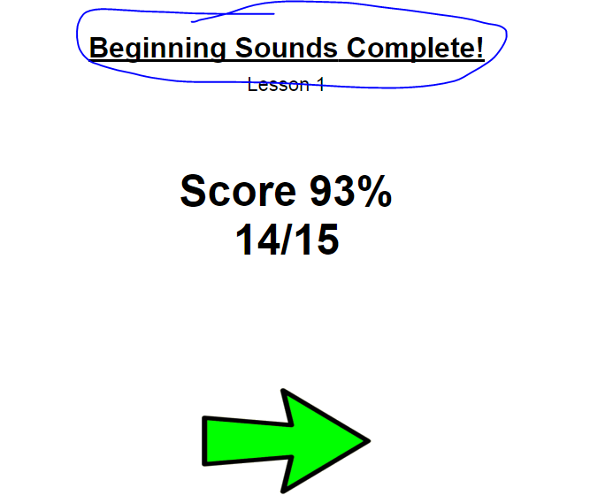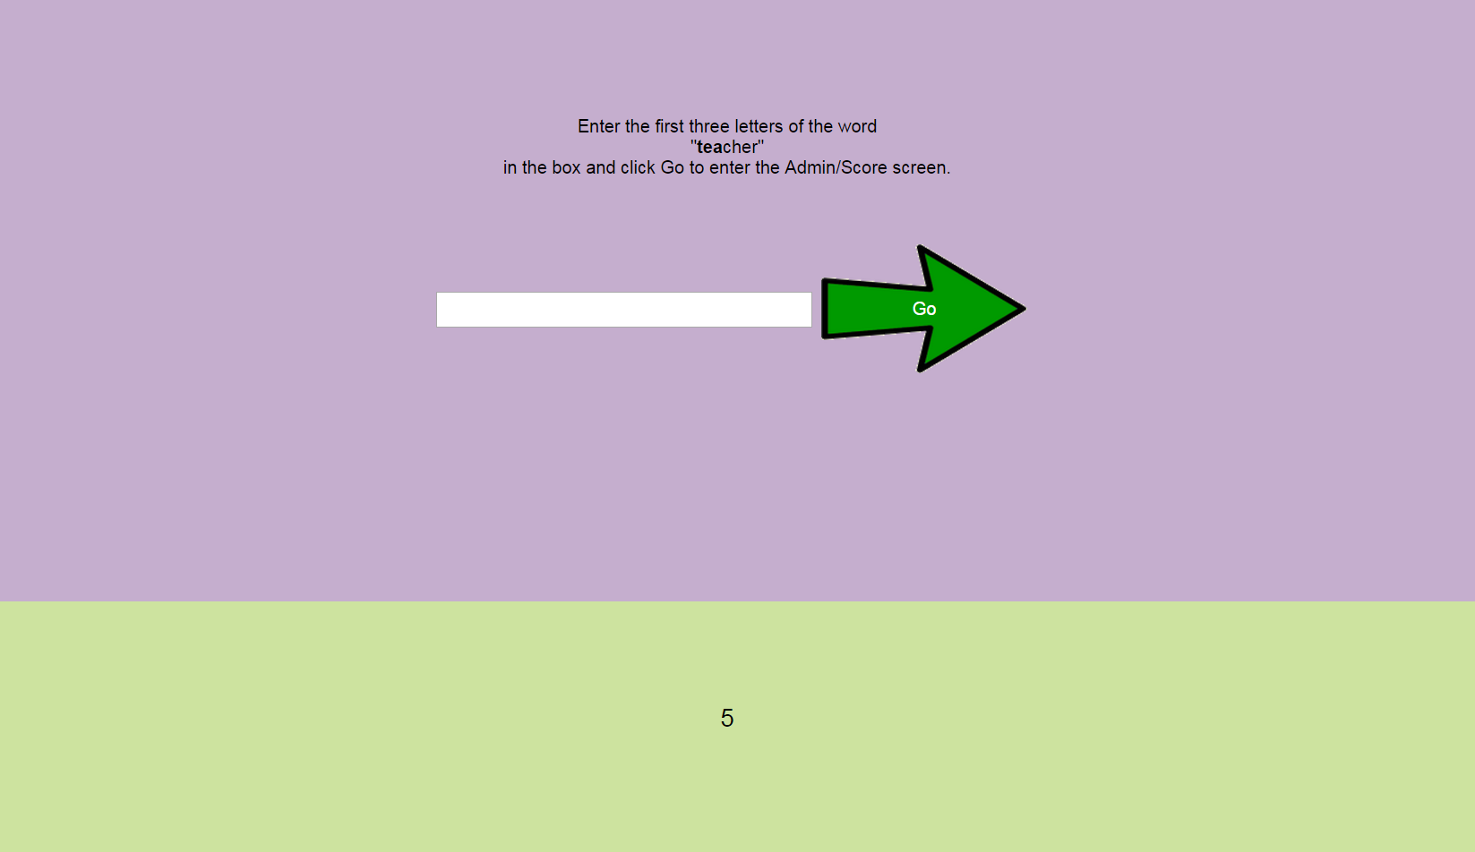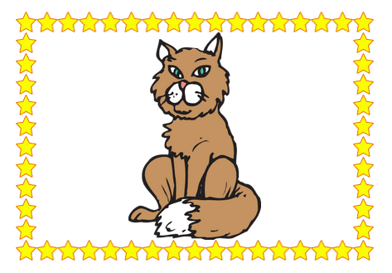

- 4.11: Graphic for “egg” is too light; replace with graphic of three eggs in a nest with an arrow pointing to an egg. ***The egg has already been replaced. If it’s not in the software, it’s because it hasn’t been updated it in the software but the graphic was replaced a while ago. –Chip Updated software's images to the ones on the share drive

The graphic for “Beth” looks like a woman in a uniform; change to just a girl/woman without a hat. ***I have taken Beth’s hat off, which was surely easier than finding another Beth. –Chip Updated software's images to the ones on the share drive
5.18: The graphic for “strong” looks fuzzy because of the shading used. Try to find another graphic for “strong.” ***I think the issue with strong is just the blocky style that the illustrator used, which in theory isn’t a problem for the age group. However, I have another with a more sophisticated style and as a bonus it’s a minority. –Chip

New Edits:
“tea” sign in page:
- In ASG there’s a link to the Admin/Score page on the Splash screen. Do we want to add that to this splash screen as well? Done

- There’s a white line/background showing around the arrow. Fixed


Admin/Score screen:
- Add “s” to “Vowels” to match Lessons box. Done
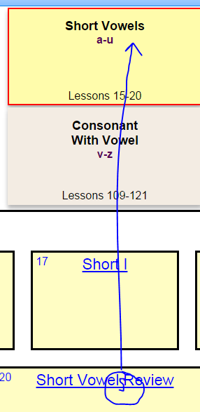

- Sometimes, but not always, the Beginning Sounds box is highlighted. When I reached the /l/ lesson and returned to the Admin page, the box was not highlighted. When I used the “Back” arrow, it took me to the lesson and then on to the specific activity where I had left off. Fixed
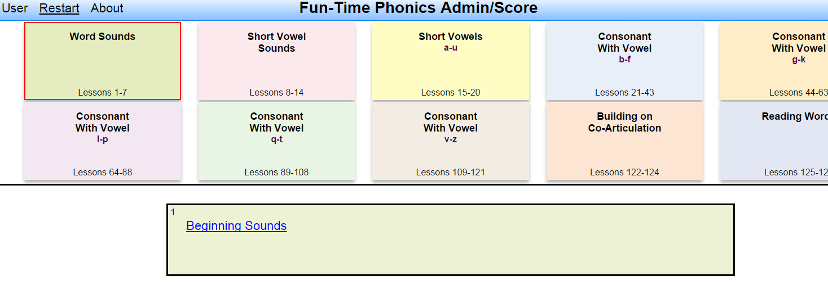

- Selecting the “Beginning Sounds” box from the Admin page takes the user immediately to that lesson rather than requiring that the green arrow be used to finalize the selection. The arrow needs to be used for all selections (as I understand it). This seems needlessly complicated

- Because the specific letters of each lesson are no longer in these boxes, I have no way of knowing which letters are taught or which letter/activity I’m currently doing. The letters need to be added, and if possible, functionality that allows users to see which lesson/letter they’re on. Done
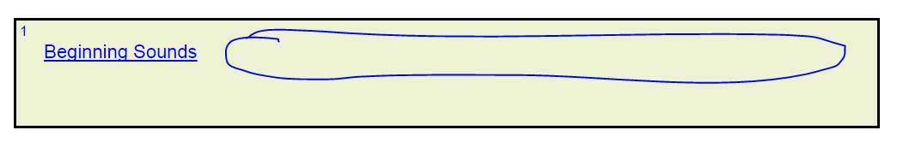

- The way the letters were originially shown on the Admin/Score page is how they should be shown in the lessons. So rather than “Lesson 1 – m” it would be “Lesson 1 /m/.” Fixed
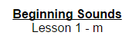

- Not sure this is the correct functionality:
I select an answer and am taken to the answer feedback screen. 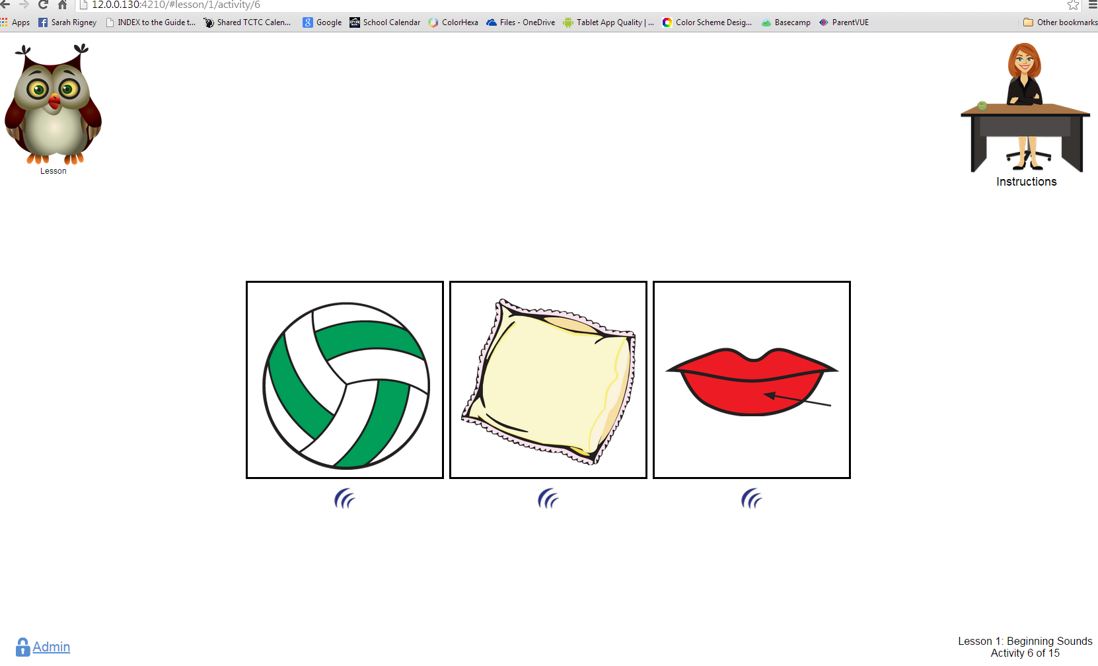 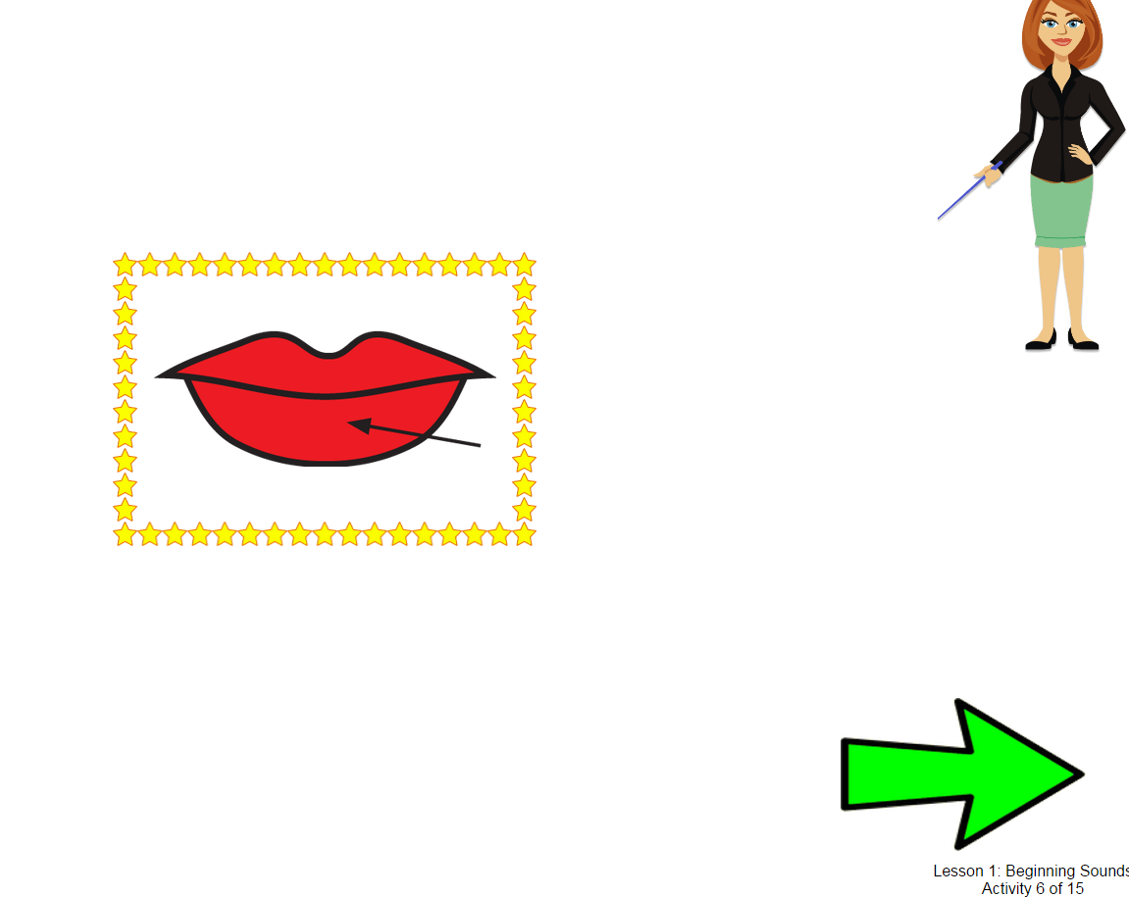
From there, I go to the Admin/Score screen, then use the “Back” arrow.
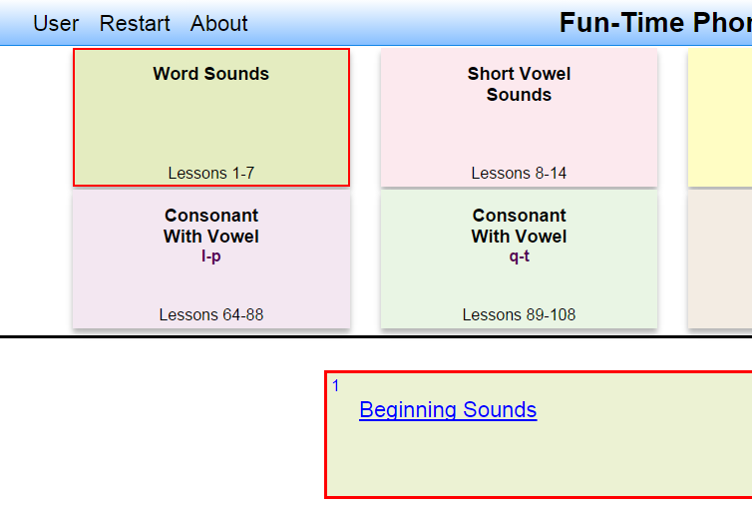

The arrow takes me to the beginning of the specific activity again, even though I’ve already completed that particular activity. Shouldn’t it take me to the answer feedback page I was most recently on? Probably, but doing so would require very extensive changes to the code
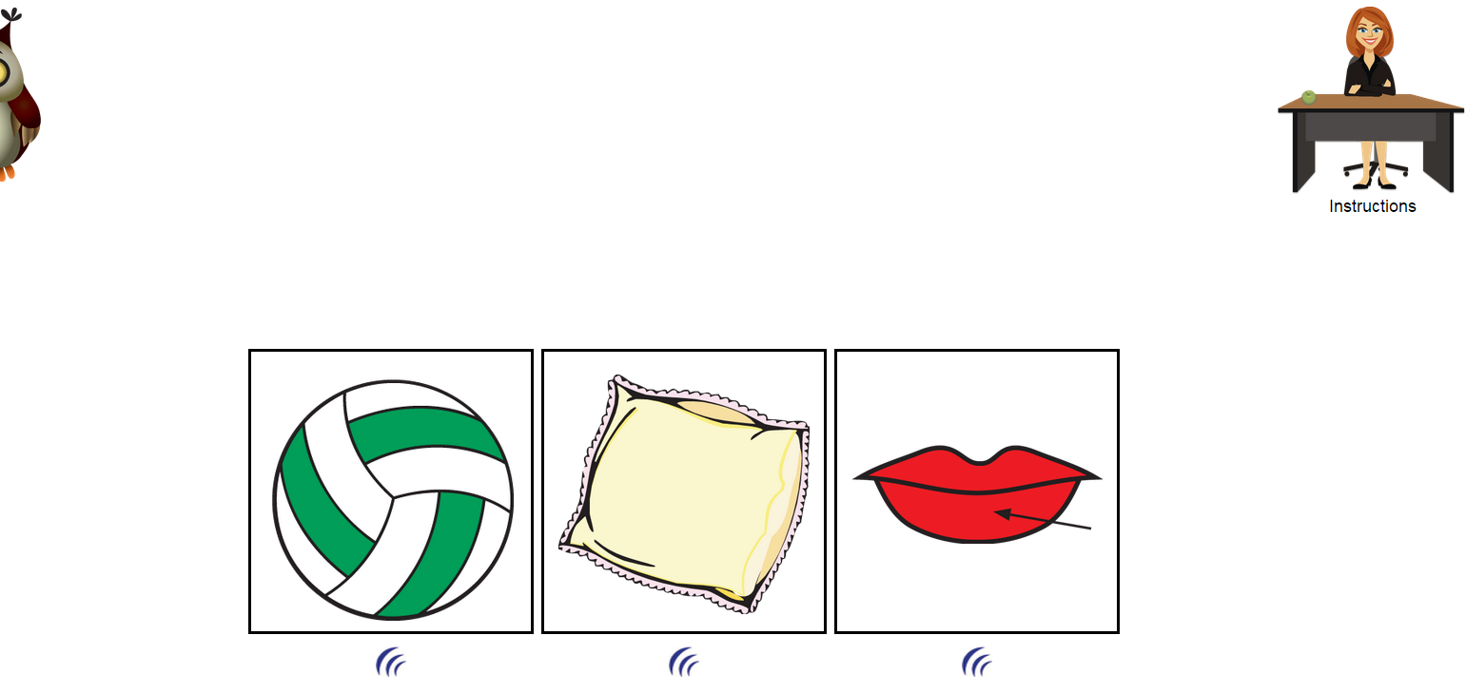
- If I select a graphic to hear the word while the instructions are still playing, the audio overlaps. I can disable the replay buttons during the animation
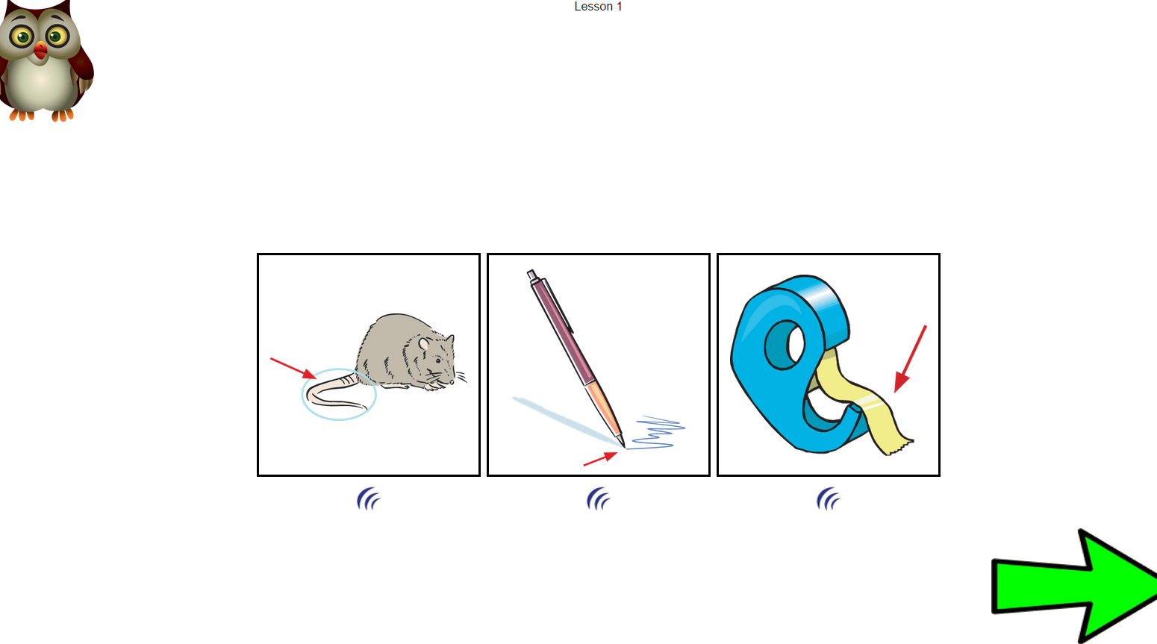

- During the lessons, add “Lesson” under owl so a user can hear the instructions again if necessary. Otherwise it’s not clear what’s going on. Done
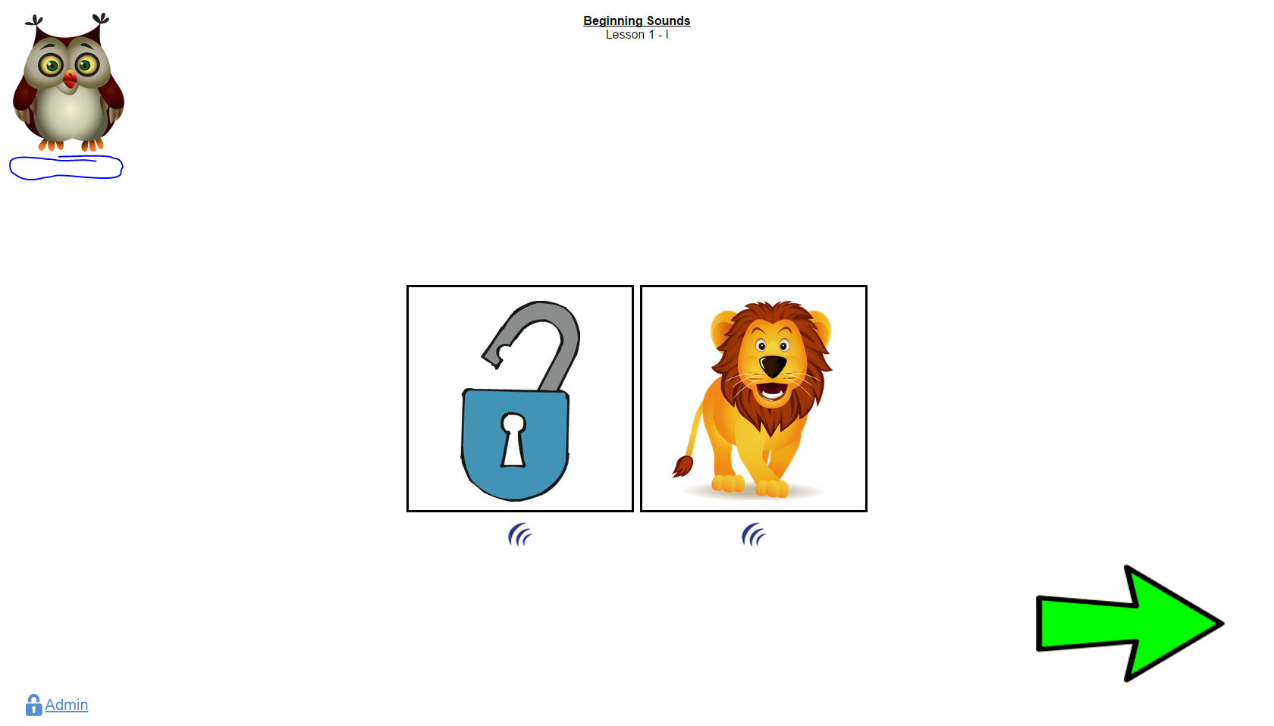

- Can we add “Activity #” inside the arrow during the lessons so it’s clear what the next step is? At the beginning of the lesson, the instructions say “…then touch the green arrow to begin” but in the lessons that follow, no instructions are given. I don’t think this is necessary on the answer feedback screens between each activity, just in the lessons (but I’m sort of undecided). Done
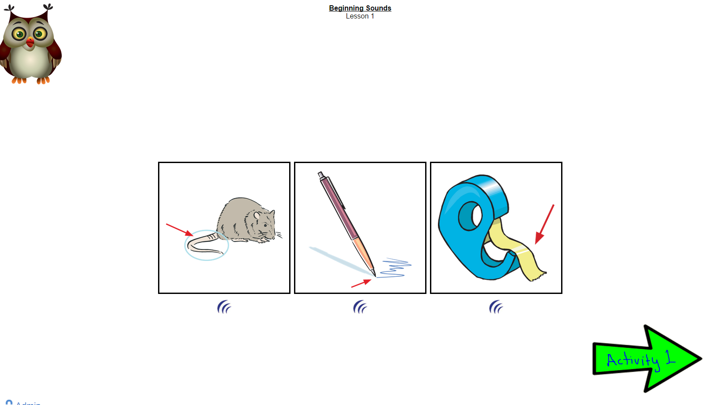

- Lesson 3, Activity 5: just a blank screen. Same with the rest of the lessons from this point on. Fixed (I wasn't able to reproduce this, but it doesn't seem to be happening anymore)
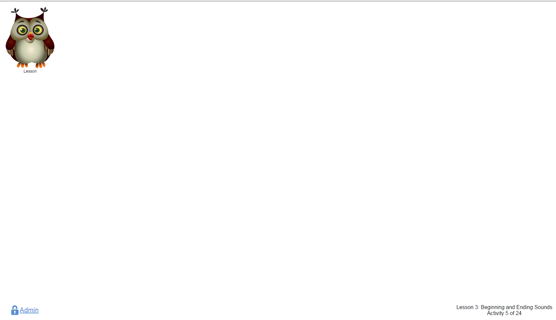

Audio issues: Scott T. has list and is working on those.

