Hi Everyone,

My responses to your questions below are highlighted in green text below each question. I also added a new edit to the list (#6).

Thanks,

MichaelB

1. Splash screen audio is missing.
2. Throughout: Replace “like” with “such as” in all instructions.
3. Throughout: The animation of the robots needs to be reversed; the arms should move when the robots are small (in the corners), not when they are large and in the center of the screen.
4. Home page, first screen: move arrow so it is aligned with “Lessons 1-7” to match other screens.

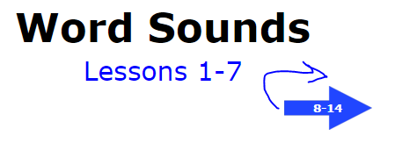 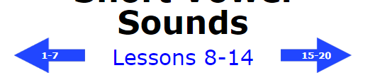

1. We need to reduce the font size or change the font; the quotation marks are touching the sides of the boxes.

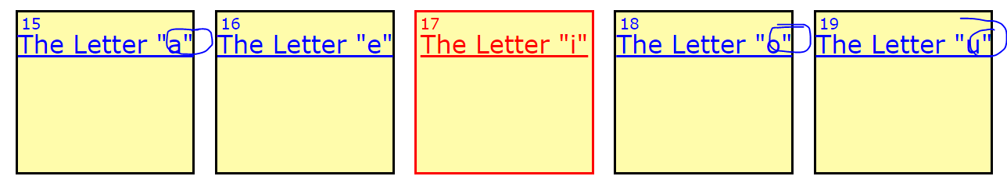

1. We need to have Dave record the congratulations screen ‘orange arrow audio’ and the ‘orange and green arrow audio’. Here are the audio scripts for Dave.

“Nice work! Touch the green arrow to begin the next lesson.”

“Good job, but we need to practice this some more. Touch the orange arrow to play this lesson again. “

We also need Jimmy needs to add applause to the lesson congratulations screens.

1. Throughout: Need to replace single quotation marks with double quotation marks.



1. Lesson 7:

Female robot could give the instructions that the male robot now says before the drawn out word. This would be like Lesson 6. Then there is no need to show the male robot.

**** I like Terry’s solution to this problem. We will have the female robot give the general lesson instructions with just the first activity. However, if a user touches the teacher to hear the instructions for any of the other 19 activities, we will have her give the general instructions before the answer options.

Done

1. Lesson 8 and all similar lesson completion pages: Add quotation marks to “a.”

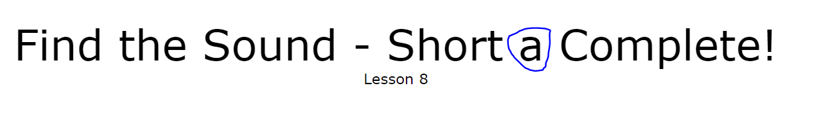

1. Lessons 8-9—Instructions should show up under teacher once the sounds have played the first time. After the first activity, it did not show until I replayed the instructions. This is true for lessons 8 and 9 but 10-12 showed Instructions.
2. Lesson 15: Change font for “a” to “**a**” instead. (Verdana, maybe?)

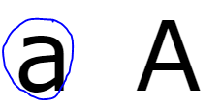

1. In the lesson, before the last word is pronounced, Dave says “and.” Please delete.

Terry or Jimmy?

1. Lessons 8 and 9: Play instructions for each activity (the way they are in lessons 10-12 currently).

MOB

**** We will have the female robot give the general lesson instructions with just the first activity. However, if a user touches the teacher to hear the instructions for any of the other 19 activities, we will have her give the general instructions before the answer options.

Done

1. Lessons 15-19: Play instructions for each activity. ***Waiting for feedback from Michael on these.

**** We will have the female robot give the general lesson instructions with just the first activity. However, if a user touches the teacher to hear the instructions for any of the other 19 activities, we will have her give the general instructions before the answer options.

Done

1. Lessons 15-19: We need to use double quotation marks around the letters in the lesson titles at the top of each screen and on the “Activity Complete” pages.



1. Lessons 16, 17, 18, 19

After the first activity, Instruction did not show up under female robot after words were pronounced. It showed up after I played the instructions again. Lesson 15 was OK.

1. Lesson 17: The uppercase “I” should be taller than the lowercase “i.” ***Same issue in Lessons 37-41: The uppercase “F” should be at least as tall as the lowercase “f.”

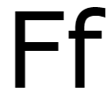

1. Lesson 20: Robot is overlapping the letters.

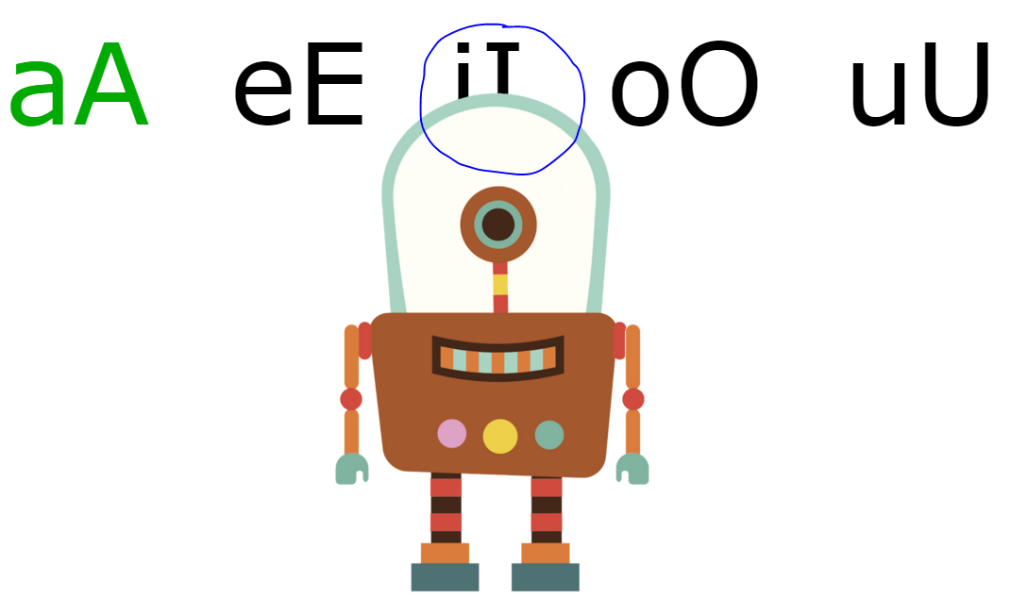

1. Lesson 20 and on: Need to highlight the last robot to speak.
2. Lesson 20, activities 1-15: Female robot’s instructions say, “Drag the letter to the picture that makes…” but only one picture is shown on the screen. Are there supposed to be three images shown, or do we need to change the instructions to match what’s on screen?

**** Let’s modify the instructions to say “Drag the letter to the picture that makes the middle sound in _______ .

**** I also think the incorrect response should be changed to “________ doesn’t make the ____ sound, so there I no ___ in _________ .

1. Lesson 20, activities 16 – 30: Three images are shown, but there are no instructions explaining what to do. The female robot just says “cat, cut, coat” when clicked. The letter is not dragged in this activity; we are supposed to click on the appropriate image, but that is not explained.

MOB

**** We need to have Jacqueline record these instructions as well as this correct and incorrect response:

“Touch the word that makes this letter sound.”

“________ makes the ___ sound so ________ has an ___ (a, e, i, o, u) in it.”

“ There is no ___ sound in _________ , so __________ does not have an ___ (a, e, i, o, u) in it.”

1. Lesson 20: Scoring needs to be fixed:

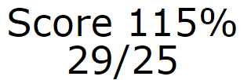

1. Lesson 20 and on: Correct feedback says “Correct!” rather than “Yes,” which is what we say in the previous lessons. Which one do we want to go with? Or do we want to use both?

**** I guess we should replace “Correct” with “Yes” but I don’t think this is a big deal. All preschoolers understand “yes”, but some might not understand “correct”, but they will hear the applause either way, so I think both will work.

1. Lessons 21, 26, 30 (and all similar lessons): This lesson has two screens before the activities begin. In an earlier lesson with two screens, the second screen automatically appears once the audio for the first screen is done. In these later lessons this doesn’t happen, and there is no audio saying “Touch the green arrow to continue the lesson.” Remove the green arrow from the first screen and have the lesson continue from the first screen to the second automatically.
2. Lesson 21 (and all similar lessons): The instructions say, “The letter ‘B’ looks like this,” and we show “Bb” at the top of the screen. Then the instructions say, “When we read the letters ‘ba’ they tell us…” but the letters at the top of the screen are still “Bb.” This is confusing. When that second line of audio begins, can we change the letters to the letter combination that is being focused on? We show the letters being focused on in the green arrows, so that also seems to conflict with the letters shown at the top of the screen (see below, right).

**** Yes, in the second part of the Lesson, we should show the letters “ba” on the screen.

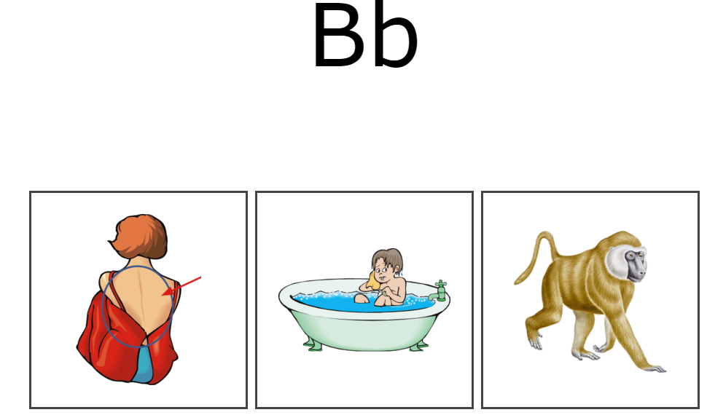 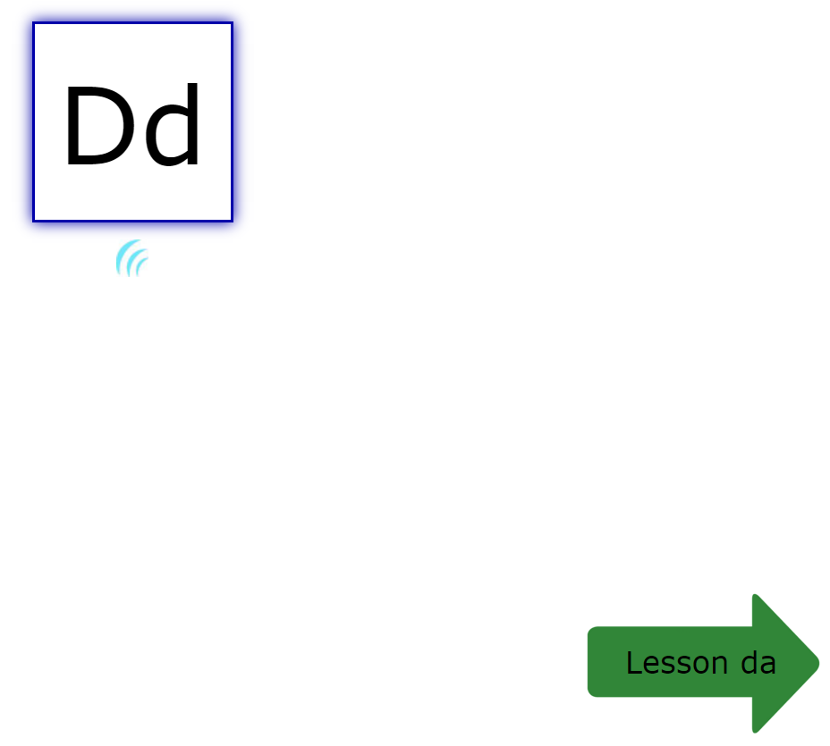

1. Lesson 21: Correct/Incorrect feedback says “___ makes the sound in ___ .” It should be, “___ makes the ___ sound in ___.” ***Same issue in lesson 26, act. 3.
2. Lesson 21 and on: When I click and drag the letters at the top of the page, the whole white box around the letters moves. Is that supposed to happen, or do we just want the letters to move? And when I drag the letters I get the “No” symbol (circle w/ a line through it).
3. Lesson 21: “Biscuit” is the only graphic (at least that I’ve seen so far) that is a photo. It doesn’t match the style of any of the other graphics. Is this okay? I’m assuming this is because it’s nearly impossible to find graphics for bicuits. Same issue w/ Lesson 33, “dimple” graphic. (And the graphic for “dimple” is really pixelated and blurry.)

Patti—have Scott find a better “dimple” but biscuit is OK for now.

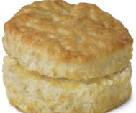 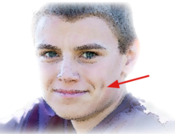

1. Lesson 24, act. 5: “Ball” and “bottle” both make the short o sound, so this is confusing. Can we replace “ball” with “bell”?

Patti--yes

1. Lesson 26, 30 (and all similar lessons): There is a lot of audio with not much appearing on the screen to help us keep track; it have the letters being referred to in the audio appear above each box to correspond with the audio and graphics.

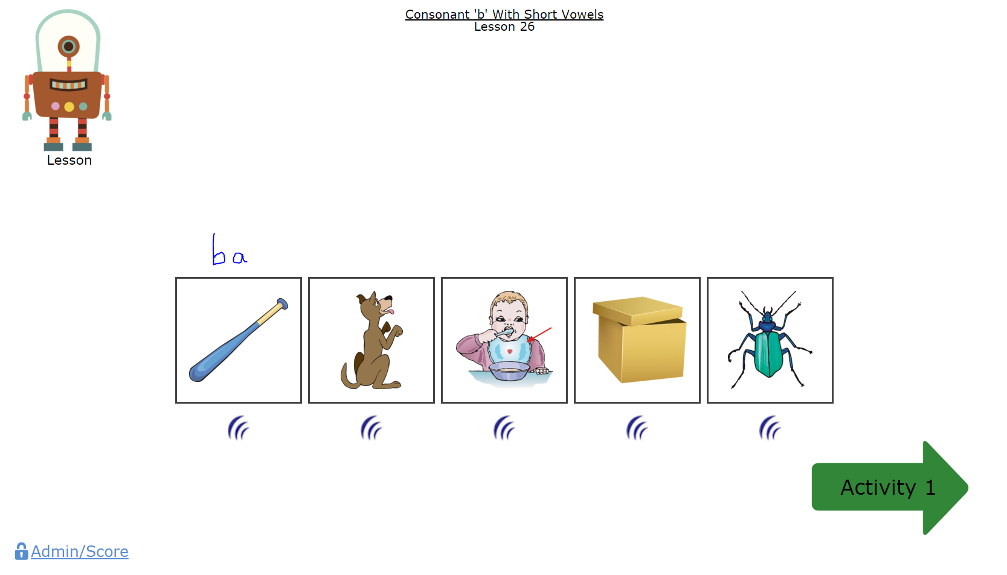

1. Lesson 27: answer choices are overlapping the audio icon.

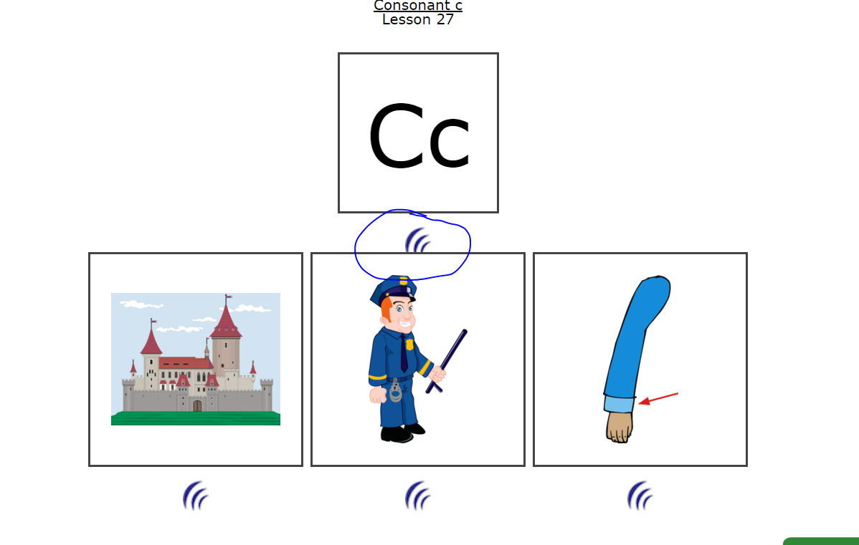

1. Lesson 28, Act. 2: missing graphic and audio.

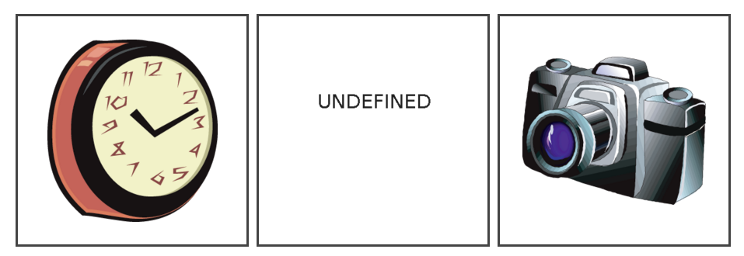

1. Lesson 28, Act. 7: This one is too hard. “Collar” and “call” make the same sound. We need to replace “call” with something else. Let’s try “cut.”

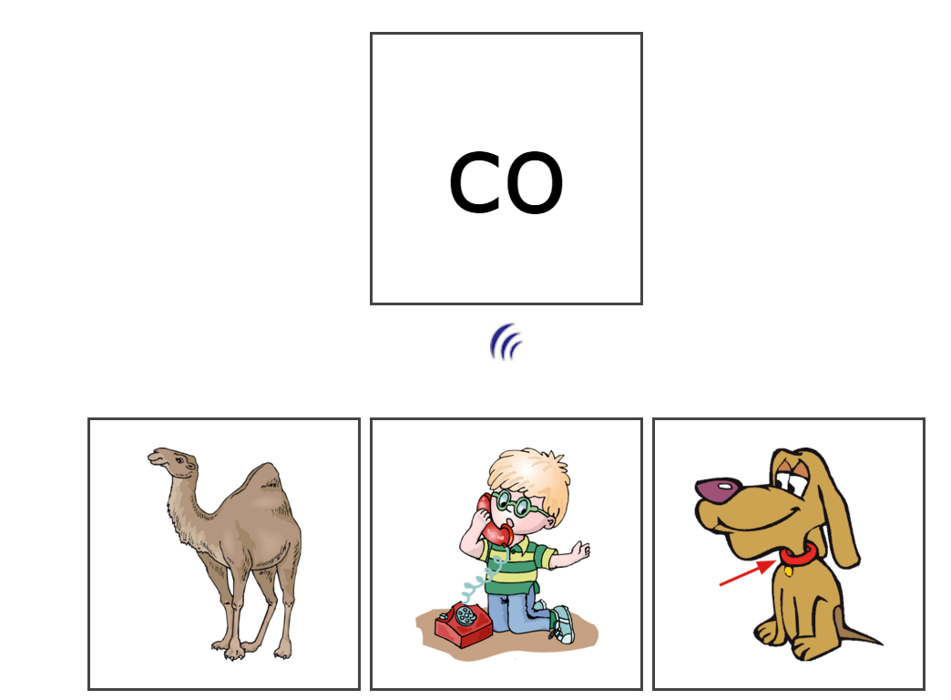

1. Lesson 30: Lesson title in bottom right corner is overlapping the audio icon.

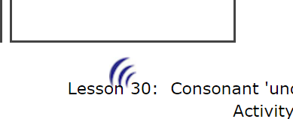

1. Lesson 30, but probably an issue in all lessons (I didn’t get a “try again” arrow until this one): The arrow is overlapping the score.

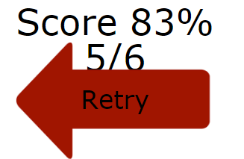

1. Lesson 31 and 36 Instructions: The /da/ sound is missing from the male robot’s instructions.
2. Lessons 21 and on: When I click the audio icon under the graphic at the top of the screen, that audio overlaps with the audio for the answer choices.
3. Lesson 37, instructions: There is no audio for “fashion” or “falcon.” (I’m assuming it’s a falcon.)

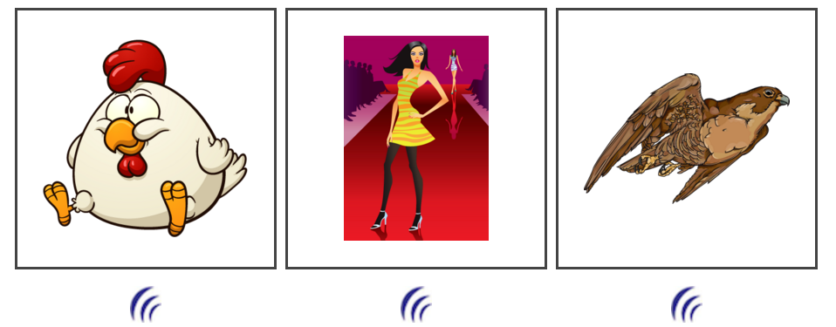

1. Lesson 38, act. 2: There is no audio for “fudge.” (This doesn’t look like fudge. Just saying.) ***An informal poll of four other people in the office suggests that on one really thinks this looks like fudge. Can we replace the graphic? Here’s one suggestion:

Patti—have Scott replace fudge—he knows

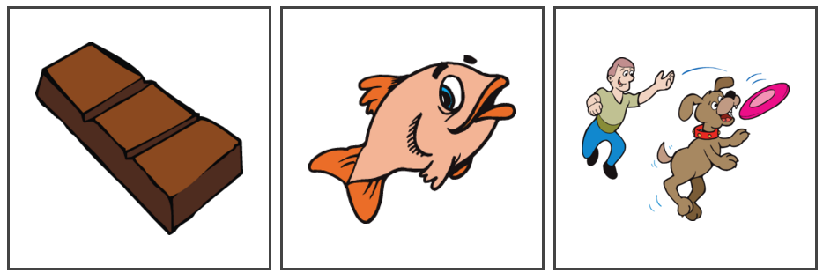 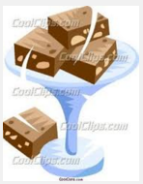

1. Lesson 38, act. 3: The audio for “farmer” says “fudge.”

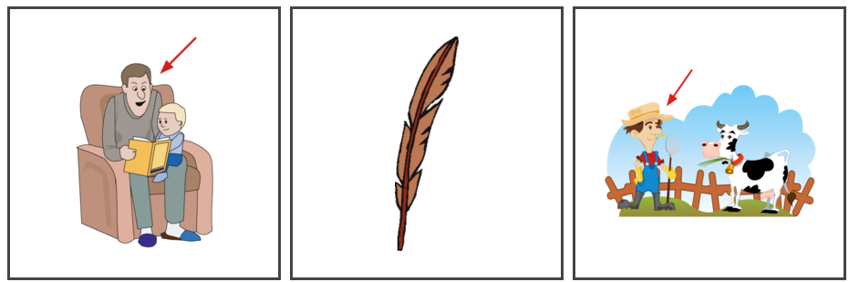

1. Lesson 40, instructions: The red arrow in the graphic for “fodder” is not visible enough. Can we try it in white or black? White first.

Patti—Scott will have to do this. He knows.

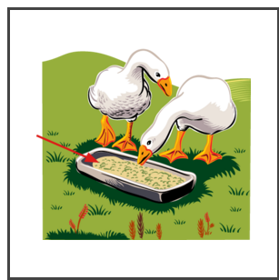

1. Lesson 40, act. 2: We can’t use both “fall” and “follow” for the “fo” sound; they make the same sound, so it’s too hard for a young student. Replace “fall” audio and graphic with “factory.”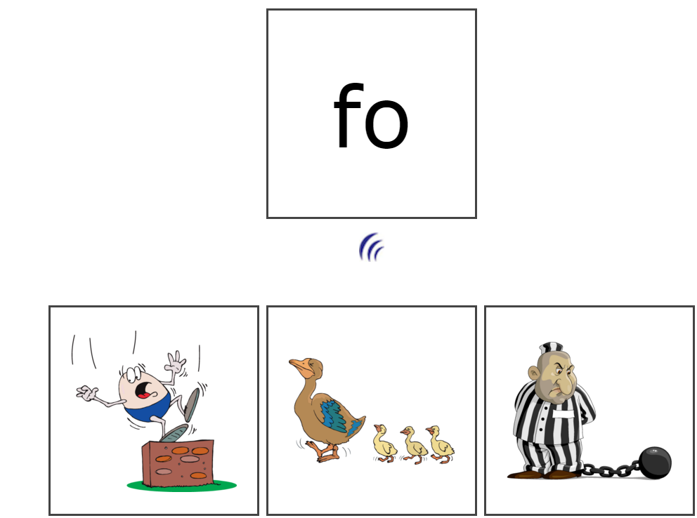
2. Same issue with Lesson 41, act. 3: Replace “follow” audio and graphic with “fond.”

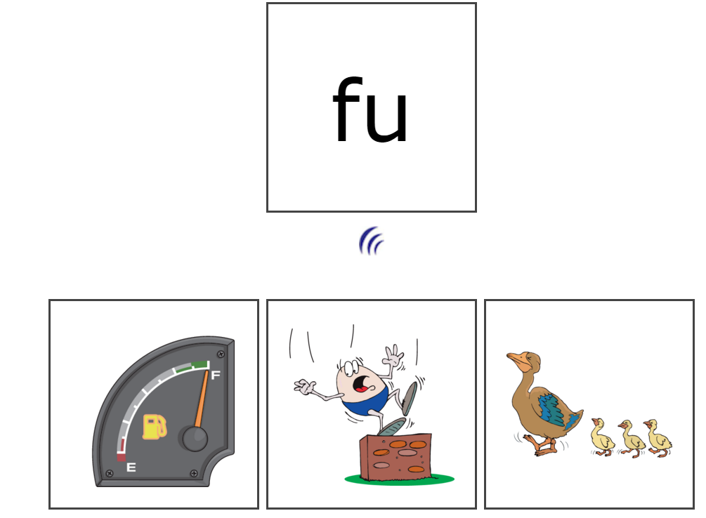

**Audio**

***Jacqueline:***

1. Throughout: short /o/ sounds more like /ah/ in “cat” rather than /ah/ in “hot.”
2. Lesson 7, act. 11: “nap” still sounds like “map.”
3. Lessons 13, 14-21 (and probably others after this as well): Correct feedback is too drawn out—does not flow; there are odd inflections that do not fit the words/context. Is there a way to record more of the phrase together?
4. Need new audio recorded for lessons 15-19: “This is not the letter [a,e,i,o,u]” **** I agree
5. Need new recording of “letter” for lessons 15-19. Can be more natural and less enunciated.
6. Need new recording of “letters” for lessons 21-25. Can be more natural and less enunciated.
7. Need audio for “belt.” It’s missing.
8. Need new recording of “collar.” Current recording is too high pitched.
9. Record “such as” if we don’t have it already.
10. Need “Say the word the same way I say it, then touch its picture.” (For lesson 7)
11. Need “fudge.”

***Dave:***

1. Need new recording of “letter” for lesson 20 and on. Can be more natural and less enunciated.
2. Lesson 21: Dave’s short a sound is incorrect. He says it like /bah/ in “bottom” rather than /ba/ in “back, bath, baboon.”
3. Record “such as” if we don’t have it already.

**To be added if Michael agrees:**

**** Yes, I agree that we should add “all” of these edits.

1. Lesson 1

#10: DIRT sounds like there is N before the D. It is said more slowly (drawn out) than RUG or STIR.

1. Lesson 2

#6: Jacqueline’s HOP needs more ending P. CAP is good.

1. Lesson 3

#1 Jacqueline’s HOP needs more ending P even though it is beginning sounds we are emphasizing. It will be replaced everywhere if agree to 1 #6 above.

1. #4—Jacqueline’s PAL needs more L like call and pill. It is almost like she gave more emphasis on the words spilled with a double L.
2. #16: BRIDGE—Jacqueline--can really hear the M before the B. Needs to be replaced wherever BRIDGE is used.
3. Lesson 18, #13 FLIP, FLAP, FLOP sound a little off from the other activities
4. Lesson 20, #7 BOX sounds different from words in other activities.
5. Lesson 32, Jacqueline: Need new recording of “d-e.” Sounds like “b-e.”
6. Lesson 33, Jacqueline: Need new recording of the sound for “di.” Sounds like /bih/.
7. Lesson 33, Jacqueline: “disguise” needs the “di” sound to be more drawn out.
8. Lesson 34, Jacqueline: “Donna” has more of a long /o/ sound, like /dōne-uh/
9. Lesson 37, Jacqueline: There’s a sound (mouth sound) in “f-a.”
10. Lesson 37, Jacqueline: There is a clicking sound in “fetch” and “foxhole.”
11. Lesson 39, Jacqueline: “festival” has a catch at the end.
12. Lesson 39, Jacqueline: “funnel” has a scratchy beginning sound.