WR Flashcards Edits 6.12.15

**All levels**

Need to make sure we remove the “Sounds” link before this is released. Once we're ready to release, I'll remove these

A description... A description...

When I use the keyboard’s space bar I’m able to advance to the next screen in an activity once I’ve selected an answer. Is that intentional? This is intentional. I use it to quickly cycle through the activities to check certain words/parts

In levels 1, 2, and 3 the Home button still needs to be preloaded so it doesn’t flicker when it’s first hovered over. The home button is preloaded. Both the idle and hover images are loaded immediately when the app starts.

**Level 2**

Game 2

The example word is supposed to be “**sentiment**.” Fixed

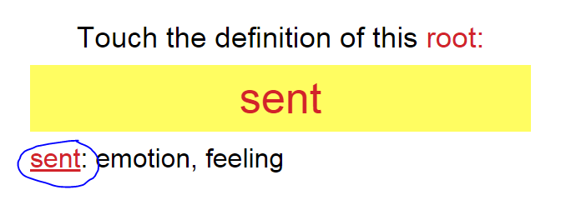

1. Games 7 and 10, “sedative.” There are only two answer choices (the correct ones). Need a third option. The word “sedative” has “ative” listed as both a suffix and a choosable part. I've corrected it on my end and asked Terry to correct it in the data.

**\*\*\*This has been corrected in Game 7 but not in Game 10.**

1. And the correct answer is showing as incorrect. Fixed

**\*\*\*Needs to be corrected in Game 10.**

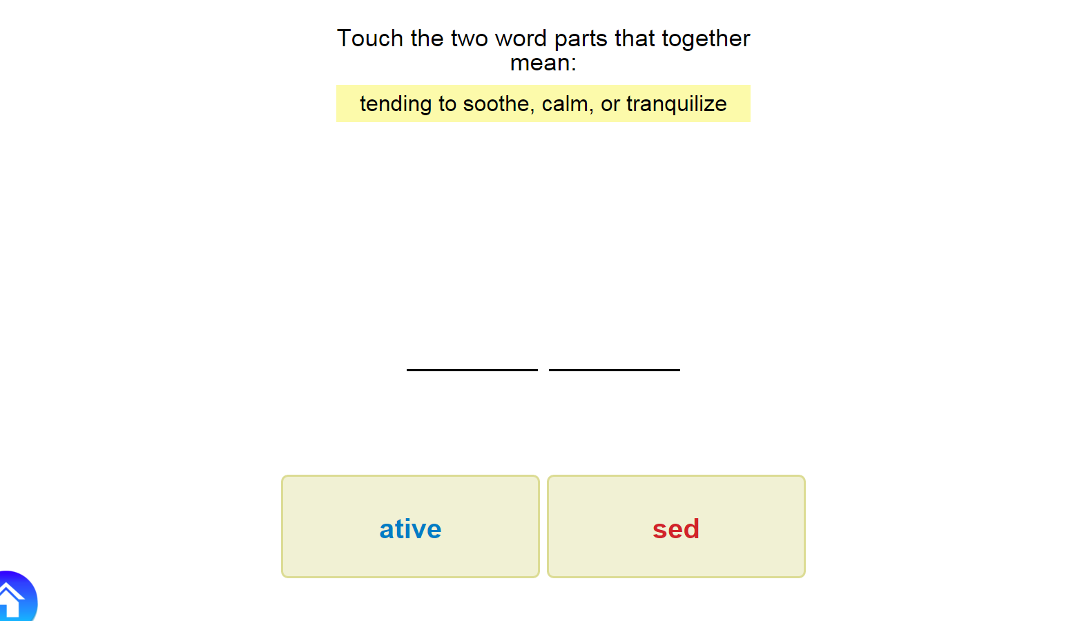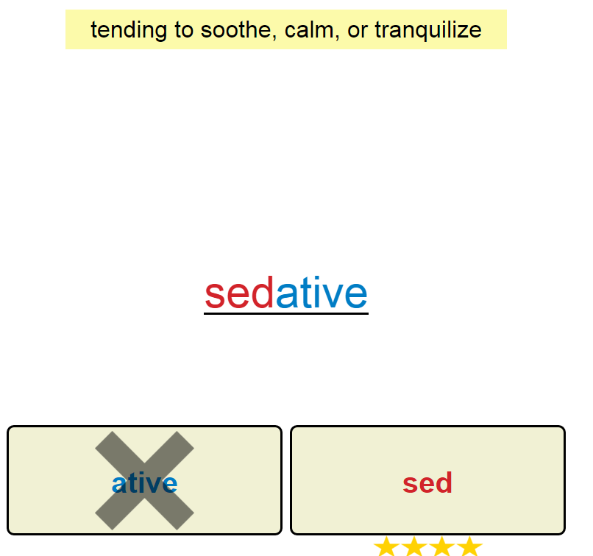

1. Games 7 and 10, “sentiment.” “iment” is missing; there are only two answer choices. I thought this was fixed, but there are three “sentiment”s in the word list, and I forgot to correct the one for level 2. Fixed (hopefully for good)

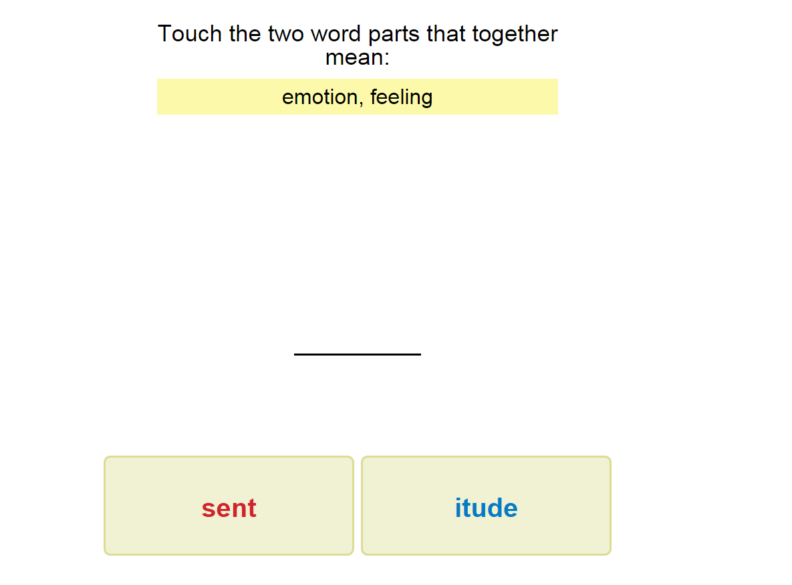 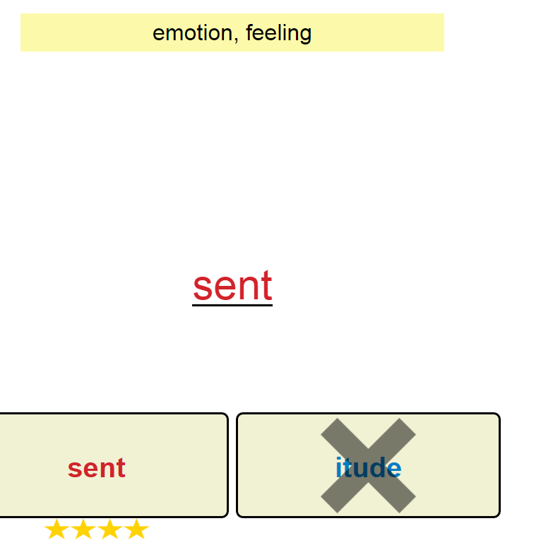

1. Games 8 and 11, “functional”—audio says “functionalism.” We have audio for “functional.”

Fixed. The word being chosen is actually “functionalism”; it was just missing the “ism” part in my data. This should also fix “functional” showing up twice in the 3 part activities

1. Game 11: The incorrect answer choice is missing. Fixed

