2023 Certificates: Install How-To

Introduction

Later this month (June 2026) the Security Certificates issued by Microsoft in 2011 will expire. These certificates are stored in UEFI firmware on all PCs that had once ran Windows 8 or newer.

In 2023 Microsoft released an updated file (shimx64.efi) that is used to perform the first part of Secure Boot verification on Linux PCs with Secure Boot in an enabled state.

Almost all of the existing Operating Systems that used these 2011 Certificate will still boot.

The reason is the subtlety of the differences in definitions of ‘Expired’ versus ‘Revoked’ words. Microsoft has stated that at some undefined point in the future they will Revoke the 2011 certs.

This expiration does NOT have any effect on Linux drivers or libraries signed by your PC (by Debian’s public certificate) or internal or external Hardware Manufacturer’s existing Security Certificates. Their certificates do NOT depend on the Microsoft certificates to achieve CA Root authenticity in any way.

Installing the new certificates in Linux

- Install the Debian package fwupd (2.0.10 or newer) by typing in terminal:

sudo apt install fwupd

- Update the local database of firmware updates by typing in terminal:

sudo fwupdmgr get-updates

- Run the ‘update’ option in terminal:

sudo fwupdmgr update

- You will be prompted two times to Perform operation? [Y|n]:
Example is below.

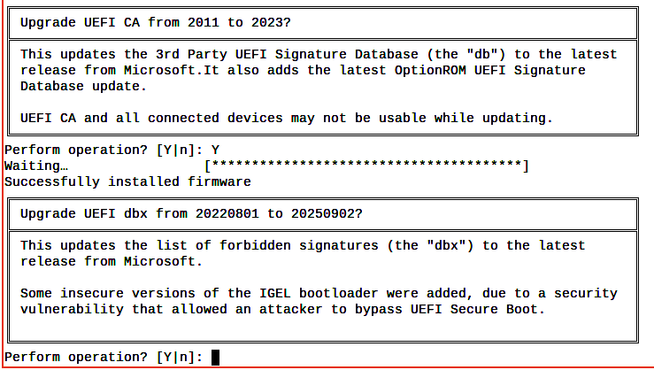
Press [enter] to answer Y to each.

Updating shimx64.efi

The 1.49 version of shim-signed.efi is in Debian Sid. In MX Linux 25 version 1.47 is current. Grub is signed by Debian so no update of it is needed. To update it type in terminal:

sudo apt install shim-signed

Verify certificates installation

To verify the Certificates type in terminal: mokutil –db –short. Example below.

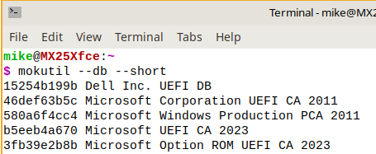
Notice 2011 and 2023 certificates are present. This is normal.

To verify the shimx64.efi signing
In terminal enter:
sbverify --list /boot/efi/EFI/MX/shimx64.efi
Below is typical output before shimx64.efi is signed with the 2023 certificates:
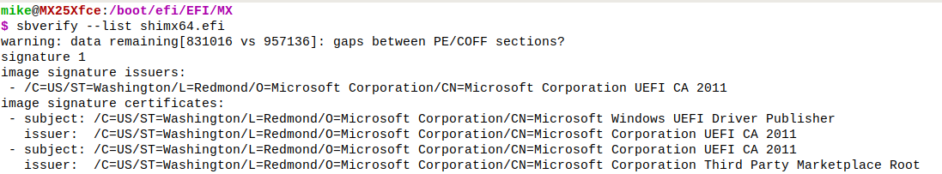
Source - https://learn.microsoft.com/en-us/windows-hardware/manufacture/desktop/windows-secure-boot-key-creation-and-management-guidance?view=windows-11#14-signature-databases-db-and-dbx

“For devices that are intended to support Linux, other 3rd party UEFI apps, or include special hardware requiring Option ROMs, OEMs may ship devices with this alternative configuration:”
After update this is what the Cerificate Store in the TPM should look like:
PK | OEM or Microsoft PK
KEK | Microsoft Corporation KEK 2K CA 2023
DB | Windows UEFI CA 2023  Microsoft UEFI CA 2023  Microsoft Corporation UEFI CA 2011  Microsoft Option ROM UEFI CA 2023
DBX | Latest dbx package

Windows 11
The concept of the phrase ‘the clock is ticking’ is in play. Procrastinating past the time Microsoft does the revocations WILL have consequences. A quote from Microsoft:

“OEMs must ship the device with the Windows UEFI CA 2023-signed Windows Boot Manager, both on the device and in bootable media provided with the device. This ensures that the device uses the Windows Boot Manager that will continue to be serviced after the 2011 certificates expire.”

Links

Secure Boot Certificate Changes in 2026 Red Hat Customer Portal

Windows Secure Boot certificate expiration and CA updates Microsoft Support

SecureBootCAChanges Debian WiKi

When Secure Boot certificates expire on Windows devices

Please direct ALL support requests to the MX Linux Forum -- https://forum.mxlinux.org/
Created by FullScale4Me on June 4, 2026 Last updated June 22, 2026

When Secure Boot certificates expire on Windows devices - https://support.microsoft.com/en-us/topic/when-secure-boot-certificates-expire-on-windows-devices-c83b6afd-a2b6-43c6-938e-57046c80c1c2

