Accessing your phone via USB cable

Connect to your PC using the USB cable.

Check the notifications on your phone by swiping the screen from the top to bottom.

If the connection has been recognized by your phone you should see a two line notice:

'USB for charging phone'
'Tap for other USB options.'
Tap this notification.

In the section named 'Use USB for' select 'Transferring files / Android Auto'

Enter your PIN when prompted and tap 'OK'.
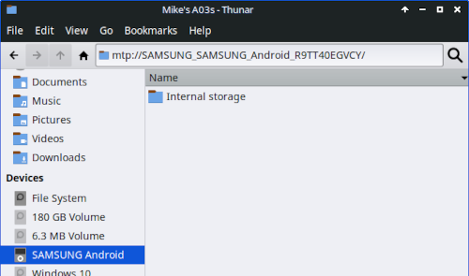
Your phone should now appear as:

'SAMSUNG Android'

in the File Manager section 'Devices'.

If the above does not work

Go to: 'Settings > Apps >' and tTap the 3 lines with the downward facing arrow, to the right of 'Your apps' >

Toggle on 'Show system apps >' then tap 'OK >'

Scroll down, and tap on 'USB Settings >'

Tap 'Storage >' then tap 'clear cache' then 'clear data'.

Restart your device. Do this by pressing 'down-volume' and 'power' at the same time and hold.

Tap the 'Restart' twice.

Verified on a Samsung S23 Inspiration: https://eu.community.samsung.com/t5/other-galaxy-s-series/usb-connection/td-p/7469166

Please direct ALL support requests to the MX Linux Forum -- https://forum.mxlinux.org/
Created: July 7, 2026 Updated: July 7, 2026

