Dual Boot: MX Linux 25 & Windows – How-to Guide

Dual Boot is also known as Install alongside Windows [Boot Manager] in other distributions.

Dual Booting is an option for intermediate level PC users to keep an existing Windows 10/11 installation, with both OS having full access to all resources. Mixing Legacy partition (MBR) disks with UEFI (GPT) disks as a part of the Grub boot process is NOT supported here.

Recommend adding a second hard disk drive - Some PCs may have a space for a second disk. Leaving the existing Windows installation on its own drive has a stability advantage. Windows being the first installed Operating System is preferred.

The MX Installer now has support for 64 bit UEFI Secure Boot installations. Users will still need to use a signed kernel (currently the Debian stable 6.12 kernels) for this support to work. The “AHS” releases (Xfce AHS & KDE) with the Liquorix kernels do not support Secure Boot.

MX Linux requires a partition with a minimum of 8.5 Gb free space, with 20 Gb recommended disk space. MX 25 KDE edition installed weighs in at around 11 Gb. Consider implementing a partition for data sharing area between Windows and MX Linux. Use FAT 32, ExFAT or NTFS.

Its highly recommended that keeping the Home directory in MX Linux on a separate partition can improve the reliability and ease of subsequent upgrades. Selecting 'Replace Existing Installation' preserves the home directory of the root partition during the MX Linux installation while deleting everything else.

1.1 Prepare MX Boot USB

Ventoy is preferred. See https://fullscale4me.com/Ventoy-How-To.pdf

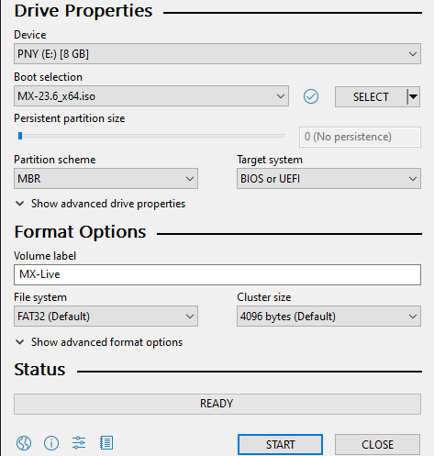
Rufus https://rufus.ie/ (right) is very flexible. At first it looks a bit complicated, but only takes 1 or 2 added clicks after picking the ISO.

 Pick the ISO with 'SELECT '
 Verify the correct 'Device' is chosen.
 Click the 'START' button.

Rufus may ask you to choose between 'ISO image' or 'dd image' mode. Try 'ISO image' first.

Modern PCs should use GPT as the 'Partition scheme'. MBR 'Partition scheme' may also work.

Older PCs, pre 2012 may not boot from GPT 'Partition scheme'; use the MBR 'Partition scheme' instead.

For really old PCs in Format Options click ' Show advanced drive properties', check 'Add fixes for old BIOSes (extra partition, align, etc.)', then click 'START'.

2.0 How-To steps summary outlines

What follows are summaries of how-to steps for the two most likely installation scenarios.

2.1 All on a single hard disk outline

  - Backup your user data.
  - Prepare MX boot USB . Section 1.1
  - Prepare Windows for Dual Booting section 3.0
    - Create a Recovery USB Drive for Windows. section 3.2
    - Backup your Windows License Key. section 7.3
    - Disable BitLocker in Windows (if enabled). section 7.4
    - Disable Windows Fast Startup. section 3.6
    - Perform a Disk Check & Defragment Hard Drive. Section 3.2 & 3.3
    - Shrink Windows C drive with 'Disk Management'. section 3.8
    - Create the new partition for MX Linux.
Reboot and access PC firmware

  - PC Firmware changes to allow Dual Boot section 4.0

    - SATA Controller – change to 'AHCI Mode'. section 4.6
    - Turn off Fast Boot . Section 4.4

  - Installing MX Linux on the new partition Section 5.0
    - Booting and installing MX Linux 25 section 5.1
      - Create optional data sharing 'MyData' partition. Section 5.7
    - Install MX Linux on the new partition.

2.2 TWO hard disk drives outline

Do NOT install the 2nd hard disk drive at first. Follow steps!
  - Backup your user data.
  - Prepare MX boot USB Section 1.1
  - Prepare Windows for Dual Booting section 3.0
    - Create a Recovery USB Drive for Windows. section 7.2
    - Backup your Windows License Key. section 7.3
    - Disable BitLocker in Windows (if enabled). section 7.4
    - Disable Windows Fast Startup. Section 3.6

  - PC Firmware changes to allow Dual Boot section 4.0

    - SATA controller – change to 'AHCI' mode. section 4.6
    - Turn off Fast Boot aka Quick Boot. Section 4.4
    - Shutdown PC.

  - Prepare the second hard disk
    - Boot from the MX USB section 1.1
    - Prepare MX hard drive.
    - Create the ESP (FAT 32) and / root (ext4) partitions on 2nd drive.
    - Create data sharing 'MyData' partition. Section 5.7

  - Booting and installing MX Linux 25 Section 5.0
    - Install MX Linux 25 on the 2nd hard drive. Section 5.1

3.0 Preparing Windows for Dual Booting

3.1 Procedure to locate the BitLocker Keys
- Go to: https://onedrive.live.com/about/en-us/signin/
- Log into your Microsoft Online Account
- Locate the BitLocker Recovery Keys:
- Click 'Devices'.
- Click 'See Details'.
- Click 'BitLocker Data Protection'.
- Click 'Manage Recovery Keys'.
Write the Keys down, copy the Recovery Keys to a safe location - NOT on this PC!
Also print the Recovery Keys out.

3.2 Check Hard Drive for surface errors

- In Windows File Explorer left-click on 'This PC'.
- Left click the C drive.
- Right click and select 'Properties'.
- In the pop-up select the 'Tools' tab.
- Click on ‘Check’ in the 'Error checking' section.
- In the pop-up click 'Scan drive'. Windows will restart and at the bottom of the screen a row of text will appear similar to below the rotating circle of dots.
Fixing (C:) Stage 2: 27% (226414 of 822896); Total: 34% ETA 0:00:49

Once completed you will receive a summary of your hard drive health.

3.3 Defragment the hard Drive – mechanical drives ONLY

- In Windows open File Explorer and right-click on 'This PC'.
- Left click the C drive and then right click the C drive. Click 'Properties'.
- In the pop-up click the 'Tools' tab.
- Click on 'Optimize' in the 'Optimize and defragment drive' section.
- In the pop-up ensure the correct drive is highlighted and click 'Optimize'...wait.

3.4 Shrinking the C drive for MX Linux

MX Linux needs a minimum of 8.5 Gb of free space and preferably 25 Gb is recommended.

Right click on the Windows Start Menu and select 'Disk Management'.

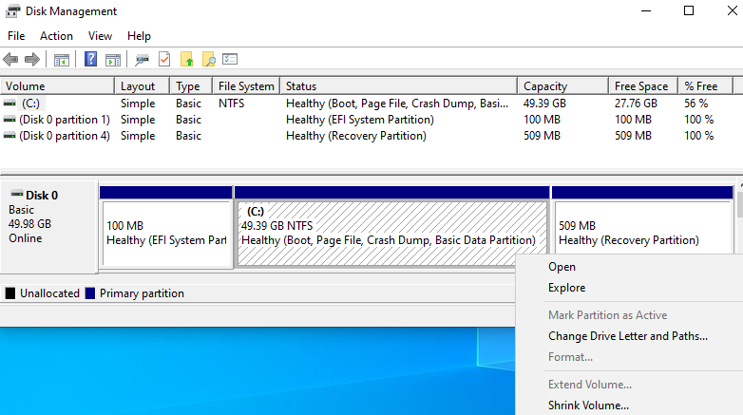
Above is a single hard drive PC. Disk 0 shows: 100 MB (EFI) and 49.39 GB (C:) drive (highlighted ////). Also shown is the right-click menu content.

To do the resizing

Right click on the (C:) drive and select 'Shrink Volume…'

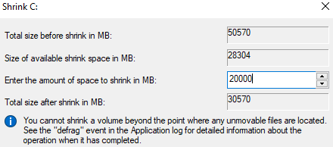

In the pop-up above:
- Type in 20,000 in the white box for a new size of ~20 Gb and click the 'Shrink' button.
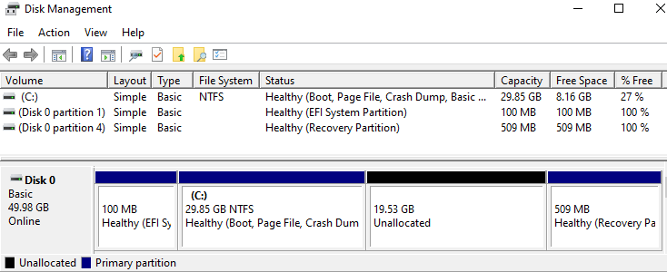

3.5 Creating the partition for MX Linux – all on one disk

NOTE: If encryption is being setup a separate / and a 1 Gb /boot partition (ext4) is required.

- Right click in the newly created free space (black bar with ‘Unallocated’ showing)
- Click 'New Simple Volume'. Click 'Next' and 'Next'.
- Select 'Basic Volume'. As the wizard run skip assigning a drive letter.
- Give it a Label and leave 'Format this volume…' selected. Example below.
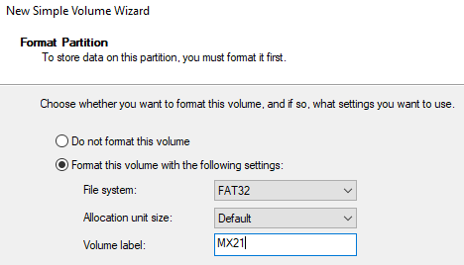
Make note of the size shown and volume Label of this new partition. You will use it to identify the drive where you will install MX Linux later.

- Click 'Finish'.

3.6 Turn off Windows Fast Startup

- Left-click the start button and type 'CMD' in the search box.
- In the search results, click on 'Run as Administrator'.
- Click 'Yes' to the question: 'Do you want to allow this app to make changes to your device?'
- Type 'powercfg /h off' and press enter. See footnote below
Restart your PC...do NOT select Shut down and power back on!
- On some PCs not turning this OFF may interfere with the WiFi functionality.
- Windows Update may turn Fast Startup back on!

4.0 PC Firmware changes to allow Dual Boot

A few settings in this section are unlocked/made visible in the 'advanced mode' (MSI & others).

List of PC brands with their corresponding hot-keys

Set the Admin/Supervisor Password
A few of the newest PCs require (Acer & other brands too) a non blank Supervisor/Admin Password for any non-Windows EFI files to be ‘trusted’. Many times there are menu selections under major topics that only become visible once an admin password is entered and saved.

4.1 Accessing your PC’s Firmware
Advanced method – Hold the Shift button down and then click the Start button. While still holding the Shift button click the Power button and then the Reset choice.

Windows 11
  - Click Start Button and click the Settings (gear) icon.
  - type in search 'UEFI'.
  - Click on 'Change advanced startup options'.
  - Under ‘Advanced startup’ click 'Restart now' and again ‘Restart now’.
The PC will restart in UEFI mode.
  - Click 'Troubleshoot' and then 'Advanced options'.
  - Click 'UEFI Firmware Settings' and then click 'Restart'.

Windows 10
- Click the Start Button and then click Settings aka the gear icon.
- Search on 'Reset this PC' and click it.
- In 'Advanced Startup' click 'Restart now'. The PC will restart in UEFI mode.
- After it restarts click 'Troubleshoot' and then click 'Advanced Options'.
- Click 'UEFI Firmware Settings' and then click 'Restart'.

4.2 OS Boot Manager – HP

This HP firmware places an entry 'OS Boot Manager' within hardware 'UEFI Boot Order' entries. This, when navigated to via arrow becomes highlighted (white below). Press enter to see the selections in the sub-menu it presents.

In the example below 'ubuntu' is the entry now selected; 'Windows Boot Manager' was selected initially on entry to this sub-menu.

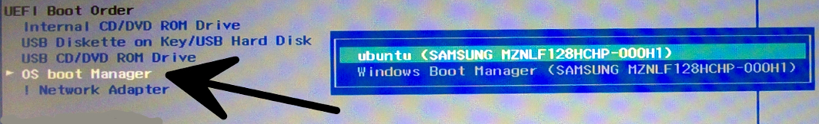
Arrow to the correct item then press enter to accept your choice.

Boot Mode Select – MSI

4.3 Secure Boot – Platform Trust Security
In this section 'Disable' or turn 'Off' the 'Platform Trust Technology' aka 'PTT'. Also 'Boot Path Security' might need disabling.

On some PCs a Secure Boot 'Mode' sometimes called 'Custom' aka 'Setup' needs to be selected to allow Secure Boot security manual changes. This setting may be located in the Security section instead of Secure Boot, sometimes known as 'Trusted Execution' – Dell.
The following Secure Boot options may or may not be present (hardware maker dependent):

Windows WHQL Support

Under Windows OS Configuration. Enables the support for Windows 10/11 or disables for other operating systems. Disable/Turn OFF. This setting may also be found under OS Type. Set the OS Type > Other OS (rather than Windows UEFI mode).

When left enabled the entry in the UEFI Boot Order may be forced/locked to the top when ‘Windows WHQL Support’ is Enabled. (Windows Hardware Quality Labs aka WHQL).

Secure Boot (Mode) [Standard] or [Custom] - MSI

Set to Custom – this allows the user to configure the Secure Boot settings and manually load the secure keys. Standard has Microsoft hard-coded Windows settings.

Platform Mode – Lenovo - Setup or User. This may require Reset Factory Keys if they had been deleted.

4.4 Turn off Fast Boot

Fast Boot is used to reduce your PCs motherboard's portion of the total startup time. It will disable full (hardware) initialization of more devices to speed up system boot time. When Fast Boot is enabled, you may not be able to boot from a USB flash drive (on some PCs).

With Fast Boot enabled: 'Boot from Network', 'Optical', 'Wi-Fi' and (possibly) secondary USB outlets may be disabled. So, they may not be available until an Operating System fully loads.

The Fast Boot settings may have several functional levels or just ON/OFF. Often seen: 'Minimal' (often the default), 'Thorough' (the system does not skip any steps in the boot process), and 'Auto'.
NOTE: Set Fast Boot to 'OFF' / 'Disabled' or 'Thorough' if 'OFF' is NOT an option.

4.5 Reset Boot Order/Priority/Boot Sequence
Boot Sequence (UEFI) - Allows you to change the order in which the computer attempts to find an Operating System.

The options are: Windows Boot Manager or Boot List Option-UEFI – the latter is what we want!

Boot Sequence – UEFI NVME Drive BBS Priorities (AMI)

Allows you to change the order in which the computer attempts to find an operating system. All the options are selected: Diskette Drive, Internal HDD, USB Storage Device, or CD/DVD/CD-RW Drive.

HP - additional configuration requirement

1. Go to Boot Configuration and select 'add a ‘Customized Boot'.
2. Point 'Customized Boot' to \EFI\MX\grubx64.efi and change UEFI Boot Order with 'Customized Boot' on top.
NOTE: The path (2 above) may be MX, MX25 or MX Linux.

UEFI Boot Path Security

Allows you to control whether the system prompts the user to enter the Admin password when booting to a UEFI boot path. Also known as BIOS write protect.

Choose one of these options: Always, Except Internal HDD—Default
or
BIOS Override lock (AMI) – unlock.

The PC going back to old setup after reboot is a sign that these setting exists…may be a similar name that is not above.

4.6 SATA Controller - Change to AHCI Mode

NOTE:
- You cannot change out of RAID if your system has Intel Optane Memory in use.
- It is required to disable Optane to change the SATA Mode from Raid (RSTe) to AHCI.
- On some motherboards these settings may be under 'Advanced Windows OS configuration.'

Disabling Intel Optane Memory (Dell)

- On the taskbar, click the search box.
- Type Intel Rapid Storage Technology.
- Click Intel Rapid Storage Technology.
- On the Intel Optane Memory tab, click Disable to disable the Intel Optane Memory.

The MX Linux Installer program may not see SSD Hard Drives if the motherboard Firmware has the SATA Controller 'Mode' set to 'RAID' mode or 'RST' mode (aka IRST/RST/Optane). The PCs motherboard SATA Controller’s Mode must be set to 'AHCI Mode'.

Windows most likely was installed when the SATA Controller Mode was set to RAID.

Disable the VMD Controller – ASUS

To turn RST OFF in BIOS: press Ctrl Key and S simultaneously (with the Caps Lock Key ON). This will bring up VMD Controller aka VMD Configuration Settings underneath F12 Boot Menu.

Disable the VMD Controller

Warning: If you have BitLocker enabled, save your Recovery Keys elsewhere (or write it on paper) before attempting to change the SATA mode to AHCI. You will need it for Safe Mode boot. Alternately disable BitLocker before performing this change.

Also Know As – Intel Volume Management Device. This was the original. Above are many captures of brand specific ‘marketing spins’ of the VMD feature used by many manufacturers.
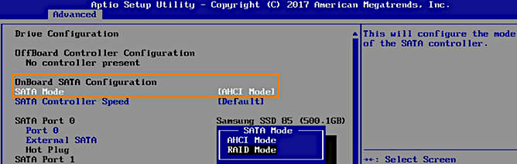
Figure is an example – your PC could be different.

Using MSConfig to Change Windows SATA Controller to AHCI mode

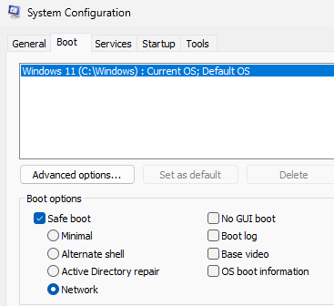
- Type 'msconfig' in the search box and press enter.
- Click 'Run as Administrator', select the 'Boot' tab and check 'Safe boot'.
- Click 'Network' , 'Apply', 'OK' and reboot PC.
- Enter the PC firmware and change the SATA Controller 'Mode' from 'RAID/RST' to 'AHCI'.
- Save Changes and Exit. Windows will then boot into Safe Mode again.
- Once in Safe Mode, run msconfig as Administrator.
- Select the 'Boot' tab, UN-check 'Safe boot', click 'Apply', 'OK' and reboot.
Windows will then restart in normal mode with the AHCI drivers enabled.

To verify AHCI mode is set (in Windows 10/11)

- Open 'Device Manager' and expand IDE ATA/ATAPI Controller.
- Left click 'Standard SATA AHCI Controller', right click and then left click on 'Properties'.
- Select the 'Driver' tab and click 'Driver Detail's.
The 'Driver files:' show: ‘C:\Windows\system32\DRIVERS\storageahci.sys’.

5.0 Installing MX Linux 25 on the new partition

5.1 Booting and installing MX Linux

- Insert the LiveMedium USB in the fastest available USB port (blue) and restart the PC.
- After the PC powers on tap the ESC, F9 or F12 key to bring up the (one-time) Boot Menu.
- Alternately on some PCs you may need to instead use the F2, F8, F10 or F9 key.
- On some PCs you may offered TWO options to boot; always take the one labeled UEFI
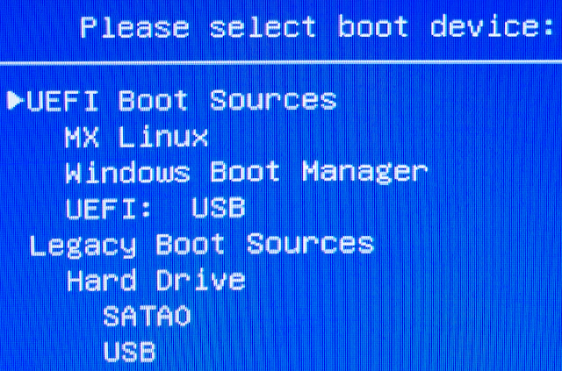
Ensure that the MX Installer automatically selects 'Customize the disk layout'.

5.2 Root partition selection
The MX Linux Installer REQUIRES you to select where to place root / partition. In the listing left click the partition in the 'Device' column you had just created. This highlights it blue (below).
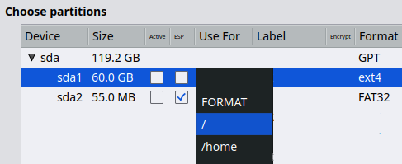
- Change it from blank to / aka the Root partition (see above).

5.3 EFI System Partition background
This partition is also known as the ESP, short for 'EFI System Partition'. Modern PCs use them.

The ESP partition is recommended to be a FAT32 formatted file system AND marked as an ESP.

Windows 11 requires a minimum of 100 Mb for the ESP, Windows 10 the minimum is 50 Mb. If multi-booting with an Ubuntu based distribution increase this to 300 Mb.

5.4 Identifying the current ESP location
A critical aspect of Dual Boot setup is the MX Linux Installer REQUIRES you to identify which partition to install the EFI portion of the boot files. Below shows that the existing EFI partition is sda1.

The next step after 'Customize the disk layout' is 'Choose partitions' (below). How do I know it is sda1? The 'Format' column shows 'FAT32' for sda1.

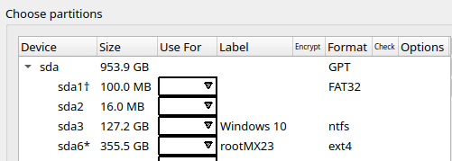
Note in the above example the 'Format' column says GPT for 'Device' sda.

5.5 Selecting the ESP partition.

Do the following:

- Left click on the ESP partition.
- Click the 'Use For' on the FAT32 partition. Use the down arrow pull-down to select 'ESP'.
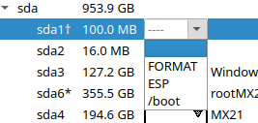
- When this is done the MX Linux Installer will change the 'Format' to 'Preserve (FAT32)'. This is to ensure that any EFI data present is kept.

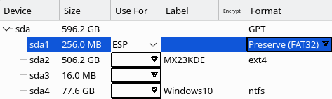

5.6 Dual hard disk considerations

Two physical disks adds resiliency to lessen the chances of a Windows Update modifying the MX Linux bootup info. By dual it also means multiple ESP, IE one for MX Linux and one for Windows. Create the second EFI partition (FAT32 formatted, 100 Mb) on the second physical drive.

Other distro's advocate delaying installing the 2nd hard drive until just before you install (MX) Linux.

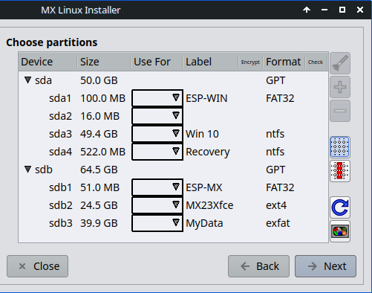
An example of how to configure Dual Boot with two hard disks

Notes on the above:
- Partition sdb2 has been labeled MX23Xfce for / aka root usage.
- There are two ESP partitions: 1st as 'ESP-MX' - sdb1 and 2nd as 'ESP-WIN' - sda1.
- Windows partitions: unlabled sda2, 'Win 10' & 'Recovery'. All labels added post installation.
- An optional 'DualData' partition exists as sdb3 for data sharing between Windows & MX Linux.

5.7 The 'MyData' Partition setup

The previous steps in making the MyData partition adds a bookmark in Thunar. Use the MX Tool 'Disk Manager' to ensure that it continues to appear by checking 'Enable' next to it and then 'Quit'.

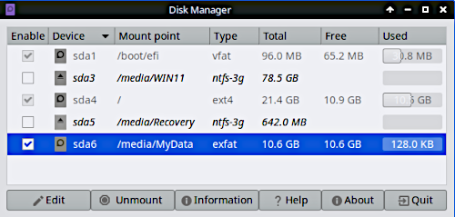
Sda6 'Enabled' as MyData

6.0 Troubleshooting and common issues
Also see MX Linux 25 User Manual - Troubleshooting, section 2.6

6.1 No operating System found!

The Boot Order has to be set such that the disk (group) that has the ESP partition (where MX Linux Installer put Grub) is the one booted. The firmware NVRAM holds the 'path' to the Grub boot code. This 'path' in Grub’s configuration is a combination of physical drive and partitions. MX Boot Repair from a Live USB boot can many times fix this.

6.2 Black or blank screen
Display distortions and even a blank screen are sometimes seen. To fix go to the 'Advanced Options' on Welcome Screen select nomodeset (failsafe nomodeset) then finish booting.

Some PCs need, instead of quiet splash: acpi_osi=Linux acpi_backlight=vendor or pci=nomsi.
Some laptops may just have backlight set way down, press F key to make it brighter. You can use the F12 key in the boot loader to see a menu of what boot options are selected by your current menu choices. Boot codes not listed in these menus must be added manually.

More boot parameters (MX 25): https://mxlinux.org/wiki/system/boot-parameters/

6.3 Incorrect Windows time In Dual Boot
Windows assumes Local Time and Linux expects UTC time. Making Linux use local time the same way Windows does is a good option. Do ONE of these two ways to address the difference.

1) LINUX: Change the time setting for Linux: https://mxlinux.org/wiki/help-files/date-time/

2) WINDOWS: perform the following steps (may cause issues with some 3rd party apps):

- Open Regedit on Windows and navigate to:

- HKEY_LOCAL_MACHINE\SYSTEM\CurrentControlSet\Control\TimeZoneInformation\.

- Right-click the “TimeZoneInformation” key.

- Select "New" => DWORD (32-bit) Value. (or QWORD on 64-bit systems).

- Name your new value RealTimeIsUniversal.

- Double-click the RealTimeIsUniversal value you've just created, set its value to 1.

- Click “OK” to exit Regedit.

Right click time in the systray and left click Adjust date/time.

Turn OFF 'Set Time Automatically'.

6.4 Grub Boot Menu disappears

The Windows twice yearly 'Features Update' many times will insert itself as the first (top) entry in your PC Motherboard’s UEFI firmware listings. This will cause the PC to boot directly into Windows with no MX Linux Grub Boot Menu being presented to you.

First, check if the Grub Menu entry is present in your PC’s Motherboard UEFI list is still present in the one time boot menu (F9 or F12).

Reboot the PC with the MX Linux USB and run 'MX Boot Options'. Click 'Manage UEFI Boot Options'. If the Grub Menu entry is there click to highlight it and then move it to the top by clicking 'Move up' and then reboot. If the entry is missing go to https://mxlinux.org/wiki/uefi-manager/

NOTE: The above applies to UEFI PC installations only.

7 Appendixes

7.2 Create a Recovery USB Drive for Windows
- In the search box on the taskbar type 'Create a recovery drive' and then select it.
- When the tool opens make sure to select Back up system files.
- Then select Next.
- Connect a USB drive to your PC
- Select it, and then select Next.
- Select Create. This will take some time to complete. Over an hour is not unusual.

Label 'Windows Recovery USB' and then store this USB in a safe place.

7.3 Backup your Windows License Key
To get the Windows Key copy/paste the output of below to a text file:

Windows Admin CMD: ‘wmic path SoftwareLicensingService get OA3xOriginalProductKey’

In Linux: ‘sudo strings /sys/firmware/acpi/tables/MSDM’

NOTE: The presence and contents of the MSDM is not guaranteed to be present on all PCs.

Another place the Windows key will be found is in the owner's Microsoft Online Profile.

Backup this key in some place (phone, printout, MS Account) other than the PC!

7.4 Disable BitLocker
Ifyou turn Secure Boot Off and BitLocker (Windows Drive Encryption) Enabled, you may need to manually enter your Recovery Key every time you boot up. Windows 11 Hello will not work.

BitLocker must be Disabled before doing any Hard Drive reconfiguration tasks.

- Windows 11 Home & Pro – BitLocker is enabled and should be disabled.
- Windows 10 – at the time of writing has BitLocker is not enabled.

Notes: There may be more than one Recovery Keys, The first one is for your 1st encrypted volume (partition). The 2nd is for the 2nd encrypted volume (partition).

The TPM must be enabled and Security Certificates (keys) present during these steps!

More info https://www.wikihow.com/Turn-Off-BitLocker

Procedure to disable BitLocker Using the Control Panel (Recommended)

  - Click the Start button or search icon and type "Control Panel".
  - Open the Control Panel.
  - Select System and Security, then click BitLocker Drive Encryption.
  - You will see a list of drives with their BitLocker status.
  - Click on the drive for which you want to disable BitLocker and then select "Turn off BitLocker".
  - Confirm that you want to turn off BitLocker to begin the decryption process.

Note: Sections 3.5, 3.6 and 3.7 are for mechanical Hard Drives only, NOT for Solid State Drives!

7.5 TPM aka Trusted Platform Module

TPM aka Trusted Platform Module. Older PCs, made for to Windows 7 and older will NOT have one.

BitLocker Drive Encryption and Secure Boot require a TPM. TPM is a local database store of security keys and digital certificates. Sometimes the TPM is bundled in a different name implying security. This varies by PC brand and year.

Do NOT disable the TPM as some guides found on the internet suggest!

7.6 Security Certificates
Some online guides also suggest you should delete these. DO NOT DELETE THEM!!! They take up very little space. Restoring them if needed in the future is an expert level task! The is no vulnerability or space usage aspect to this despite what some online sources offer as wise actions.

7.7 USB Configuration/USB Emulation
Security Configuration in Dell & others (seen as 'Removable Device Boot' below) allows you to enable/disable the USB controller for boot from USB.
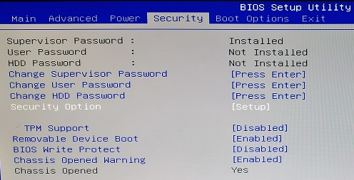
In the above example ensure 'Removable Device Boot' is 'Enabled'.
Below shows a Dell Dimension 9200 PC that has Boot From USB set to 'No Boot' aka disabled. Many PCs have ‘USB Booting’ disabled by default as a security measure.

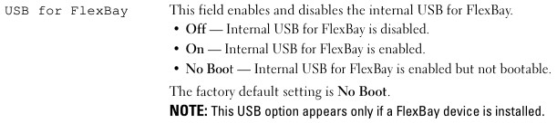
Enable Boot Support at a minimum; enabling both is more functional desirable.

7.8 Surface pro PC

An example at right of what settings are present. This may be outdated information.
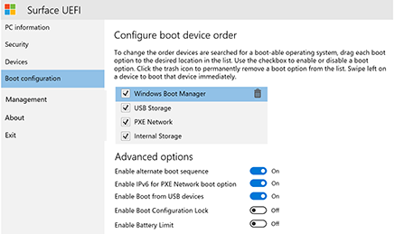

7.9 Enable the Boot Override Menu - if it exists in your PC

There are some PC brands or models that have the ESC (Acer/Asus), F9 (HP), F12 (Dell) or other key to display a 'One time Boot Menu'. This menu may be disabled by default on some PCs.
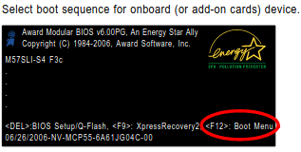
Enable/Turn ON the F12 this menu.

Exit the Firmware settings and select 'Save Changes and Restart'.

7.10 Turn off MBR/CSM/Legacy/BIOS Boot

NOTE: Verify that Windows still boots after this change.

This forces the PC into ‘UEFI Only’ Boot Mode. If this is left in Legacy it can cause several boot up problems. The white text below is highlighting that indicates a menu will come up if you press enter. Windows 11 can NOT boot in Legacy mode.

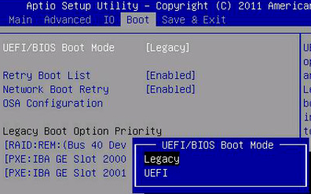
NOTE: In a few rare cases CSM/Legacy/BIOS needs to be turned off in TWO places: Boot and Security are the most common. 'Boot Mode' (default) and 'Boot fallback' aka LEGACY+UEFI. Dell refers to 'Advanced Boot Options'.
Table of Contents
1.1 Prepare MX Boot USB 1
Ventoy is preferred. See https://fullscale4me.com/Ventoy-How-To.pdf 1
2.0 How-To steps summary outlines 2
2.1 All on a single hard disk outline 2
2.2 TWO hard disk drives outline 3
3.0 Preparing Windows for Dual Booting 4
3.1 Procedure to locate the BitLocker Keys 4
3.2 Check Hard Drive for surface errors 4
3.3 Defragment the hard Drive – mechanical drives ONLY 4
3.4 Shrinking the C drive for MX Linux 5
3.5 Creating the partition for MX Linux – all on one disk 6
3.6 Turn off Windows Fast Startup 7
4.0 PC Firmware changes to allow Dual Boot 7
Set the Admin/Supervisor Password 7
4.1 Accessing your PC’s Firmware 7
Windows 11 7
Windows 10 8
4.2 OS Boot Manager – HP 8
4.3 Secure Boot – Platform Trust Security 8
4.4 Turn off Fast Boot 9
4.5 Reset Boot Order/Priority/Boot Sequence 9
4.6 SATA Controller - Change to AHCI Mode 10
5.0 Installing MX Linux 25 on the new partition 12
5.1 Booting and installing MX Linux 12
5.2 Root partition selection 12
5.3 EFI System Partition background 13
5.4 Identifying the current ESP location 13
5.5 Selecting the ESP partition. 14
5.6 Dual hard disk considerations 14
5.7 The 'MyData' Partition setup 15
6.0 Troubleshooting and common issues 16
6.1 No operating System found! 16
6.2 Black or blank screen 16
6.3 Incorrect Windows time In Dual Boot 16
6.4 Grub Boot Menu disappears 17
7 Appendixes 17
7.2 Create a Recovery USB Drive for Windows 17
7.3 Backup your Windows License Key 18
7.4 Disable BitLocker 18
Procedure to disable BitLocker Using the Control Panel (Recommended) 18
7.5 TPM aka Trusted Platform Module 19
7.6 Security Certificates 19
7.7 USB Configuration/USB Emulation 19
7.8 Surface pro PC 20
7.9 Enable the Boot Override Menu - if it exists in your PC 20
7.10 Turn off MBR/CSM/Legacy/BIOS Boot 21

Please direct ALL support requests to the MX Linux Forum -- https://forum.mxlinux.org
Last updated June 10, 2026

Do this by taking a portion of what was ‘shrunk’ from your windows C: drive. A File System of exfat is suggested over NTFS. Also add a Label:
How to Disable/Enable Fast Startup on Windows 11- https://techcommunity.microsoft.com/t5/windows-11/how-to-disable-enable-fast-startup-on-windows-11/m-p/3712330
https://ubuntuforums.org/showthread.php?t=2297947&p=13369742#post13369742
Some motherboards will maintain in NVRAM a separate UEFI boot order list PER DRIVE. (MSI)
Intel RST https://help.ubuntu.com/rst/
Resolve Missing SATA Mode Operation on Asus Laptops https://youtu.be/yL73D_m2Y3o?si=pbWdTyzMFYwXIcRD

