HELP: MX Package Installer
It is listed in the Favorites of the Start menu by default; but if that has been removed, click Start menu ≻ System ≻ MX Package Installer (MXPI) and provide the root password.
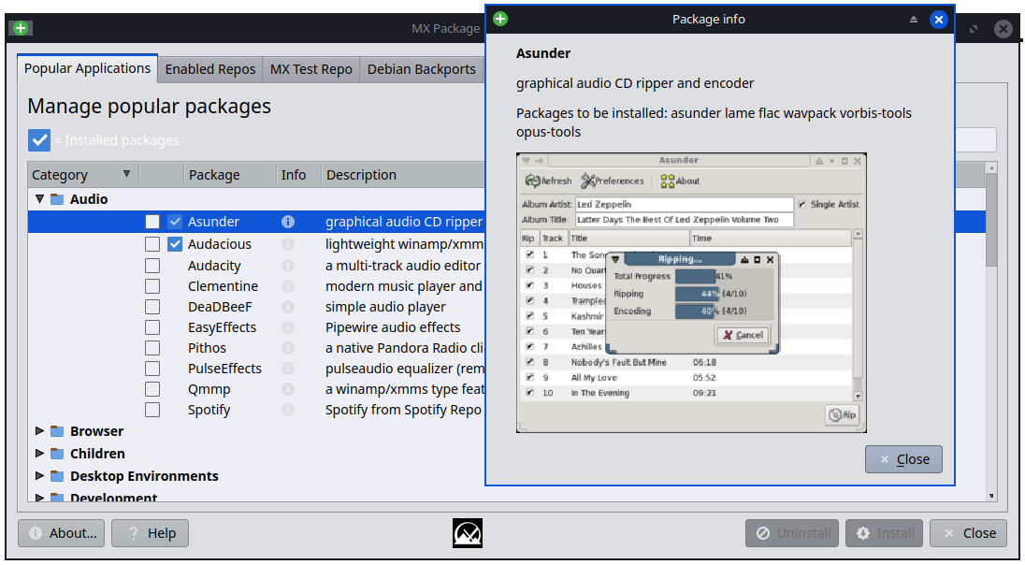

Popular Applications tab

- Expand the Category listings with the little arrow ► to see the packages available; more information (including screenshots where possible) is available by clicking on the Info icon ⓘ.
- The ‘search’ box will parse application names and display matches in the tree.
- Check those that you want, and click Install.
- The Console Output will be displayed. First the repos are updated and then your packag(es) are installed.
- If a package is already installed, you will have the option to either Uninstall or Reinstall it.
- If there are problems, there is a log in the Quick System Information app(also at /var/log/mxpi.log and mxpi.log.old) for you to post in the MX Linux Forum.

Enabled Repos tab

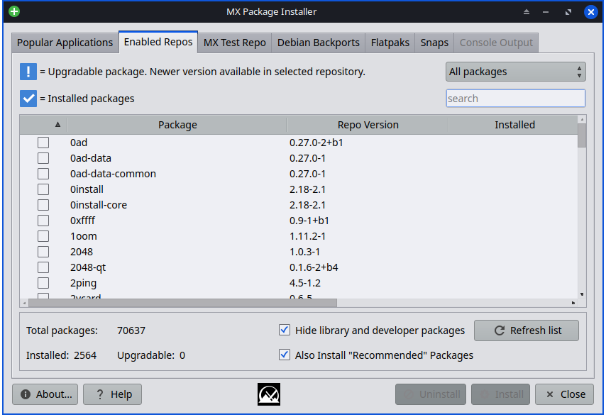
This tab gives you access to the full catalog of apps available from both MX Linux and Debian Stable - (main, contrib, non-free, non-free-firmware). It has a limited feature set and is not a replacement for a full Package Manager like the default Synaptic. Consider the MX Package Installer supplementary to Synaptic.
Filter options
The ‘Installed’ column will show a version if it differs from the ‘Repo Version’ (see above in the upper right ). The pull-down can be changed from ‘All packages’ to: ‘Installed’, ‘Upgradable’, ‘Not Installed’, and ‘Autoremovable’. All of these filter choices work in conjunction with the ‘search’ box below it.
Packages then can be manipulated in similar fashion to the Popular Applications Tab.
An ‘Autoremove’ and ‘Upgrade All’ buttons will appear when MXPI see that their affect could be used.

MX Test Repo tab

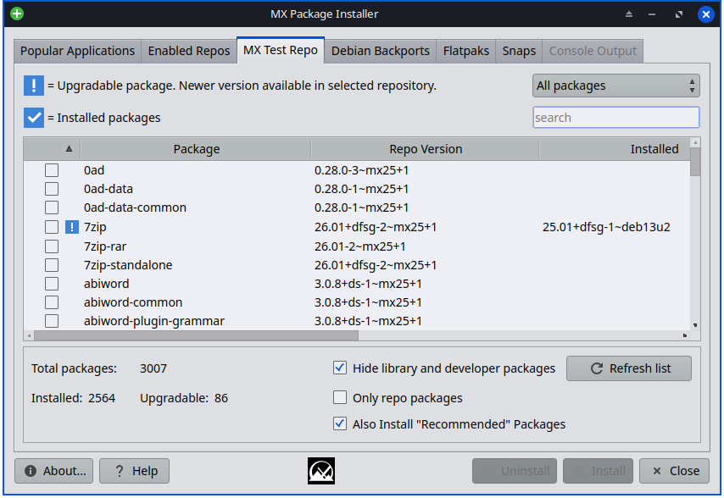
Filtering options
The ‘Installed’ column will show a version if it differs from the ‘Repo Version’ (see above in the upper right). The pull-down can be changed from ‘All packages’ to: Installed, Upgradable, Not Installed, and Autoremovable. All of these work in conjunction with the ‘search’ box below it.
An additional filtering is offered as a checkbox: Only repo packages.
This tab allows the user to browse packages available in the MX Test Repo without needing to change any Apt sources manually. FYI: The ‘MX Test Repo’ is NOT the same thing as the Debian testing repo.
If the user chooses to install a MX Test Repo package via the MX Package Installer, the Test Repo sources will be automatically added for the duration of the application install process. The MX Test Repo sources will then be ‘disabled’ (by MXPI) after the installation has completed.

Debian Backports tab

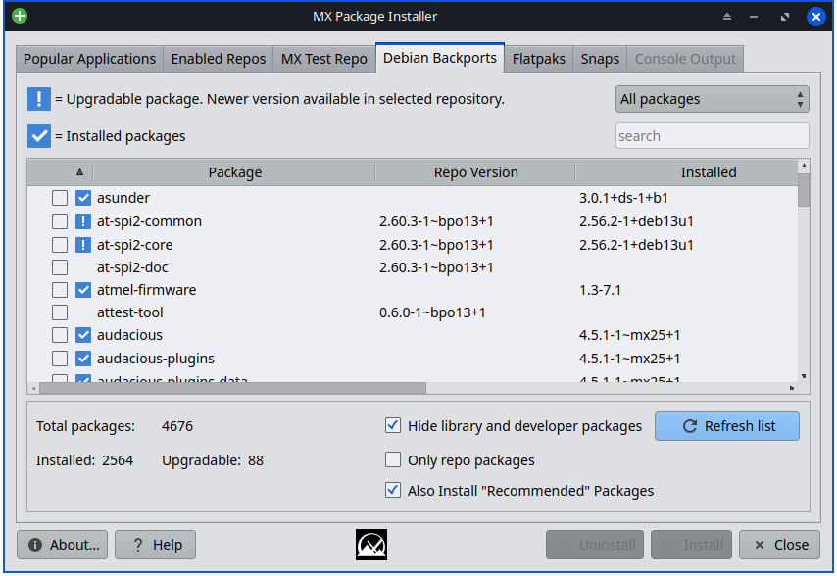
Filtering options
The ‘Installed’ column will show a version if it differs from the ‘Repo Version’ - see above.
The pull-down in the upper right can be changed from ‘All packages’ to: ‘Installed’, ‘Upgradable’, ‘Not Installed’, and ‘Autoremovable’. All of these filter choices work in conjunction with the ‘search’ box below it.
An additional filtering is offered as a checkbox: Only repo packages.
Similar to the MX Test Repo tab, this tab allows the user to browse packages available in the Debian Backports repository maintained by Debian, without needing to change any Apt sources manually.
If the user chooses to install a Debian Backports package via the MX Package Installer, the Debian Backports Repo sources will be automatically added for the duration of the application install process. The Debian Backports Repo sources will then be ‘disabled’ (by MXPI) after the installation is complete.

Flatpaks tab

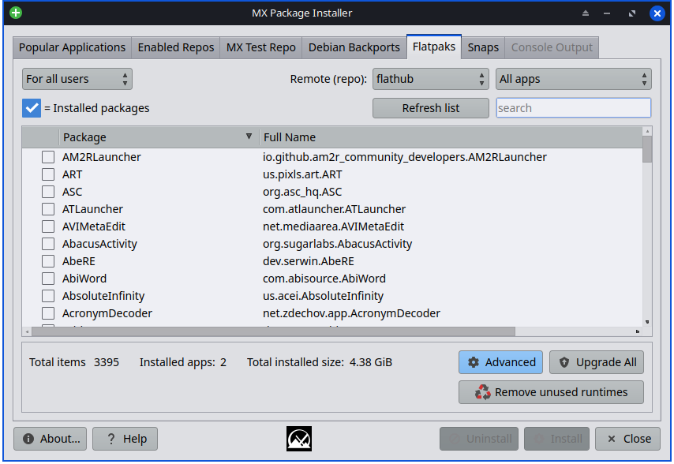
Flatpaks are a type of package that has all the needed dependencies included that’s supposed to work on multiple Linux distributions.
Flatpaks are not perfect: some might not work well, might not follow your PCs theming, etc.
The first Flatpak that you install will pull in a large runtime, so it will take a long time to download and will take a lot of space on your hard drive (around 2 Gb). The next Flatpak will most likely be able to use that runtime, so it gets a bit better after you install a couple of Flatpaks.
By default, the “flathub” Remote (repo): is used by default. Others can be added via the ‘Advanced’ dialog.
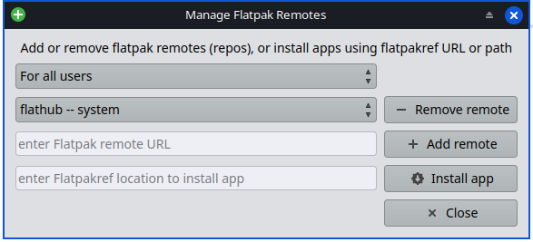
You can also install Flatpaks via ref files via the Advanced dialog.

Flathub - Apps for Linux

Snaps tab

NOTE: For the Snaps tab to appear the PC must be booted with systemd.

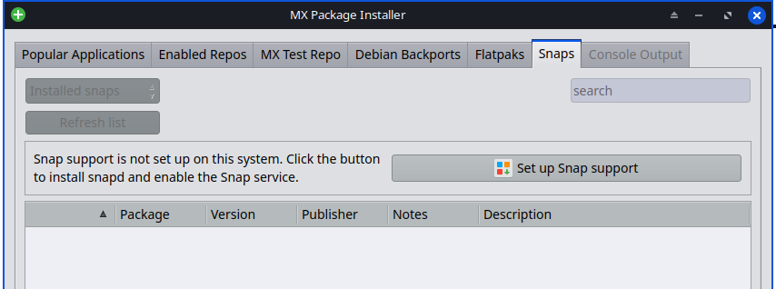
The recent update (mx-packageinstaller 26.06.2) adds a new Snaps tab on PCs that support Snap packages. An easy Snap setup for PCs that do not have Snap support (snap daemon) ready yet.
To setup - click ‘Set up Snap support’.
- Searches the Snap store to install, remove, or update Snap packages from inside MXPI.
- Show live Snap installation progress in the Output tab while Snaps download and install.
- Newly installed Snap apps appear in Start menu & terminal commands (after relogging in).
Below shows what the MXPI Snaps tab looks like after a Snap app (firefox 151) has been installed.
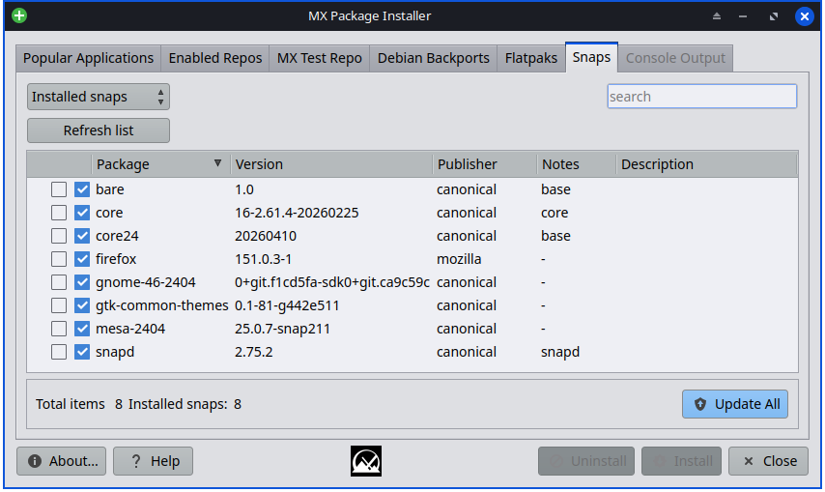

MX Package Installer — Question & Answer

Q: What effect does ticking “Hide library and developer packages” actually have? Does it just hide stuff as a declutter convenience, or could it possibly prevent essential libraries from being installed ?

A: it hides application libraries (lib* packages) from the listing. but nothing prevents them from being installed if they are needed by an application.

Q: What effect does unticking “Also Install Recommended Packages” actually have? Does it just prevent unsolicited clutter, or might it prevent required dependencies?

A: Debian has three levels of dependencies on packages:

Debian has three levels of dependencies on packages:

1) depends, which are necessary;
2) recommends, which can be nice and extend functionality, but are not strictly speaking required; and
3) suggests, which are usually other applications that might compliment the package.

By default, MX does not install the “recommends” by default. but checking the option means it will.

Q: If subsequently regretting installing a program plus its recommended packages? Is there any way to uninstall not just the originally selected program, but all of its recommended packages that came with it as well?

A: For the most part, when uninstalling a package, its dependent packages will be marked “autorem ovable.” We do not remove those by default, but you can from the command line by entering the code below.
Look at the list carefully to make sure nothing you want or need is autoremovable. Usually things like libraries and “data” packages are small and OK to remove. things like Xorg/xserver, xfce, kde...big stuff like that should not be autoremoved.

sudo apt autoremove -s (-s simulate)

Development history: Dolphin_Oracle, Adrian, fehlix
License: here
v. 20260610

