

MX Linux 25
OEM install manual
v. 202604022
manual AT mxlinux DOT org

Limitations

Remember, this software is provided AS-IS with no warranty what-so-ever. It is solely your responsibility to back up your data before proceeding.

Not all screen options are covered in this manual. For furthur guidance see the MX Linux 25 User Manual https://www.mxlinux.org/manuals

OEM Installation

Original Equipment Manufacturer (OEM) is a special installation method that it allows the PC to be shut down just after the Linux OS portion of MX has been installed. Later, a second party boots up that PC and then can resume the MX new user portion of the setup.

This is useful for selling or giving away a computer with an Operating Sysytem pre-installed on it. MX Linux can be installed as an OEM by using a switch in terminal:

sudo minstall --oem

Note: that is two hyphens before oem.

This will install the Operating System only, delaying prompts for user-specific options such as PC name, user name (ID) and password.

Subsequently when booting into this newly installed Operating System for the first time, the user will be asked to provide those details.

How it works

The MX Installer during its operation automatically installs a startup script on Operating System.

When booting into the installed Operating System, the script runs:

sudo minstall --oobe

to activate the Out Of Box Experience aka OOBE screens that prompts for the missing details.

When the user has finished entering those details, the script is automatically disabled by the installer so that it is never run again.

If the computer is shut down before all OOBE steps are completed, the screen will reappear until the user has entered the required details.

OEM Installation 1st Phase

BEFORE PROCEEDING, CLOSE ALL OTHER APPLICATIONS.

1 Starting the installation

On each page, please read the instructions, make your selections, and then click on Next when you are ready to proceed. You will be prompted for confirmation before any destructive actions are performed.

The right side presents user choices for interaction as the installation proceeds. The Help tab (left) provides clarification of the content of the right side. MX Linux can be installed as an OEM by using a switch in terminal:

sudo minstall --oem

Note: that is two hyphens before oem. Password: demo

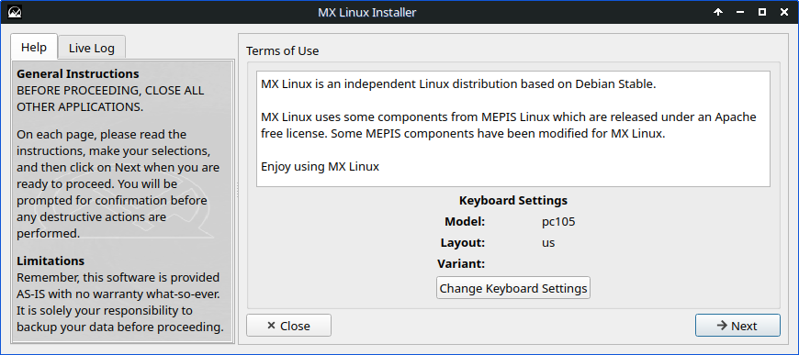
Use 'Change Keyboard Settings' button to change to the keyboard. The keyboard at the top of the Layouts list will be the default, and the others in the list are switchable.

Click '→ Next'

Select type of installation

Use these summaries below to selecting the type of installation:

- (MX User Manual section 2.5.1) Select this option if you plan to use the entire hard drive for MX Linux. The disk will be re-partitioned and ALL existing data will be lost.

Regular install using the entire disk

- (MX User Manual section 2.5.2) Pick this option if you need more control over where MX Linux is installed to. There you will then be able to select and configure the disks and partitions you need.

Customize the disk layout

- (MX User Manual section 2.5.3) will attempt to replace an existing installation with the same disk configuration as the existing installation. Home directories and most settings are preserved.

Replace existing installation

2 Installation Confirmation

A message will ask you to confirm your choice:

'Format and use the entire disk (disk_name) for MX Linux?'
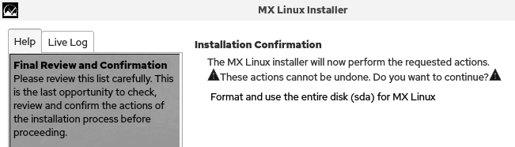

Please review this list carefully. This is the last chance to alter these actions before proceeding.

Click 'Start'

3 Create a swap file

A swap file is more flexible than a swap partition; it is considerably easier to resize a swap file to adapt to changes in system usage.

By default, this is checked if no swap partitions have been set, and unchecked if swap partitions are set. This option should be left untouched, and is for experts only. Setting the size to 0 has the same effect as un-checking this option.

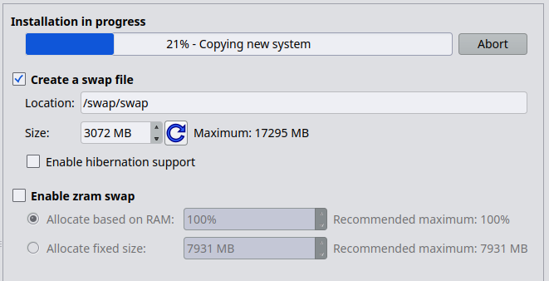
See the MX Linux 25 User Manual for more details on other options on this screen.

Click '→ Next'

4 OEM 'Installation complete' screen

After the 'Installation in progress' is finished an 'Installation complete' screen will be presented.

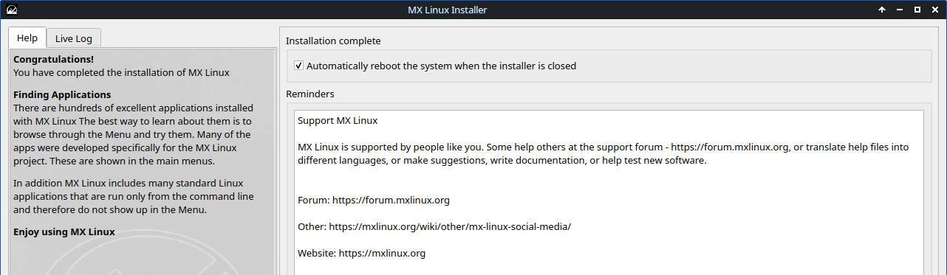
Click '→ Finish'

The PC will REBOOT on its own.

OEM Installation 2nd phase

After the PC reboots into MX Linux the box below will appear.

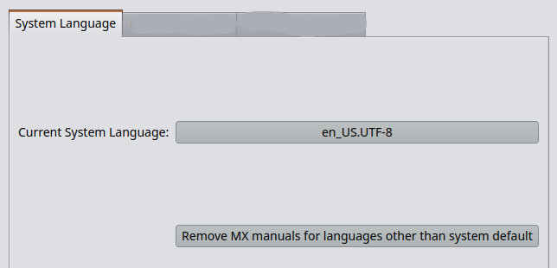
This GUI allows the choice of the system-wide default language. Clicking the Current System Language: button will bring up a language selection dialog.

Click 'Close'

A message: “Gathering information, please standby” will briefly appear. Then, the screen below.

Click '→ Next'

5 Computer Network Names

Many users choose a unique name for their computer: laptop1, MyBox, StudyDesktop, UTRA, etc. You may also just leave the default name MX as it is.

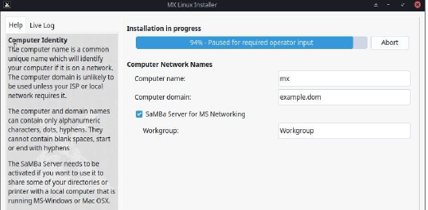
You can just click '→ Next' here once you have finished the screen 'Computer Network Names' configurations.

6 Localization Defaults

The defaults will usually be correct here if you were careful to enter any exceptions at the USB boot screen. These settings can be changed when you have booted into MX Linux.

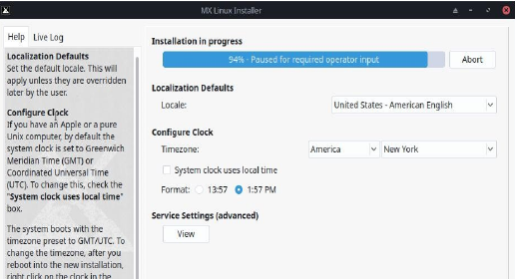
- Set the default locale. This will apply unless they are overridden later by the user.

Locale

- If you have an Apple or a pure Unix computer, by default the PC clock is set to Greenwich Meridian Time (GMT) or Coordinated Universal Time (UTC). To change this, check the "System clock uses local time" box.

Configure Clock
The system boots with the timezone preset to GMT/UTC. To change the timezone, after you reboot into the new installation, right-click on the clock in the Panel and select Properties.
Click '→ Next'

7 Default User Account

The level of security on the passwords you choose here will depend greatly on the setting of the actual computer. A home desktop is generally less likely to be broken into.

If you check Autologin, you will be able to bypass the login screen and speed up the boot process. The downside of that choice is that anyone with some kind of access to your computer would be able to log directly into your account.

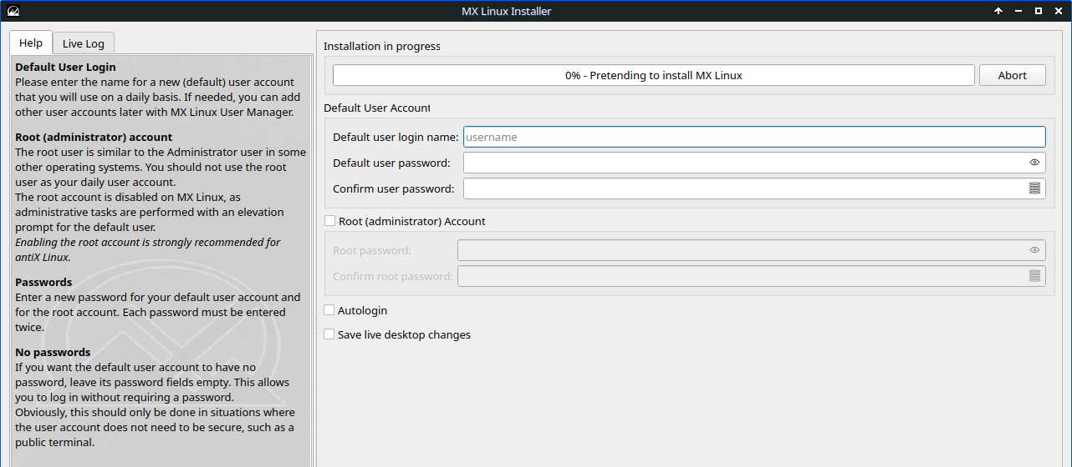

Root (Administrator) Account

The root user is similar to the Administrator user in some other operating systems. You should not use the root user as your daily user account. The root account can be disabled on MX Linux by leaving it unchecked, as administrative tasks can be performed with an elevation prompt with the default user.

Click '→ Next'

8 Ending messages

On screen: “Configuration complete. Restarting system.”

The PC will reboot on its own.

9 Finishing up
Some starting tips:

- Setup Wi-Fi if applicable
- Run updates
- Install Microsoft Fonts
- Install user's preferred web browser & social media apps
- Setup E-mail
- Setup printer
- Leave a copy of MX Linux 25 Quick-Start Guide PDF on Desktop

