Ventoy – How-To

Ventoy allows booting from one or more ISOs without having to burn them to a USB. The Ventoy program is installed on a USB drive, NOT on the PC system. This USB drive then can boot from any of the ISOs on the USB drive. This is a one time per USB installation of Ventoy. Ventoy eliminates having to burn each ISO to a separate USB drive. For best results, I recommend Ventoy 1.1.01 or newer, especially for MX Linux 25.

Ventoy automatically adds ISOs of your choice to its boot menu so that you can decide which one to use for bootup. Moreover, the USB drive is not dedicated to Ventoy, you can add documents and other files without affecting the Ventoy program operation.
The Ventoy installation program will create two partitions on the USB drive selected by the user. One is used for Ventoy program itself and the other for the user's ISOs files.

1 Important notes
MX Linux 25 requires Ventoy version 1.1.10
There are 3 major tasks in preparing a Ventoy USB drive prior to use:
- Running the downloaded Ventoy USB preparation installation program.
- Copying the ISOs to the Ventoy partition on the USB.
- Booting from the USB – the Ventoy ISO installer starts automatically.
There's been a LOT of confusion about Ventoy – mostly the blurring together of the 3 major tasks above.

2 Installation notes

Please backup ALL important data on the USB drive as it will be re-formatted!
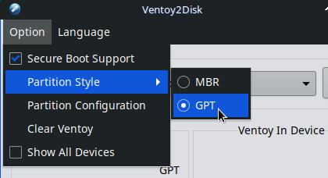
There might be an issue with the type of partition aka Partition Style of
MBR vs GPT. Generally for newer PCs use GPT. MBR is the default.

Ventoy will prompt you - 'This device will be formatted and all the data will be lost. Continue?' (Yes/No).

Then a Double Check with a Yes/No again.
The installation will finish with a notice: 'Congratulations! Ventoy has been successfully installed to the device'.

3 Linux – Ventoy Installation
- Download the Ventoy file for Linux from the Ventoy website. https://www.ventoy.net/
- In your File Manager navigate to the file location.
- Right click on the file and choose 'Open with Archive Manager'.
- Click 'Extract', click 'Extract' again in the popup.
- Click 'Show the Files' and then right-click the Ventoy folder (example: ventoy-1.1.00)
- Select 'Open Terminal Here' or 'Open in Terminal'.
- Insert the USB drive in a USB 3 outlet (if available)
- Launch the Ventoy installer by typing:
sudo ./VentoyGUI.x86_64
- Press enter. Enter your password and press enter.
If the USB drive does not appear in the 'Device' drop-down list, click the green refresh button to the right.

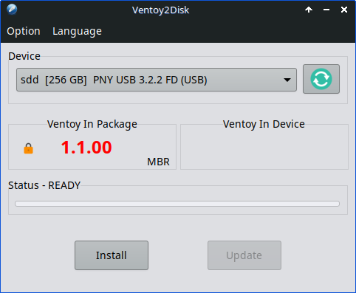
Once you have verified the correct USB drive is selected click 'Install'.

4 Windows – Ventoy Installation

- Download the file for Windows from the Ventoy website https://www.ventoy.net/
- Click to highlight the file and then right click and choose Extract.

'Compressed folder Tools' appears as a tab.
- Click 'Extract All' and accept the popup by clicking 'Extract'.

A new Window File Explorer window appears.
- Double click on the [folder name] name.
- Double Click on the file 'Ventoy2Disk.exe'.
- For the 'User Access Control' popup click 'Yes'.
- In the popup for 'Device' select the USB drive you want Ventoy installed on.

Once you have verified the correct USB drive is selected click 'Install'.

5 Preparing the USB drive for usage
Download your ISOs from the Internet and temporarily save them to your 'Desktop' folder. Once copied to your Ventoy drive you can move them to your 'Downloads' folder.
- Insert the Ventoy drive into a USB port on your PC. Your File Manager should open automatically with the Ventoy drive highlighted. In the example below Windows File Explorer is showing 'Ventoy (E:)'.
- Resize the File Manager to cover only part of the screen. (Super + right-arrow).
- Ensure that the 'Ventoy' drive (in This PC) is highlighted. See below.
- Click, Drag and Drop each ISO to the Windows File Manager window open space.
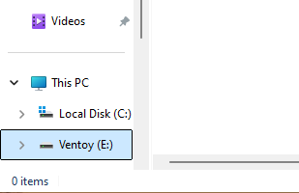
Windows 11 File Explorer is showing 'Ventoy (E:)'
WARNING: Do NOT eject the USB' drive immediately after copying your ISOs. Data is still being copied and the USB drive should NOT be immediately disconnected. Use the 'Unmount drive' (upward facing arrow ) in the 'System Tray' after taking some time (~1/2 to 1 minute) to wait.

6 Booting the Ventoy USB
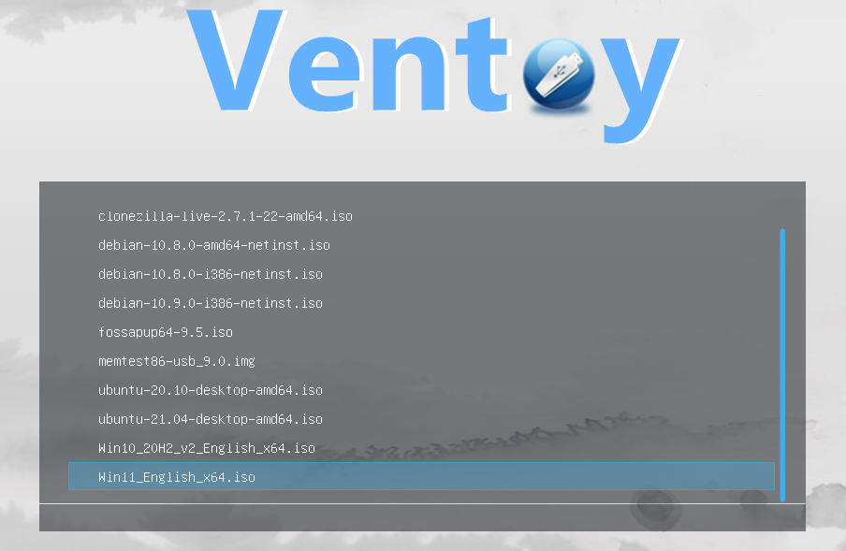
Insert the prepared USB into a USB jack and start the PC. Use the 'One time boot' menu keystroke (F12, F9, F2 or Esc – machine dependent). Choose your USB and press enter.
Use you Up/Down arrow keys to select the desired ISO and press enter.
A secondary boot menu will appear. Take the first choice and press enter.

About Secure Boot in UEFI mode

Secure Boot is supported from Ventoy 1.0.07 and is enabled by default since 1.0.76. Ventoy can boot fine no matter whether the secure boot in the BIOS is enabled or disabled.

If the secure boot is enabled in the BIOS, please follow this guide https://ventoy.net/en/doc_secure.html This enrolling of keys is a 'one time' per PC action.

Ventoy home page https://www.ventoy.net/en/index.html

Created: February 6, 2025 Updated: January 24, 2026

USB3 outlet (blue tab in the center), if available, otherwise the USB2 outlet (black tab in the center).

