Bluetooth devices – How To

Bluetooth is a method for moving data over short distances using wireless. It is used for peripherals of all kinds: phones, audio equipment, keyboard, and mice. Only coverage of Cinnamon, Fluxbox, Gnome, KDE and Xfce.
For high-end audio Bluetooth speakers and other devices see this A2DP link. To select a profile right-click on the device then check 'Audio and input profiles'. Right-click again and hover over 'Audio Profile' and select a profile. The 'PulseAudio Volume Control' aka 'Audio mixer...' has the same selections on the 'Configuration' tab.
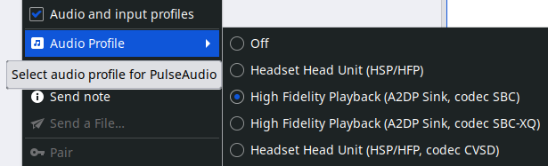
NOTE: The Pairing and Trust state of a given Bluetooth device are the only ones that persist through PC reboots. So, the subsequent usage of a Bluetooth device only requires a right-click ' Connect' for it to work.

Pairing & Connecting
Some peripherals (keyboards, mice, etc.) link automatically. Others such as smart-phones and audio headsets, need to be paired (& connected if pairing does not). For security reasons, Bluetooth devices will only talk to each other if they have been "introduced" first, aka Pairing.
Make sure the device you are interested in is discoverable (pairing enabled). Some devices require a special keypress to enter pairing mode.

Cinnamon, Fluxbox & Xfce
This section covers connections with the Blueman app that is  in the SysTray. One time setup:
- From the Start Menu, type 'Blue' in the search box and click 'Bluetooth Manager'.
- Answer 'Yes' to the question: 'Shall Bluetooth get enabled automatically?'
- Click 'Adapter' and change the setting to: 'Always visible' and then X out of the popup.

Now you should have the Bluetooth icon  in your SysTray (blueman-applet).

Connecting devices
Enable pairing and act quickly, as pairing may have a relatively short time-out period, sometimes 10-seconds.

- Click the Bluetooth icon  and the Blueman app will open.
- Click ' Search' to find devices.
- Highlight the desired device and click the Trust icon  in the toolbar.
- Click the Pair icon in the toolbar. FYI: most devices will connect at this point. This is normal.
- Double-click the device. It should connect and send a short beep sound through the connection.

Occasionally a device will NOT stay connected. If so, right-click on the device and then left-click  Connect'

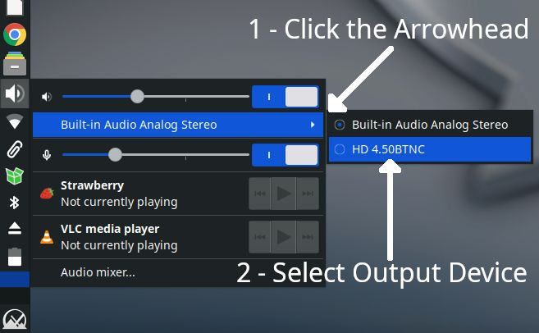
Setting the sound profile - Xfce
Left-click the speaker icon in the System Tray.
Left-click the right facing arrow  in the blue bar (1).
A fly-out menu results (2). Select the desired device.
Note: the blue highlighted 'HD 4.50BTNC' is not yet selected.
Other devices will be listed below it as more choices (2).

Reconnecting devices
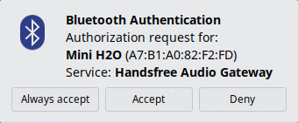
Starting with MX Linux 25 Xfce a 'Bluetooth Authentication' popup appears when you power on a previously connected Bluetooth device when in range. FYI - Pairing and Trust are persistent on Linux installations. If you choose 'Always Accept' the device will finish connecting on its own for the next power on.

KDE – Plasma
Right-click the Bluetooth icon  in the SysTray and verify that 'Enable bluetooth' is checked.
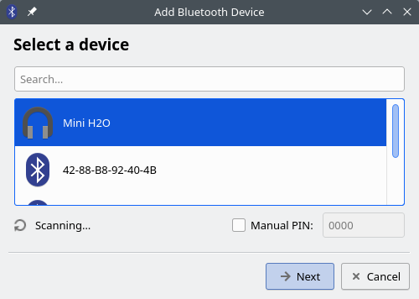
To add a new device:

- Click the Bluetooth icon and click '+ Add New Device…'
A popup 'Select a device' will scan for Bluetooth peripherals.
- Highlight the desired device and click '® Next'.
- A 'Setup Finished' popup will appear.
If there are several Bluetooth devices in the area it may take several 10s of seconds for all to appear.

Changing the output device
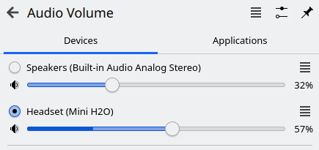
Click the speaker icon. A pop-up will allow device selection. At right shows 'Speakers' and 'Mini H2O' as choices.

Occasionally KDE will refuse to re-connect to a previously used device. Power cycling the device usually clears this. If not right-click the Bluetooth icon, select 'Configure Bluetooth…' then delete the device  that is not connecting.

Other KDE settings - right-click the Bluetooth icon and click Configure Bluetooth…'. This is where you can delete stale devices and ones that fail to reconnect.

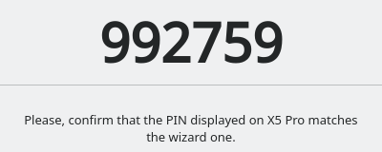
KDE – PIN to allow connection aka Legacy Pairing:

If you're using an older Bluetooth device that does not support Secure Simple Pairing (SSP), it might use Legacy Pairing, they require a PIN to connection. There will be a 6-digit suggested PIN.

Along the bottom are two buttons where you can confirm the PIN either 'Matches' or ' Does not match' on the device.

If you can't find a specific PIN for your device, you can try using a generic PIN like "0000" or "1234". These are commonly used default PINs for many Bluetooth devices. See devices maker's website for more.

Sound Profile

From the Start menu, Settings, Input & Output, Sound. Choose your Playback Device 'Profile:' with the .

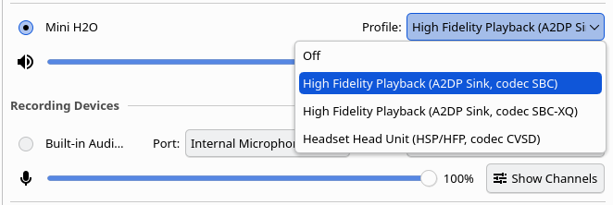

Gnome – Ubuntu

At the top right click on the Network icon. In the Bluetooth area click the > button. Click on 'Bluetooth Settings' to scan for devices. Click on desired device to connect. X out to close window.

To remove a device

Go to 'Bluetooth Settings', click device & then click 'Forget Device...' On the confirmation popup click 'Forget'.

PulseAudio Tweaks for Better Quality
Edit ~/.config/pulse/default.pa (create if missing): Add load-module module-bluetooth-policy auto_switch=2 at the end. Restart Pulse: pulseaudio -k && pulseaudio –start then test with pavucontrol switch output device and profile manually.

Object (file) Transfer
To be able to pass objects (documents, photos, etc.) back and forth between an MX Linux and a device using Bluetooth. First confirm that the phone and PC have Bluetooth enabled and are visible.
Note: Install the file 'bluez-obexd' (Object Exchange daemon for sharing content) as it is needed.
To send a file:
- Right-click the Bluetooth icon in the Notification Area > '®Send Files to Device…'
- On the cell-phone: follow the appropriate on screen instructions for your device.
- Keep your eye on the receiving device to confirm acceptance of the object being transferred.

Tethering with Bluetooth
Tethering or phone-as-modem (PAM) is the sharing of a mobile device's cellular data connection with other connected computers. Most mobile carriers charge extra for tethering; as it uses a large amount of data. Check your cell plan. More on using Bluetooth Devices to a cell-phone as an Internet Access Point here tethering.

Bluetooth troubleshooting
Make sure Bluetooth is actually turned on for both the device and in the Blueman app (if present). It’s easy to overlook. Some devices power off when the battery is low. Bluetooth is short range, less than 30 feet (10 m).

There are some Bluetooth devices which will only pair to one phone or PC at a time (they store an address internally). For those devices, unpair AND disconnect them from the currently connected phone or PC.

Powering off a Bluetooth devices after disconnection has shown to make new connections more successful.

PulseAudio or PipeWire does not always auto-switch profiles smoothly. If the profile is grayed out, run:

pactl set-card-profile bluez_card.XX_XX_XX_XX_XX_XX a2dp_sink

Replace the XXs with your device's MAC from right-click info Address:.

Be aware that certain Broadcom binaries can not be distributed through the Debian repositories. Please see GitHub: winterheart - Broadcom Bluetooth firmware for Linux kernel.

Some recent (Bluetooth 6.x) dongles may not yet have drivers in the kernel and thus will not be fully recognized (partial service listings). The most likely solution is to upgrade the kernel. The hciconfig and hcitool (command line) terminal tools can be helpful when problems arise.

- To check if the Bluetooth daemon is running check in MX Service Manager
- To check that your BT device is present and working: hcitool dev hci0
For similar tools, consult the man page for hcitool (or use 'hcitool -h' for a summary).
- If the applet is not in the Notification Area: blueman-applet
- If Bluetooth Manager does not seem to start: blueman-manager
From Quick System Info app or in terminal run inxi -Exxxz. An example output below.
Bluetooth:
Device-1: Plugable Bluetooth 5.0 Adapter type: USB driver: btusb v: 0.8
bus-ID: 2-1.4:4 chip-ID: 2230:0016 class-ID: e001 serial:
Report: hciconfig ID: hci0 rfk-id: 1 state: up rfk-block: hardware: no
software: yes address: by-v: 3.0 lmp-v: 5.1 sub-v: 8761 hci-v: 5.1 rev: b

Notable info above:
- the 'driver: btusb' has a value, not n/a.
- 'state: up' not 'down'.

- Rfk-block – either a hardware or a software block will stop a connection. Software - older versions of Blueman have a on/off slider in their header. See ' on' state at right. Hardware are most likely a PC firmware setting.

Verify in the MX Linux Package Installer that you have the following installed (blue check):

blueman, bluetooth, bluez, bluez-cups, bluez-firmware, firmware-iwlwifi, bluez-tools, python3-bluez, python3-gattlib, libbluetooth3 and bluez-hcidump.

If using PipeWire (check with pactl info), add pipewire-pulse and wireplumber. For MX Linux 21 ONLY- 'pulseaudio-module-bluetooth'.

The file 'bluez-obexd' is optional - Object Exchange daemon for sharing content (file transfer).

Use: sudo apt install –reinstall [list of packages]

Older Laptops – Use TLP to turn off power saving. Install three additional packages: tlp, tlp-rdw, tlpui. Once TLP is installed on the Start menu click TLP UI and select 'Configuration' tab item 'USB'. In 'USB_EXCLUDE_BTUSB' toggle it to 'ON' (turns blue). Click 'Save' in the upper right.

Dual Booting
For dual booting multiple Linux’s ensure that all files from /var/lib/bluetooth/BT-Adapter-MAC-address are identical on each installation. Some Bluetooth devices can not handle multiple pairings associated with the same MAC address. More - https://wiki.archlinux.org/title/Bluetooth#Dual_boot_pairing

Computer is not visible
If your PC is not 'discovered' from your phone. Xfce: this setting is in 'Bluetooth Adapters'. Enable 'Always visible' in Visibility settings. KDE: in etc/bluetooth/main.conf set to stay discoverable forever.
Laptops: With Intel Centrino dual function Wi-Fi/Bluetooth adapters seen in older laptops, there exists a prerequisite. The Wi-Fi adapter MUST be on/enabled BEFORE turning on the Bluetooth. For most, this can be done by turning OFF the Airplane Mode (F-key with an airplane  or a radio tower  on it). More here.

Links

MX Linux Wiki - Bluetooth

TLP - Optimize Linux Laptop Battery Life - https://linrunner.de/tlp/index.html
“...TLP is a feature-rich command line [and GUI] utility for Linux, saving laptop battery power without the need to delve deeper into technical details….” TLP now covers all laptops, not just ThinkPads.

Wikipedia - List of Bluetooth profiles

Please direct ALL support requests to the MX Linux Forum -- https://forum.mxlinux.org/
Created by: FullScale4Me on: October 3, 2024 Updated: May 11, 2026

