(JS)

1. What is hoisting in JavaScript?
2. Why we use Javascript *
3. Loops in JS (For Loop,ap,Filter) *
4. Operators in Javascript *
5. Arrays, Objects in JS *
6. What is the difference between Var, Let, and Const? *
7. What are primitive and non-primitive data types in JavaScript? *
8. What is the difference between slice() and splice()?
9. What is DOM Manipulation (TextContent, InnerHTML, Styles, ­QuerySelector)
10. What are async/await and promises?
11. What is the difference between loose equality (==) and strict equality (===)? *
12. Are strings methods in JavaScript? *
13. What is synchronous and asynchronous code in javascript? *

(CSS)

1. Why we use CSS *
2. Display properties (flex) *
3. CSS positioning
4. What are the advantages of using CSS? *
5. What is Box Modal
6. CSS selectors *

(Html)

1. Why we use HTML *
2. Forms(lable, input tags) *
3. Tables *
4. What is HTML, What are HTML tags, What are HTML Attributes *

(Problems)

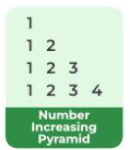

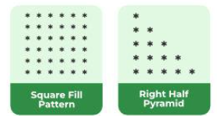

* Print 1 to 100 using for loop
* Print 100 to 1 for loop
* swap two numbers with using third variable,
* swap two numbers without using third variable
* Print elements in an array, find the largest number in an array
* Print some off all numbers in an array
* Reverse a string