Report of the AE1 of PROGRAMMING

Name: Yangjiangdai Pan

Student ID: 2294163P

Assumptions that I have made to check if it affects the implementation:

1. The length of the customer’s name.

Result: the window can not show all of the characters at once if it is too long, but it would not affect the rest of the window.

1. The length of the wine’s name.

Result: the window can not show all of the characters at once if it is too long, but it would not affect the rest of the window.

Deficiencies: My program meets the specification.

Details: Input: Customer name: Yangjiangdai Pan; Balance: 42

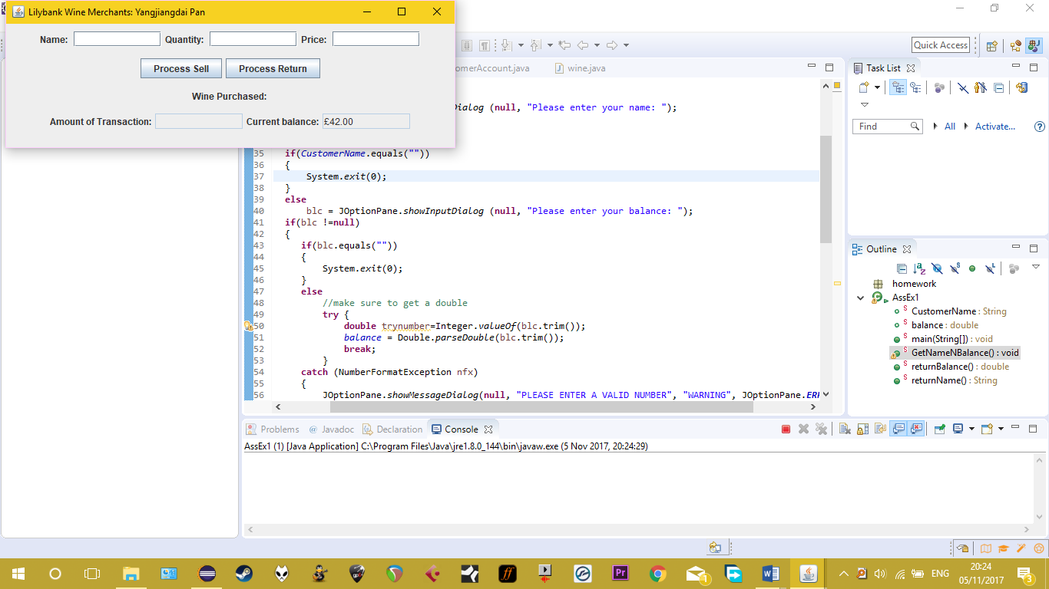

FIGURE.1 (Each figure has a larger version on the next page)

Invalid data:

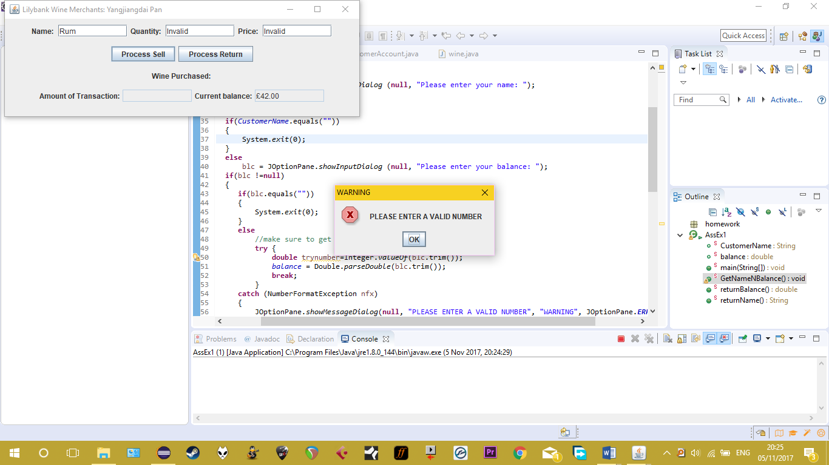

FIGURE.2

Test transaction:

Input1: Name: Vodka Quantity: 666 Price: 25.99

Expected output1: Amount of Transaction: 17309.34 Current balance: 17351.34

Input2: Name: Whiskey Quantity: 2814 Price: 24.39

Expected output2: Amount of Transaction: 54906.77 Current balance: 37555.43CR

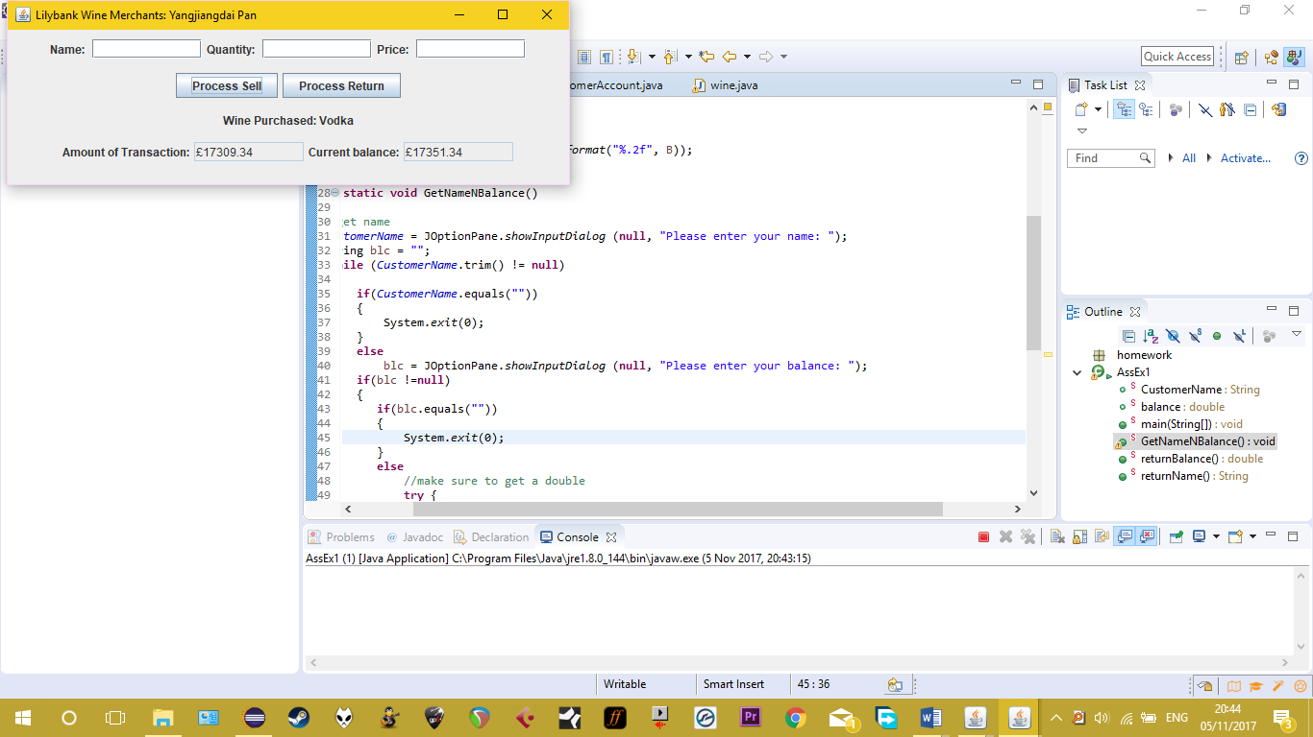

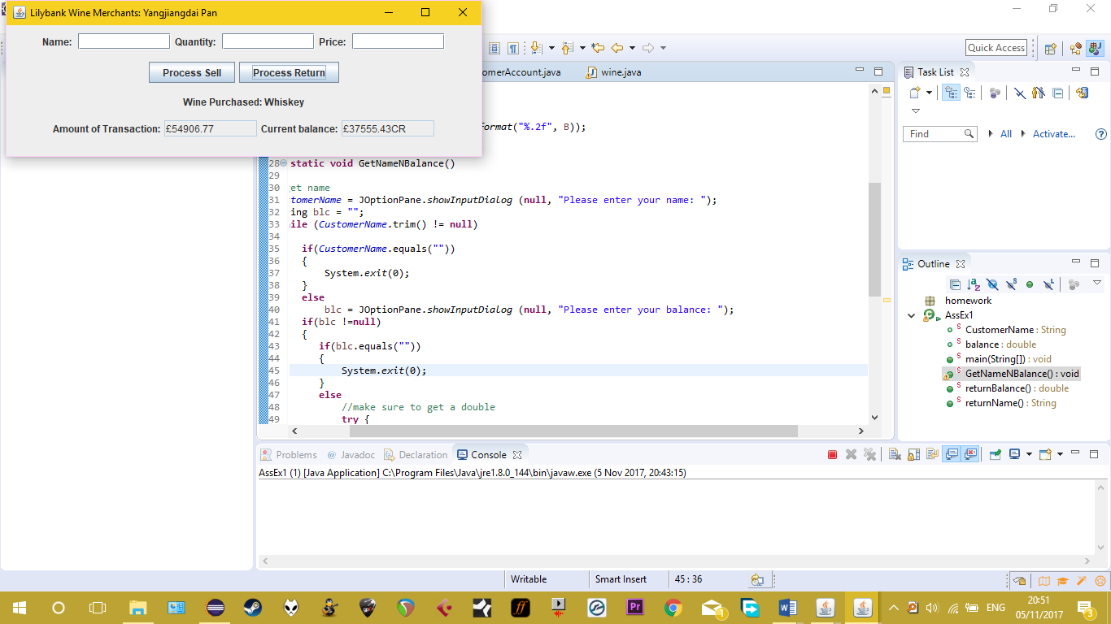FIGURE.3

FIGURE.4

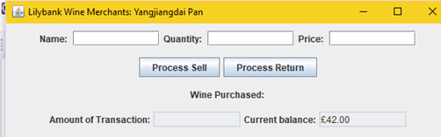

FIGURE.1

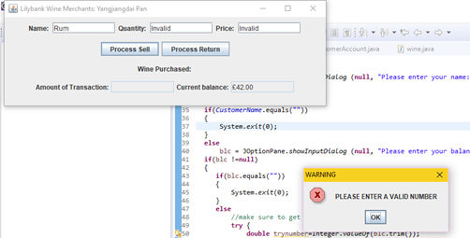

FIGURE.2

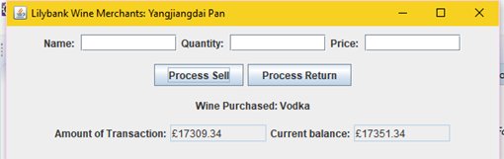

FIGURE.3

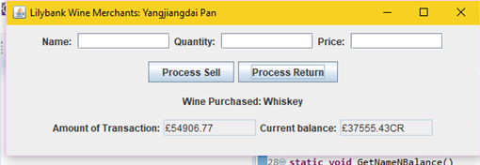

FIGURE.4