Report of the AE2 of PROGRAMMING

Name: Yangjiangdai Pan

Student ID: 2294163P

Assumptions that I have made to check if it affects the implementation:

1. The length of the keyword.

There is going to be a warning message of invalid keyword.

1. The repeat characters are not close to each other.

There was a bug that if the repeat characters are not close to each other, the program would fail showing the warning message, but it is fixed.

1. If the program can not find the file (wrong file name).

There is going to be a warning message of invalid file name.

Deficiencies: My program meets the specification.

Details:

1. Invalid data (keywords have repeat character, keywords have non-capital character, and invalid file name).

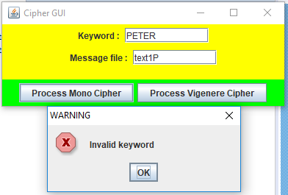

**Figure 1 repeat letters**

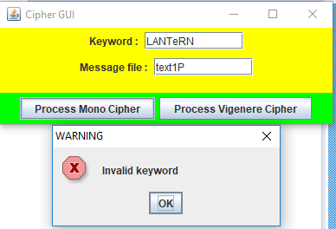

**Figure 2 non-capital letter**

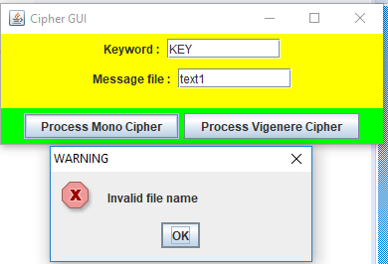

**Figure 3 invalid file name**

1. Monoalphabetic: cipher array, plaintext file, encryption, decryption and letter frequencie.

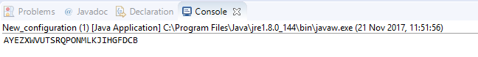

**Figure 4 mono cipher**

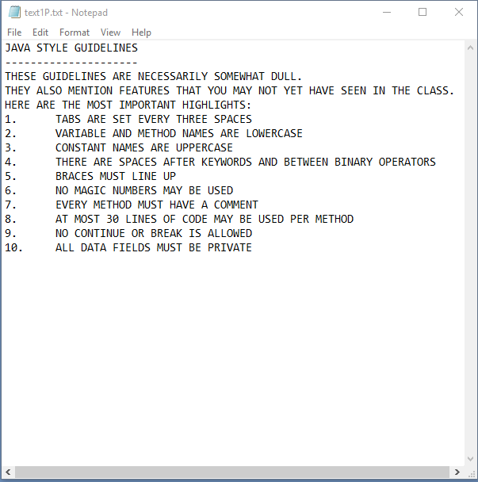

**Figure 5 mono plaintext file**

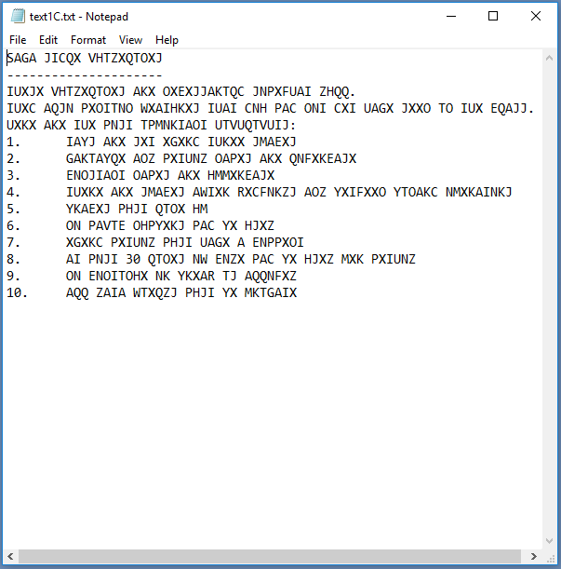

**Figure 6 mono encryption**

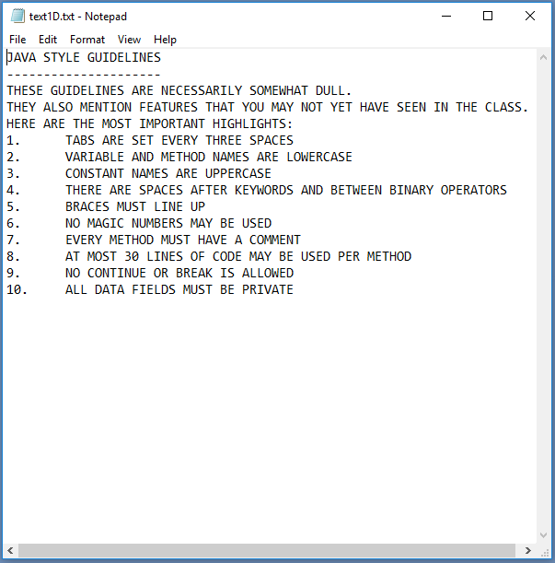

**Figure 7 mono decryption**

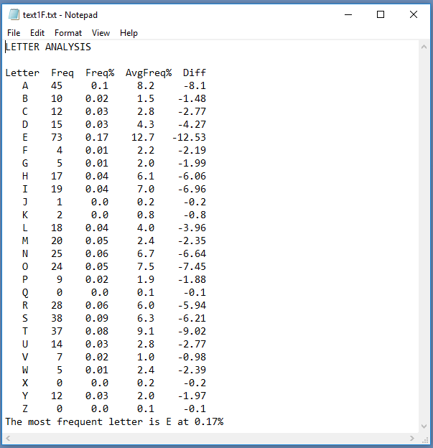

**Figure 8 letter frequencies (original)**

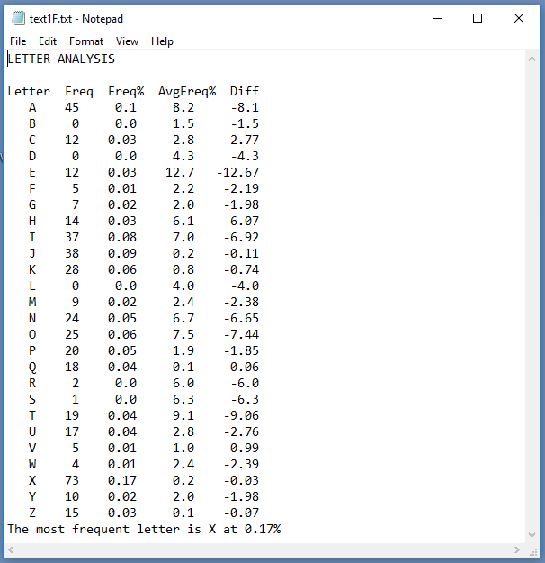

**Figure 9 letter frequencies (encode)**

1. Vigenère: cipher array, cipher plaintext file, encryption, decryption, and letter frequencies.

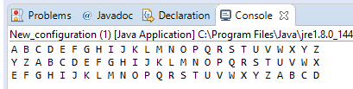

**Figure 10 V cipher**



**Figure 11 V plaintext file**

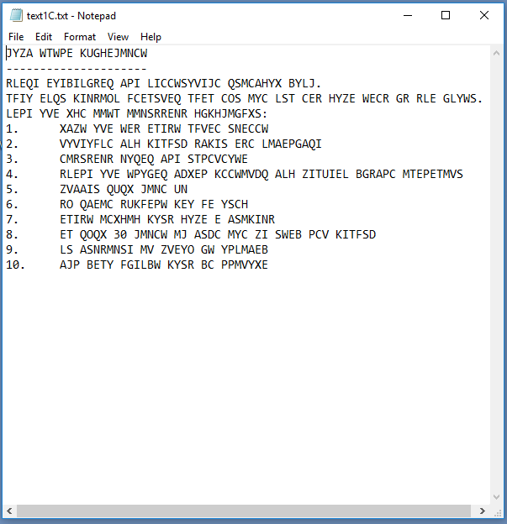

**Figure 12 V encryption**

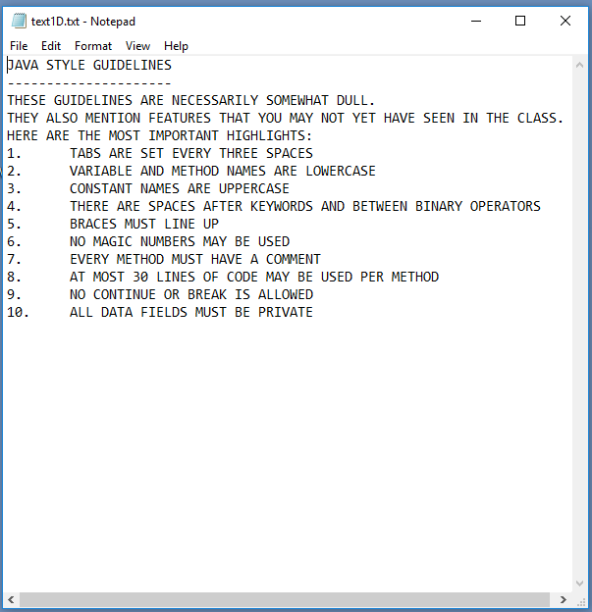

**Figure 13 V decryption**

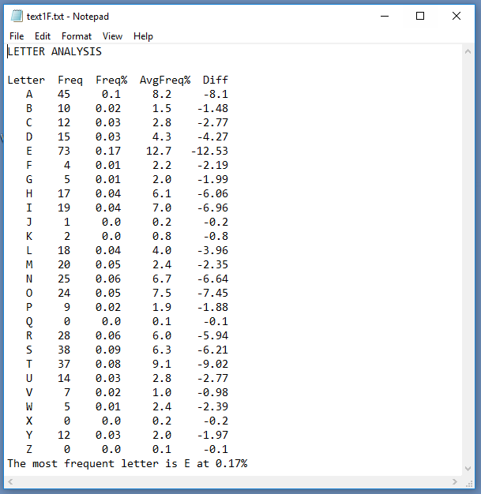

**Figure 14 V letter frequencies (original)**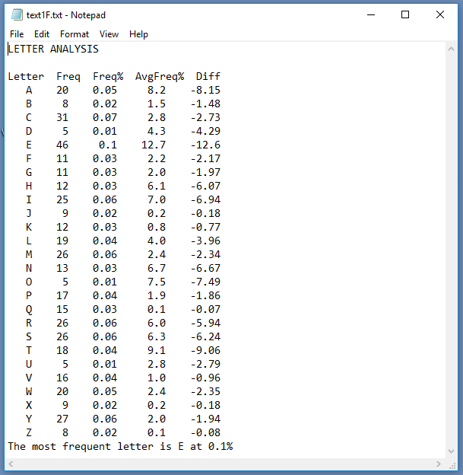

**Figure 15 letter frequencies (encode)**